Supplementary Material

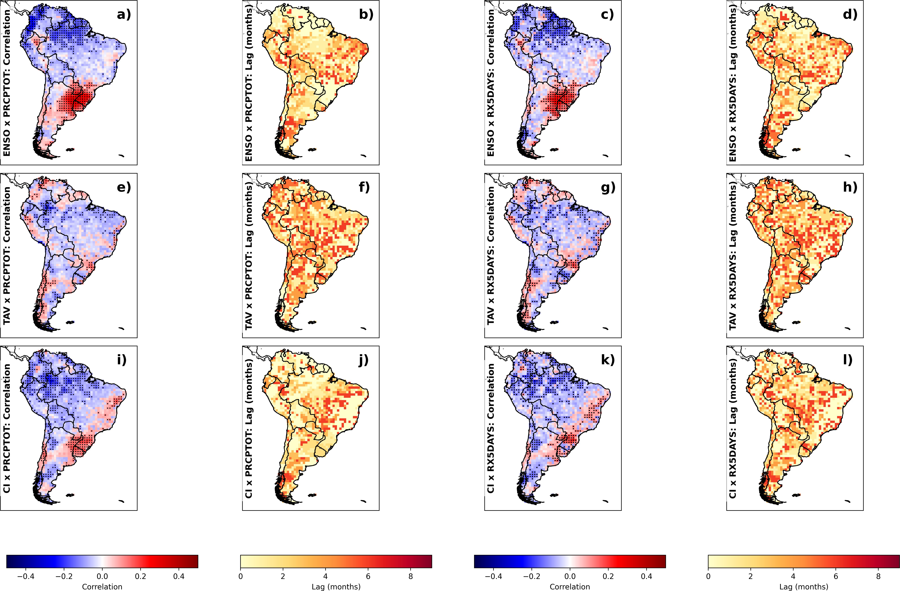

Fig. S1 Maximum lagged correlations between large-scale climate modes and precipitation extremes over South America (SA) (2000–2024). Panels (a), (e), and (i) show the maximum absolute correlation coefficient between ENSO, TAV, and CI with PRCPTOT, respectively; panels (c), (g), and (k) show the corresponding maximum correlations with RX5DAY. Panels (b), (f), and (j) show the lag (in months) at which the maximum correlation with PRCPTOT was obtained for ENSO, TAV, and CI, respectively; panels (d), (h), and (l) show the corresponding lags for RX5DAY. Warm (cold) colors in correlation panels indicate positive (negative) correlations. Colors in lag panels indicate the lag in months (0–8) at which the maximum absolute correlation was obtained. All correlations were computed from monthly anomaly time series after removal of the climatological seasonal cycle by subtracting the 2000–2024 calendar-month mean. Dotted areas indicate regions where the maximum correlations are statistically significant at the 95% confidence level after Bonferroni correction for multiple testing (Wilks, 2016).

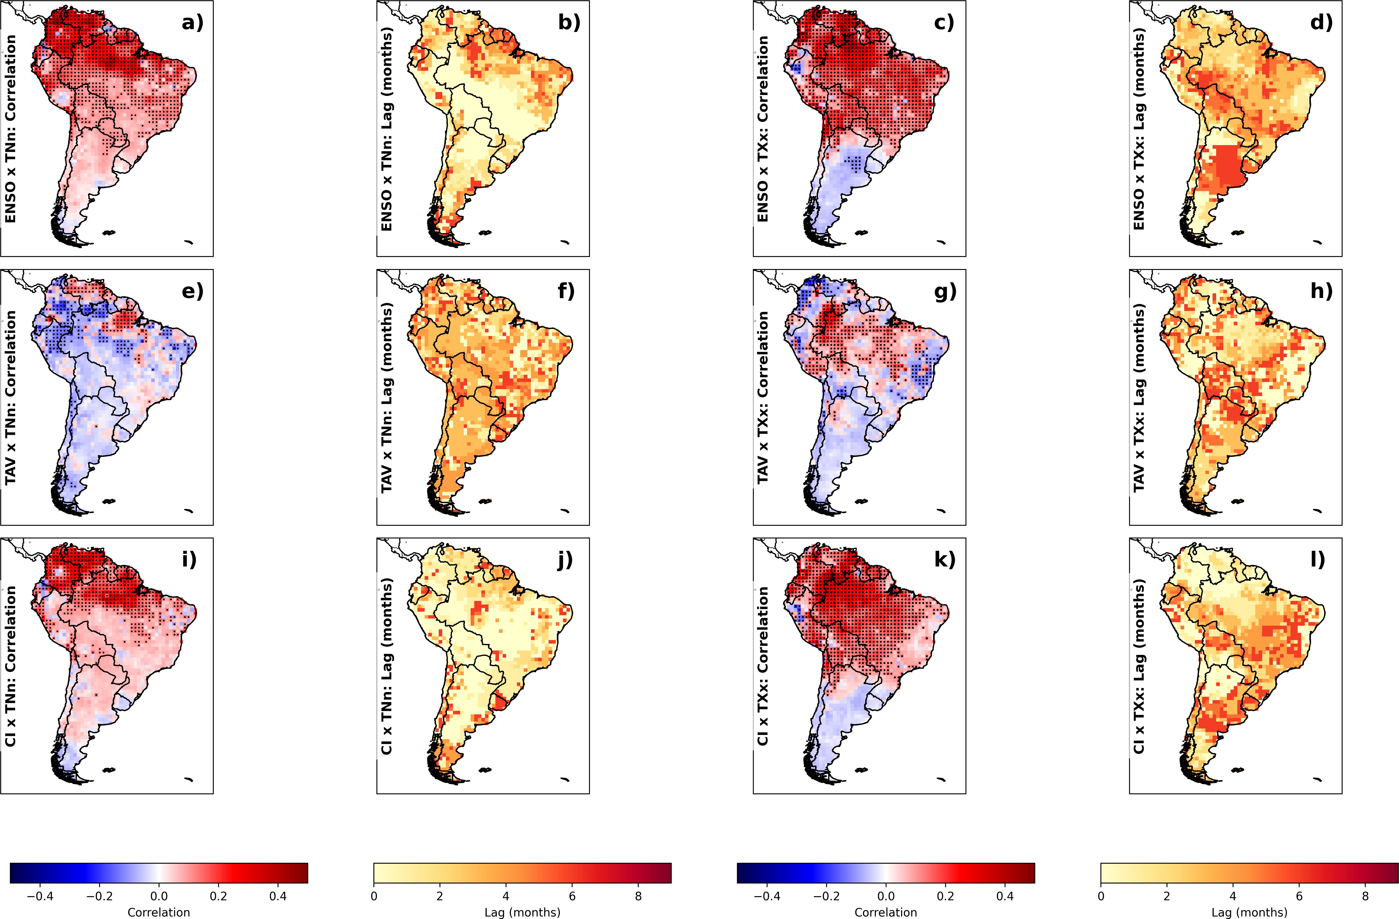

Fig. S2 The same as Fig. S1, but for temperature extreme indices TNn (extreme minimum temperature) and TXx (extreme maximum temperature).

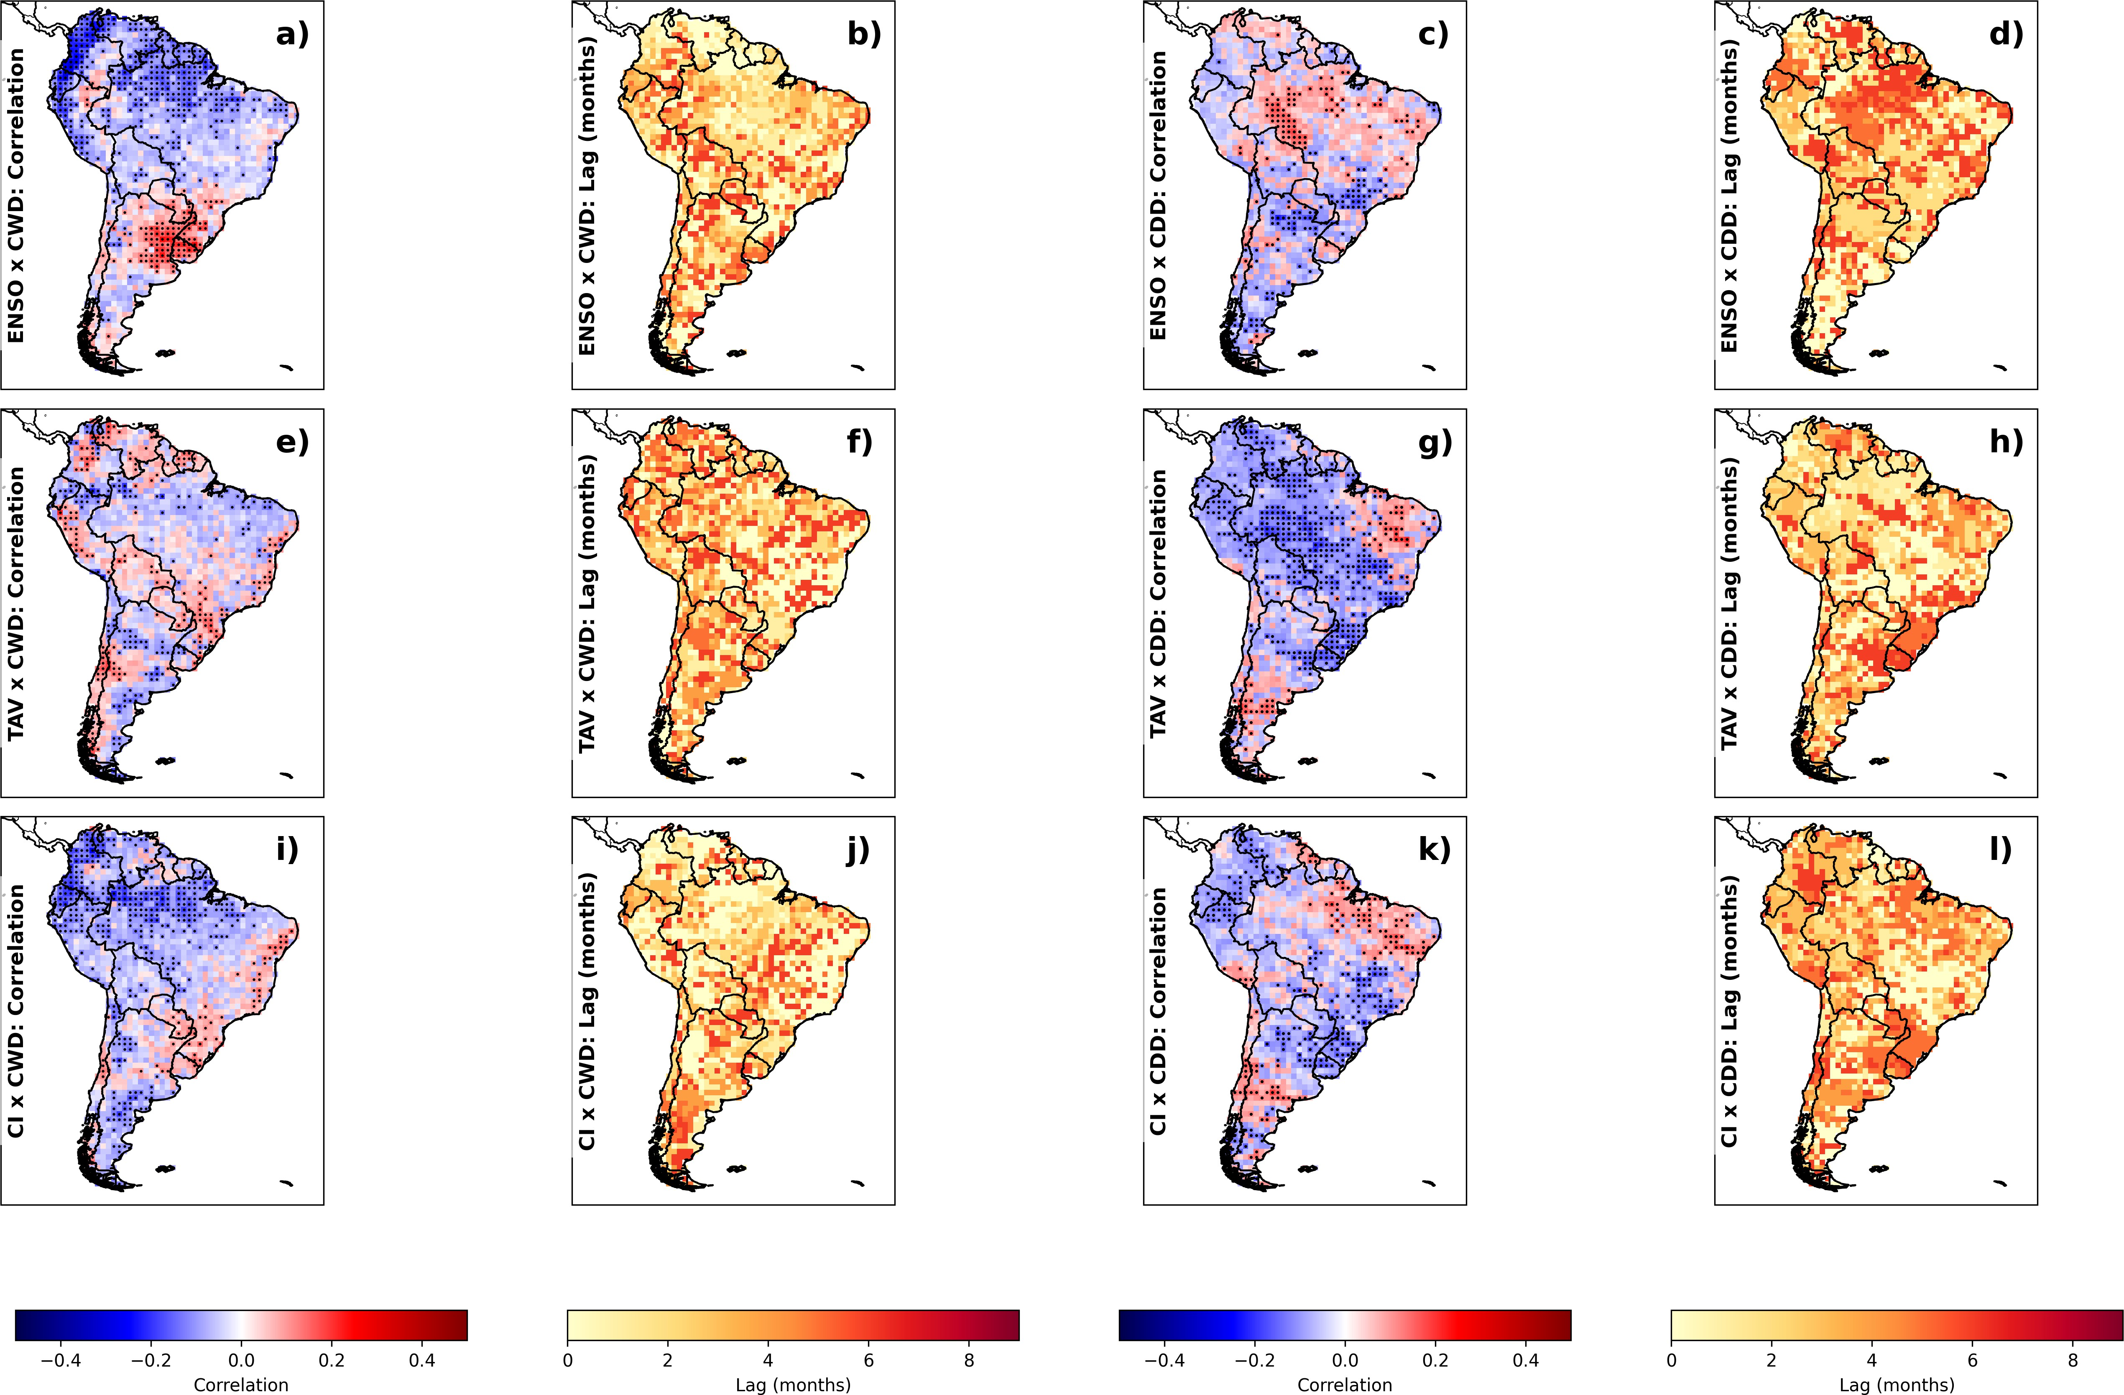

Fig. S3 The Same as Figure S1, but for CWD and CDD extrem index.

