Supplemental Item 1: Search Strategy
Medline
Ovid MEDLINE(R) ALL <1946 to January 29, 2025>

1 Minimally Invasive.ti,ab. 100201
2 Minimally Invasive Surgical Procedures/ 31518
3 Laparoscopy/ 109631
4 Laparoscop*.ti,ab. 163226
5 Endoscopy/ 62153
6 Endoscop*.ti,ab. 267752
7 ((endoscop* or Laparoscop*) and splenectomy).ti,ab. 3002
8 Minimally Invasive splenectomy.ti,ab. 18
9 1 or 2 or 3 or 4 or 5 or 6 or 7 or 8 525591
10 open surg*.ti,ab. 33922
11 Conversion to Open Surgery/ 1485
12 open Splenomegaly.ti,ab. 1
13 open splenectomy.ti,ab. 398
14 open partial splenectomy.ti,ab. 14
15 10 or 11 or 12 or 13 or 14 35198
16 splenectomy.ti,ab. 22706
17 Splenectomy/ 22913
18 (splenomegaly or spleen).ti,ab. 164875
19 Splenomegaly/ 11212
20 partial splenectomy.ti,ab. 616
21 16 or 17 or 18 or 19 or 20 192610
22 Treatment Outcome/ 1230626
23 (surgical and (outcome or modality)).ti,ab. 180237
24 (perioperative and (complication or outcome*)).ti,ab. 64782
25 Postoperative Complications/ 419599
26 Postoperative Complications*.ti,ab. 84911
27 Post-operative Complications*.ti,ab. 9509
28 (peri-operative and (complication or outcome*)).ti,ab. 4669
29 Perioperative Care/ or Perioperative Period/ 21024
30 length of stay.ti,ab. 88584
31 "Length of Stay"/ 108795
32 operative time.ti,ab. 40516
33 Operative Time/ 20030
34 surgical wound*.ti,ab. 7610
35 Blood Loss, Surgical/ 21570
36 surgical blood loss.ti,ab. 581
37 22 or 23 or 24 or 25 or 26 or 27 or 28 or 29 or 30 or 31 or 32 or 33 or 34 or 35 or 36 1875112
38 p?ediatric*.ti,ab. 495330
39 Pediatrics/ 59406
40 38 or 39 510885
41 9 and 15 and 21 and 37 and 40 37
Embase
Embase <1974 to 2025 January 29>

1 Minimally Invasive.ti,ab. 146772
2 minimally invasive surgery/ 59663
3 laparoscopy/ 101848
4 Laparoscop*.ti,ab. 263256
5 endoscopy/ 142686
6 Endoscop*.ti,ab. 433984
7 ((endoscop* or Laparoscop*) and splenectomy).ti,ab. 4871
8 Minimally Invasive splenectomy.ti,ab. 26
9 1 or 2 or 3 or 4 or 5 or 6 or 7 or 8 840160
10 open surg*.ti,ab. 51357
11 open surgery/ 27395
12 open partial splenectomy.ti,ab. 16
13 open Splenomegaly.ti,ab. 1
14 10 or 11 or 12 or 13 66418
15 splenectomy.ti,ab. 30215
16 partial splenectomy/ or splenectomy/ 42519
17 splenomegaly/ 43496
18 (splenomegaly or spleen).ti,ab. 212780
19 partial Splenectomy.ti,ab. 790
20 15 or 16 or 17 or 18 or 19 263552
21 treatment outcome/ 1016854
22 (surgical and (outcome or modality)).ti,ab. 271095
23 (perioperative and (complication or outcome*)).ti,ab. 98240
24 postoperative complication/ 442343
25 Postoperative Complications*.ti,ab. 118452
26 Post-operative Complications*.ti,ab. 20359
27 (peri-operative and (complication or outcome*)).ti,ab. 11364
28 perioperative complication/ or perioperative care/ or perioperative period/ 76088
29 length of stay.ti,ab. 165252
30 "length of stay"/ 302125
31 operative time.ti,ab. 69254
32 operation duration/ 164162
33 surgical wound*.ti,ab. 9862
34 operative blood loss/ 43359
35 surgical blood loss.ti,ab. 826
36 21 or 22 or 23 or 24 or 25 or 26 or 27 or 28 or 29 or 30 or 31 or 32 or 33 or 34 or 35 2034518
37 9 and 14 and 20 and 36 625
38 open splenectomy.ti,ab. 526
39 14 or 38 66858
40 9 and 20 and 36 and 39 895
41 p?ediatric*.ti,ab. 771641
42 pediatrics/ 96210
43 41 or 42 798527
44 40 and 43 68

CINAHL
# | Query | Last Run Via | Results
S35 | S8 AND S13 AND S19 AND S34 | Interface - EBSCOhost Research Databases  Search Screen - Advanced Search  Database - CINAHL | 64
S34 | S20 OR S21 OR S22 OR S23 OR S24 OR S25 OR S26 OR S27 OR S28 OR S29 OR S30 OR S31 OR S32 OR S33 | Interface - EBSCOhost Research Databases  Search Screen - Advanced Search  Database - CINAHL | 619,559
S33 | TI surgical blood loss OR AB surgical blood loss | Interface - EBSCOhost Research Databases  Search Screen - Advanced Search  Database - CINAHL | 133
S32 | (MH "Blood Loss, Surgical") | Interface - EBSCOhost Research Databases  Search Screen - Advanced Search  Database - CINAHL | 6,299
S31 | TI surgical wound* OR AB surgical wound* | Interface - EBSCOhost Research Databases  Search Screen - Advanced Search  Database - CINAHL | 1,910
S30 | TI operative time OR AB operative time | Interface - EBSCOhost Research Databases  Search Screen - Advanced Search  Database - CINAHL | 7,799
S29 | (MH "Length of Stay") | Interface - EBSCOhost Research Databases  Search Screen - Advanced Search  Database - CINAHL | 53,350
S28 | TI length of stay OR AB length of stay | Interface - EBSCOhost Research Databases  Search Screen - Advanced Search  Database - CINAHL | 34,896
S27 | (MH "Perioperative Care") | Interface - EBSCOhost Research Databases  Search Screen - Advanced Search  Database - CINAHL | 13,495
S26 | TI peri-operative and (complication* or outcome*) OR AB peri-operative and (complication* or outcome*) | Interface - EBSCOhost Research Databases  Search Screen - Advanced Search  Database - CINAHL | 1,659
S25 | TI Post-operative Complications* OR AB Post-operative Complications* | Interface - EBSCOhost Research Databases  Search Screen - Advanced Search  Database - CINAHL | 1,699
S24 | TI Postoperative Complications* OR AB Postoperative Complications* | Interface - EBSCOhost Research Databases  Search Screen - Advanced Search  Database - CINAHL | 14,318
S23 | (MH "Postoperative Complications") | Interface - EBSCOhost Research Databases  Search Screen - Advanced Search  Database - CINAHL | 85,838
S22 | TI perioperative and (complication* or outcome*) OR AB perioperative and (complication* or outcome*) | Interface - EBSCOhost Research Databases  Search Screen - Advanced Search  Database - CINAHL | 21,798
S21 | TI ( surgical and (outcome or modality) ) OR AB ( surgical and (outcome or modality) ) | Interface - EBSCOhost Research Databases  Search Screen - Advanced Search  Database - CINAHL | 76,363
S20 | (MH "Treatment Outcomes") | Interface - EBSCOhost Research Databases  Search Screen - Advanced Search  Database - CINAHL | 443,844
S19 | S14 OR S15 OR S16 OR S17 OR S18 | Interface - EBSCOhost Research Databases  Search Screen - Advanced Search  Database - CINAHL | 11,392
S18 | TI partial splenectomy OR AB partial splenectomy | Interface - EBSCOhost Research Databases  Search Screen - Advanced Search  Database - CINAHL | 69
S17 | (MH "Splenomegaly") | Interface - EBSCOhost Research Databases  Search Screen - Advanced Search  Database - CINAHL | 1,064
S16 | TI ( splenomegaly or spleen ) OR AB ( splenomegaly or spleen ) | Interface - EBSCOhost Research Databases  Search Screen - Advanced Search  Database - CINAHL | 8,841
S15 | (MH "Splenectomy") | Interface - EBSCOhost Research Databases  Search Screen - Advanced Search  Database - CINAHL | 1,858
S14 | TI splenectomy OR AB splenectomy | Interface - EBSCOhost Research Databases  Search Screen - Advanced Search  Database - CINAHL | 2,237
S13 | S9 OR S10 OR S11 OR S12 | Interface - EBSCOhost Research Databases  Search Screen - Advanced Search  Database - CINAHL | 5,530
S12 | TI open partial splenectomy OR AB open partial splenectomy | Interface - EBSCOhost Research Databases  Search Screen - Advanced Search  Database - CINAHL | 2
S11 | TI open splenectomy OR AB open splenectomy | Interface - EBSCOhost Research Databases  Search Screen - Advanced Search  Database - CINAHL | 63
S10 | TI open Splenomegaly OR AB open Splenomegaly | Interface - EBSCOhost Research Databases  Search Screen - Advanced Search  Database - CINAHL | 0
S9 | TI open surg* OR AB open surg* | Interface - EBSCOhost Research Databases  Search Screen - Advanced Search  Database - CINAHL | 5,473
S8 | S1 OR S2 OR S3 OR S4 OR S5 OR S6 OR S7 | Interface - EBSCOhost Research Databases  Search Screen - Advanced Search  Database - CINAHL | 112,339
S7 | TI Minimally Invasive splenectomy OR AB Minimally Invasive splenectomy | Interface - EBSCOhost Research Databases  Search Screen - Advanced Search  Database - CINAHL | 5
S6 | TI ( (endoscop* or Laparoscop*) and splenectomy ) OR AB ( (endoscop* or Laparoscop*) and splenectomy ) | Interface - EBSCOhost Research Databases  Search Screen - Advanced Search  Database - CINAHL | 493
S5 | TI Endoscop* OR AB Endoscop* | Interface - EBSCOhost Research Databases  Search Screen - Advanced Search  Database - CINAHL | 54,689
S4 | TI Laparoscop* OR AB Laparoscop* | Interface - EBSCOhost Research Databases  Search Screen - Advanced Search  Database - CINAHL | 33,567
S3 | (MH "Laparoscopy") OR (MH "Surgery, Laparoscopic") | Interface - EBSCOhost Research Databases  Search Screen - Advanced Search  Database - CINAHL | 23,809
S2 | (MH "Minimally Invasive Procedures") | Interface - EBSCOhost Research Databases  Search Screen - Advanced Search  Database - CINAHL | 13,738
S1 | TI Minimally Invasive OR AB Minimally Invasive | Interface - EBSCOhost Research Databases  Search Screen - Advanced Search  Database - CINAHL | 20,293

Cochrane Library
#1 (Minimally Invasive):ti,ab,kw 9383
#2 MeSH descriptor: [Minimally Invasive Surgical Procedures] this term only 1467
#3 MeSH descriptor: [Laparoscopy] this term only 7516
#4 (Laparoscop*):ti,ab,kw 29982
#5 MeSH descriptor: [Endoscopy] this term only 2626
#6 (Endoscop*):ti,ab,kw 36914
#7 ((endoscop* or Laparoscop*) and splenectomy):ti,ab,kw 135
#8 (Minimally Invasive splenectomy):ti,ab,kw 21
#9 #1 or #2 or #3 or #4 or #5 or #6 or #7 or #8 71632
#10 (open surg*):ti,ab,kw 32539
#11 MeSH descriptor: [Conversion to Open Surgery] this term only 65
#12 (open Splenomegaly):ti,ab,kw 186
#13 (open splenectomy):ti,ab,kw 175
#14 (open partial splenectomy):ti,ab,kw 12
#15 #10 or #11 or #12 or #13 or #14 32767
#16 MeSH descriptor: [Treatment Outcome] this term only 197835
#17 (surgical and (outcome or modality)):ti,ab,kw 69606
#18 (perioperative outcome*):ti,ab,kw 15997
#19 MeSH descriptor: [Postoperative Complications] this term only 24057
#20 (Postoperative Complications*):ti,ab,kw 61706
#21 (Post-operative Complications*):ti,ab,kw 8655
#22 (peri-operative outcome*):ti,ab,kw 1583
#23 (peri-operative complication*):ti,ab,kw 1161
#24 MeSH descriptor: [Perioperative Care] this term only 1374
#25 MeSH descriptor: [Perioperative Period] this term only 384
#26 (length of stay):ti,ab,kw 37127
#27 MeSH descriptor: [Length of Stay] explode all trees 9749
#28 (operative time):ti,ab,kw 27867
#29 MeSH descriptor: [Operative Time] this term only 2261
#30 (surgical wound*):ti,ab,kw 17636
#31 MeSH descriptor: [Blood Loss, Surgical] this term only 3637
#32 (surgical blood loss):ti,ab,kw 11468
#33 #16 or #17 or #18 or #19 or #20 or #21 or #22 or #23 or #24 or #25 or #26 or #27 or #28 or #29 or #30 or #31 or #32 333899
#34 (splenectomy):ti,ab,kw 832
#35 MeSH descriptor: [Splenectomy] this term only 252
#36 (splenomegaly or spleen):ti,ab,kw 4405
#37 MeSH descriptor: [Splenomegaly] this term only 106
#38 (partial splenectomy):ti,ab,kw 71
#39 #34 or #35 or #36 or #37 or #38 5049
#40 #9 and #15 and #33 and #39 91

Manually searched and added
1 | Makansi et al Comparison of perioperative outcomes between laparoscopic and open partial splenectomy in children and adolescents (2021)
2 | Khirallah et al Laparoscopic versus open splenectomy in children with benign hematological diseases in children. (2017)
3 | Minkes et al Laparoscopic versus open splenectomy in children
4 | Fachin et al. Open Versus Laparoscopic Splenectomies in Children: A Comparative Study Performed at a Public Hospital in Brazil (2019)

Supplemental Item 2: Risk of Bias in Non-Randomized Studies of Interventions (ROBINS-I)
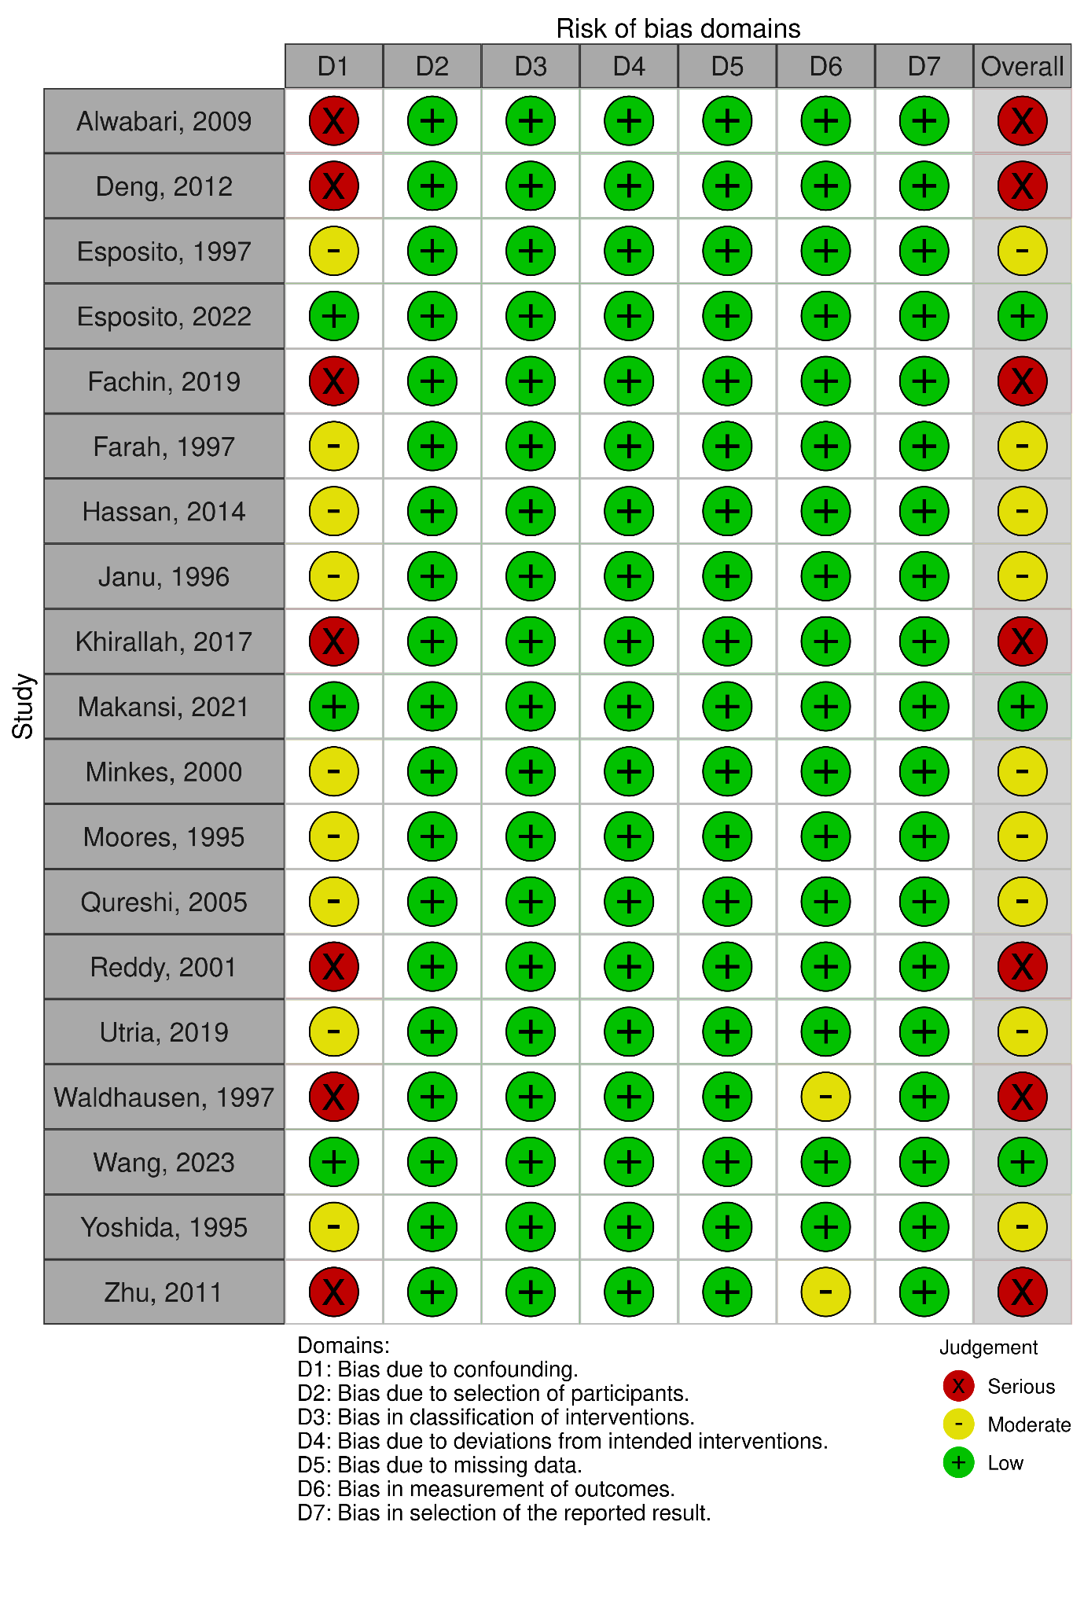
Supplemental Item 3: PRISMA flowchart of the study selection process
