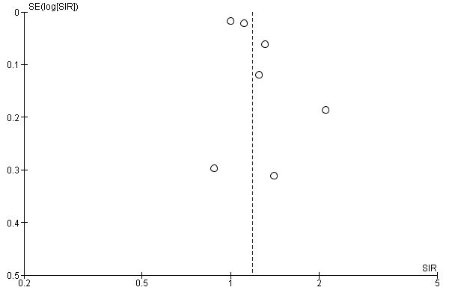
Supplementary Figure 1. Funnel plot for urinary bladder cancer.

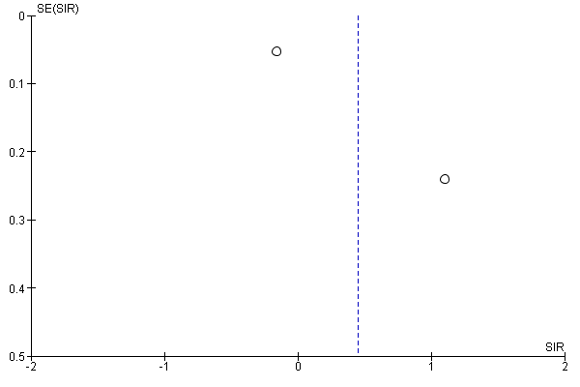
Supplementary Figure 2. Funnel plot for brain cancer.

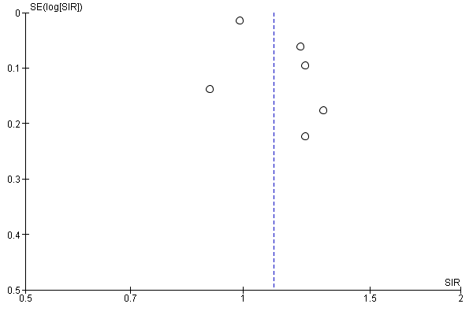
Supplementary Figure 3. Funnel plot for breast cancer.

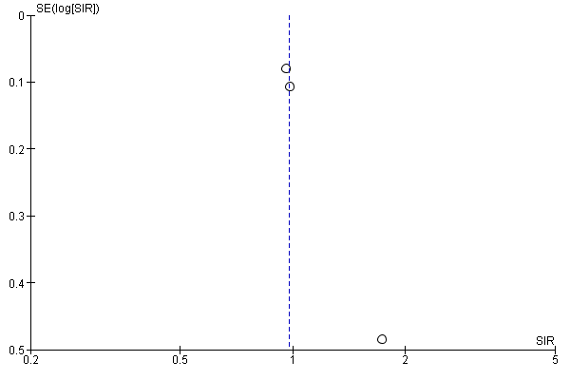
Supplementary Figure 4. Funnel plot for cervical cancer.

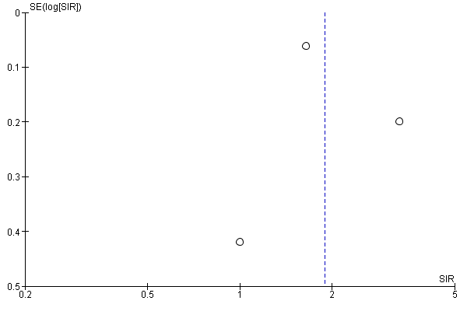
Supplementary Figure 5. Funnel plot for female genital cancer.

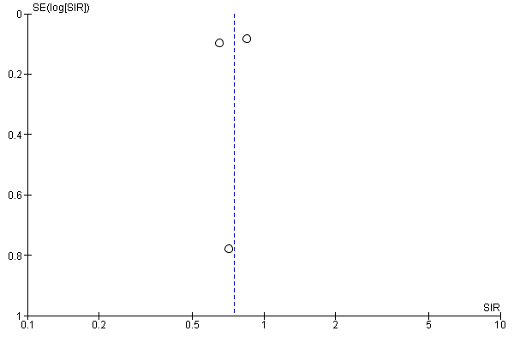
Supplementary Figure 6. Funnel plot for gallbladder cancer.

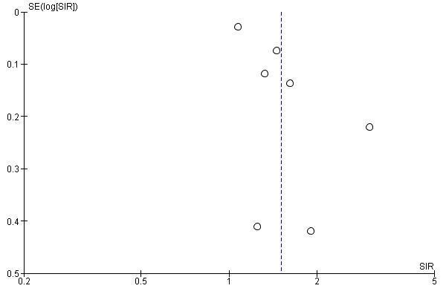
Supplementary Figure 7. Funnel plot for kidney cancer.

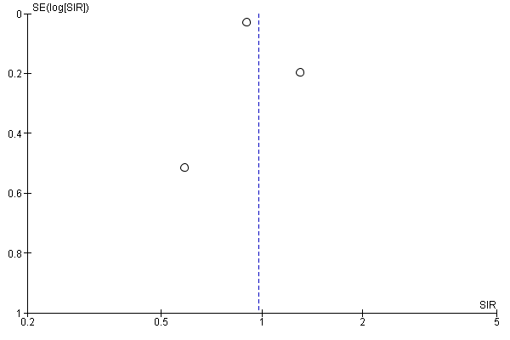
Supplementary Figure 8. Funnel plot for leukaemia.

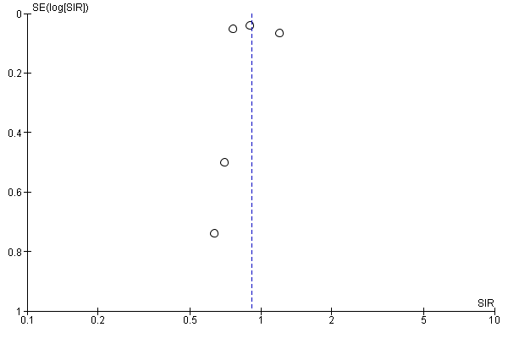
Supplementary Figure 9. Funnel plot for liver, hepatic duct, and biliary tract cancer.

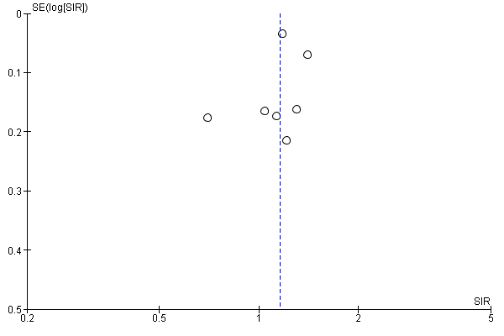
Supplementary Figure 10. Funnel plot for lung, bronchial, and mediastinal cancer.

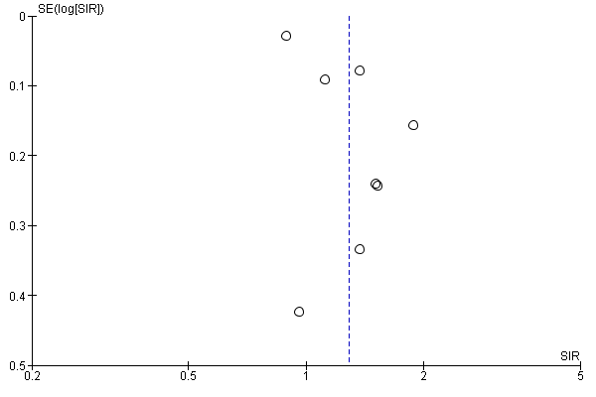
Supplementary Figure 11. Funnel plot for melanoma.

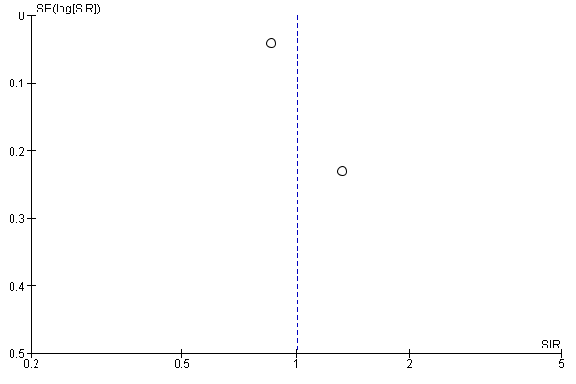
Supplementary Figure 12. Funnel plot for myeloma.

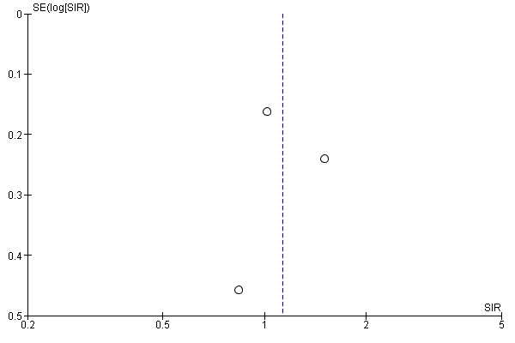
Supplementary Figure 13. Funnel plot for non-Hodgkin lymphoma.

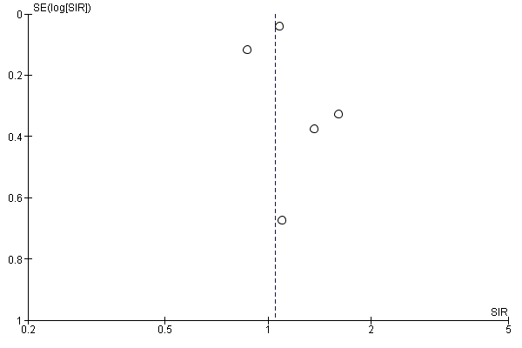
Supplementary Figure 14. Funnel plot for oesophageal cancer.

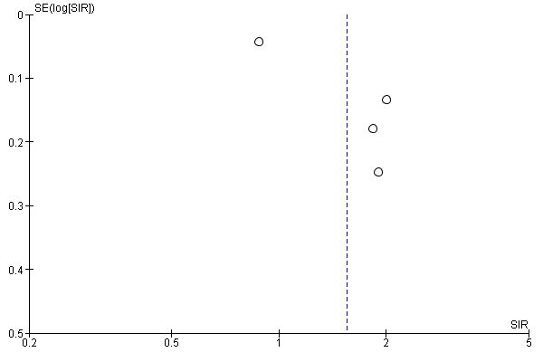
Supplementary Figure 15. Funnel plot for ovarian cancer.

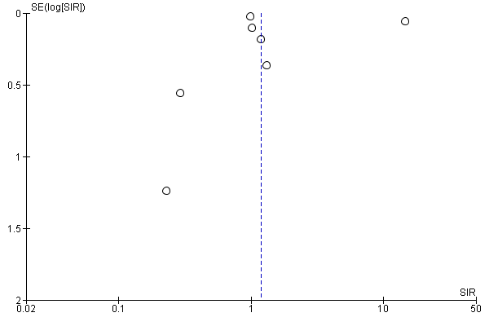
Supplementary Figure 16. Funnel plot for pancreatic cancer.

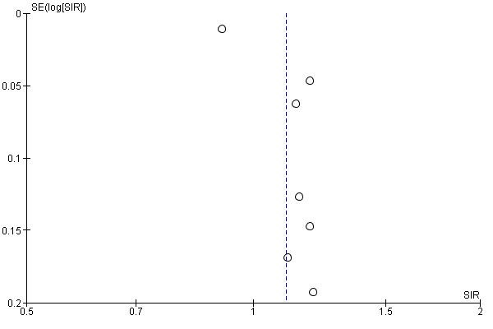
Supplementary Figure 17. Funnel plot for prostate cancer.

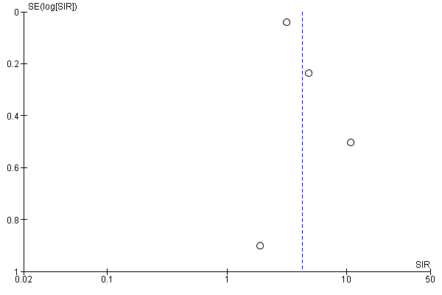
Supplementary Figure 18. Funnel plot for small intestinal cancer.

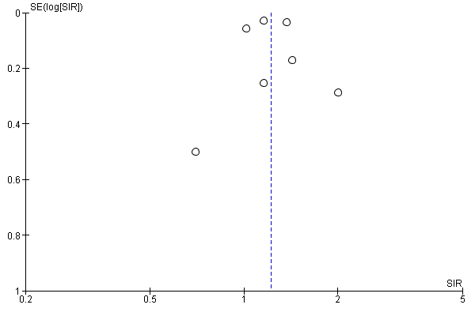
Supplementary Figure 19. Funnel plot for stomach cancer.

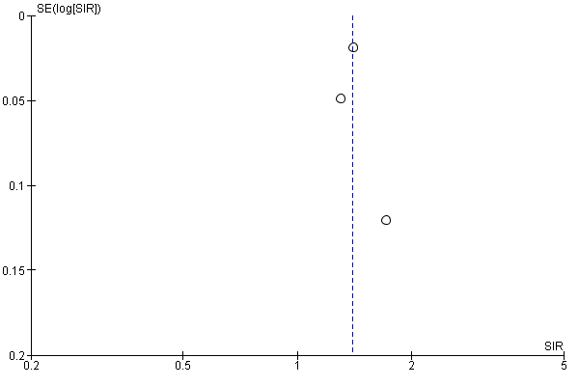
Supplementary Figure 20. Funnel plot for thyroid cancer.

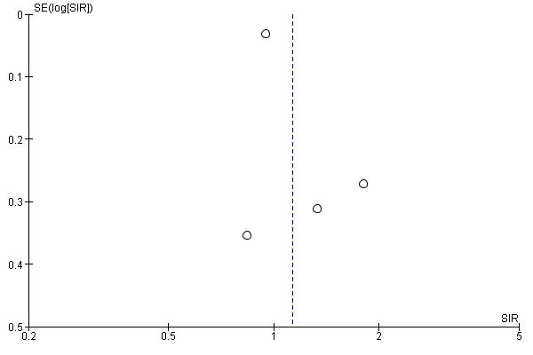
Supplementary Figure 21. Funnel plot for upper aerodigestive tract cancer.

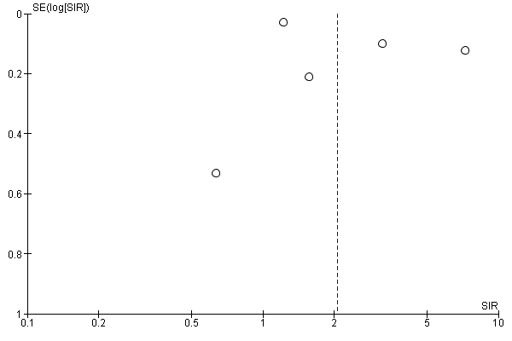
Supplementary Figure 22. Funnel plot for uterine cancer.

