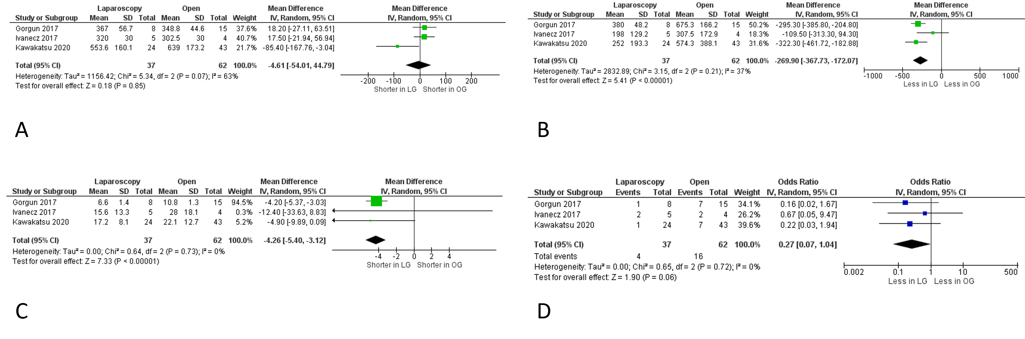
Supplementary Fig 6: Subgroup meta-analysis of operative outcomes in patients with primary tumour located in the rectum: (a) operative time; (b) intraoperative blood loss; (c) length of stay; (d) morbidity
Legend: Each study is shown by the point estimate of the odds ratio/mean difference (OR/MD; square proportional to the weight of each study) and 95% confidence interval (CI) for the OR (extending lines); the combined ORs/mean difference and 95% CIs by random effects calculations are shown by diamonds.
(a) Rectum only; LAP versus OPEN and operative time (n=99, p=0.85; test for heterogeneity Cochran Q: 5.34, df: 2, p=0.07, I²: 63%)
(b) Rectum only; LAP versus OPEN and blood loss (n=99, p<0.00001; test for heterogeneity Cochran Q: 3.15, df: 2, p=0.21, I²: 37%)
(c) Rectum only; LAP versus OPEN and length of stay (n=99, p<0.00001; test for heterogeneity Cochran Q: 0.64, df: 2, p=0.73, I²: 0%)
(d) Rectum only; LAP versus OPEN and morbidity (n=99, p=0.06; test for heterogeneity Cochran Q: 0.65, df: 2, p=0.72, I²: 0%)

