Trends in the Prevalence and Incidence of Ulcerative Colitis in Japan and the United States
Michiyo Yamazaki, Hsingwen Chung, Youran Xu, Hong Qiu
Supplementary material

Fig. S1 Period Prevalence* (per 100,000 population) of UC stratified by sex and age in the JMDC (Japan) and CCAE (US) databases
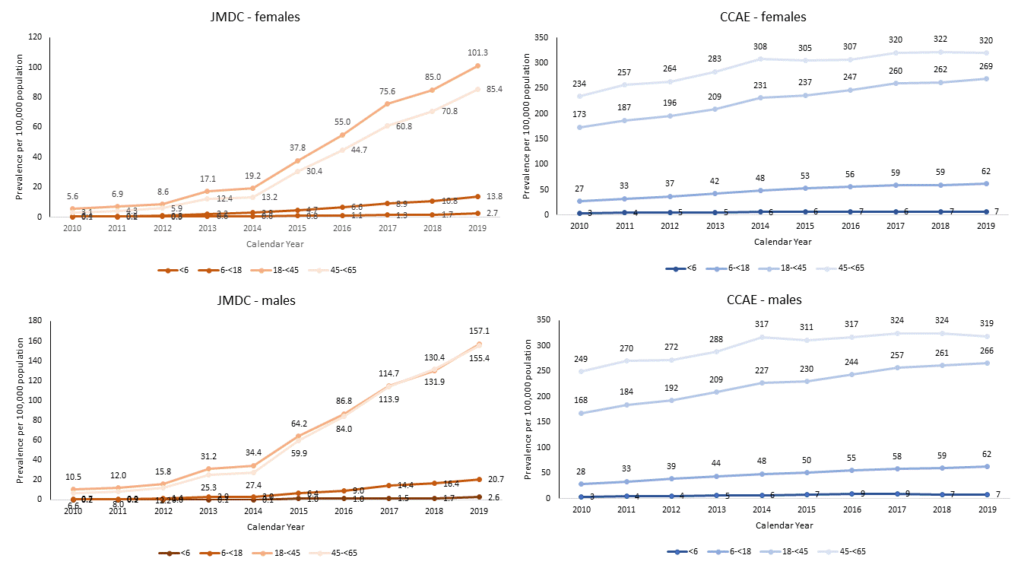
*crude (unweighted) rates in the CCAE and age-standardized rates in the JMDC using direct standardization based on the CCAE’s age distribution.

Fig. S2-1 Annual Period Prevalence per 100,000 population in the CCAE (US)
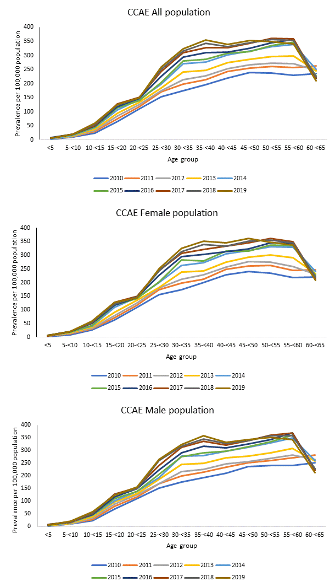

Fig. S2-2 Annual Period Prevalence* per 100,000 population in the JMDC (Japan)
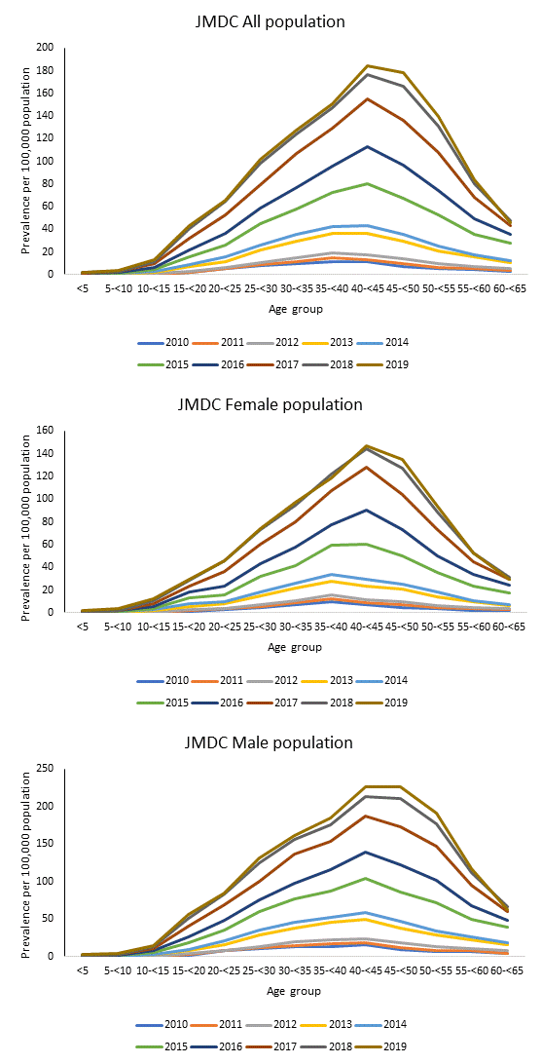

*age-standardized rates in the JMDC using direct standardization based on the CCAE’s age distribution.

Fig S3 Age-specific Annual Incidence Rates* (per 100,000 person-years) of UC in the JMDC (Japan) and CCAE (US) databases stratified by sex
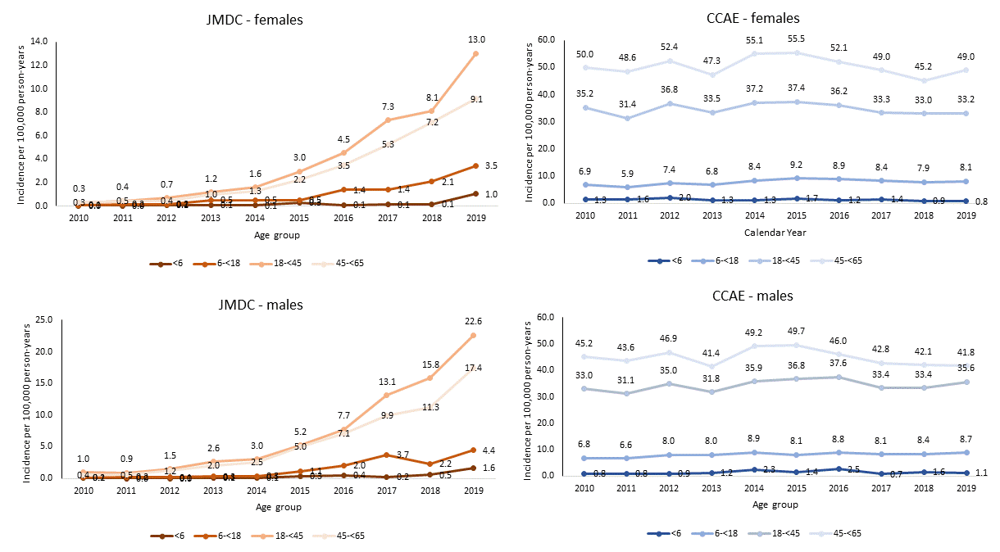
*crude (unweighted) rates in the CCAE and age-standardized rates in the JMDC using direct standardization based on the CCAE’s age distribution.

Table S1 UC-specific Medications Available During the Study Period (2010-219) in the US and Japan and the Date of Approval
Drug category | ATC code | Drug (generic name) | Year of first approval for UC indication
Drug category | ATC code | Drug (generic name) | The US | Japan
5-ASA | A07EC01 | Sulfasalazine | 1950 | 1969
5-ASA | A07EC02 | Mesalazine | 1987 | 1996
5-ASA | A07EC03 | Olsalazine | 1990 | -
5-ASA | A07EC04 | Balsalazide | 2000 ª | -
Biologic | L04AB02 | Infliximab | Sep 2005 | Jun 2010 ^{b}
Biologic | L04AB04 | Adalimumab | Sep 2012 ^{c} | Jun 2013
Biologic | L04AB06 | Golimumab | May 2013 ^{c} | Mar 2017
Biologic | L04AA33 | Vedolizumab | May 2014 | Jul 2018
Biologic | L04AC05 | Ustekinumab | Oct 2019 ^{c} | - ^{d}
Abbreviations: 5-ASA= ATC=The Anatomical Therapeutic Chemical code; UC= ulcerative colitis; US=United States.
Footnotes:
a: indication expansion for 5 years of age and older in 2006; b: infliximab was approved for 6 years of age and older in 2017; c: orphan designation for pediatric population during the study period (adalimumab was approved for pediatric population 5-<17 years of age in 2021, outside the study period); d: ustekinumab was approved in 2020 (outside the study period).

https://www.accessdata.fda.gov/scripts/cder/daf/index.cfm?event=overview.process&ApplNo=007073
Real life results in using 5-ASA for maintaining mild to moderate UC patients in Japan, a multi-center study, OPTIMUM Study. Nagahori et al. BMC Gastroenterology (2017) 17:47. DOI 10.1186/s12876-017-0604-y
https://www.accessdata.fda.gov/scripts/cder/daf/index.cfm?event=overview.process&ApplNo=019618
Real life results in using 5-ASA for maintaining mild to moderate UC patients in Japan, a multi-center study, OPTIMUM Study. Nagahori et al. BMC Gastroenterology (2017) 17:47. DOI 10.1186/s12876-017-0604-y
https://www.accessdata.fda.gov/scripts/cder/daf/index.cfm?event=BasicSearch.process
https://www.accessdata.fda.gov/scripts/cder/daf/index.cfm?event=overview.process&ApplNo=020610
https://www.accessdata.fda.gov/drugsatfda_docs/appletter/2006/020610s016ltr.pdf
https://www.accessdata.fda.gov/drugsatfda_docs/appletter/2005/103772_5113ltr.pdf
https://www.pmda.go.jp/files/000232774.pdf
https://www.mt-pharma.co.jp/news/assets/pdf/MTPC170518.pdf
https://www.accessdata.fda.gov/drugsatfda_docs/appletter/2012/125057Orig1s232ltr.pdf
https://www.pmda.go.jp/files/000232771.pdf
https://www.accessdata.fda.gov/drugsatfda_docs/appletter/2013/125289Orig1s077,s078,s079ltr.pdf
https://www.pmda.go.jp/files/000232770.pdf
https://www.accessdata.fda.gov/drugsatfda_docs/appletter/2014/125476Orig1s000ltr.pdf
https://www.pmda.go.jp/files/000235288.pdf
https://www.accessdata.fda.gov/drugsatfda_docs/appletter/2019/761044Orig1s003,%20125261Orig1s152ltr.pd

