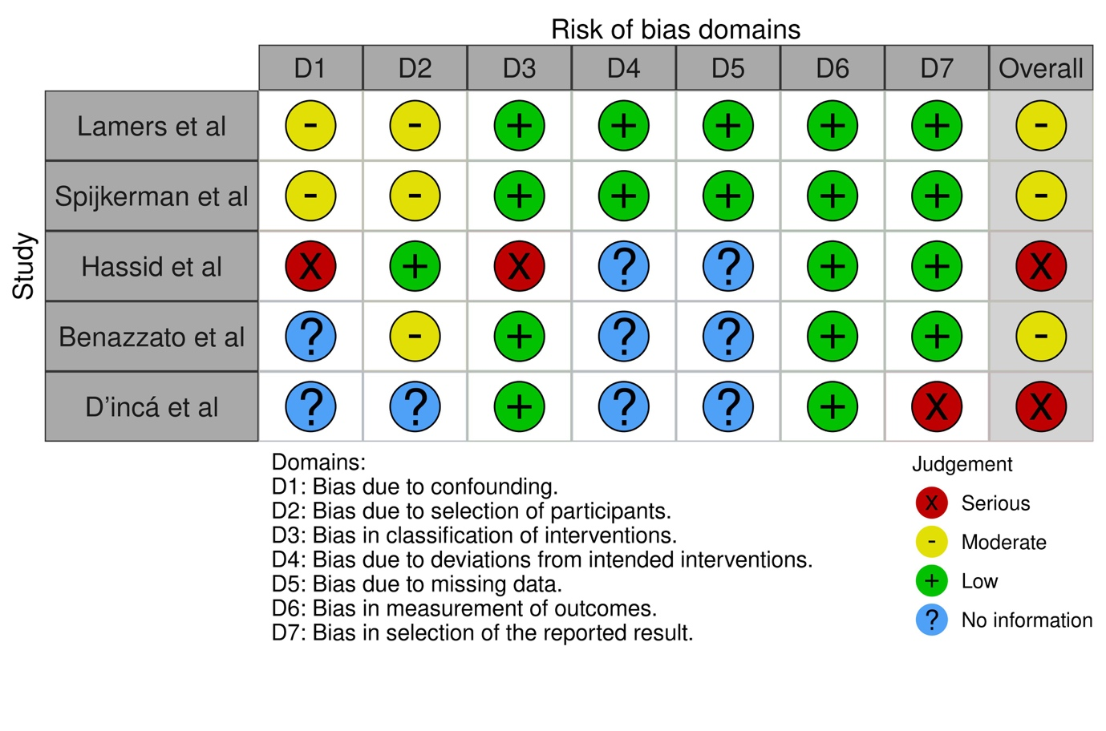
Figure 1. Graph of bias for observational studies inflammatory response to exercise.

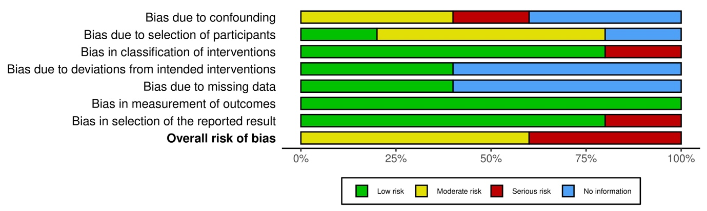
Figure 2. Summary plot for observational studies inflammatory response to exercise.

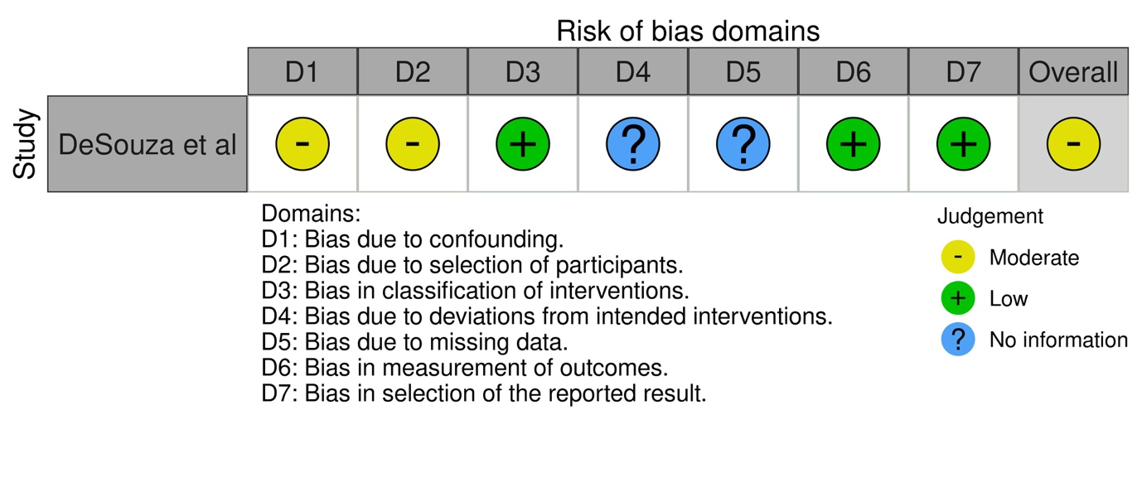
Figure 3. Graph of bias for observational studies of body composition

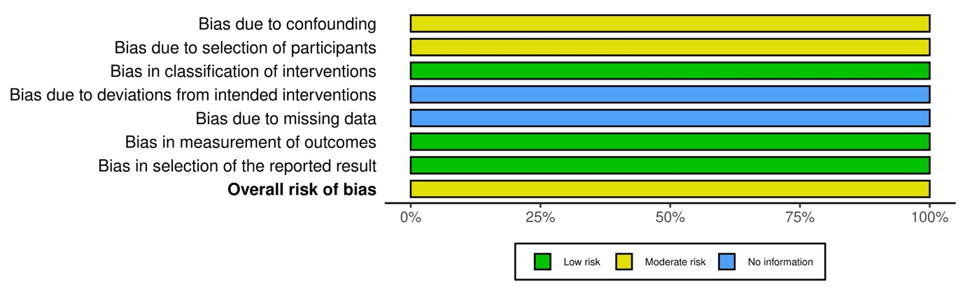
Figure 4. Summary plot for observational studies of body composition

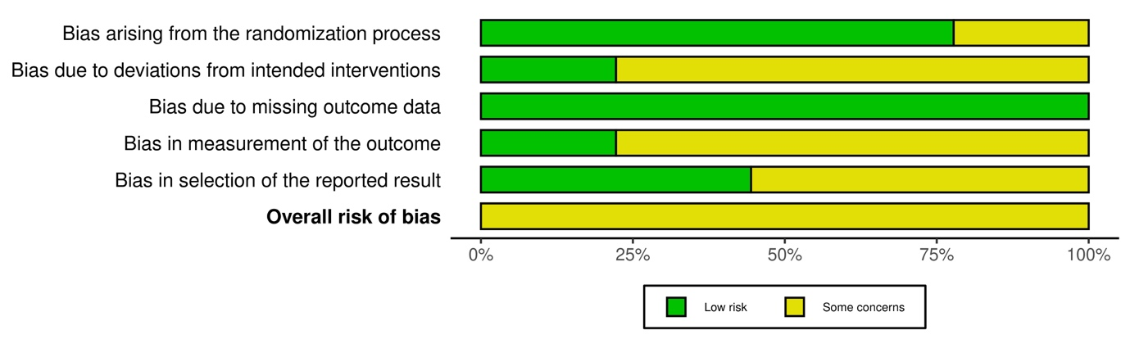
Figure 5. Summary plot for inflammatory response in RCTs
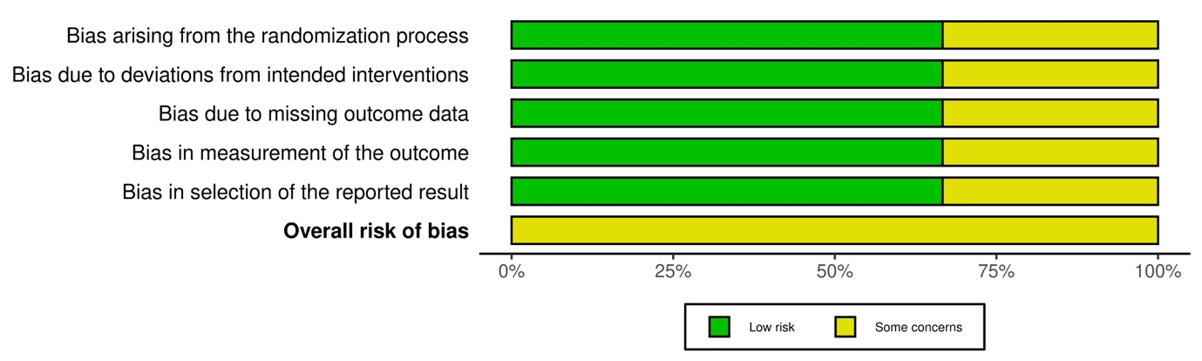
Figure 6. Summary plot for body composition in RCTs

