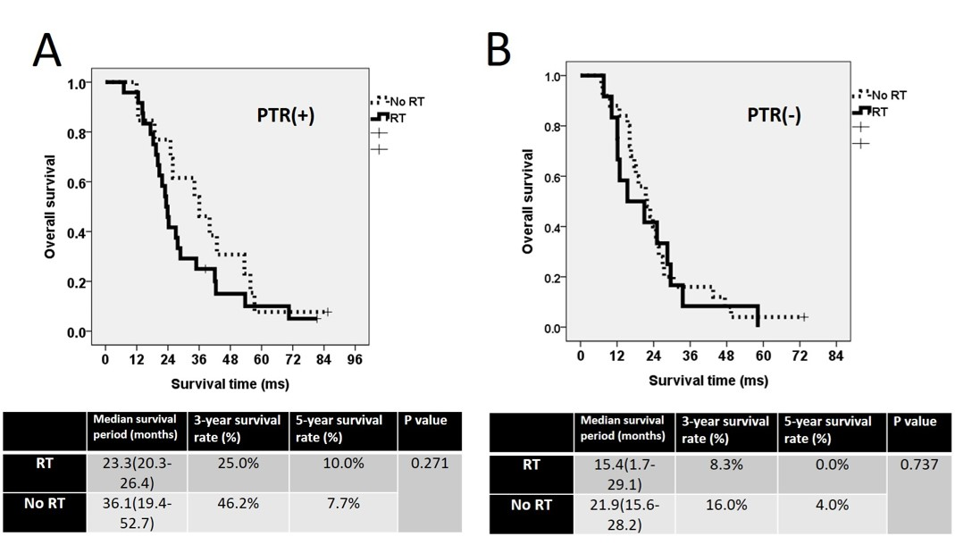
Supplementary figure 1. (A) The overall survival curve of PTR(+)RT(+)” and “PTR(+)RT(-)”; (B) The overall survival curve of “PTR(-)RT(+)”, and “PTR(-)RT(-)”.

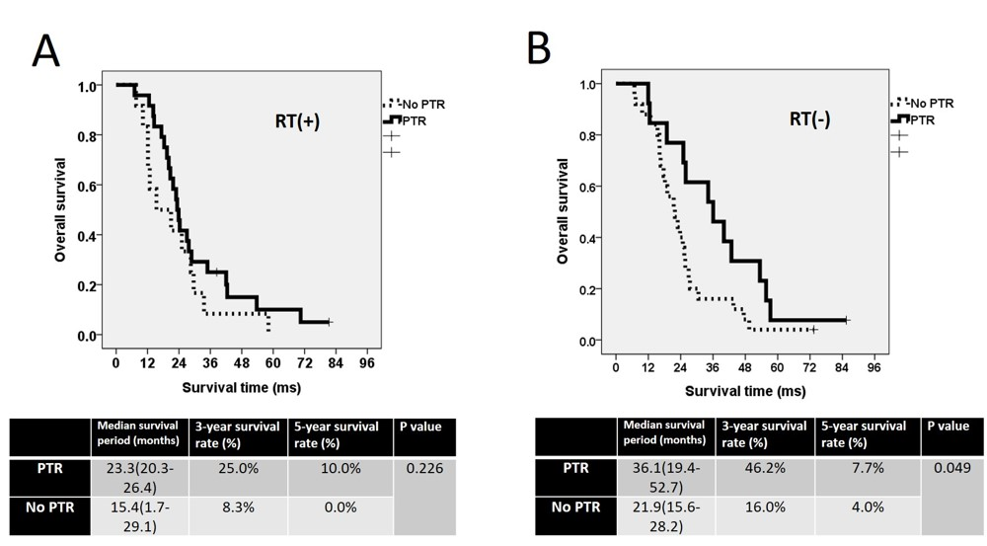
Supplementary figure 2. (A) The overall survival curve of PTR(+)RT(+)” and “PTR(-)RT(+)”; (B) The overall survival curve of “PTR(+)RT(-)”, and “PTR(-)RT(-)”.

