Table1 Results of mesh meta-analysis comparing ADR with different interventions［OR（95%CI）］
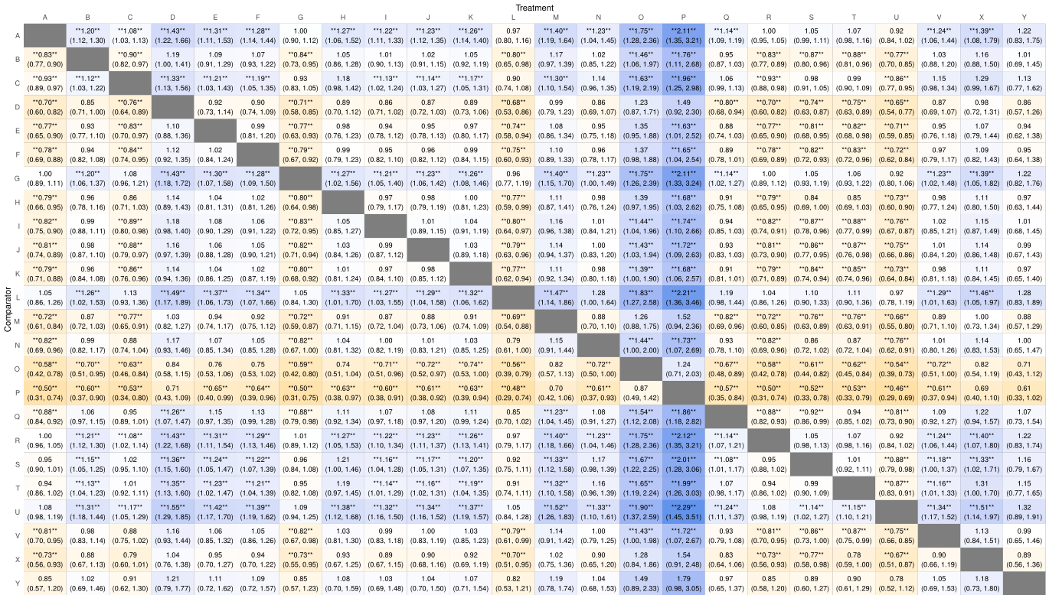

Table2 Results of mesh meta-analysis comparing PDR with different interventions［OR（95%CI）］
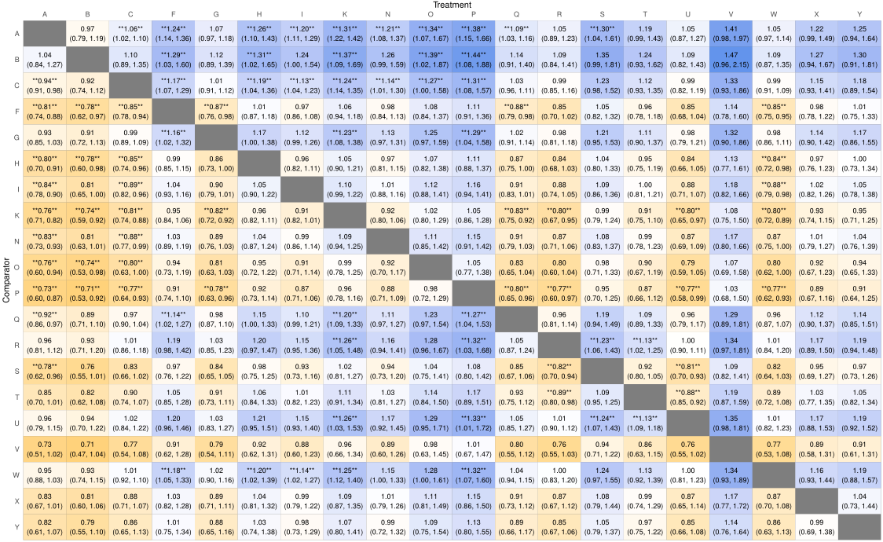

Table3 Results of mesh meta-analysis comparing SSL with different interventions［OR（95%CI）］
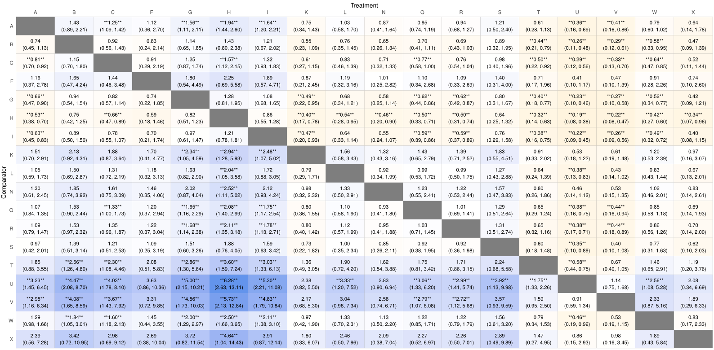

Fig1.ADR sensitivity analysis
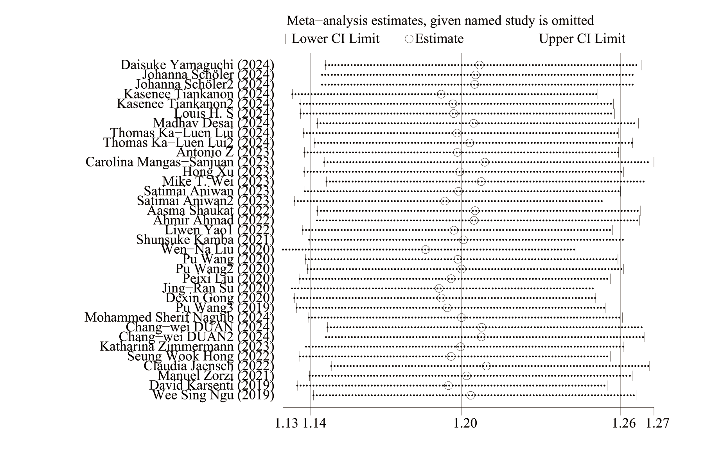
Fig2.ADR publication bias detection
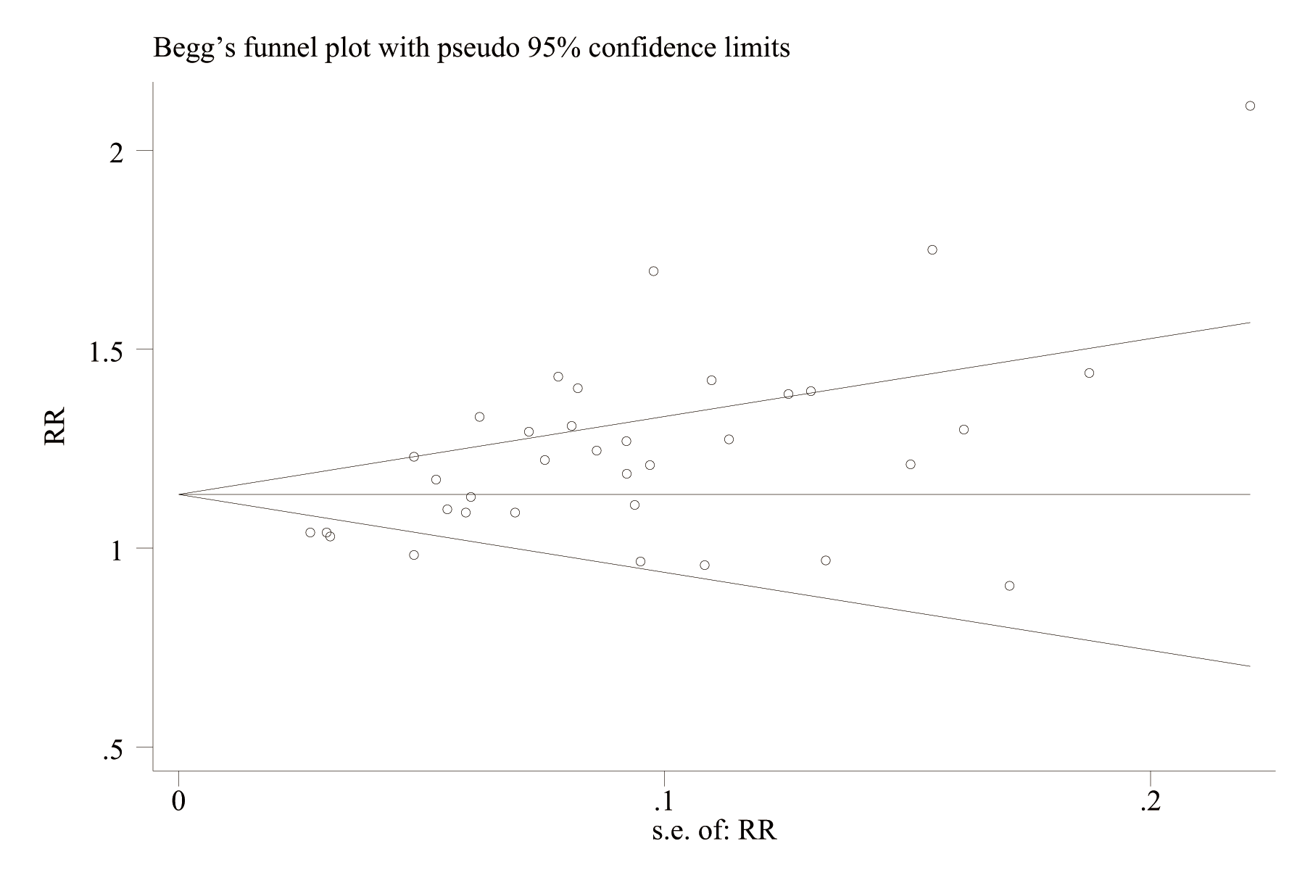

Fig3.Node analysis diagram of ADR
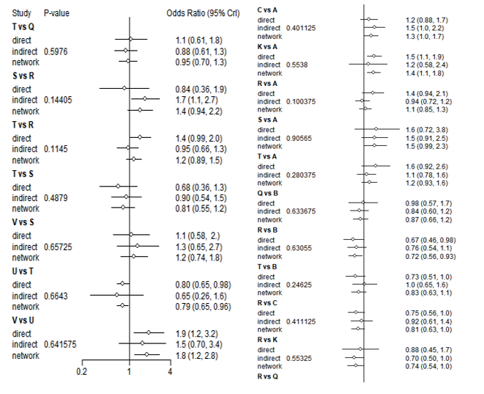
Fig4.Node analysis diagram of PDR
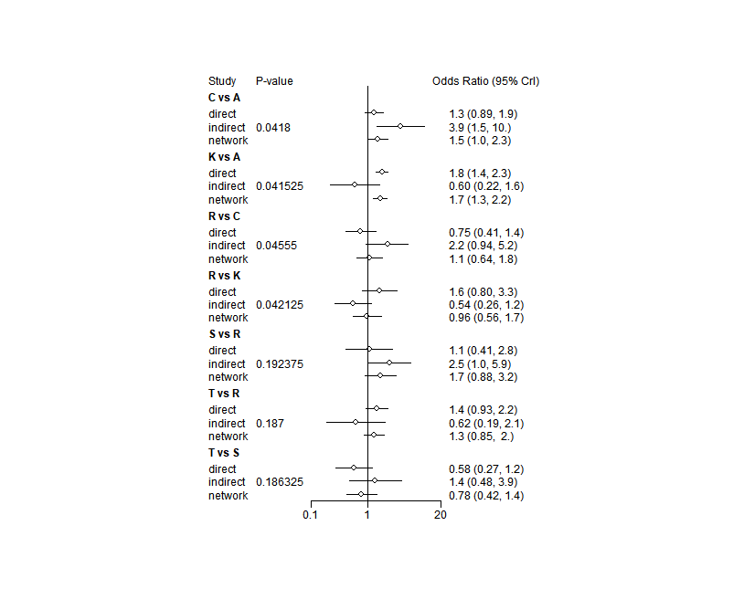

Fig5.Node analysis diagram of SSL
