Title: Efficacy of non-pharmacological interventions for the restoration of postoperative intestinal motility of patients with colorectal cancer: A systematic review and meta-analysis of randomized controlled trials
Journal: International Journal of Colorectal Disease
Lanlan Zheng¹, Xuan Zhang², Baoyu Ma³, Yuan Yuan¹, Hui Yang^{4*}
1 School of Medicine, University of Electronic Science & Technology of China, Chengdu, China
2 Colorectal Surgery Department, Sichuan Cancer Hospital & Institute, Sichuan Cancer Center, Affiliated Cancer Hospital of University of Electronic Science and Technology of China, Chengdu, China
3 Chengdu Medical College School of Nursing, Chengdu, China
4 Nursing Department, Sichuan Cancer Hospital & Institute, Sichuan Cancer Center, Affiliated Cancer Hospital of University of Electronic Science and Technology of China, Chengdu, China

*Corresponding author:
Hui Yang
Address: No. 55 Section 4, Renmin Nan Lu, Chengdu City, Sichuan Province, China.
Email: yanghui1@scszlyy.org.cn.
Phone number: +86 189-0819-1080.

Supplemental Content
Table S1. The operational definitions of the included non-pharmacological interventions 2
Table S2. The GRADE Certainty assessment for outcomes 4
Table S3.Certainty of network evidence assessment 8

Figure S1.Risk of bias graph of included randomized controlled trials 9
Figure S2.Cumulative probability ranking of the effect of non-pharmacological interventions on reducing time to first flatus、time to first defecation and length of postoperative hospital stay. Note: 1: Water; 2: 100mg Caffeine; 3: 200mg Caffeine; 4: Caffeinated Coffee; 5: Decaffeinated Coffee; 6: Tea. 10

Appendix 1 11
Appendix 2 13
Appendix 3 20

Table S1. The operational definitions of the included non-pharmacological interventions
Types of non-pharmacological intervention | Operational definitions
Gum-chewing | Gum chewing sends signals to the brain that food is being consumed, triggering saliva release, activating the cephalic phase of digestion, and digestive enzyme secretion. It might aid post-gastrointestinal surgery by stimulating the cephalic phase of digestion, which begins with the sight, smell, taste, and chewing of food¹.
Electroacupuncture | Acupuncture is a therapy that involves inserting fine needles into specific acupoints on the human body to regulate bodily functions by stimulating the flow of Qi and blood through needling. Electroacupuncture combines it with electrical stimulation², enabling objective, and quantifiable adjustments of stimulation frequency and intensity, which can shorten flatus, defecation time, and hospitalization time of patients with POI after abdominal surgery and promote the recovery of gastrointestinal function³.
Transcutaneous Tibial Nerve Stimulation | TTNS activates the peripheral nervous system, particularly through the tibial nerve, which interacts with the enteric nervous system. This stimulation can enhance the motility of the intestines by modulating the release of neurotransmitters that promote bowel movements⁴.
Transcutaneous electrical acupoint stimulation | TEAS is a non-invasive technique that applies electrical stimulation to specific acupuncture points on the body. It stimulates peripheral nerves at acupuncture points, leading to the modulation of the enteric and central nervous systems, which helps restore normal bowel function by enhancing neural communication. It also promotes the release of various neurotransmitters, including endorphins and serotonin, which can improve gastrointestinal motility⁵.
Acupressure | Acupressure is a traditional Chinese medicine technique that is noninvasive and uses fingers to rub, knead, nail pinch, and press. It stimulates specific acupoints, activating sensory pathways that influence the autonomic nervous system. This activation can enhance the coordination between the central nervous system and the enteric nervous system, promoting gastrointestinal motility⁶.
Soluble Dietary Fiber Enteral Nutrition | Soluble fiber can absorb water and form a gel-like substance in the gut, which can enhance peristalsis⁷.
Coffee and caffeine intake | Coffee may increase colon motility through the multifactorial effects of caffeine, polyphenols, dietary fiber, and Maillard reaction products and alter the gut-brain axis and gut microbiota⁸.
Tea | Tea is rich in catechins, various amino acids, and caffeine, possessing antioxidant, anti-inflammatory, hypocholesterolemic, anti-atherosclerotic, and antimicrobial pharmacological properties⁹.
Reference：
1. Lew SL, Cheng LJ, Yap SY, Liaw YQ, Park J, Lau ST. Effect of chewing gum on clinical outcomes and postoperative recovery in adult patients after gastrointestinal surgery: an umbrella review. Int J Surg. Published online March 12, 2025. doi:10.1097/JS9.0000000000002332
2. Liao Z, Tan X, Liu Y, Li W, Wang G, Wang D. Efficacy and safety of electrical stimulation for functional impairment and pain in patients with rheumatoid arthritis: a protocol for systematic review and network meta-analysis of RCTs. BMJ Open. 2025;15(4):e095309. doi:10.1136/bmjopen-2024-095309
3. Cai Y, Li H, Nan H, et al. Randomized Trial on Electroacupuncture for Recovery of Postoperative Gastrointestinal Function Based on Long-Term Monitoring Device. Ann Surg Oncol. Published online April 4, 2025. doi:10.1245/s10434-025-17239-3
4. Venara A, Bougard M, Mucci S, et al. Perioperative Transcutaneous Tibial Nerve Stimulation to Reduce Postoperative Ileus After Colorectal Resection: A Pilot Study. Dis Colon Rectum. 2018;61(9):1080-1088. doi:10.1097/DCR.0000000000001171
5. Jiang T, Li J, Meng L, Wang J, Zhang H, Liu M. Effects of transcutaneous electrical acupoint stimulation on gastrointestinal dysfunction after gastrointestinal surgery: A meta-analysis. Complement Ther Med. 2023;73:102938. doi:10.1016/j.ctim.2023.102938
6. Chao HL, Miao SJ, Liu PF, et al. The Beneficial Effect of ST-36 (Zusanli) Acupressure on Postoperative Gastrointestinal Function in Patients With Colorectal Cancer. Oncology Nursing Forum. 2013;40(2):E61-E68. doi:10.1188/13.ONF.E61-E68
7. Xu R, Ding Z, Zhao P, Tang L, Tang X, Xiao S. The Effects of Early Post-Operative Soluble Dietary Fiber Enteral Nutrition for Colon Cancer. Nutrients. 2016;8(9):584. doi:10.3390/nu8090584
8. Yang TW, Wang CC, Sung WW, Ting WC, Lin CC, Tsai MC. The effect of coffee/caffeine on postoperative ileus following elective colorectal surgery: a meta-analysis of randomized controlled trials. Int J Colorectal Dis. 2022;37(3):623-630. doi:10.1007/s00384-021-04086-3
9. Reygaert WC. Green Tea Catechins: Their Use in Treating and Preventing Infectious Diseases. Biomed Res Int. 2018;2018:9105261. doi:10.1155/2018/9105261

Table S2. The GRADE Certainty assessment for outcomes
Outcome | No. of studies | No. of included patients |  | MD[95%CI] | Quality assessment |  |  |  |  | Quality
Outcome | No. of studies | Comparison |  | MD[95%CI] | Risk of bias | Inconsistency | Indirectness | Imprecision | Publication bias | Quality
Time to first flatus | 7 | Gum-chewing | Control | -5.88[-10.33,-1.43] | Serious | Serious | Not serious | Not serious | Unclear¹ | Low
Time to first flatus | 7 | 521 | 527
Time to first flatus | 3 | Electroacupuncture | Control | -6.29[-15.32,2.74] | Not serious | Serious | Not serious | Not serious | Unclear¹ | Moderate
Time to first flatus | 3 | 188 | 184
Time to first flatus | 2 | TTNS | Control | -14.95[-18.28,-11.61] | Serious | Not serious | Not serious | Serious | Unclear¹ | Moderate
Time to first flatus | 2 | 185 | 189
Time to first flatus | 1 | Acupressure | Control | -19.92[-32.57,-7.27] | Very serious | None | Not serious | Not serious | Unclear¹ | Low
Time to first flatus | 1 | 30 | 30
Time to first flatus | 1 | Caffeinated coffee | Tea | 9.00[7.07,10.93] | Not serious | None | Not serious | Not serious | Unclear¹ | High
Time to first flatus | 1 | 49 | 47
Time to first flatus | 2 | 100mg caffeine | Water | -3.97[-12.25,4.31] | Not serious | Not serious | Not serious | Not serious | Not serious | High
Time to first flatus | 2 | 40 | 36
Time to first flatus | 1 | 200mg caffeine | Water | 3.00[-16.77,22.77] | Not serious | None | Not serious | Not serious | Unclear¹ | High
Time to first flatus | 1 | 9 | 8
Time to first flatus | 1 | 100mg caffeine | 200mg caffeine | -4.60[-20.88,11.68] | Not serious | None | Not serious | Not serious | Unclear¹ | High
Time to first flatus | 1 | 10 | 9
Time to first flatus | 1 | TEAS | Control | -12.90[-18.25,-7.55] | Not serious | None | Not serious | Not serious | Unclear¹ | High
Time to first flatus | 1 | 303 | 307
Time to first flatus | 1 | SDFEN | EN | -4.10[-6.99,-1.21] | Serious | None | Not serious | Not serious | Unclear¹ | Moderate
Time to first flatus | 1 | 30 | 30
Time to first defecation | 6 | Gum-chewing | Control | -15.18[-21.67,-8.69] | Serious | Serious | Not serious | Not serious | Unclear¹ | Low
Time to first defecation | 6 | 480 | 486
Time to first defecation | 1 | Acupressure | Control | -12.00[-31.60,7.60] | Very serious | None | Not serious | Not serious | Unclear¹ | Low
Time to first defecation | 1 | 30 | 30
Time to first defecation | 3 | Electroacupuncture | Control | -6.96[-11.99,-1.93] | Not serious | Not serious | Not serious | Not serious | Unclear¹ | High
Time to first defecation | 3 | 188 | 184
Time to first defecation | 1 | Tea | Water | -4.40[-35.49,26.69] | Not serious | None | Not serious | Not serious | Unclear¹ | High
Time to first defecation | 1 | 7 | 10
Time to first defecation | 1 | TEAS | Control | --14.8[-25.21,-4.39] | Not serious | None | Not serious | Not serious | Unclear¹ | High
Time to first defecation | 1 | 303 | 307
Time to first defecation | 2 | Caffeinated coffee | Decaffeinated coffee | 16.29[5.35,27.24] | Not serious | Not serious | Not serious | Not serious | Unclear¹ | High
Time to first defecation | 2 | 67 | 61
Time to first defecation | 2 | Decaffeinated coffee | Water | -20.75[-31.63,-9.87] | Not serious | Not serious | Not serious | Not serious | Unclear¹ | High
Time to first defecation | 2 | 61 | 61
Time to first defecation | 3 | Caffeinated coffee | Water | -15.84[-23.22,-88.46] | Not serious | Not serious | Not serious | Not serious | Unclear¹ | High
Time to first defecation | 3 | 102 | 97
Time to first defecation | 1 | 100mg caffeine | Water | -22.26[-42.24,-2.28] | Not serious | None | Not serious | Not serious | Unclear¹ | High
Time to first defecation | 1 | 30 | 28
Time to first defecation | 1 | Caffeinated coffee | Water | -11.60[-21.72,-1.48] | Not serious | None | Not serious | Not serious | Unclear¹ | High
Time to first defecation | 1 | 35 | 36
Length of hospital stay | 4 | Gum-chewing | Control | -0.98[-2.12,0.16] | Serious | Not serious | Not serious | Not serious | Unclear¹ | Moderate
Length of hospital stay | 4 | 530 | 541
Length of hospital stay | 2 | TTNS | Control | -0.30[-0.52,-0.07] | Seriosu | Not serious | Not serious | Not serious | Unclear¹ | Moderate
Length of hospital stay | 2 | 185 | 189
Length of hospital stay | 2 | EA | Control | -0.11[-0.35,0.12] | Not serious | Not serious | Not serious | Not serious | Unclear¹ | High
Length of hospital stay | 2 | 144 | 143
Length of hospital stay | 1 | Caffeinated coffee | Tea | -0.91[-1.14,-0.68] | Not serious | None | Not serious | Not serious | Unclear¹ | High
Length of hospital stay | 1 | 49 | 47
Length of hospital stay | 1 | Tea | Water | 1.6[-0.72,3.92] | Not serious | None | Not serious | Not serious | Unclear¹ | High
Length of hospital stay | 1 | 7 | 10
Length of hospital stay | 1 | 100mg caffeine | Water | -0.61[-1.56,0.34] | Not serious | None | Not serious | Not serious | Unclear¹ | High
Length of hospital stay | 1 | 40 | 36
Length of hospital stay | 1 | 200mgcaffeine | Water | -0.70[-3.14,1.74] | Not serious | None | Not serious | Not serious | Unclear¹ | High
Length of hospital stay | 1 | 9 | 8
Length of hospital stay | 1 | Coffee | Water | -1.60[-3.44,0.24] | Not serious | None | Not serious | Not serious | Unclear¹ | High
Length of hospital stay | 1 | 35 | 36
Length of hospital stay | 1 | SDFEN | EN | -0.23[-0.57,0.11] | Serious | None | Not serious | Not serious | Unclear¹ | Moderate
Length of hospital stay | 1 | 30 | 30
Time to tolerate liquid diet | 1 | Acupressure | Control | -19.92[-34.69,-5.15] | Very serious | None | Not serious | Not serious | Unclear¹ | Low
Time to tolerate liquid diet | 1 | 30 | 30
Time to tolerate solid diet | 1 | Acupressure | Control | -13.68[-33.51,6.15] | Very serious | None | Not serious | Not serious | Unclear¹ | Low
Time to tolerate solid diet | 1 | 30 | 30
Time to tolerate solid diet | 2 | 100mg caffeine | Water | -13.67[-27.20,-0.14] | Not serious | Not serious | Not serious | Not serious | Unclear¹ | High
Time to tolerate solid diet | 2 | 40 | 36
Time to tolerate solid diet | 1 | 200mg caffeine | Water | -5.70[-24.91,13.51] | Not serious | None | Not serious | Not serious | Unclear¹ | High
Time to tolerate solid diet | 1 | 9 | 8
Time to tolerate solid diet | 1 | 100mg caffeine | 200mg caffeine | -7.00[-22.33,8.33] | Not serious | None | Not serious | Not serious | Unclear¹ | High
Time to tolerate solid diet | 1 | 10 | 9
Time to tolerate regular diet | 1 | TEAS | Control | -51.60[-88.15,-15.05] | Not serious | None | Not serious | Not serious | Unclear¹ | High
Time to tolerate regular diet | 1 | 303 | 307
Note: ¹The funnel plot or Egger’s test was not performed because of insufficient information (<10 studies). Abbreviations: SDFEN = Soluble Dietary Fiber Enteral Nutrition; TTNS = Transcutaneous Tibial Nerve Stimulation; TEAS = Transcutaneous Electrical Acupoint Stimulation

Table S3.Certainty of network evidence assessment
Outcome: Time to first bowel movement
Comparison | Number of studies | Within-study bias | Reporting bias | Indirectness | Imprecision | Heterogeneity | Incoherence | Confidence rating
Mixed evidence
100mg caffeine: Water | 1 | No concerns | Low risk | No concerns | No concerns | Major concerns | No concerns | Low
Caffeinated coffee: Water | 3 | No concerns | Low risk | No concerns | No concerns | Major concerns | No concerns | Low
Decaffeinated coffee: Water | 2 | No concerns | Low risk | No concerns | No concerns | No concerns | No concerns | High
Tea: Water | 1 | No concerns | Low risk | No concerns | Major concerns | No concerns | No concerns | Low
Caffeinated coffee: Decaffeinated coffee | 2 | No concerns | Low risk | No concerns | No concerns | Major concerns | No concerns | Low
Indirect evidence
Caffeinated coffee: 100mg caffeine | 0 | No concerns | Low risk | No concerns | Major concerns | No concerns | No concerns | Low
Decaffeinated coffee: 100mg caffeine | 0 | No concerns | Low risk | No concerns | Major concerns | No concerns | No concerns | Low
Tea: 100mg caffeine | 0 | No concerns | Low risk | No concerns | Major concerns | No concerns | No concerns | Low
Tea: Caffeinated coffee | 0 | No concerns | Low risk | No concerns | Major concerns | No concerns | No concerns | Low
Tea: Decaffeinated coffee | 0 | No concerns | Low risk | No concerns | Major concerns | No concerns | No concerns | Low

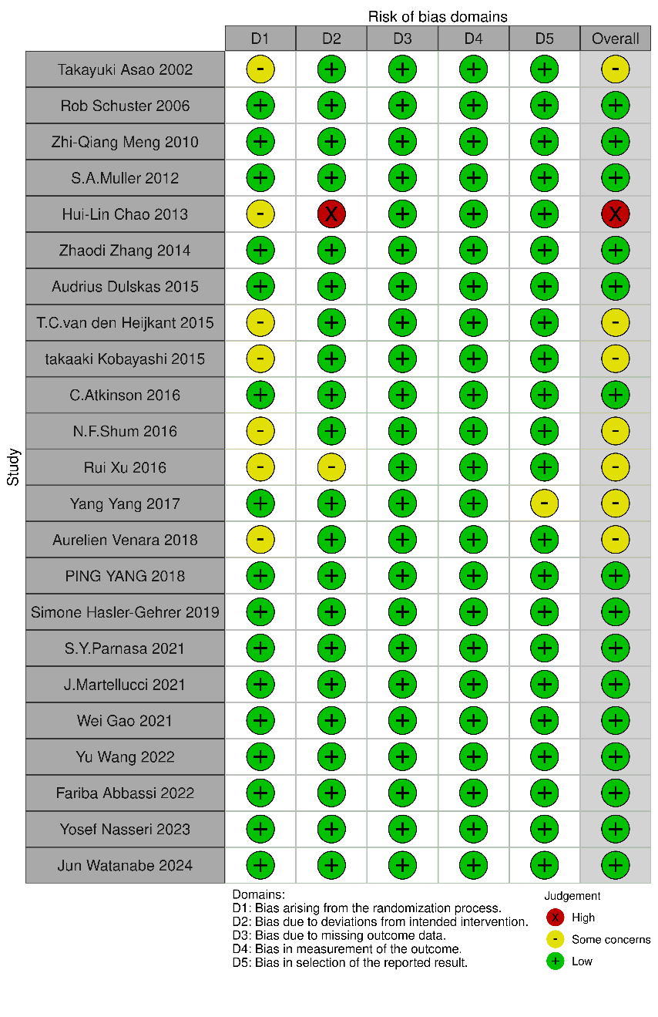
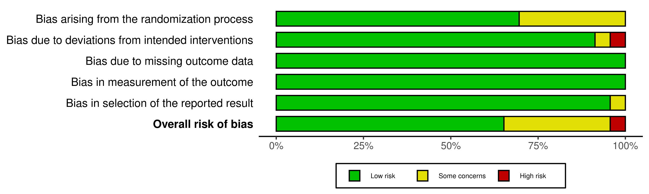

Figure S1.Risk of bias graph of included randomized controlled trials
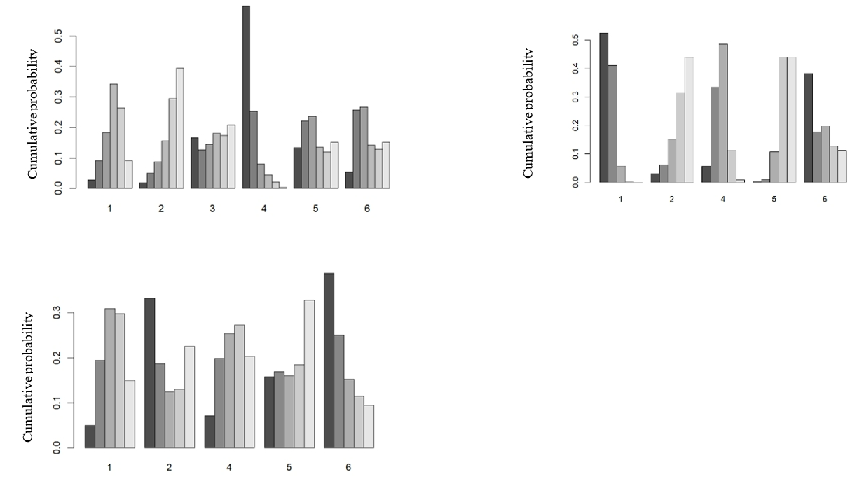

Figure S2.Cumulative probability ranking of the effect of non-pharmacological interventions on reducing time to first flatus、time to first defecation and length of postoperative hospital stay. Note: 1: Water; 2: 100mg Caffeine; 3: 200mg Caffeine; 4: Caffeinated Coffee; 5: Decaffeinated Coffee; 6: Tea.

Appendix 1
Search strategy in PubMed
#1 ((((((((((((((Colorectal Neoplasms[MeSH Terms]) OR (Colorectal Neoplasm[Title/Abstract])) OR (Neoplasm, Colorectal[Title/Abstract])) OR (Colorectal Tumors[Title/Abstract])) OR (Tumor, Colorectal[Title/Abstract])) OR (Tumors, Colorectal[Title/Abstract])) OR (Neoplasms, Colorectal[Title/Abstract])) OR (Colorectal Cancer[Title/Abstract])) OR (Cancer, Colorectal[Title/Abstract])) OR (Cancers, Colorectal[Title/Abstract])) OR (Colorectal Cancers[Title/Abstract])) OR (Colorectal Carcinoma[Title/Abstract])) OR (Carcinoma, Colorectal[Title/Abstract])) OR (Carcinomas, Colorectal[Title/Abstract])) OR (Colorectal Carcinomas[Title/Abstract])

#2(((((((((((((((((((((Colonic Neoplasms[MeSH Terms]) OR (Colonic Neoplasm[Title/Abstract])) OR (Neoplasm, Colonic[Title/Abstract])) OR (Colon Neoplasms[Title/Abstract])) OR (Colon Neoplasm[Title/Abstract])) OR (Neoplasm, Colon[Title/Abstract])) OR (Neoplasms, Colon[Title/Abstract])) OR (Neoplasms, Colonic[Title/Abstract])) OR (Cancer of Colon[Title/Abstract])) OR (Colon Cancers[Title/Abstract])) OR (Cancer of the Colon[Title/Abstract])) OR (Colonic Cancer[Title/Abstract])) OR (Cancer, Colonic[Title/Abstract])) OR (Cancers, Colonic[Title/Abstract])) OR (Colonic Cancers[Title/Abstract])) OR (Colon Cancer[Title/Abstract])) OR (Cancer, Colon[Title/Abstract])) OR (Cancers, Colon[Title/Abstract])) OR (Colon Adenocarcinoma[Title/Abstract])) OR (Adenocarcinoma, Colon[Title/Abstract])) OR (Adenocarcinomas, Colon[Title/Abstract])) OR (Colon Adenocarcinomas[Title/Abstract])

#3 (((((((((((((((((Rectal Neoplasms[MeSH Terms]) OR (Neoplasm, Rectal[Title/Abstract])) OR (Rectal Neoplasm[Title/Abstract])) OR (Neoplasms, Rectal[Title/Abstract])) OR (Rectum Neoplasms[Title/Abstract])) OR (Neoplasm, Rectum[Title/Abstract])) OR (Rectum Neoplasm[Title/Abstract])) OR (Rectal Tumors[Title/Abstract])) OR (Rectal Tumor[Title/Abstract])) OR (Tumor, Rectal[Title/Abstract])) OR (Cancer of Rectum[Title/Abstract])) OR (Rectum Cancers[Title/Abstract])) OR (Cancer of the Rectum[Title/Abstract])) OR (Rectal Cancer[Title/Abstract])) OR (Cancer, Rectal[Title/Abstract])) OR (Rectal Cancers[Title/Abstract])) OR (Rectum Cancer[Title/Abstract])) OR (Cancer, Rectum[Title/Abstract])

#4 #1 OR #2 OR #3

#5(((((((Gastrointestinal Motility[MeSH Terms]) OR (Gastrointestinal Motilities[Title/Abstract])) OR (Motilities, Gastrointestinal[Title/Abstract])) OR (Motility, Gastrointestinal[Title/Abstract])) OR (Intestinal Motility[Title/Abstract])) OR (Intestinal Motilities[Title/Abstract])) OR (Motilities, Intestinal[Title/Abstract])) OR (Motility, Intestinal[Title/Abstract])

#6(((((((((((Bowel motility recovery[Title/Abstract]) OR (Bowel function recovery[Title/Abstract])) OR (Intestinal motility recovery[Title/Abstract])) OR (Intestinal function recovery[Title/Abstract])) OR (Gastrointestinal motility recovery[Title/Abstract])) OR (Gastrointestinal function recovery[Title/Abstract])) OR (Bowel motility restoration[Title/Abstract])) OR (Bowel function restoration[Title/Abstract])) OR (Intestinal motility restoration[Title/Abstract])) OR (Intestinal function restoration[Title/Abstract])) OR (Gastrointestinal motility restoration[Title/Abstract])) OR (Gastrointestinal function restoration[Title/Abstract])

#7 #5 OR #6

#8 #4 AND #7
Appendix 2
Forest plot showing the results of pairwise meta-analysis for dietary treatments
Outcome 1: Time to first flatus
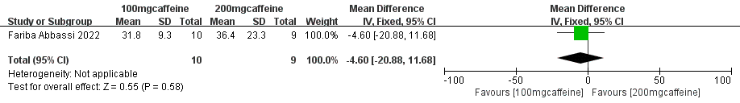

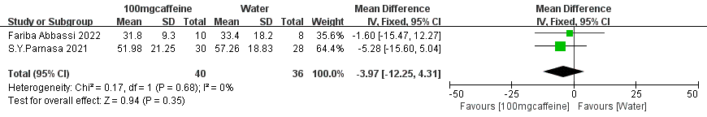

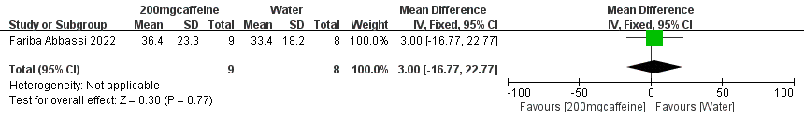

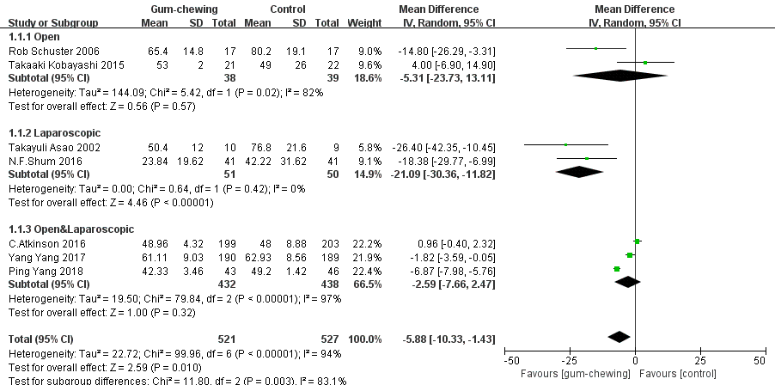

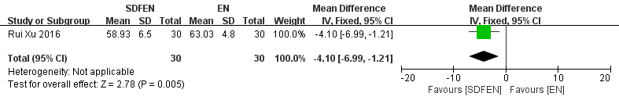

Outcome 2: Time to first defecation
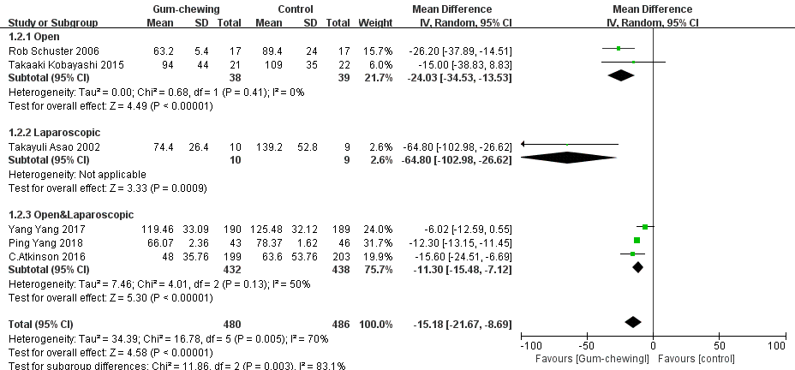

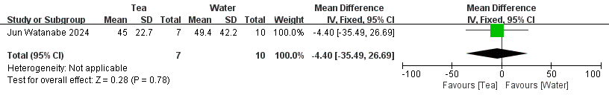
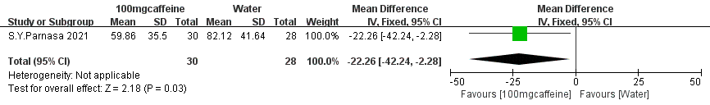

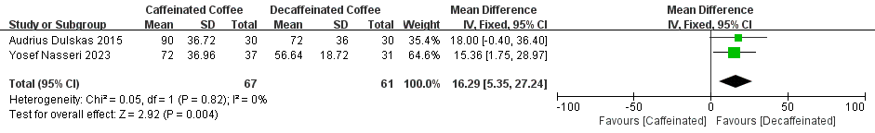

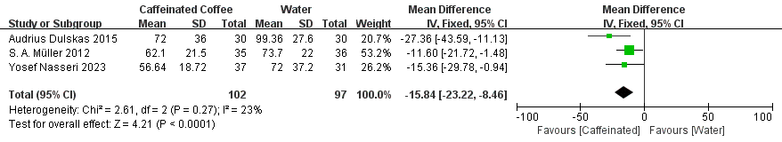

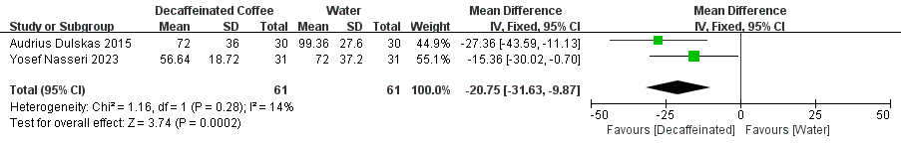
Outcome 3:Length of hospital stay
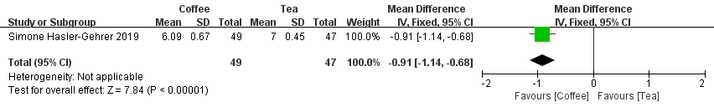

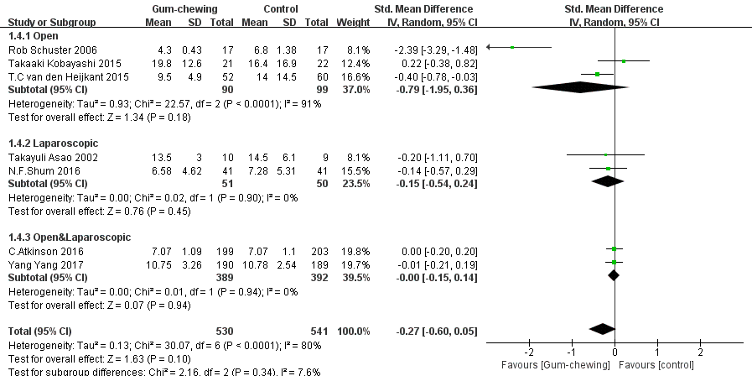

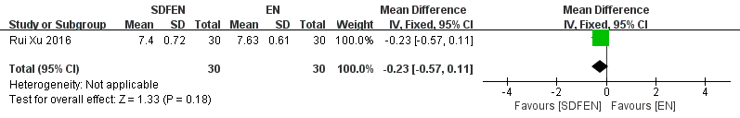

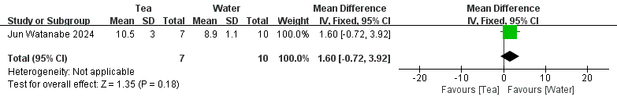

Outcome 4: Length of postoperative hospital stay
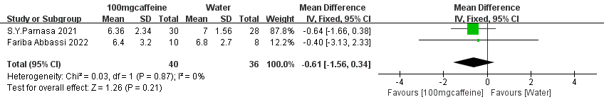

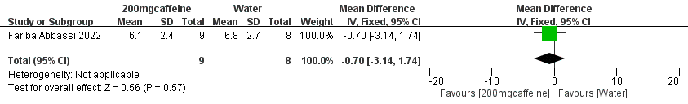

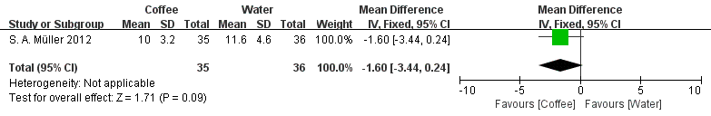

Forest plot showing the results of pairwise meta-analysis for physical treatments
Outcome 1: Time to first flatus
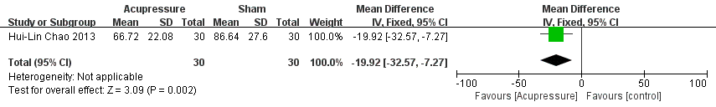

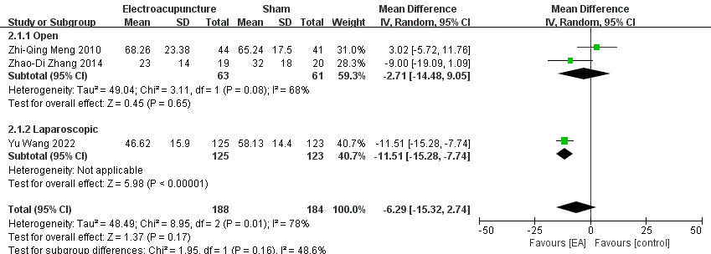

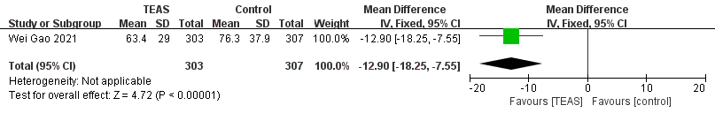

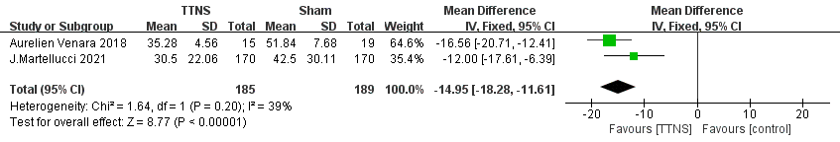

Outcome 2: Time to first defecation
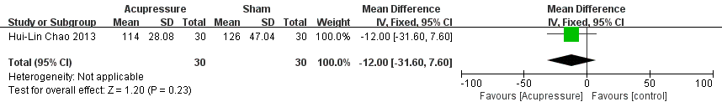

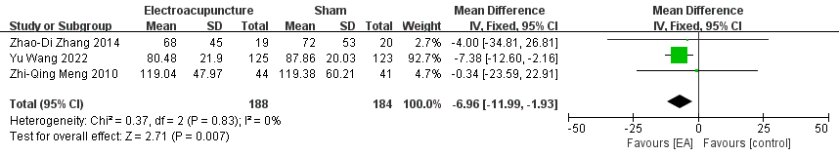

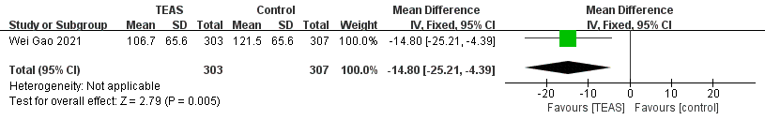

Outcome 3: Time to tolerate liquid diet
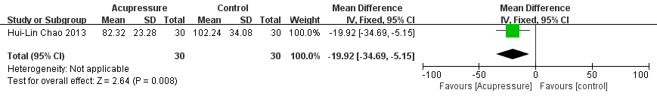

Outcome 4: Time to tolerate solid diet
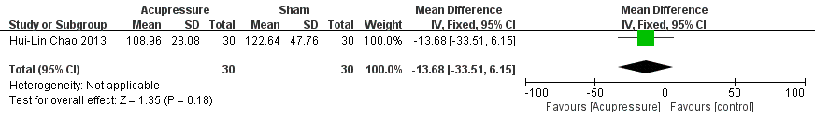

Outcome 5: Time to tolerate regular diet

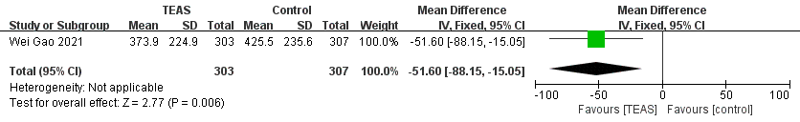

Outcome 6: Length of hospital stay
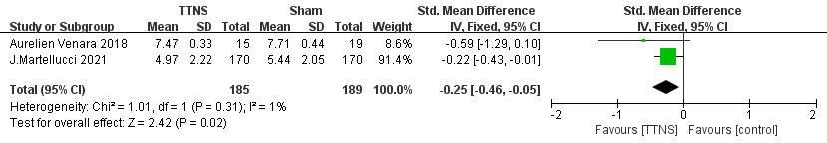

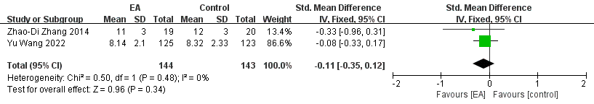

Appendix 3
Leave-one-out analysis for gum chewing
Outcome 1: Time to first flatus
Outcome 2: Time to first defecation

Outcome 3: Length of hospital stay
Leave-one-out analysis for electroacupuncture
Outcome: Time to first flatus

