Supplementary material
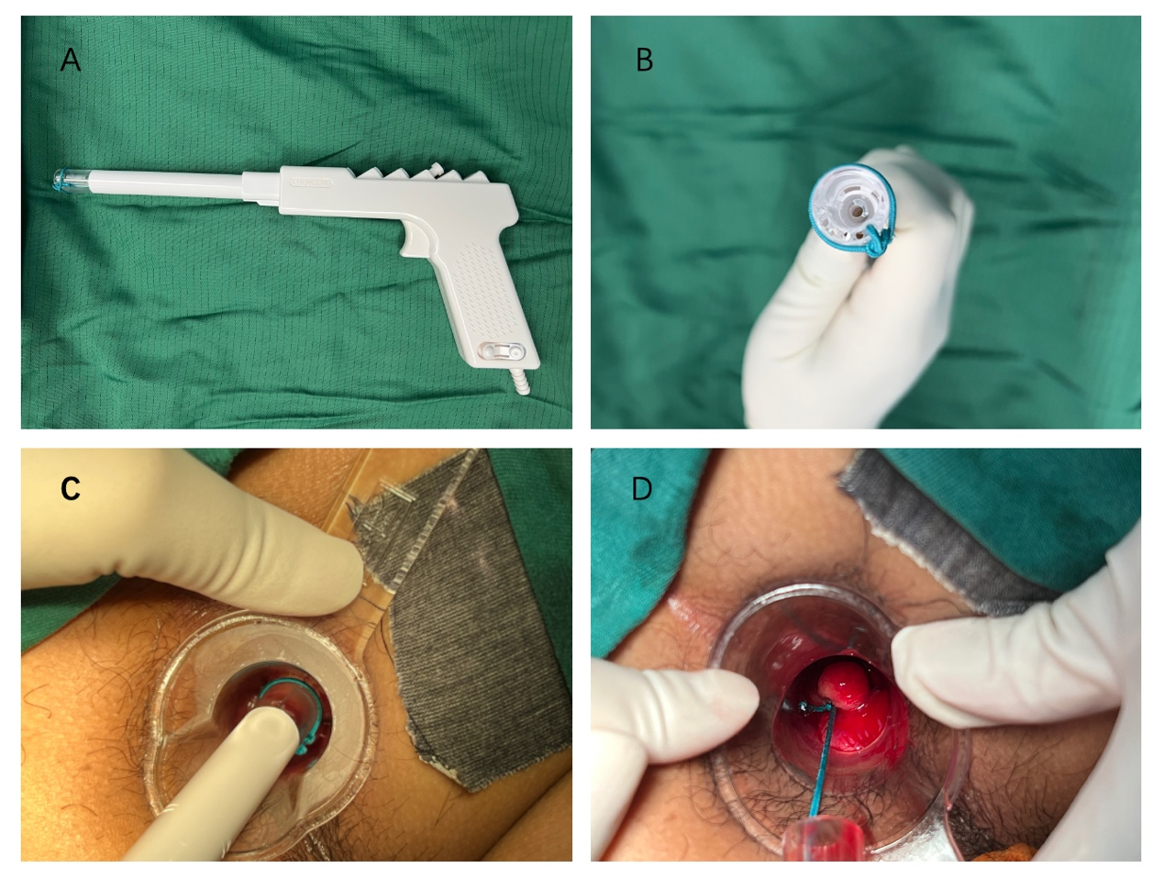
Supplementary Figure 1: Procedure and equipment for rubber band ligation (RBL) using a disposable suction ligator. (A) The disposable suction ligator (Model: CG–TZQ–D1; Chengeng Medical Technology Co., Ltd., Guangzhou, China) used in the procedure. (B) Frontal view of the ligator head, showing the 12 mm inner-diameter suction chamber. (C) Aspiration of the prolapsed hemorrhoidal tissue into the ligator chamber under negative pressure (0.08–0.1 MPa), guided through an anoscope. (D) Deployment of the rubber band at the base of the aspirated hemorrhoid to complete ligation.

