SUPPLEMENT

Eligibility Criteria
Inclusion Criteria
- indication for elective PCI according to the guidelines of European Society of Cardiology, American Heart Association/American College of Cardiology
- Age > 18 years
- written consent
- Native de novo coronary lesion suitable for angioplasty and OCT imaging
Exclusion Criteria
General
- Pregnancy and breast feeding mother
- Co-morbidity with an estimated life expectancy of < 50 % at 1 year
- Scheduled major surgery in the next 6 months
- Not able to give informed written consent or non-compliance
- Participation in other PCI trial
- Acute coronary syndromes and cardiogenic shock
- Known allergy to aspirin, thienopyridines or against taxol derivates
Lesion related
- Culprit lesion within the proximal 10 mm of the right or left coronary artery
- previous revascularization of the possible study lesion
- vessel supplied by an aortocoronary bypass
- estimated lesion length > 30 mm
- reference luminal diameter > 4 mm

Figures 3 a-c: Comparison of (a) minimal and reference lumen diameter (MLD, RLD), (b) % diameter

stenosis, and (c) cumulative distribution percentages of minimal lumen diameter (MLD) at

baseline, postprocedural and at 6-month f/u

Figure 3a

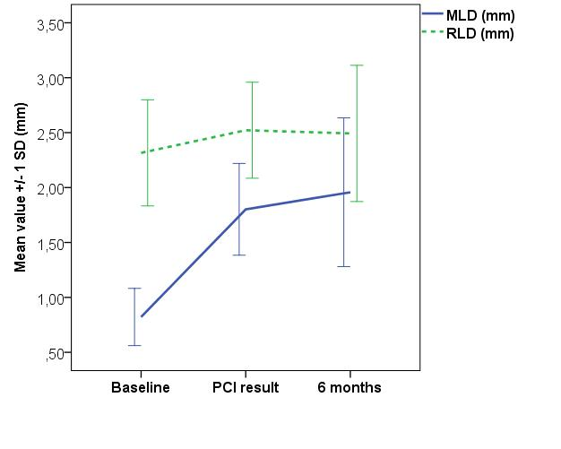

Figure 3b

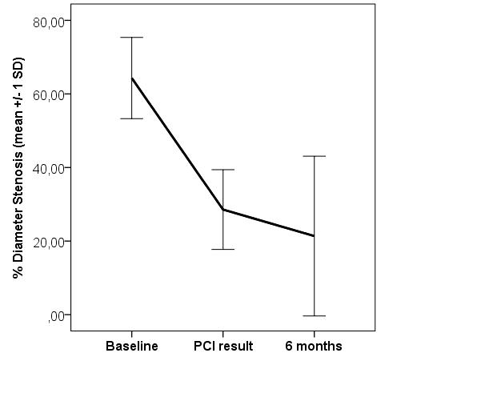

Figure 3c

