Activity of the Adrenomedullin System to Personalize Post-Discharge Diuretic Treatment in Acute Heart Failure

Supplemental materials

Tables

Supplemental Table 1. TRIPOD Checklist for prediction model development.
Section/Topic | Item | Checklist Item | Page
Title and abstract
Title | 1 | Identify the study as developing and/or validating a multivariable prediction model, the target population, and the outcome to be predicted. | 1
Abstract | 2 | Provide a summary of objectives, study design, setting, participants, sample size, predictors, outcome, statistical analysis, results, and conclusions. | 2
Introduction
Background and objectives | 3a | Explain the medical context (including whether diagnostic or prognostic) and rationale for developing or validating the multivariable prediction model, including references to existing models. | 4, 5
Background and objectives | 3b | Specify the objectives, including whether the study describes the development or validation of the model or both. | 5
Methods
Source of data | 4a | Describe the study design or source of data (e.g., randomized trial, cohort, or registry data), separately for the development and validation data sets, if applicable. | 6
Source of data | 4b | Specify the key study dates, including start of accrual; end of accrual; and, if applicable, end of follow-up.
Participants | 5a | Specify key elements of the study setting (e.g., primary care, secondary care, general population) including number and location of centres. | 6
Participants | 5b | Describe eligibility criteria for participants. | 6
Participants | 5c | Give details of treatments received, if relevant. | 6
Outcome | 6a | Clearly define the outcome that is predicted by the prediction model, including how and when assessed. | 8, 9
Outcome | 6b | Report any actions to blind assessment of the outcome to be predicted. | 8, 9
Predictors | 7a | Clearly define all predictors used in developing or validating the multivariable prediction model, including how and when they were measured. | 7, 8
Predictors | 7b | Report any actions to blind assessment of predictors for the outcome and other predictors. | 6-8
Sample size | 8 | Explain how the study size was arrived at. | 9
Missing data | 9 | Describe how missing data were handled (e.g., complete-case analysis, single imputation, multiple imputation) with details of any imputation method. | 9
Statistical analysis methods | 10a | Describe how predictors were handled in the analyses. | 9
Statistical analysis methods | 10b | Specify type of model, all model-building procedures (including any predictor selection), and method for internal validation. | 8, 9
Statistical analysis methods | 10d | Specify all measures used to assess model performance and, if relevant, to compare multiple models. | 9
Risk groups | 11 | Provide details on how risk groups were created, if done.

Results
Participants | 13a | Describe the flow of participants through the study, including the number of participants with and without the outcome and, if applicable, a summary of the follow-up time. A diagram may be helpful. | 11
Participants | 13b | Describe the characteristics of the participants (basic demographics, clinical features, available predictors), including the number of participants with missing data for predictors and outcome. | 11
Model development | 14a | Specify the number of participants and outcome events in each analysis. | 11, 12
Model development | 14b | If done, report the unadjusted association between each candidate predictor and outcome.
Model specification | 15a | Present the full prediction model to allow predictions for individuals (i.e., all regression coefficients, and model intercept or baseline survival at a given time point). | 11, 12
Model specification | 15b | Explain how to use the prediction model.
Model performance | 16 | Report performance measures (with CIs) for the prediction model. | 11, 12
Discussion
Limitations | 18 | Discuss any limitations of the study (such as nonrepresentative sample, few events per predictor, missing data). | 16
Interpretation | 19b | Give an overall interpretation of the results, considering objectives, limitations, and results from similar studies, and other relevant evidence. | 14-16
Implications | 20 | Discuss the potential clinical use of the model and implications for future research. | 15, 16
Other information
Supplementary information | 21 | Provide information about the availability of supplementary resources, such as study protocol, Web calculator, and data sets. | Supplementary materials
Funding | 22 | Give the source of funding and the role of the funders for the present study. | 17

Supplemental Table 2. Interaction p-values in bivariable models using a cox proportional hazard analysis for predicting all-cause mortality at 365 days including one biomarker and medication at discharge.

 | Diuretics | ACE inhibitors or ARB | Beta blockers | Aldosterone antagonists
lg bio-ADM at admission, pg/mL | < 0.001 | 0.003 | 0.097 | 0.013
lg bio-ADM at discharge, pg/mL | < 0.001 | 0.016 | 0.488 | 0.175
lg MR-proADM at admission, nmol/L | 0.046 | 0.215 | 0.107 | 0.587
lg MR-proADM at discharge, nmol/L | 0.001 | 0.152 | 0.601 | 0.060

ACE: Angiotensin-converting-enzyme. ARBs: Angiotensin receptor blocker. bio-ADM: bioactive adrenomedullin. MR-proADM: midregional proadrenomedullin.

Supplemental Table 3. Patient’s characteristics according to discharge prescription of diuretics.
 | Patients discharged without diuretics  (n = 276*) | Patients discharged with diuretics  (n = 1,568*) | p-value
Demographics
Age, years | 76.0 (66.0-84.0) | 78.0 (69.0-84.0) | 0.097
Female gender, % | 38.5 | 33.5 | 0.110
BMI, kg/m² | 26.6 (23.7-30.8) | 27.7 (24.1-31.8) | 0.184
Clinical parameters at ED
SBP, mmHg | 134 (113-152) | 134 (118-153) | 0.214
HR, beats/min | 81 (69-106) | 85 (71-103) | 0.707
LV Ejection Fraction, % | 35 (26-450) | 40 (27-53) | 0.176
LVEDD, cm | 5.4 (4.6-6.0) | 5.2 (4.6-5.9) | 0.470
LVESD, cm | 4.4 (3.2-5.3) | 4.2 (3.3-5.0) | 0.225

 | Patients discharged without diuretics  (n = 276*) | Patients discharged with diuretics  (n = 1,568*) | p-value
Medical history
CKD, % | 26.5 | 33.9 | 0.017
Hypertension, % | 60.9 | 71.0 | 0.001
Dyslipidaemia, % | 33.6 | 42.8 | 0.009
Stroke or TIA, % | 18.8 | 15.6 | 0.228
Current or ex-smoker, % | 54.4 | 55.2 | 0.837
PAD, % | 6.6 | 11.1 | 0.037
Atrial fibrillation, % | 41.8 | 43.1 | 0.711
COPD, % | 11.8 | 16.5 | 0.072
Diabetes, % | 33.0 | 31.9 | 0.716
Medication at presentation
ACE inhibitors or ARB, % | 57.6 | 62.7 | 0.143
Beta blockers, % | 46.5 | 54.4 | 0.026
Aldosterone antagonists, % | 10.9 | 13.6 | 0.260
Loop diuretics, % | 53.1 | 67.2 | < 0.001
 | Patients discharged without diuretics  (n = 276*) | Patients discharged with diuretics  (n = 1,568*) | p-value
Medication at discharge
ACE inhibitors or ARB, % | 26.1 | 79.0 | < 0.001
Beta blockers, % | 27.2 | 69.5 | < 0.001
Aldosterone antagonists, % | 10.9 | 35.0 | < 0.001
Laboratory parameters at admission
Haemoglobin, g/L | 127 (113-142) | 124 (110-137) | 0.021
Sodium, mmol/L | 138 (135-141) | 139 (136-141) | 0.031
Potassium, mmol/L | 4.3 (3.9-4.8) | 4.3 (3.9-4.6) | 0.075
Creatinine, μmol/L | 112 (85.0-150.0) | 111.0 (89.0-145.0) | 0.838
Urea, mmol/L | 8.9 (6.4-14.1) | 9.7 (6.9-14.3) | 0.778
NT-proBNP, pg/mL | 2,449 (1,046-5,585) | 3,145 (1,493-6,108) | 0.008
Bio-ADM, pg/mL | 45.6 (28.7-79.6) | 44.4 (30.3-67.9) | 0.558
MR-proADM, nmol/L | 1.54 (0.94- 2.62) | 1.67 (1.21-2.32) | 0.202
 | Patients discharged without diuretics  (n = 276*) | Patients discharged with diuretics  (n = 1,568*) | p-value
Laboratory parameters at discharge
Haemoglobin, g/L | 124 (106-136) | 121 (108-134) | 0.242
Sodium, mmol/L | 139 (136-141) | 139 (136-141) | 0.129
Potassium, mmol/L | 4.1 (3.8-4.5) | 4.10 (3.8-4.5) | 0.402
Urea, mmol/L | 9.5 (6.3-16.3) | 9.7 (6.9-14.3) | 0.967
Creatinine, μmol/L | 108.0 (84.0-157.0) | 111.0 (89.0-145.0) | 0.815
NT-proBNP, pg/mL | 1,655 (651-3,160) | 1,960 (882-4,280) | 0.015
Bio-ADM, pg/mL | 35.3 (23.3-73.1) | 37.1 (26.1-54.6) | 0.719
MR-proADM, nmol/L | 1.30 (0.81-1.86) | 1.43 (1.07-1.99) | 0.148

ACE: Angiotensin-converting-enzyme. ARBs: Angiotensin receptor blocker. BMI: Body mass index. bio-ADM: bioactive adrenomedullin.
CAD: Coronary artery disease. CCB: Calcium channel blockers. COPD: Chronic obstructive pulmonary disease. CKD: Chronic kidney disease. ED: Emergency department. HR: Heart rate. MR-proADM: midregional proadrenomedullin. LVEF: Left ventricular ejection fraction. LVEDD: Left ventricular end diastolic diameter. NT-proBNP: N-terminal pro-B-type natriuretic peptide. PAD: Peripheral artery disease. SBP: Systolic blood pressure.
*In 42 of the overall cohort of 1886 patients, there was no information on prescription of diuretics at discharge

Supplemental Table 4. Interaction p-values in bivariable models using a cox proportional hazard analysis for predicting all-cause mortality or AHF hospitalizations at 365 days including one biomarker, and medication at discharge.

 | Diuretics | ACE inhibitors or ARB | Beta blockers | Aldosterone antagonists
lg bio-ADM at admission, pg/mL | < 0.001 | 0.008 | 0.254 | 0.244
lg bio-ADM at discharge, pg/mL | < 0.001 | 0.023 | 0.732 | 0.509
lg MR-proADM at admission, nmol/L | 0.011 | 0.045 | 0.019 | 0.542
lg MR-proADM at discharge, nmol/L | <0.001 | 0.011 | 0.389 | 0.285

ACE: Angiotensin-converting-enzyme. AHF: Acute heart failure. ARBs: Angiotensin receptor blocker. bio-ADM: bioactive adrenomedullin. MR-proADM: midregional proadrenomedullin.

Supplemental Table 5. Interaction p-values in multivariable models using a cox proportional hazard analysis for predicting all-cause mortality or AHF hospitalizations at 365 days including age, bio-ADM or MR-proADM, NT-proBNP at discharge, creatinine at discharge, and medication at discharge.

 | Diuretics | ACE inhibitors or ARB | Beta blockers | Aldosterone antagonists
lg bio-ADM at admission, pg/mL | < 0.001 | 0.186 | 0.615 | 0.687
lg bio-ADM at discharge, pg/mL | < 0.001 | 0.015 | 0.007 | 0.699
lg MR-proADM at admission, nmol/L | 0.044 | 0.263 | 0.254 | 0.069
lg MR-proADM at discharge, nmol/L | 0.001 | 0.036 | 0.391 | 0.580

ACE: Angiotensin-converting-enzyme. AHF: Acute heart failure. ARBs: Angiotensin receptor blocker. bio-ADM: bioactive adrenomedullin. MR-proADM: midregional proadrenomedullin. NT-proBNP: N-terminal pro-B-type natriuretic peptide.
Supplemental Table 6. Interaction p-values in bivariable models using a cox proportional hazard analysis for predicting all-cause mortality at 365 days including bio-ADM or MR-proADM, and diuretics at discharge according to ejection fraction group.

 | HFrEF | HFmrEF | HFpEF
lg bio-ADM at admission, pg/mL | < 0.001 | 0.834 | 0.142
lg bio-ADM at discharge, pg/mL | 0.003 | 0.087 | 0.031
lg MR-proADM at admission, nmol/L | 0.011 | 0.248 | 0.224
lg MR-proADM at discharge, nmol/L | 0.014 | 0.414 | 0.888

bio-ADM: bioactive adrenomedullin. HFmrEF: heart failure with mid-range ejection fraction. HFpEF: heart failure with preserved ejection fraction. HFrEF: heart failure with reduced ejection fraction. MR-proADM: midregional proadrenomedullin.

Supplemental Table 7. Interaction p-values in multivariable models using a cox proportional hazard analysis for predicting all-cause mortality at 365 days including age, bio-ADM or MR-proADM, NT-proBNP at discharge, creatinine at discharge, and diuretics at discharge according to ejection fraction group.

 | HFrEF | HFmrEF | HFpEF
lg bio-ADM at admission, pg/mL | < 0.001 | 0.806 | 0.181
lg bio-ADM at discharge, pg/mL | 0.026 | 0.278 | 0.052
lg MR-proADM at admission, nmol/L | 0.043 | 0.171 | 0.400
lg MR-proADM at discharge, nmol/L | 0.019 | 0.331 | 0.889

bio-ADM: bioactive adrenomedullin. HFmrEF: heart failure with mid-range ejection fraction. HFpEF: heart failure with preserved ejection fraction. HFrEF: heart failure with reduced ejection fraction. MR-proADM: midregional proadrenomedullin. NT-proBNP: N-terminal pro-B-type natriuretic peptide.

Supplemental Table 8. Interaction p-values in multivariable models using a cox proportional hazard analysis for predicting all-cause mortality at 365 days including age, NT-proBNP, creatinine at discharge, and medication at discharge.

 | Diuretics | ACE inhibitors or ARB | Beta blockers | Aldosterone antagonists
lg NT-proBNP at admission, pg/mL | 0.428 | 0.914 | 0.244 | 0.709
lg NT-proBNP at discharge, pg/mL | 0.009 | 0.307 | 0.237 | 0.575

ACE: Angiotensin-converting-enzyme. ARBs: Angiotensin receptor blocker. bio-ADM: bioactive adrenomedullin. MR-proADM: midregional proadrenomedullin. NT-proBNP: N-terminal pro-B-type natriuretic peptide.

Supplemental Table 9. Interaction p-values in multivariable models using a cox proportional hazard analysis for predicting all-cause mortality or AHF hospitalizations at 365 days including age, NT-proBNP, creatinine at discharge, and medication at discharge.

 | Diuretics | ACE inhibitors or ARB | Beta blockers | Aldosterone antagonists
lg NT-proBNP at admission, pg/mL | 0.184 | 0.871 | 0.385 | 0.631
lg NT-proBNP at discharge, pg/mL | 0.007 | 0.258 | 0.135 | 0.028

ACE: Angiotensin-converting-enzyme. AHF: Acute heart failure. ARBs: Angiotensin receptor blocker. bio-ADM: bioactive adrenomedullin. MR-proADM: midregional proadrenomedullin. NT-proBNP: N-terminal pro-B-type natriuretic peptide.
Supplemental Table 10. Clinical characteristics of patients with bio-ADM concentrations above the median at discharge and without diuretics at discharge who died during the 365-day follow-up (n = 31).
PID | Age, years | Female gender | SBP at admission, mmHg | SBP at discharge,  mmHg | bio-ADM at admission, pg/mL | bio-ADM at discharge, pg/mL | Diuretics at admission | ACE inhibitors/ ARBs at admission | ACE inhibitors/ ARBs at discharge | Creatinine at admission, μmol/L | Creatinine at discharge, μmol/L | eGFR at discharge,  ml/min/1.73m2 | NT-proBNP at admission, pg/mL | NT-proBNP at discharge, pg/mL | LVEF
76 | 93 | No | 122 | 78 | 71 | 48 | Yes | No | No | 236 | 341 | 16 | 8820.01 | 12771.27 | 33
123 | 88 | No | 135 | 108 | 129 | 188 | Yes | Yes | No | 145 | 131 | 48 | 6341.65 | 11822.22 | 17
184 | 70 | No | 123 | 76 | 38 | 48 | Yes | Yes | No | 83 | 223 | 27 | 733.61 | 849.37 | *
209 | 63 | No | 104 | 126 | 103 | 385 | Yes | No | No | 135 | 114 | 60 | 1835.58 | 6253.50 | 58
245 | 73 | Yes | 137 | 68 | 51 | 52 | Yes | Yes | No | 98 | 44 | 129 | 7111.19 | 5848.20 | 41

PID | Age, years | Female gender | SBP at admission, mmHg | SBP at discharge,  mmHg | bio-ADM at admission, pg/mL | bio-ADM at discharge, pg/mL | Diuretics at admission | ACE inhibitors/ ARBs at admission | ACE inhibitors/ ARBs at discharge | Creatinine at admission, μmol/L | Creatinine at discharge, μmol/L | eGFR at  discharge,  ml/min/1.73m² | NT-proBNP at admission, pg/mL | NT-proBNP at discharge, pg/mL | LVEF
296 | 89 | No | 120 | 110 | 30 | 77 | Yes | Yes | No | 113 | 123 | 51 | 968 | 2143 | *
327 | 88 | No | 99 | * | 95 | 99 | Yes | No | No | 148 | 143 | 43 | 10537 | 10323 | *
374 | 64 | No | 106 | * | 107 | 47 | Yes | Yes | No | 93 | 103 | 67 | 1278 | 1005 | 39
386 | 92 | Yes | 184 | * | 31 | 71 | Yes | Yes | No | 118 | 283 | 14 | 2057 | 2913 | 47
395 | 78 | No | 84 | 145 | 127 | 163 | Yes | Yes | No | 185 | * | * | 4816 | 4328 | 65
446 | 75 | No | 138 | 135 | 54 | 84 | Yes | No | No | 368 | 348 | 16 | 8607 | 8902 | 48
PID | Age, years | Female gender | SBP at admission, mmHg | SBP at discharge,  mmHg | bio-ADM at admission, pg/mL | bio-ADM at discharge, pg/mL | Diuretics at admission | ACE inhibitors/ ARBs at admission | ACE inhibitors/ ARBs at discharge | Creatinine at admission, μmol/L | Creatinine at discharge, μmol/L | eGFR at  discharge,  ml/min/1.73m² | NT-proBNP at admission, pg/mL | NT-proBNP at discharge, pg/mL | LVEF
516 | 78 | No | 155 | 115 | 217 | 210 | Yes | Yes | No | 151 | 291 | 19 | 7739 | 6934 | 24
525 | 82 | Yes | 136 | 68 | 62 | 53 | No | Yes | No | 110 | 117 | 41 | 5925 | * | 34
542 | 64 | No | 128 | * | 1773 | 734 | No | No | No | 135 | 83 | 86 | 2319 | 1855 | 15
545 | 74 | No | 118 | * | 572 | 539 | Yes | No | No | 234 | 318 | 18 | 2422 | 2713 | 41
546 | 92 | No | * | 86 | 92 | 238 | Yes | No | No | 107 | 133 | 34 | 1845 | 1828 | 24
554 | 98 | No | 110 | * | 176 | 182 | Yes | No | No | 176 | 292 | 18 | 2598 | 2753 | 34
PID | Age, years | Female gender | SBP at admission, mmHg | SBP at discharge,  mmHg | bio-ADM at admission, pg/mL | bio-ADM at discharge, pg/mL | Diuretics at admission | ACE inhibitors/ ARBs at admission | ACE inhibitors/ ARBs at discharge | Creatinine at admission, μmol/L | Creatinine at discharge, μmol/L | eGFR at  discharge,  ml/min/1.73m² | NT-proBNP at admission, pg/mL | NT-proBNP at discharge, pg/mL | LVEF
561 | 65 | No | 113 | 121 | 45 | 50 | Yes | Yes | No | 83 | 143 | 46 | 946 | 141 | 32
568 | 78 | No | 150 | 110 | 132 | 95 | No | Yes | No | 201 | * | * | 2010 | 1848 | *
614 | 89 | No | 158 | 130 | 195 | 166 | Yes | Yes | No | 265 | 403 | 13 | 2082 | 1613 | 47
623 | 89 | Yes | 135 | 89 | 158 | 98 | Yes | Yes | No | 147 | 147 | 31 | 2334 | 2756 | *
624 | 86 | Yes | 171 | 164 | 108 | 154 | No | Yes | No | 97 | 155 | 29 | 2997 | 3747 | *
806 | 77 | No | 110 | 90 | 87 | 130 | Yes | Yes | No | 95 | 104 | 64 | 1971 | 1785 | 20
PID | Age, years | Female gender | SBP at admission, mmHg | SBP at discharge,  mmHg | bio-ADM at admission, pg/mL | bio-ADM at discharge, pg/mL | Diuretics at admission | ACE inhibitors/ ARBs at admission | ACE inhibitors/ ARBs at discharge | Creatinine at admission, μmol/L | Creatinine at discharge, μmol/L | eGFR at  discharge,  ml/min/1.73m² | NT-proBNP at admission, pg/mL | NT-proBNP at discharge, pg/mL | LVEF
844 | 81 | Yes | 130 | 67 | 86 | 154 | Yes | Yes | No | 124 | 277 | 15 | 3333 | 2422 | 64
860 | 85 | No | 108 | 75 | 88 | 80 | Yes | Yes | No | 146 | 199 | 30 | 1607 | 1525 | 25
952 | 87 | No | 110 | 82 | 68 | 149 | Yes | No | No | 265 | 277 | 20 | 6334 | 7025 | 9
1028 | 59 | Yes | 117 | 56 | 249 | 96 | Yes | Yes | No | 274 | 398 | 11 | 2656 | 1654 | 23
1120 | 70 | No | 108 | 81 | 62 | 242 | Yes | Yes | No | 126 | 136 | 48 | 2313 | 1118 | 15
1159 | 68 | No | 113 | * | 130 | 72 | Yes | Yes | No | 122 | 136 | 48 | 3219 | 1710 | 27
PID | Age, years | Female gender | SBP at admission, mmHg | SBP at discharge,  mmHg | bio-ADM at admission, pg/mL | bio-ADM at discharge, pg/mL | Diuretics at admission | ACE inhibitors/ ARBs at admission | ACE inhibitors/ ARBs at discharge | Creatinine at admission, μmol/L | Creatinine at discharge, μmol/L | eGFR at  discharge,  ml/min/1.73m² | NT-proBNP at admission, pg/mL | NT-proBNP at discharge, pg/mL | LVEF
1174 | 83 | No | 130 | 120 | 107 | 41 | No | Yes | No | 114 | 108 | 60 | 1936 | 1711 | 20
1819 | 75 | No | 87 | 93 | 206 | 87 | Yes | Yes | Yes | 223 | 92 | 74 | 9076 | 7995 | 20

* Data not available.

ACE: Angiotensin-converting-enzyme. ARBs: Angiotensin receptor blocker. bio-ADM: bioactive adrenomedullin. eGFR: estimated glomerular filtration rate using the chronic kidney disease epidemiology collaboration formula. LVEF: Left ventricular ejection fraction. NT-proBNP: N-terminal pro-B-type natriuretic peptide. PID: patient’s identification number. SBP: systolic blood pressure.

Supplemental Table 11A. Multivariable Cox proportional hazards model for mortality at 365 days including bio-ADM (n = 326).

Variable | Hazard ratio | 95% CI | p-value
Age (years) | 1.047 | 1.017-1.077 | 0.002
Beta blockers at baseline |  |  | 0.062
lg BUN (mmol/L) |  |  | 0.132
lg Haemoglobin (g/L) |  |  | 0.629
lg NT-proBNP (ng/L) | 3.216 | 1.810-5.714 | < 0.001
Haemoconcentration* |  |  | 0.093
lg bioADM* (ng/L) | 3.427 | 1.286-9.133 | 0.014
*at discharge
bio-ADM: bioactive adrenomedullin. BUN: Blood urea nitrogen. CI: Confidence interval. NT-proBNP: N-terminal pro-B-type natriuretic peptide.

Supplemental Table 11B. Multivariable Cox proportional hazards model for mortality at 365 days including MR-proADM (n = 204).

Variable | Hazard ratio | 95% CI | p-value
Age (years) | 1.042 | 1.007-1.078 | 0.017
Beta blockers at baseline |  |  | 0.267
lg BUN (mmol/L) |  |  | 0.553
lg Haemoglobin (g/L) |  |  | 0.580
lg NT-proBNP (ng/L) | 3.975 | 1.819-8.690 | 0.001
Haemoconcentration* |  |  | 0.747
lg MR-proADM* (ng/L) | 87.612 | 4.291-1,788.949 | 0.004
* at discharge
BUN: Blood urea nitrogen. CI: Confidence interval. NT-proBNP: N-terminal pro-B-type natriuretic peptide. MR-proADM: midregional proadrenomedullin. NT-proBNP: N-terminal pro-B-type natriuretic peptide.

Supplemental Table 12. Patient’s characteristics according to survival status at 365 days after excluding patients receiving palliative care.
 | Dead at 365 Days (n = 504) | Alive at 365 Days (n = 1,372) | p-value
Demographics
Age, years | 81.5 (75.0-87.0) | 76.5 (67.0-83.0) | < 0.001
Female gender, % | 37.0 | 38.2 | 0.631
BMI, kg/m² | 24.9 (21.8-28.4) | 28.1 (24.6-32.8) | < 0.001
Clinical parameters at ED
SBP, mmHg | 126 (110-146) | 137 (120-155) | < 0.001
HR, beats/min | 85 (72-101) | 87 (72-105) | 0.125
LV Ejection Fraction, % | 35 (24-49) | 40 (29-54) | < 0.001
LVEDD, cm | 5.3 (4.6-6.1) | 5.2 (4.6-5.9) | 0.317
LVESD, cm | 4.20 (3.4-5.2) | 4.20 (3.3-5.0) | 0.387
Medical history
CKD, % | 44.8 | 28.9 | < 0.001
Hypertension, % | 67.9 | 70.4 | 0.313
Dyslipidaemia, % | 41.2 | 42.4 | 0.687
Stroke or TIA, % | 21.3 | 14.3 | 0.001
Current or ex-smoker, % | 57.9 | 54.6 | 0.266
PAD, % | 13.3 | 9.7 | 0.046
Atrial fibrillation, % | 40.5 | 43.1 | 0.374
COPD, % | 17.7 | 15.5 | 0.326
Diabetes, % | 31.7 | 32.1 | 0923
Medication at presentation
ACE inhibitors or ARB, % | 58.8 | 62.3 | 0.216
Beta blockers, % | 52.2 | 54.1 | 0.526
Aldosterone antagonists, % | 16.9 | 11.7 | 0.008
Loop diuretics, % | 77.0 | 61.0 | < 0.001

 | Dead at 365 Days (n = 504) | Alive at 365 Days (n = 1,372) |  | p-value
Medication at discharge
ACE inhibitors or ARB, % | 52.6 | 76.3 | < 0.001
Beta blockers, % | 46.7 | 68.3 | < 0.001
Aldosterone antagonists, % | 26.2 | 33.0 | 0.006
Loop diuretics, % | 77.4 | 88.3 | < 0.001
Laboratory parameters at admission
Haemoglobin, g/L | 120 (108-132) | 127 (113-139) |  | < 0.001
Sodium, mmol/L | 138 (134-141) | 139 (136-141) |  | < 0.001
Potassium, mmol/L | 4.4 (3.9-4.8) | 4.2 (3.9-4.6) |  | 0.004
Creatinine, μmol/L | 132 (100.0-180.0) | 105.0 (83.0-134.0) |  | < 0.001
Urea, mmol/L | 12.3 (8.7-17.8) | 8.4 (6.2-11.7) |  | < 0.001
NT-proBNP, pg/mL | 4,745 (2,381-9,131) | 2,629 (1,254-5,342) |  | < 0.001
BNP, pg/mL | 1,897 (810-3,036) | 1120 (605-2,128) |  | 0.009
Bio-ADM, pg/mL | 56.9 (35.2-94.3) | 41.5 (28.8-62.0) |  | < 0.001
MR-proADM, nmol/L | 2.24 (1.68- 3.04) | 1.50 (1.14-2.14) |  | < 0.001
Laboratory parameters at discharge
Creatinine, μmol/L | 132.0 (100.0-191.0) | 107.0 (85.0-135.0) |  | < 0.001
NT-proBNP, pg/mL | 3,327 (1,683-8,438) | 1,659 (686-3,417) |  | < 0.001
Bio-ADM, pg/mL | 43.9 (28.7-71.2) | 34.4 (25.2-51.7) |  | < 0.001
MR-proADM, nmol/L | 1.77 (1.44-2.55) | 1.29 (0.99-1.83) |  | < 0.001

ACE: Angiotensin-converting-enzyme. ARBs: Angiotensin receptor blocker. BMI: Body mass index. bio-ADM: bioactive adrenomedullin. CAD: Coronary artery disease. CCB: Calcium channel blockers. COPD: Chronic obstructive pulmonary disease. CKD: Chronic kidney disease. ED: Emergency department. HR: Heart rate. MR-proADM: midregional proadrenomedullin. LV: Left ventricle. PAD: Peripheral artery disease. SBP: Systolic blood pressure.

Supplemental Table 13. Interaction p-values in bivariable models using a cox proportional hazard analysis for predicting all-cause mortality at 365 days including one biomarker and medication at discharge after excluding patients receiving palliative care.

 | Diuretics | ACE inhibitors or ARB | Beta blockers | Aldosterone antagonists
lg bio-ADM at admission, pg/mL | <0.001 | 0.003 | 0.107 | 0.015
lg bio-ADM at discharge, pg/mL | < 0.001 | 0.051 | 0.809 | 0.350
lg MR-proADM at admission, nmol/L | 0.068 | 0.209 | 0.113 | 0.562
lg MR-proADM at discharge, nmol/L | 0.071 | 0.518 | 0.305 | 0.201

ACE: Angiotensin-converting-enzyme. ARBs: Angiotensin receptor blocker. bio-ADM: bioactive adrenomedullin. MR-proADM: midregional proadrenomedullin.
Supplemental Table 14. Interaction p-values in multivariable models using a cox proportional hazard analysis for predicting all-cause mortality at 365 days including age, bio-ADM or MR-proADM, NT-proBNP at discharge, creatinine at discharge, and medication at discharge after excluding patients receiving palliative care.

 | Diuretics | ACE inhibitors or ARB | Beta blockers | Aldosterone antagonists
lg bio-ADM at admission, pg/mL | < 0.001 | 0.108 | 0.618 | 0.590
lg bio-ADM at discharge, pg/mL | 0.002 | 0.032 | 0.938 | 0.625
lg MR-proADM at admission, nmol/L | 0.600 | 0.419 | 0.819 | 0.121
lg MR-proADM at discharge, nmol/L | 0.146 | 0.749 | 0.581 | 0.914

ACE: Angiotensin-converting-enzyme. ARBs: Angiotensin receptor blocker. bio-ADM: bioactive adrenomedullin. MR-proADM: midregional proadrenomedullin. NT-proBNP: N-terminal pro-B-type natriuretic peptide.

Supplemental Table 15. Interaction p-values in bivariable models using a cox proportional hazard analysis for predicting all-cause mortality or AHF hospitalizations at 365 days including one biomarker, and medication at discharge after excluding patients receiving palliative care.

 | Diuretics | ACE inhibitors or ARB | Beta blockers | Aldosterone antagonists
lg bio-ADM at admission, pg/mL | < 0.001 | 0.009 | 0.305 | 0.287
lg bio-ADM at discharge, pg/mL | < 0.001 | 0.066 | 0.931 | 0.777
lg MR-proADM at admission, nmol/L | 0.022 | 0.049 | 0.023 | 0.493
lg MR-proADM at discharge, nmol/L | 0.026 | 0.048 | 0.678 | 0.575

ACE: Angiotensin-converting-enzyme. AHF: Acute heart failure. ARBs: Angiotensin receptor blocker. bio-ADM: bioactive adrenomedullin. MR-proADM: midregional proadrenomedullin

Supplemental Table 16. Interaction p-values in multivariable models using a cox proportional hazard analysis or predicting all-cause mortality or AHF hospitalizations at 365 days including age, bio-ADM or MR-proADM, NT-proBNP at discharge, creatinine at discharge, and medication at discharge after excluding patients receiving palliative care.

 | Diuretics | ACE inhibitors or ARB | Beta blockers | Aldosterone antagonists
lg bio-ADM at admission, pg/mL | 0.001 | 0.207 | 0.513 | 0.595
lg bio-ADM at discharge, pg/mL | 0.001 | 0.053 | 0.608 | 0.994
lg MR-proADM at admission, nmol/L | 0.345 | 0.322 | 0.340 | 0.053
lg MR-proADM at discharge, nmol/L | 0.067 | 0.153 | 0.696 | 0.950

ACE: Angiotensin-converting-enzyme. AHF: Acute heart failure. ARBs: Angiotensin receptor blocker. bio-ADM: bioactive adrenomedullin. MR-proADM: midregional proadrenomedullin. NT-proBNP: N-terminal pro-B-type natriuretic peptide.
Supplemental Table 17. Interaction p-values in multivariable models using a cox proportional hazard analysis for predicting all-cause mortality at 365 days including age, NT-proBNP, creatinine at discharge, and medication at discharge after excluding patients receiving palliative care.

 | Diuretics | ACE inhibitors or ARB | Beta blockers | Aldosterone antagonists
lg NT-proBNP at admission, pg/mL | 0.375 | 0.944 | 0.292 | 0.810
lg NT-proBNP at discharge, pg/mL | 0.023 | 0.254 | 0.249 | 0.537

ACE: Angiotensin-converting-enzyme. ARBs: Angiotensin receptor blocker. NT-proBNP: N-terminal pro-B-type natriuretic peptide.

Supplemental Table 18. Interaction p-values in multivariable models using a cox proportional hazard analysis for predicting all-cause mortality or AHF hospitalizations at 365 days including age, NT-proBNP, creatinine at discharge, and medication at discharge after excluding patients receiving palliative care.

 | Diuretics | ACE inhibitors or ARB | Beta blockers | Aldosterone antagonists
lg NT-proBNP at admission, pg/mL | 0.199 | 0.799 | 0.406 | 0.581
lg NT-proBNP at discharge, pg/mL | 0.030 | 0.249 | 0.119 | 0.028

ACE: Angiotensin-converting-enzyme. AHF: Acute heart failure. ARBs: Angiotensin receptor blocker. NT-proBNP: N-terminal pro-B-type natriuretic peptide.
Figure legends
Supplemental Figure 1. Patient flow diagram.
Supplemental Figure 2. Patients’ all-cause mortality according to study site (n = 1,886).
Supplemental Figure 3. Patients’ all-cause mortality or AHF hospitalizations according to study site (n = 1,671).
Supplemental Figure 4. Time dependent ROC curves describing the prognostic performance of admission bio-ADM and MR-proADM to predict all-cause mortality or AHF rehospitalisations during 365-day follow-up (n = 747).
Supplemental Figures 5A and B. All-cause mortality or AHF rehospitalisations stratified according to bio-ADM concentration and the use of diuretics at discharge: A) Values at admission (n = 1,629). B) Values at discharge (n = 997).
Supplemental Figures 6A and B. All-cause mortality or AHF rehospitalisations stratified according to MR-proADM concentration and the use of diuretics at discharge: A) Values at admission (n = 721). B) Values at discharge (n = 438).
Supplemental Figure 7. Mortality according to bio-ADM and MR-proADM concentrations at presentation and acute ward discharge. A) Values at admission, B) Values at discharge. Bio-ADM levels were available for 1,886 patients at admission and 1,001 patients at discharge. MR-proADM levels were available for 764 patients at admission and 440 patients at discharge.
Supplemental Figure 8. Time dependent ROC curves describing the prognostic performance of admission bio-ADM, the OPTIMIZE-HF risk score, and their combination to predict all-cause mortality during 365-day follow-up (n = 1,706).
Supplemental Figure 9. Time dependent ROC curves describing the prognostic performance of admission MR-proADM, the OPTIMIZE-HF risk score, and their combination to predict all-cause mortality during 365-day follow-up (n = 725).
Supplemental Figure 10. All-cause mortality according to study site after excluding patients receiving palliative care (n = 1,876).
Supplemental Figure 11. All-cause mortality or AHF rehospitalisations according to study site after excluding patients receiving palliative care (n = 1,661).
Supplemental Figure 12. Mortality stratified according to bio-ADM and MR-proADM concentration and the use of diuretics at discharge after excluding patients receiving palliative care: A) bio-ADM at presentation (n = 1,834); B) bio-ADM at discharge (n = 987).
Supplemental Figure 13. All-cause mortality or AHF rehospitalisations according bio-ADM concentration and the use of diuretics at discharge after excluding patients receiving palliative care: A) Values at admission (n = 1,619). B) Values at discharge (n = 987).
Supplemental Figure 14. Time dependent ROC curves describing the performance of bio-ADM and MR-proADM to predict all-cause mortality during 365-day follow-up (n = 758) after excluding patients receiving palliative care
Supplemental Figure 15. Time dependent ROC curves describing the prognostic performance of bio-ADM and MR-proADM to predict all-cause mortality or AHF rehospitalisations during 365-day follow-up after excluding patients receiving palliative care (n=741).
Supplemental Figure 16. Mortality according to bio-ADM and MR-proADM concentrations at presentation and acute ward discharge after excluding patients receiving palliative care. A) Values at admission, B) Values at discharge. Bio-ADM levels were available for 1,876 patients at admission and 991 patients at discharge. MR-proADM levels were available for 758 patients at admission and 435 patients at discharge.

Figures

Supplemental Figure 1. Patient flow diagram.
1,001 patients with bio-ADM measurements at discharge
764 patients with MR-proADM measurements at admission
440 patients with MR-proADM measurements at discharge

bio-ADM: bioactive adrenomedullin. MR-proADM: midregional proadrenomedullin.
2,069 patients enrolled
183 patients without bio-ADM measurements at admission

1,886 patients included
in this analysis
Supplemental Figure 2. Patients’ all-cause mortality according to study site (n = 1,886).
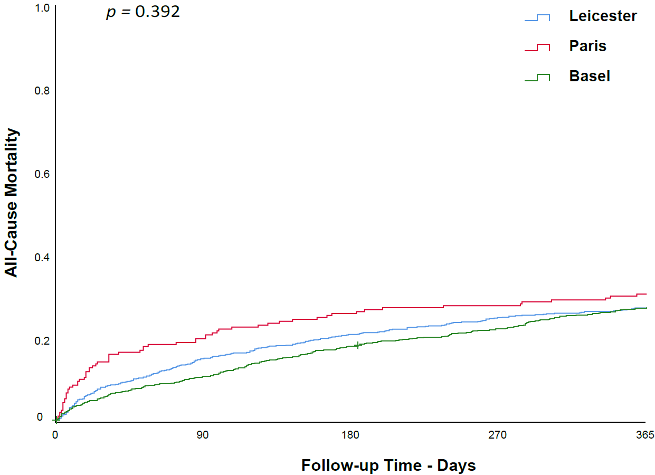

Supplemental Figure 3. Patients’ all-cause mortality or AHF rehospitalisations according to study site (n = 1,671).
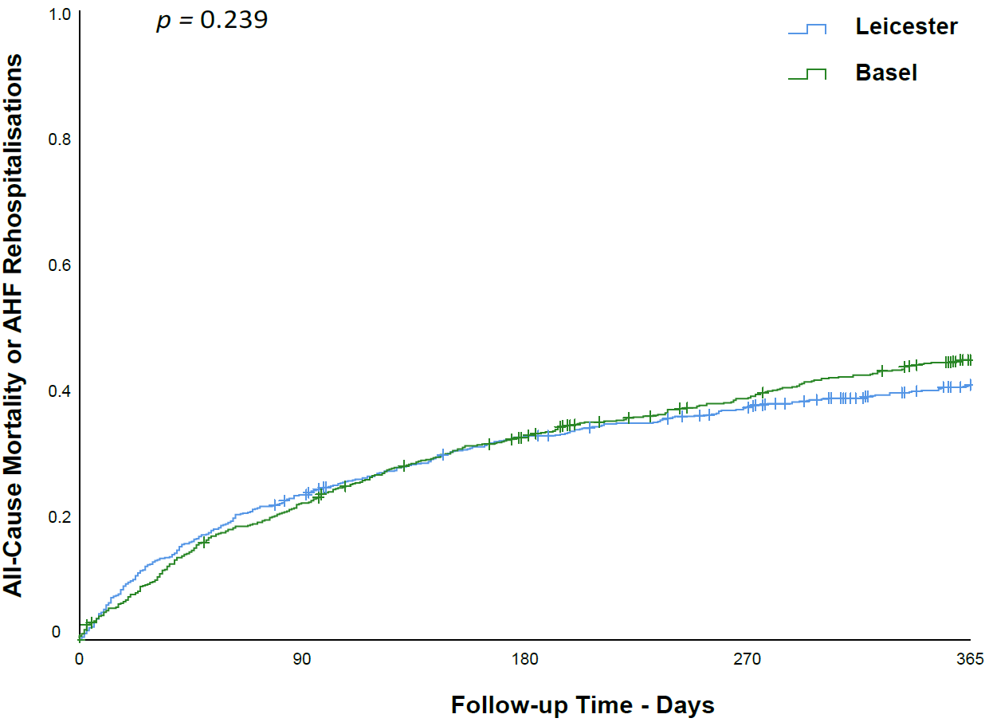
AHF: Acute heart failure.

Supplemental Figure 4. All-cause mortality and AHF hospitalizations stratified according to bio-ADM concentration and the use of diuretics at discharge: A) Values at admission (n = 1,629). B) Values at discharge (n = 997).
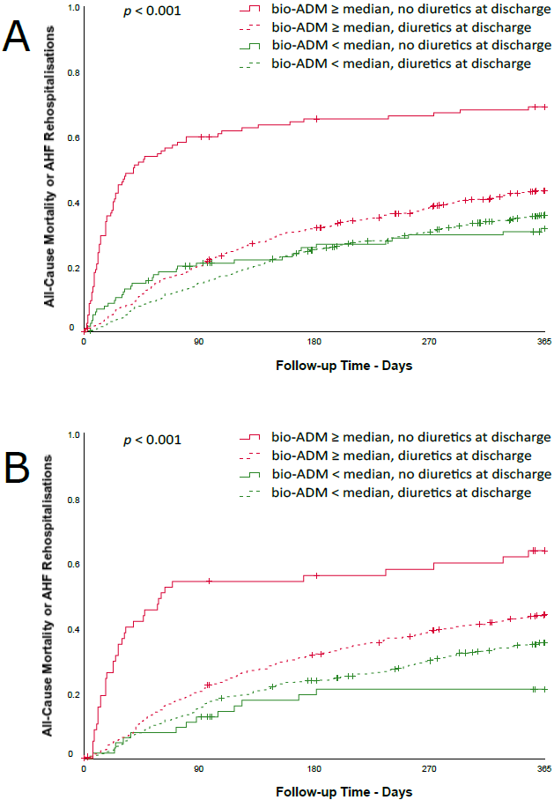
AHF: Acute heart failure. bio-ADM: bioactive adrenomedullin.

Supplemental Figure 5. All-cause mortality and AHF hospitalizations stratified according to MR-proADM concentration and the use of diuretics at discharge: A) Values at admission (n = 721). B) Values at discharge (n = 438).
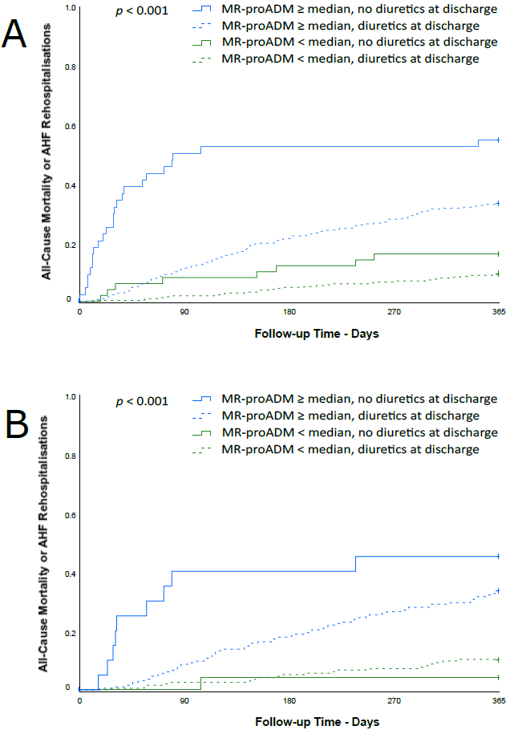
AHF: Acute heart failure. MR-proADM: midregional proadrenomedullin.

Supplemental Figure 6. Time dependent ROC curves describing the prognostic performance of admission bio-ADM and MR-proADM to predict all-cause mortality or AHF hospitalizations during 365-day follow-up (n= 747).
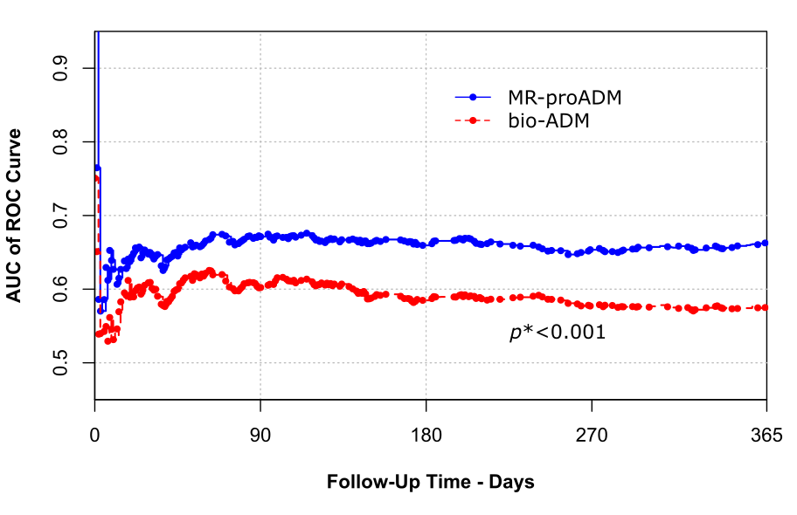

* at 90, 180, and 365 days
AHF: Acute heart failure. AUC of ROC curve: area under the time dependent receiver operating characteristic curve. bio-ADM: bioactive adrenomedullin. MR-proADM: midregional proadrenomedullin.

Supplemental Figure 7. Mortality according to bio-ADM and MR-proADM concentrations at presentation and acute ward discharge. A Values at admission, B Values at discharge. Bio-ADM levels were available for 1,886 patients at admission and 1,001 patients at acute ward discharge. MR-proADM levels were available for 764 patients at admission and 440 patients at acute ward discharge.

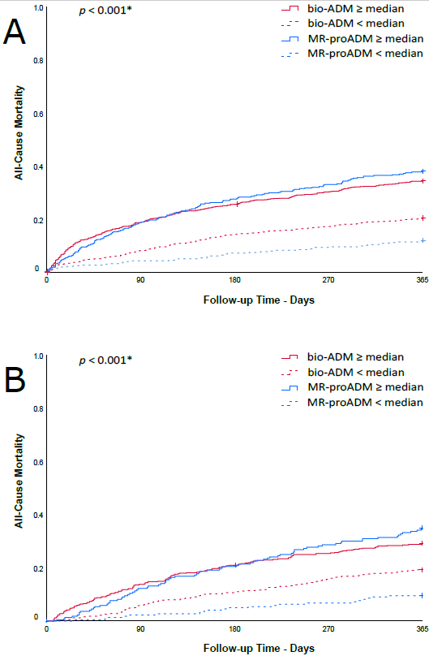
* for bio-ADM and also MR-proADM
bio-ADM: bioactive adrenomedullin. MR-proADM: midregional proadrenomedullin.
Supplemental Figure 8. Time dependent ROC curves describing the prognostic performance of admission bio-ADM, the OPTIMIZE-HF risk score, and their combination* to predict all-cause mortality during 365-day follow-up (n = 1,706).
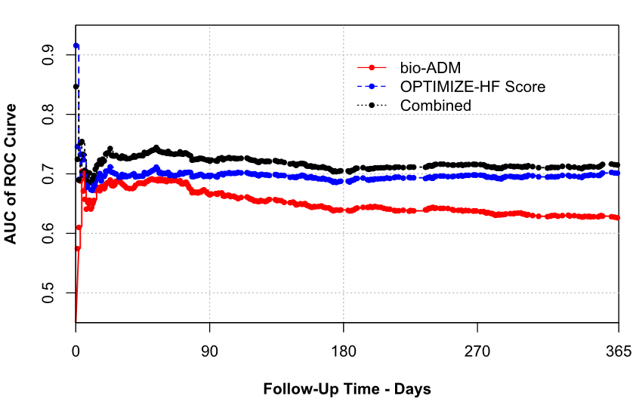

* There was a significant improvement of the prognostic accuracy of the OPTIMIZE-HF risk score when combining it with bio-ADM throughout 90 days follow-up (p-value < 0.001 at 90 as well as at 60 days follow-up).
AUC of ROC curve: area under the time dependent receiver operating characteristic curve. bio-ADM: bioactive adrenomedullin.

Supplemental Figure 9. Time dependent ROC curves describing the prognostic performance of admission MR-proADM, the OPTIMIZE-HF risk score, and their combination* to predict all-cause mortality during 365-day follow-up (n = 725).

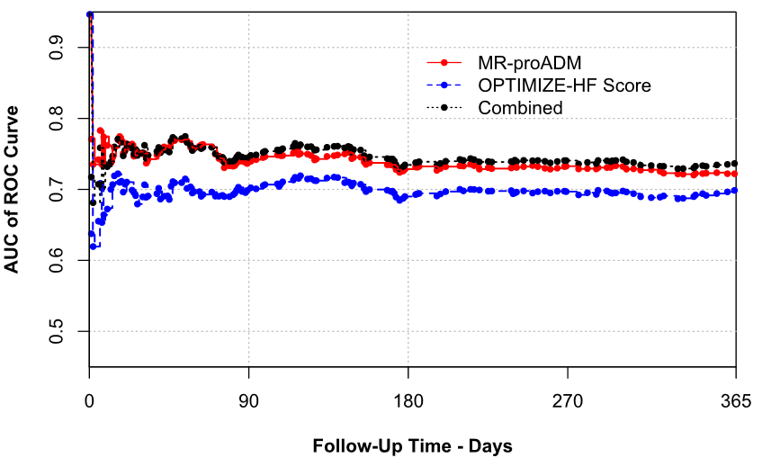
* There was a significant improvement of the prognostic accuracy of the OPTIMIZE-HF risk score when combining it with MR-proADM throughout 90 days follow-up (p-value = 0.006 at 90 days and < 0.001 at 60 follow-up).
AUC of ROC curve: area under the time dependent receiver operating characteristic curve. MR-proADM: midregional proadrenomedullin.

Supplemental Figure 10. All-cause mortality according to study site after excluding patients receiving palliative care (n = 1,876).
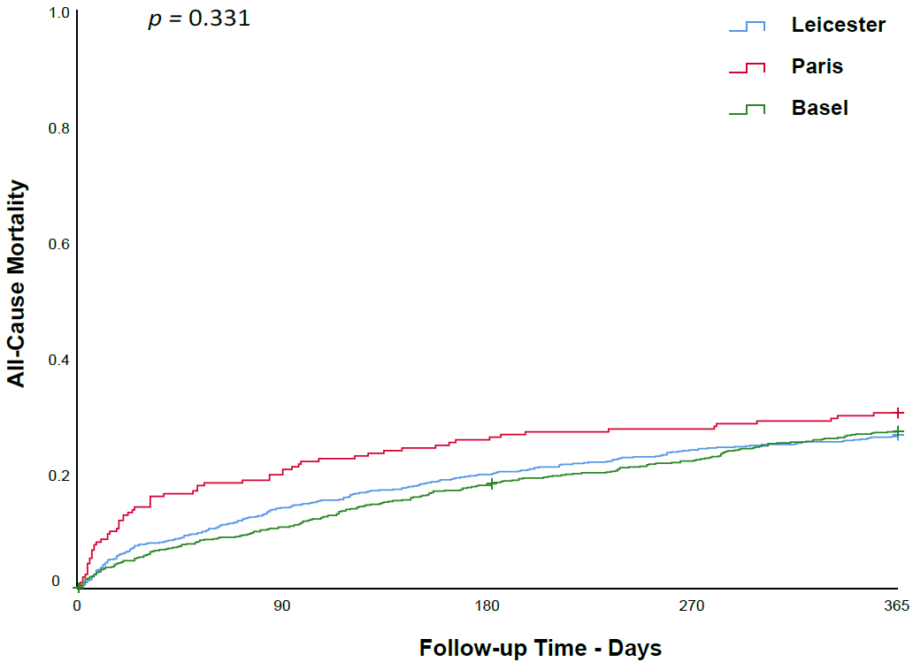

Supplemental Figure 11. All-cause mortality and/or AHF hospitalizations according to study site after excluding patients receiving palliative care (n = 1,661).
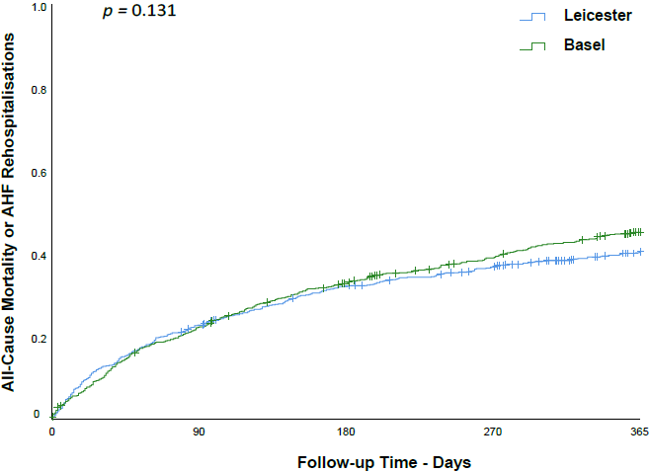
AHF: Acute heart failure.

Supplemental Figure 12. All-cause mortality stratified according to bio-ADM concentration and the use of diuretics at discharge after excluding patients receiving palliative care: A) bio-ADM at presentation (n = 1,834); B) MR-proADM at presentation (n = 732); C) bio-ADM at discharge (n = 987); D) MR-proADM at discharge (n = 433).
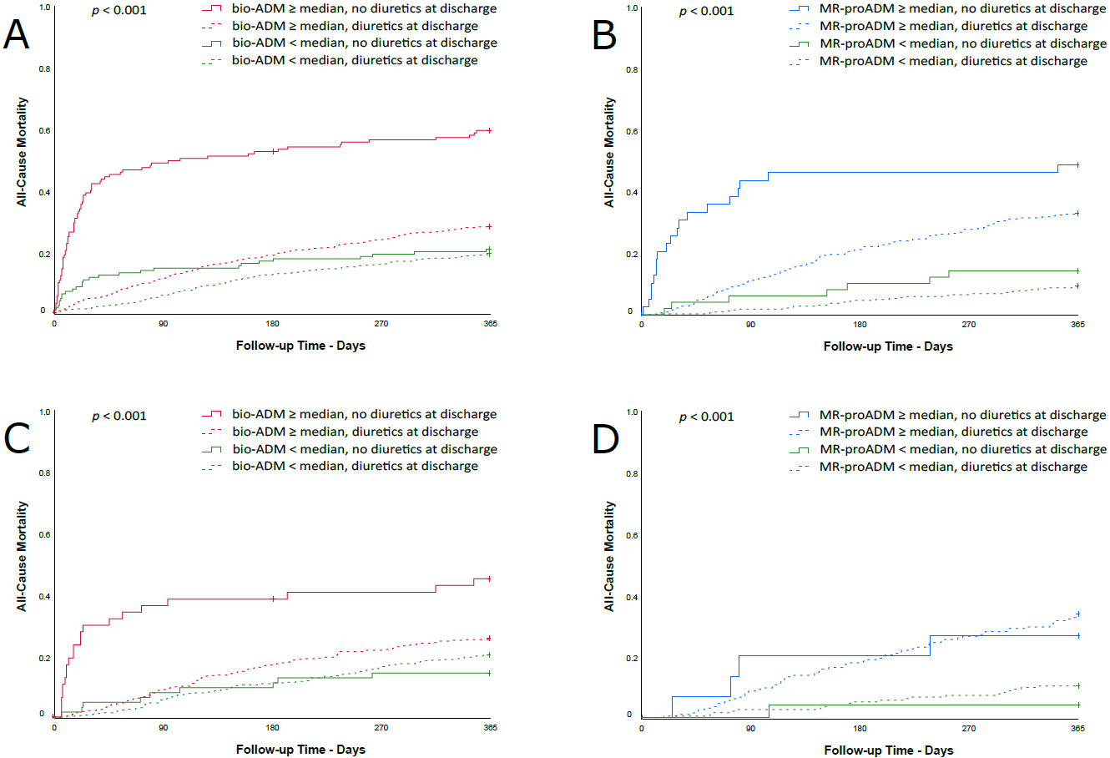
bio-ADM: bioactive adrenomedullin. MR-proADM: midregional proadrenomedullin.
Supplemental Figure 13. All-cause mortality and AHF hospitalizations stratified according to bio-ADM concentration and the use of diuretics at discharge after excluding patients receiving palliative care: A) bio-ADM at presentation (n = 1,619); B) MR-proADM at presentation (n = 715); C) bio-ADM at discharge (n = 987); D) MR-proADM at discharge (n = 433).
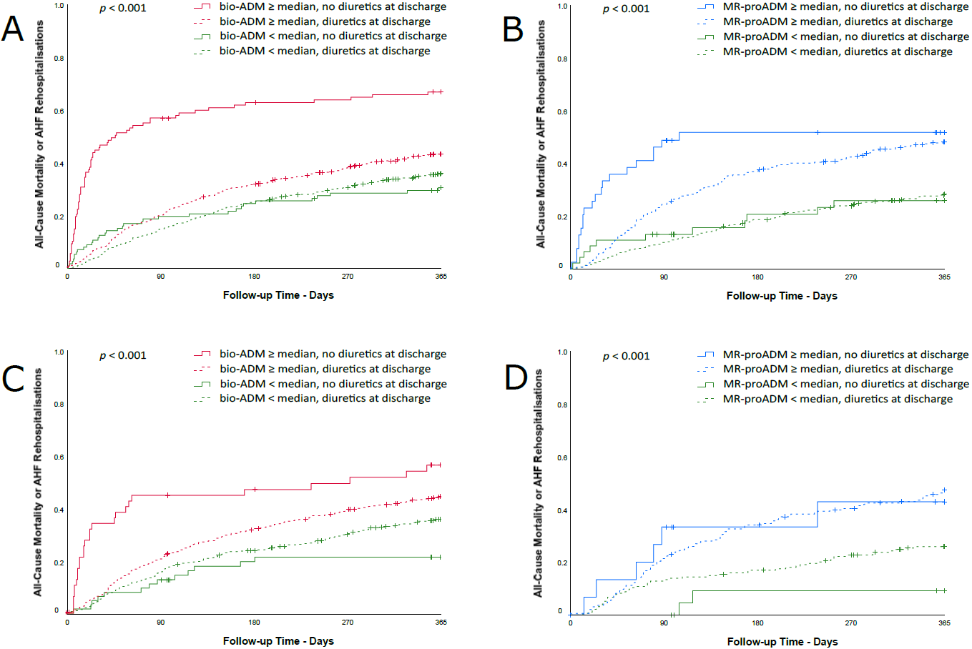

AHF: Acute heart failure. bio-ADM: bioactive adrenomedullin. MR-proADM: midregional proadrenomedullin.
Supplemental Figure 14. Time dependent ROC curves describing the prognostic performance of admission bio-ADM and MR-proADM to predict all-cause mortality during 365-day follow-up (n = 758) after excluding patients receiving palliative care.
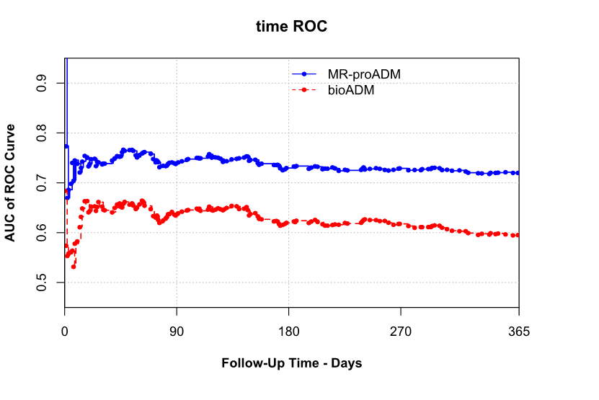

AUC of ROC curve: area under the time dependent receiver operating characteristic curve. bio-ADM: bioactive adrenomedullin. MR-proADM: midregional proadrenomedullin.
Supplemental Figure 15. Time dependent ROC curves describing the prognostic performance of admission bio-ADM and MR-proADM to predict all-cause mortality or AHF hospitalizations during 365-day follow-up after excluding patients receiving palliative care (n=741).
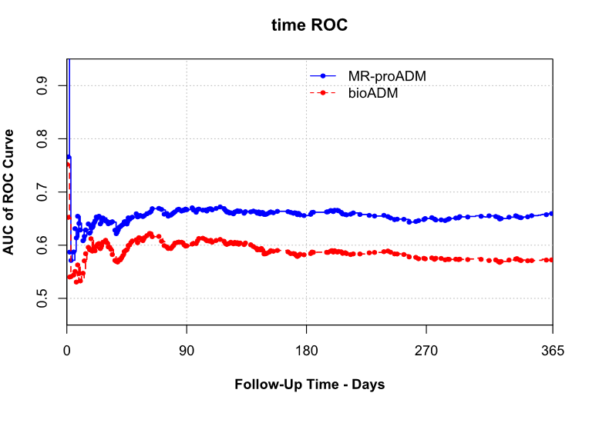
AHF: Acute heart failure. AUC of ROC curve: area under the time dependent receiver operating characteristic curve. bio-ADM: bioactive adrenomedullin. MR-proADM: midregional proadrenomedullin.

Supplemental Figure 16. All-cause mortality according to bio-ADM and MR-proADM concentrations at presentation and discharge after excluding patients receiving palliative care. A) Values at admission, B) Values at discharge. Bio-ADM levels were available for 1,876 patients at admission and 991 patients at discharge. MR-proADM levels were available for 758 patients at admission and 435 patients at discharge.

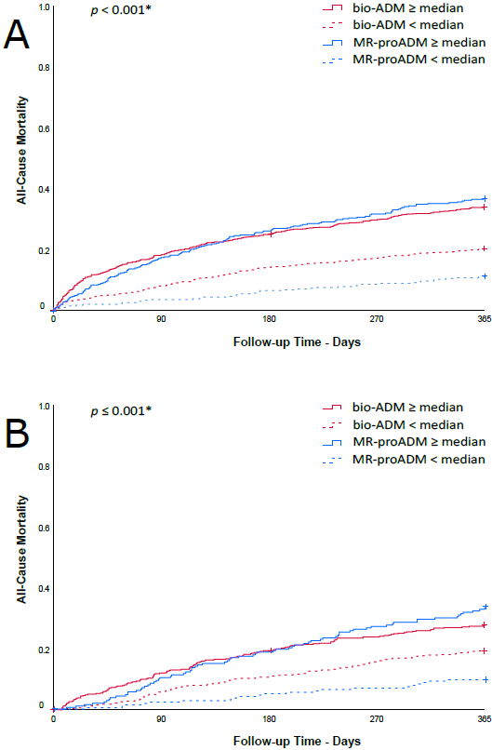
* for the comparison between bio-ADM groups; for the comparison of MR-proADM groups, the p-value was <0.001 in both A) and B)
bio-ADM: bioactive adrenomedullin. MR-proADM: midregional proadrenomedullin.

