Additional files
Supplementary Table 1 CMR measurements stratified per subgroup

Uncorrected automated data

 | ARVC patients  (n=37) | At-risk ARVC group (n=66) | Control group  (n=54) | p-value
Manual measurements
Right ventricle
EF | 47.1 ± 9.0**‡ | 55.5 ± 5.9 | 56.2 ± 6.1 | <0.001
SV | 99.0 ± 15.9‡ | 92.7 ± 18.3 | 99.5 ± 23.4 | 0.116
EDV | 218.1 ± 53.2**‡ | 168.6 ± 34.9 | 178.1 ± 41.3 | <0.001
EDVI | 111.6 ± 25.4**‡ | 93.7 ± 14.8 | 92.9 ± 18.5 | <0.001
ESV | 119.1 ± 45.8**‡ | 76.0 ± 20.8 | 78.6 ± 22.6 | <0.001
ESVI | 60.8 ± 22.7**‡ | 42.1 ± 9.9 | 41.1 ± 11.2 | <0.001
Left ventricle
EF | 53.3 ± 5.7**‡ | 56.4 ± 4.4 | 56.7 ± 5.3 | 0.003
SV | 101.0 ± 18.1 | 94.6 ± 18.3 | 101.3 ± 23.1 | 0.133
EDV | 190.5 ± 33.4‡ | 168.6 ± 33.6 | 179.0 ± 38.3 | 0.011
EDVI | 97.5 ± 14.3 | 93.6 ± 12.8 | 93.2 ± 16.0 | 0.322
ESV | 89.6 ± 20.7**‡ | 74.0 ± 18.3 | 77.7 ± 19.0 | 0.001
ESVI | 45.6 ± 8.7**‡ | 41.0 ± 7.9 | 40.5 ± 8.9 | 0.010
Uncorrected automatic measurements
Right ventricle
EF | 49.2 ± 9.0**‡ | 56.9 ± 5.8 | 57.4 ±7.7 | <0.001
SV | 98.5 ± 21.8 | 90.2 ± 20.5 | 97.0 ± 26.6 | 0.139
EDV | 204.7 ± 51.0**‡ | 159.9 ± 35.3 | 169.2 ± 41.9 | <0.001
EDVI | 104.6 ± 24.0**‡ | 88.7 ± 15.1 | 88.0 ± 18.1 | <0.001
ESV | 106.2 ± 39.5**‡ | 69.7 ± 19.4 | 72.3 ± 22.7 | <0.001
ESVI | 54.3 ± 19.5**‡ | 38.6 ± 8.9 | 37.7 ± 11.1 | <0.001
Left ventricle
EF | 55.6 ± 5.7**‡ | 58.7 ± 5.6 | 59.3 ± 5.3 | 0.005
SV | 102.8 ± 17.9 | 95.8 ± 17.0 | 102.6 ± 22.6 | 0.091
EDV | 186.2 ± 32.8‡ | 164.6 ± 32.3 | 173.5 ± 36.9 | 0.010
EDVI | 95.3 ± 14.3 | 91.4± 12.7 | 90.4 ± 15.4 | 0.246
ESV | 83.3 ± 20.0**‡ | 68.8 ± 19.2 | 70.9 ±18.3 | 0.001
ESVI | 42.5 ± 9.0**† | 38.1 ± 8.7 | 36.9 ± 8.5 | 0.009

Significant difference 0.01-0.05 (*) or (**<0.01) between control and ARVC patients
Significant difference 0.01-0.05 (†) or (‡<0.01) between at-risk and ARVC patients

Corrected automated measurements with simulated correction of the most basal slice

 | ARVC patients  (n=37) | At-risk ARVC group (n=66) | Control group  (n=54) | p-value
Manual measurements
Right ventricle
EF | 47.1 ± 9.0**‡ | 55.5 ± 5.9 | 56.2 ± 6.1 | <0.001
SV | 99.0 ± 15.9‡ | 92.7 ± 18.3 | 99.5 ± 23.4 | 0.116
EDV | 218.1 ± 53.2**‡ | 168.6 ± 34.9 | 178.1 ± 41.3 | <0.001
EDVI | 111.6 ± 25.4**‡ | 93.7 ± 14.8 | 92.9 ± 18.5 | <0.001
ESV | 119.1 ± 45.8**‡ | 76.0 ± 20.8 | 78.6 ± 22.6 | <0.001
ESVI | 60.8 ± 22.7**‡ | 42.1 ± 9.9 | 41.1 ± 11.2 | <0.001
Left ventricle
EF | 53.3 ± 5.7**‡ | 56.4 ± 4.4 | 56.7 ± 5.3 | 0.003
SV | 101.0 ± 18.1 | 94.6 ± 18.3 | 101.3 ± 23.1 | 0.133
EDV | 190.5 ± 33.4‡ | 168.6 ± 33.6 | 179.0 ± 38.3 | 0.011
EDVI | 97.5 ± 14.3 | 93.6 ± 12.8 | 93.2 ± 16.0 | 0.322
ESV | 89.6 ± 20.7**‡ | 74.0 ± 18.3 | 77.7 ± 19.0 | 0.001
ESVI | 45.6 ± 8.7**‡ | 41.0 ± 7.9 | 40.5 ± 8.9 | 0.010
Corrected automatic measurements
Right ventricle
EF | 48.3 ± 9.6**‡ | 56.1 ± 6.0 | 57.2 ±7.4 | <0.001
SV | 98.7 ± 20.7 | 91.6 ± 21.0 | 99.0 ± 27.3 | 0.159
EDV | 210.1 ± 50.5**‡ | 164.1 ± 35.5 | 173.2 ± 42.3 | <0.001
EDVI | 107.4± 23.8**‡ | 91.1 ± 14.9 | 90.1 ± 18.5 | <0.001
ESV | 111.4 ± 41.8**‡ | 72.5 ± 19.3 | 74.1 ± 22.2 | <0.001
ESVI | 56.9 ± 20.7**‡ | 40.2 ± 9.0 | 38.8 ± 11.1 | <0.001
Left ventricle
EF | 54.6 ± 5.2**‡ | 57.8 ± 4.9 | 58.1 ± 5.2 | 0.003
SV | 100.7 ± 18.0 | 94.9 ± 18.1 | 101.3 ± 23.7 | 0.173
EDV | 185.4 ± 33.4‡ | 165.1 ± 33.0 | 174.2± 37.5 | 0.018
EDVI | 94.8 ± 14.4 | 91.7 ± 12.9 | 90.7 ± 15.5 | 0.376
ESV | 84.7 ± 19.5**‡ | 70.2 ± 18.2 | 72.9 ±17.6 | 0.001
ESVI | 43.2 ± 8.5**† | 38.9 ± 8.1 | 38.0 ± 8.4 | 0.011

Significant difference 0.01-0.05 (*) or (**<0.01) between control and ARVC patients
Significant difference 0.01-0.05 (†) or (‡<0.01) between at-risk and ARVC patients
Abbreviations as in manuscript

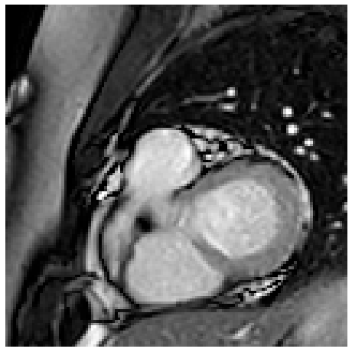 | 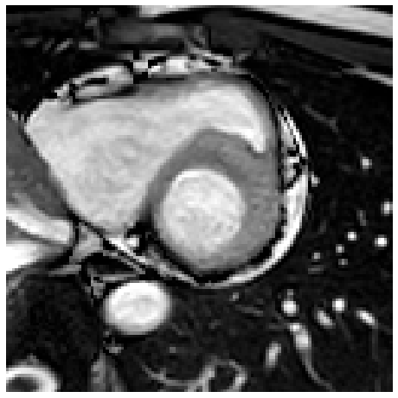 | 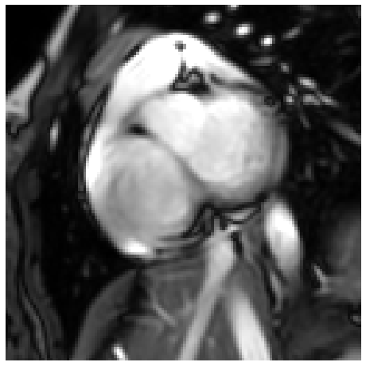 | 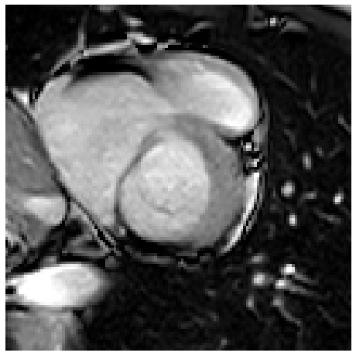
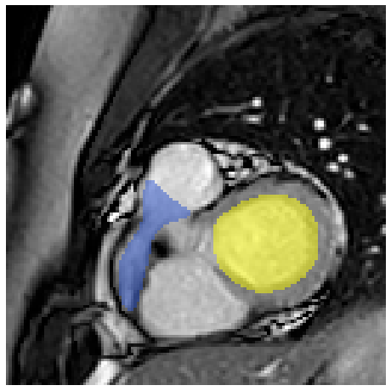 | 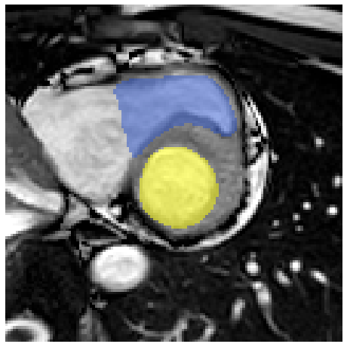 | 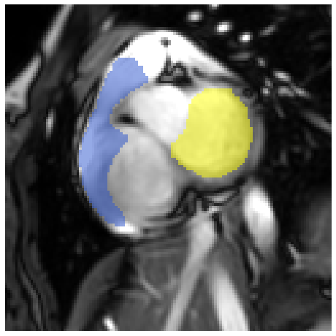 | 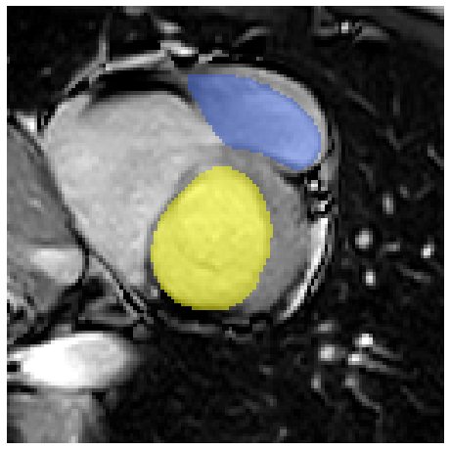

Supplementary Figure 1. Examples illustrating RV shape variability in manual reference segmentations for basal slices.
Shown are original CMR without (top row) and with (bottom row) manual reference segmentations of the left (yellow) and right (blue) ventricle.

Without basal correction | 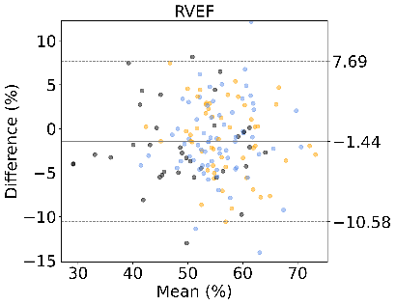 | 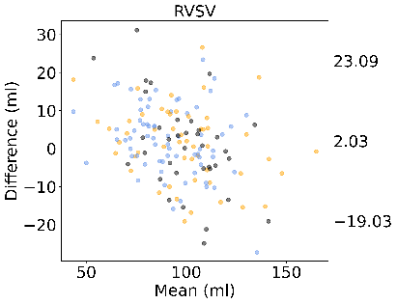 | 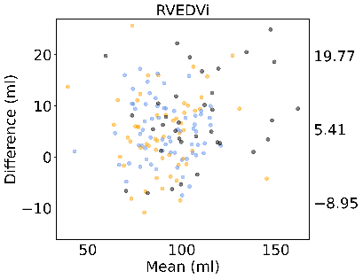 | 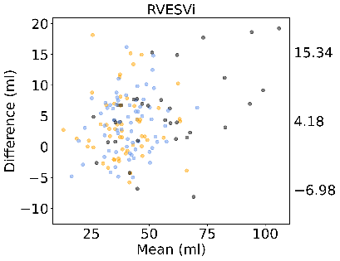
With basal correction | 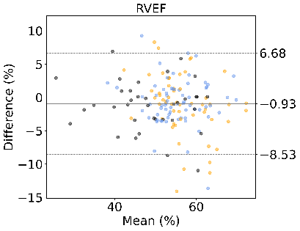 | 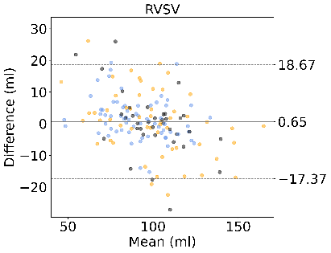 | 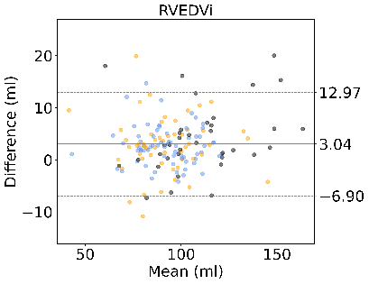 | 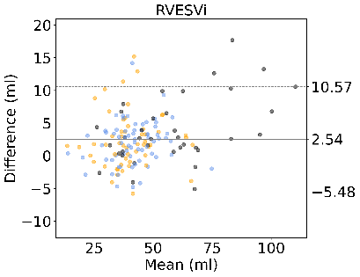

Supplementary Figure 2. Bland-Altman plots of right ventricular CMR measurements
Absolute agreement between: (top row) manuals vs. uncorrected automatic CMR measurements; and (bottom row) manuals vs. automatic+ basal correction CMR measurements. Data points are stratified by disease classification 1) ARVC patients (in black); 2) at-risk family members (in blue) and 3) control subjects (in orange).
Abbreviations as in manuscript.

Without basal correction | 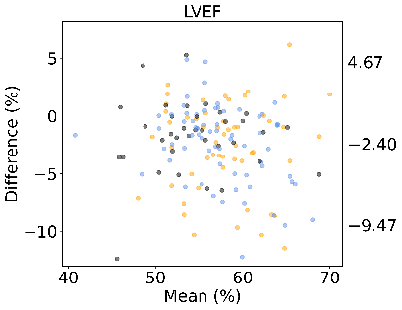 | 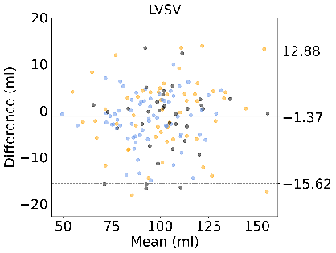 | 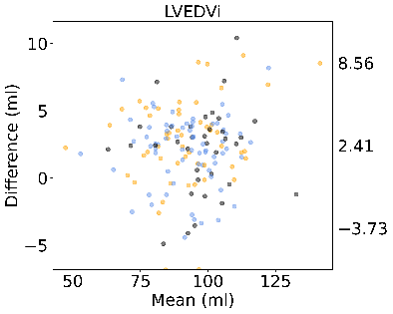 | 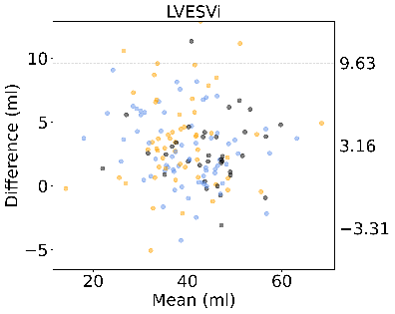
With basal correction | 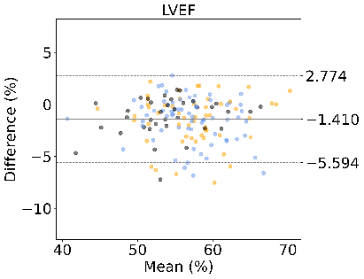 | 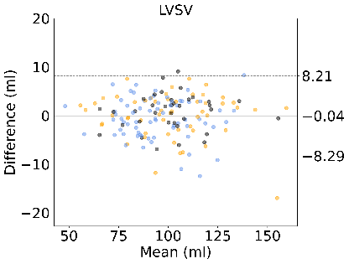 | 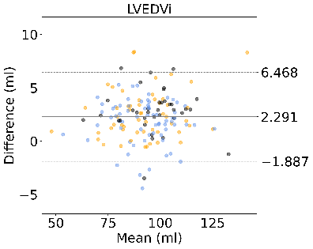 | 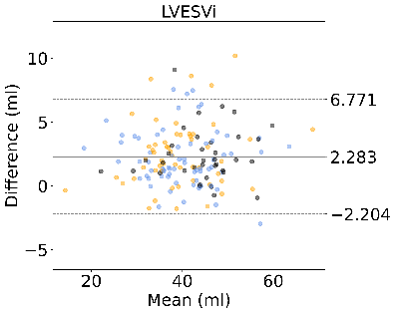

Supplementary Figure 3. Bland-Altman plots of left ventricular CMR measurements
Absolute agreement between: (top row) manuals vs. uncorrected automatic CMR measurements; and (bottom row) manuals vs. automatic + basal correction CMR measurements. Data points are stratified by disease classification 1) ARVC patients (in black); 2) at-risk family members (in blue) and 3) control subjects (in orange).
Abbreviations as in manuscript.

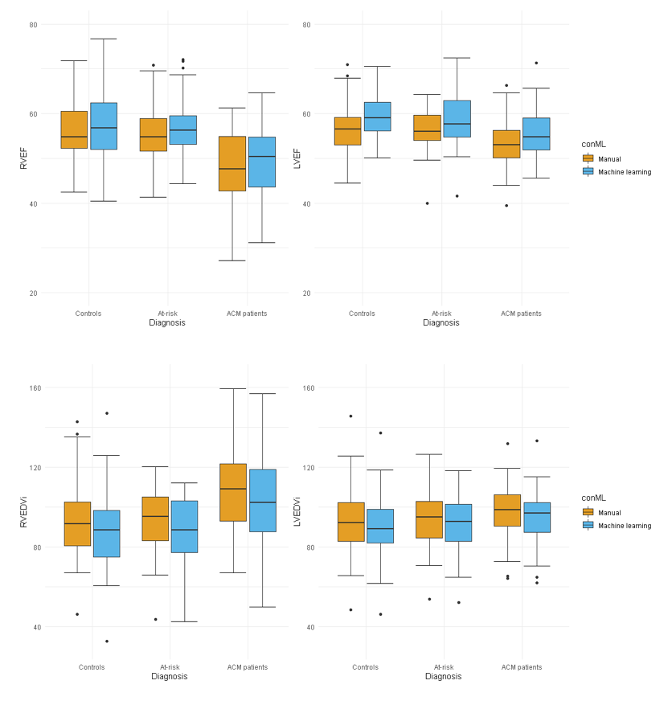
Supplementary Figure 4. Boxplots depicting RV and LV function and dimension.
This data represents the basal uncorrected automatic data. CMR measurements are given for controls, at-risk family members and ARVC patients, stratified per method (manual [orange] vs. automatic [blue]).
Abbreviations: EDVI= end-diastolic volume index; EF= ejection fraction; LV= left ventricle; RV= right ventricle

Supplementary Figure 5. Classification of CMR criteria of TFC (no, minor and major) for manual and uncorrected automatic CMR measurements. The thick blue arrows indicate the matching subjects (between manual and automatic), the thinner blue arrows indicate the number of patients that change CMR classification category when using automated measurements. Cohen’s Kappa between manual and automatic measurements was κ 0.82±0.05. Minor TFC, sensitivity 32% and specificity 100%; major TFC, sensitivity 58% and specificity 99%).
Abbreviations: CMR= cardiovascular magnetic resonance; N= number of subjects; TFC= task force criteria

