Supplementary files

Sensitivity analysis: exact matching without clinical variables
Patients included in the sensitivity analysis were those recorded in the SwedeHF registry who were alive on 1 April 2016, had an LVEF < 50%, and had received at least one dispensation of ARNI or had at least one dispensation of ACEi/ARB between 1 April 2016 and 31 December 2020. Combined treatment with ARNI and ARB was not permitted, nor was sequential use of ARNI followed by ACEi/ARB.
Sensitivity analyses were performed to test the consistency of the data and robustness of the primary analysis. Exact 1:2 matching without clinical variables was performed for each calendar year between 2016 and 2020. This was based on the date of treatment initiation in patients receiving ARNI, and a hypothetical randomly selected month in the same year for those who received ACEi/ARB. Patients selected for the ACEi/ARB group were confirmed alive and receiving medication on day 1 of the hypothetical randomly selected month before the exact matching was performed using the following variables collected at the index registration: sex, age, HF duration (< 6/≥ 6 months), and index year. Patients receiving ARNI were followed from the date of treatment, and those receiving ACEi/ARB from the randomly selected starting month. Both groups were followed up until the studied outcome, death, or 31 December 2020.

Statistics
Continuous variables are presented as mean and standard deviation, or median, minimum, and maximum, and categorical variables as number and percentage. The incidence of all-cause and CV-related mortality was described using crude event rates per 100 person-years with exact Poisson 95% confidence intervals (CIs), hazard ratios (HRs; Cox regression) with 95% CIs, and log-rank test. Analyses stratified by NT-proBNP (≤ median, > median) and by ejection fraction (40–49% [HFmrEF], < 40% [HFrEF]) were performed post hoc on 1:1 matching groups. The proportional hazards assumption was examined by visual review of log(–log(survival)) versus log(follow-up time) curves. Cumulative incidence curves were produced for all study outcomes; for CV mortality and hospitalizations, other death and all-cause death, respectively, were considered to be competing risk.[22] For tests between the ARNI and ACEi/ARB groups with respect to baseline data, Fisher’s exact test was used for dichotomous variables, Mantel–Haenszel chi-square trend test for ordered categorical variables, and Mann–Whitney U-test for continuous variables; tests were two-tailed and evaluated on 0.05 significance level. All analyses were performed using SAS software version 9.4 (SAS Institute Inc., Cary, NC, USA).

Supplementary table S1 Clinical and medical characteristics for patients who received ARNI ±3 months or ACEi/ARB ≤ 3 months from index registration in SwedeHF pre- and post-1:1 propensity score matching

Variable | Pre-matching |  |  | Post-matching (1:1)
Variable | ARNI (n=1506) | ACEi/ARB (n=17,108) | p valueª | ARNI (n=1372) | ACEi/ARB (n=1372) | p valueª
Sex, male, n (%)^{b} | 1186 (78.8) | 11,488 (67.1) | < 0.0001 | 1062 (77.4) | 1089 (79.4) | 0.23
Age at index, years, mean ± SD^{b} | 67.8 ± 12.2 | 72.7 ± 12.0 | < 0.0001 | 68.2 ± 12.2 | 68.6 ± 12.9 | 0.25
HF duration ≥ 6 months, n (%)^{b} | 894 (60.2) | 6273 (38.1) | < 0.0001 | 781 (57.8) | 768 (56.6) | 0.58
Inpatient care, n (%)^{b} | 152 (10.1) | 4355 (25.5) | < 0.0001 | 148 (10.8) | 144 (10.5) | 0.85
Body mass index, kg/m², n (%)^{b} | n=1263 | n=13512 |  | n=1143 | n=1145
< 18.5 | 11 (0.9) | 281 (2.1) | < 0.0001 | 11 (1.0) | 8 (0.7) | 0.81
18.5–25 | 361 (28.6) | 4656 (34.5) | < 0.0001 | 335 (29.4) | 337 (29.4)
> 25–30 | 479 (37.9) | 4999 (37.0) | < 0.0001 | 425 (37.2) | 444 (38.8)
> 30–35 | 267 (21.1) | 2369 (17.5) | < 0.0001 | 243 (21.3) | 226 (19.7)
> 35 | 145 (11.5) | 1207 (8.9) | < 0.0001 | 129 (11.3) | 130 (11.4)
Systolic blood pressure, mmHg, mean ± SD^{c} | n=1340 | n=12,506 |  | n=1211 | n=1201
Systolic blood pressure, mmHg, mean ± SD^{c} | 120.4 ± 18.5 | 128.0 ± 20.7 | < 0.0001 | 121.0 ± 18.5 | 124.8 ± 20.8 | < 0.0001
Diastolic blood pressure, mmHg, mean ± SD^{c} | n=1336 | n=12470 |  | n = 1207 | n = 1193
Diastolic blood pressure, mmHg, mean ± SD^{c} | 73.0 ± 11.5 | 74.9 ± 12.2 | <0.0001 | 73.3 ± 11.5 | 74.9 ± 12.7 | 0.0094
NYHA functional class, n (%)^{b} | n = 1353 | n = 12678 |  | n = 1227 | n = 1230
I | 95 (7.0) | 1653 (13.0) | <0.0001 | 95 (7.7) | 104 (8.5) | 0.52
II | 626 (46.3) | 6595 (52.0) | <0.0001 | 576 (46.9) | 577 (46.9) | 0.52
III | 609 (45.0) | 4258 (33.6) | <0.0001 | 535 (43.6) | 532 (43.3) | 0.52
IV | 23 (1.7) | 172 (1.4) | <0.0001 | 21 (1.7) | 17 (1.4) | 0.52
LVEF, %, n (%)^{b} |  |  | <0.0001 |  |  | 0.72
40–<50 | 130 (8.6) | 6294 (36.8) | <0.0001 | 130 (9.5) | 115 (8.4) | 0.72
30–<40 | 634 (42.1) | 6339 (37.1) | <0.0001 | 590 (43.0) | 632 (46.1) | 0.72
<30 | 742 (49.3) | 4475 (26.2) | <0.0001 | 652 (47.5) | 625 (45.6) | 0.72
NT-proBNP, pg/ml, median (min., max.)^{b} | n = 1252 | n = 13083 | 0.0001 | n = 1134 | n = 1144 | 0.78
NT-proBNP, pg/ml, median (min., max.)^{b} | 1813 (42, 47 052) | 2150 (6, 122 000) |  | 1873 (42, 47 052) | 1867 (19, 122 000)
Comorbidities, n (%)^{b}
No ischaemic aetiology | 663 (55.2) | 7637 (58.9) | 0.014 | 617 (56.6) | 613 (55.4) | 0.61
Hypertension | 1060 (70.4) | 11859 (69.3) | 0.41 | 973 (70.9) | 960 (70.0) | 0.62
Atrial fibrillation | 769 (51.1) | 9001 (52.6) | 0.26 | 709 (51.7) | 700 (51.0) | 0.76
COPD | 223 (14.8) | 3029 (17.7) | 0.0044 | 214 (15.6) | 214 (15.6) | 1.00
Diabetes mellitus | 495 (32.9) | 4261 (24.9) | <0.0001 | 450 (32.8) | 436 (31.8) | 0.60
Blood diseases | 279 (18.5) | 3449 (20.2) | 0.14 | 251 (18.3) | 246 (17.9) | 0.84
Stroke/TIA | 225 (14.9) | 2266 (13.2) | 0.073 | 200 (14.6) | 191 (13.9) | 0.66
Psychiatric diagnoses^{d} | 171 (11.4) | 2396 (14.0) | 0.0040 | 162 (11.8) | 164 (12.0) | 0.95
Musculoskeletal diseases^{d} | 205 (13.5) | 2951 (17.2) | 0.0003 | 191 (13.9) | 205 (14.9) | 0.48
Malignant cancer^{d} | 136 (9.0) | 1950 (11.4) | 0.0049 | 129 (9.4) | 126 (9.2) | 0.90
Treatments, n (%)
Beta blockers | 1426 (99.2) | 15,512 (97.4) | < 0.0001 | 1301 (99.2) | 1285 (99.2) | 1.00
Diuretics | 1072 (72.8) | 10,310 (68.0) | 0.0002 | 978 (73.0) | 992 (73.9) | 0.66
Mineralocorticoid receptor antagonists^{b} | 1055 (70.1) | 6521 (38.2) | <0.0001 | 932 (68.0) | 935 (68.2) | 0.96
Implantable cardiovascular device^{b} | 353 (23.5) | 816 (4.8) | < 0.0001 | 246 (18.0) | 227 (16.6) | 0.36
Cardiac resynchronization therapy^{b} | 208 (13.8) | 575 (3.4) | < 0.0001 | 150 (10.9) | 160 (11.7) | 0.59
ACEi/ARB prior to 3 months before index date, n (%) | 1150 (76.4) | 9415 (55.0) | < 0.0001 | 1028 (74.9) | 918 (66.9) | < 0.0001
Time from index date to initiation of ARNI, years, median (min., max.) | –0.04  (–0.25, 0.24) | N/A |  | –0.04  (–0.25, 0.24) | N/A
ACEi, angiotensin-converting enzyme inhibitor; ARB, angiotensin receptor blockers; ARNI, angiotensin receptor–neprilysin inhibitor; COPD, chronic obstructive pulmonary disease; HF, heart failure; LVEF, left ventricular ejection fraction; max., maximum; min., minimum; N/A, not applicable; NT-proBNP, N-terminal pro B-type natriuretic peptide; NYHA, New York Heart Association; SD, standard deviation; SwedeHF, Swedish Heart Failure Registry; TIA, transient ischaemic attack.
ªFor comparison between groups, Fisher’s Exact test (lowest one-sided p value multiplied by 2) was used for dichotomous variables, the Mantel–Haenszel Chi-square test was used for ordered categorical variables, and the Mann–Whitney U-test was used for continuous variables.
^{b}Variable used in matching.
^{c}Outpatients only.
^{d}In the 3 years before admission.

Supplementary Table S2 Clinical and medical characteristics for patients who received ARNI ±3 months or ACEi/ARB ≤3 months from index registration in SwedeHF following 1:2 and 1:3 propensity score matching for sensitivity analysis.
Variable | 1:2 matching |  |  | 1:3 matching
Variable | ARNI (n = 1238) | ACEi/ARB (n = 2476) | P valueª | ARNI (n = 1112) | ACEi/ARB (n = 3336) | P valueª
Sex, male, n (%) | 943 (76.2) | 1883 (76.1) | 0.97 | 842 (75.7) | 2553 (76.5) | 0.61
Age at index, years, mean ± SD | 68.8 ± 12.0 | 68.8 ± 13.1 | 0.59 | 69.0 ± 12.1 | 69.4 ± 12.8 | 0.24
Inpatient care, n (%) | 144 (11.6) | 293 (11.8) | 0.90 | 138 (12.4) | 395 (11.8) | 0.65
HF duration ≥6 months, n (%) | 670 (55.1) | 1316 (54.1) | 0.62 | 577 (52.8) | 1695 (51.7) | 0.54
Body mass index, kg/m², n, (%) | n = 1029 | n = 2057 |  | n = 924 | n = 2759
<18.5 | 11 (1.1) | 21 (1.0) | 0.42 | 11 (1.2) | 31 (1.1) | 0.85
18.5–25 | 308 (29.9) | 638 (31.0) | 0.42 | 281 (30.4) | 830 (30.1) | 0.85
>25–30 | 388 (37.7) | 782 (38.0) | 0.42 | 350 (37.9) | 1052 (38.1) | 0.85
>30–35 | 216 (21.0) | 418 (20.3) | 0.42 | 188 (20.3) | 563 (20.4) | 0.85
>35 | 106 (10.3) | 198 (9.6) | 0.42 | 94 (10.2) | 283 (10.3) | 0.85
Systolic blood pressure, mmHg, mean ± SD^{b} | n = 1082 | n = 2139 |  | n = 963 | n = 2893
Systolic blood pressure, mmHg, mean ± SD^{b} | 121.3 ± 18.7 | 125.4 ± 20.8 | <0.0001 | 121.4 ± 18.6 | 125.0 ± 20.6 | <0.0001
Diastolic blood pressure, mmHg, mean ± SD^{b} | n = 1079 | n = 2128 |  | n = 961 | n = 2879
Diastolic blood pressure, mmHg, mean ± SD^{b} | 73.3 ± 11.5 | 75.1 ± 12.2 | <0.0001 | 73.2 ± 11.5 | 74.9 ± 12.6 | 0.0004
NYHA functional class, n (%) | n = 1095 | n = 2186 |  | n = 980 | n = 2933
I | 91 (8.3) | 171 (7.8) | 0.99 | 85 (8.7) | 219 (7.5) | 0.95
II | 512 (46.8) | 1045 (47.8) | 0.99 | 455 (46.4) | 1428 (48.7) | 0.95
III | 475 (43.4) | 935 (42.8) | 0.99 | 421 (43.0) | 1238 (42.2) | 0.95
IV | 17 (1.6) | 35 (1.6) | 0.99 | 19 (1.9) | 48 (1.6) | 0.95
LVEF, n (%)
40–<50 | 129 (10.4) | 244 (9.9) | 0.97 | 125 (11.2) | 339 (10.2) | 0.56
30–<40 | 541 (43.7) | 1112 (44.9) | 0.97 | 488 (43.9) | 1492 (44.7) | 0.56
<30 | 568 (45.9) | 1120 (45.2) | 0.97 | 499 (44.9) | 1505 (45.1) | 0.56
NT-proBNP, pg/ml, median (95 CI) | n = 1023 | n = 2066 |  | n = 920 | n = 2749
NT-proBNP, pg/ml, median (95 CI) | 1940 (42–47 052) | 2049 (14–122 000) |  | 1973 (42–47 052) | 2066 (19– 122 000)
Comorbidities, n (%)
No ischaemic aetiology | 561 (57.0) | 1171 (59.7) | 0.17 | 511 (57.9) | 1489 (57.1) | 0.68
Hypertension | 877 (70.8) | 1742 (70.4) | 0.79 | 777 (69.9) | 2345 (70.3) | 0.82
Atrial fibrillation | 648 (52.3) | 1279 (51.7) | 0.72 | 581 (52.2) | 1744 (52.3) | 1.00
COPD | 203 (16.4) | 364 (14.7) | 0.19 | 176 (15.8) | 495 (14.8) | 0.45
Diabetes mellitus | 395 (31.9) | 767 (31.0) | 0.59 | 342 (30.8) | 1000 (30.0) | 0.65
Blood diseases | 230 (18.6) | 472 (19.1) | 0.76 | 210 (18.9) | 627 (18.8) | 0.98
Stroke/TIA | 182 (14.7) | 358 (14.5) | 0.88 | 156 (14.0) | 456 (13.7) | 0.80
Psychiatric diagnoses^{c} | 142 (11.5) | 297 (12.0) | 0.68 | 140 (12.6) | 387 (11.6) | 0.41
Musculoskeletal diseases^{c} | 179 (14.5) | 360 (14.5) | 0.99 | 164 (14.7) | 470 (14.1) | 0.62
Malignant cancer^{c} | 121 (9.8) | 240 (9.7) | 0.98 | 114 (10.3) | 336 (10.1) | 0.90
Treatments
Beta blockers | 1175 (99.1) | 2333 (99.3) | 0.64 | 1051 (99.1) | 3139 (99.2) | 0.68
Diuretics | 881 (73.1) | 1770 (73.2) | 1.00 | 788 (73.0) | 2371 (72.9) | 0.95
Mineralocorticoid receptor antagonists | 812 (65.7) | 1645 (66.6) | 0.61 | 706 (63.6) | 2121 (63.7) | 1.00
Implantable cardiovascular device | 184 (14.9) | 351 (14.2) | 0.60 | 144 (13.0) | 398 (12.0) | 0.40
Cardiac resynchronization therapy | 115 (9.3) | 227 (9.2) | 0.94 | 98 (8.8) | 271 (8.1) | 0.51
ACEi, angiotensin-converting enzyme inhibitor; ARB, angiotensin receptor blockers; ARNI, angiotensin receptor–neprilysin inhibitor; bpm, beats per minute; CI, confidence interval; COPD, chronic obstructive pulmonary disease; HF, heart failure; LVEF, left ventricular ejection fraction; NT-proBNP, N-terminal pro B-type natriuretic peptide; NYHA, New York Heart Association; SD, standard deviation; TIA, transient ischaemic attack.
ªFor comparison between groups, Fisher’s Exact test (lowest 1-sided P value multiplied by 2) was used for dichotomous variables, the Mantel–Haenszel Chi-square test was used for ordered categorical variables, and the Mann–Whitney U-test was used for continuous variables.
^{b}Outpatients only.
^{c}In the 3 years before admission.

Supplementary Table S3 Sensitivity analyses, real-world all-cause and cardiovascular-related mortality, and all-cause and cardiovascular-related hospitalization using ARNI:ACEi/ARB ratios 1:2, and 1:3 in propensity score matching including clinical variables and using 1:2 exact matching without clinical variables
Endpoint | ARNI |  |  | ACEi/ARB |  |  | ARNI vs ACEi/ARB
Endpoint | Duration of follow-up, years, median (IQR) | Events, n/N (%) | Event rate per 100-person-years (95% CI) | Duration of follow-up, years, median (IQR) | Events, n/N (%) | Event rate per 100-person-years (95% CI) | HR (95% CI) | P-value
All-cause mortality
1:2 PS matched | 1.5 (0.8–2.3) | 151/1238 (12.2) | 7.4 (6.3–8.7) | 1.4 (0.8–2.3) | 367/2476 (14.8) | 9.2 (8.3–10.2) | 0.80 (0.67–0.97) | 0.024
1:3 PS matched | 1.5 (0.8–2.4) | 136/1112 (12.2) | 7.4 (6.2–8.7) | 1.5 (0.8–2.3) | 500/3336 (15.0) | 9.2 (8.4–10.0) | 0.80 (0.67–0.97) | 0.024
Exact matching (1:2) | 1.5 (0.8–2.3) | 619/4791 (12.9) | 8.0 (7.4–8.6) | 1.5 (0.7, 2.4) | 1389/9582 (14.5) | 8.9 (8.4–9.4) | 0.90 (0.82–0.99) | 0.026
Cardiovascular-related mortality
1:2 PS matched | 1.5 (0.8–2.3) | 55/1238 (4.4) | 2.7 (2.0–3.5) | 1.4 (0.8–2.3) | 133/2476 (5.4) | 3.3 (2.8–4.0) | 0.81 (0.59–1.11) | 0.19
1:3 PS matched | 1.5 (0.8–2.4) | 52/1112 (4.7) | 2.8 (2.1–3.7) | 1.5 (0.8–2.3) | 185/3336 (5.5) | 3.4 (2.9–3.9) | 0.83 (0.61–1.13) | 0.25
Exact matching (1:2) | 1.5 (0.8–2.3) | 234/4791 (4.9) | 3.0 (2.6–3.4) | 1.5 (0.7–2.4) | 452/9582 (4.7%) | 2.9 (2.6–3.2) | 1.04 (0.89–1.22) | 0.63
All-cause hospitalization
1:2 PS matched | 0.7 (0.3–1.5) | 622/1238 (50.2) | 49.6 (45.8–53.6) | 0.8 (0.3–1.6) | 1183/2476 (47.8) | 46.5 (43.9–49.2) | 1.05 (0.96–1.16) | 0.29
1:3 PS matched | 0.8 (0.3–1.5) | 564/1112 (50.7) | 49.9 (45.8–54.2) | 0.8 (0.2–1.6) | 1626/3336 (48.7) | 47.6 (45.3–49.9) | 1.04 (0.94–1.14) | 0.47
Cardiovascular-related hospitalization
1:2 PS matched | 0.8 (0.3–1.6) | 594/1238 (48.0) | 45.9 (42.2–49.7) | 0.8 (0.3–1.6) | 1126/2476 (45.5) | 42.9 (40.4–45.5) | 1.06 (0.96–1.17) | 0.27
1:3 PS matched | 0.8 (0.3–1.5) | 542/1112 (48.7) | 46.6 (42.8–50.7) | 0.8 (0.3–1.6) | 1567/3336 (47.0) | 44.7 (42.5–47.0) | 1.03 (0.94–1.14) | 0.51
ACEi, angiotensin-converting enzyme inhibitor; ARB, angiotensin receptor blockers; ARNI, angiotensin receptor–neprilysin inhibitor; CI, confidence interval; HR, hazard ratio; IQR, interquartile range; PS, propensity score.

Supplementary Table S4 Patient baseline characteristics for the cohort used in exact 1:2 matching without clinical variables
Variable | ARNI  (n = 4791) | ACEi/ARB  (n = 9582) | P value
Sex, male, n (%) | 3815 (79.6) | 7630 (79.6) | 1.00
Age at index, years, mean ± SD | 68.8 ± 9.9 | 68.8 ± 9.9 | 0.94
HF duration ≥6 months, n (%) | 2227 (46.5) | 4454 (46.5) | 1.00
Index year, n (%)
2004 | 7 (0.1) | 14 (0.1) | 1.00
2005 | 17 (0.4) | 34 (0.4) | 1.00
2006 | 45 (0.9) | 90 (0.9) | 1.00
2007 | 62 (1.3) | 124 (1.3) | 1.00
2008 | 96 (2.0) | 192 (2.0) | 1.00
2009 | 103 (2.1) | 206 (2.1) | 1.00
2010 | 98 (2.0) | 196 (2.0) | 1.00
2011 | 133 (2.8) | 266 (2.8) | 1.00
2012 | 146 (3.0) | 292 (3.0) | 1.00
2013 | 143 (3.0) | 286 (3.0) | 1.00
2014 | 194 (4.0) | 388 (4.0) | 1.00
2015 | 186 (3.9) | 372 (3.9) | 1.00
2016 | 374 (7.8) | 748 (7.8) | 1.00
2017 | 697 (14.5) | 1394 (14.5) | 1.00
2018 | 883 (18.4) | 1766 (18.4) | 1.00
2019 | 1006 (21.0) | 2012 (21.0) | 1.00
2020 | 601 (12.5) | 1202 (12.5) | 1.00
For categorical variables, n (%) is presented. For comparison between groups, Fisher’s Exact test (lowest 1-sided P value multiplied by 2) was used for dichotomous variables, the Mantel–Haenszel Chi-square test was used for ordered categorical variables, and the Mann–Whitney U-test was used for continuous variables.
ACEi, angiotensin-converting enzyme inhibitor; ARB, angiotensin receptor blockers; ARNI, angiotensin receptor–neprilysin inhibitor; HF, heart failure; SD, standard deviation.

Supplementary Table S5 STROBE checklist for the reporting of observational studies
 | Item | Recommendation | Page number(s)
Title and abstract | 1 | (a) Indicate the study’s design with a commonly used term in the title or the abstract | 1
Title and abstract | 1 | (b) Provide in the abstract an informative and balanced summary of what was done and what was found | 2–3
Introduction
Background/rationale | 2 | Explain the scientific background and rationale for the investigation being reported | 5–7
Objectives | 3 | State specific objectives, including any prespecified hypotheses | 6–7
Methods
Study design | 4 | Present key elements of study design early in the paper | 7
Setting | 5 | Describe the setting, locations, and relevant dates, including periods of recruitment, exposure, follow-up, and data collection | 7–9
Participants | 6 | (a) Give the eligibility criteria, and the sources and methods of selection of participants. Describe methods of follow-up | 7–9
Participants | 6 | (b) For matched studies, give matching criteria and number of exposed and unexposed | 8–9
Variables | 7 | Clearly define all outcomes, exposures, predictors, potential confounders, and effect modifiers. Give diagnostic criteria, if applicable | 8–9
Data sources/ measurement | 8* | For each variable of interest, give sources of data and details of methods of assessment (measurement). Describe comparability of assessment methods if there is more than one group | 7–10
Bias | 9 | Describe any efforts to address potential sources of bias | 7–10
Study size | 10 | Explain how the study size was arrived at | 8–9
Quantitative variables | 11 | Explain how quantitative variables were handled in the analyses. If applicable, describe which groupings were chosen and why | 8–9
Statistical methods | 12 | (a) Describe all statistical methods, including those used to control for confounding | 10
Statistical methods | 12 | (b) Describe any methods used to examine subgroups and interactions | 10
Statistical methods | 12 | (c) Explain how missing data were addressed | 8–9
Statistical methods | 12 | (d) If applicable, explain how loss to follow-up was addressed | N/A
Statistical methods | 12 | (e) Describe any sensitivity analyses | 9
Results
Participants | 13ª | (a) Report numbers of individuals at each stage of study—e.g. numbers potentially eligible, examined for eligibility, confirmed eligible, included in the study, completing follow-up, and analysed | 11  Figure 1  Supplementary figure S1
Participants | 13ª | (b) Give reasons for non-participation at each stage | 11  Figure 1  Supplementary figure S1
Participants | 13ª | (c) Consider use of a flow diagram | Figure 1  Supplementary figure S1
Descriptive data | 14ª | (a) Give characteristics of study participants (e.g. demographic, clinical, social) and information on exposures and potential confounders | 11–13
Descriptive data | 14ª | (b) Indicate number of participants with missing data for each variable of interest | Table 1
Descriptive data | 14ª | (c) Summarize follow-up time (e.g. average and total amount) | 12
Outcome data | 15ª | Report numbers of outcome events or summary measures over time | 11–13
Main results | 16 | (a) Give unadjusted estimates and, if applicable, confounder-adjusted estimates and their precision (e.g. 95% confidence interval). Make clear which confounders were adjusted for and why they were included | 13–15  Table 2
Main results | 16 | (b) Report category boundaries when continuous variables were categorized | 13–15  Table 2
Main results | 16 | (c) If relevant, consider translating estimates of relative risk into absolute risk for a meaningful time period | 13–15  Table 2
Other analyses | 17 | Report other analyses done—e.g. analyses of subgroups and interactions, and sensitivity analyses | 14, 15
Discussion
Key results | 18 | Summarize key results with reference to study objectives | 15–17
Limitations | 19 | Discuss limitations of the study, taking into account sources of potential bias or imprecision. Discuss both direction and magnitude of any potential bias | 21
Interpretation | 20 | Give a cautious overall interpretation of results considering objectives, limitations, multiplicity of analyses, results from similar studies, and other relevant evidence | 18–20
Generalizability | 21 | Discuss the generalizability (external validity) of the study results | 18–20
Other information
Funding | 22 | Give the source of funding and the role of the funders for the present study and, if applicable, for the original study on which the present article is based | 22
ªGive information separately for exposed and unexposed groups.
Source: https://www.strobe-statement.org/index.php?id=available-checklists

Supplementary Figure S1 Cumulative incidence estimates with 95% confidence intervals for all-cause mortality for ARNI versus ACEi/ARB groups matched using propensity score matching including clinical variables: (A) 1:2 ratio, (B) 1:3 ratio. ACEi, angiotensin-converting enzyme inhibitor; ARB, angiotensin receptor blockers; ARNI, angiotensin receptor–neprilysin inhibitor.
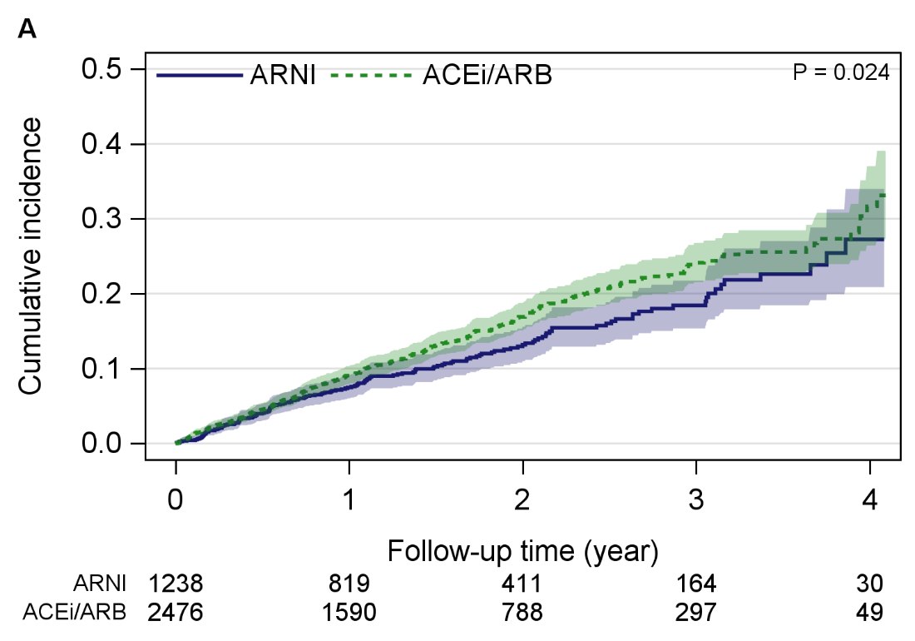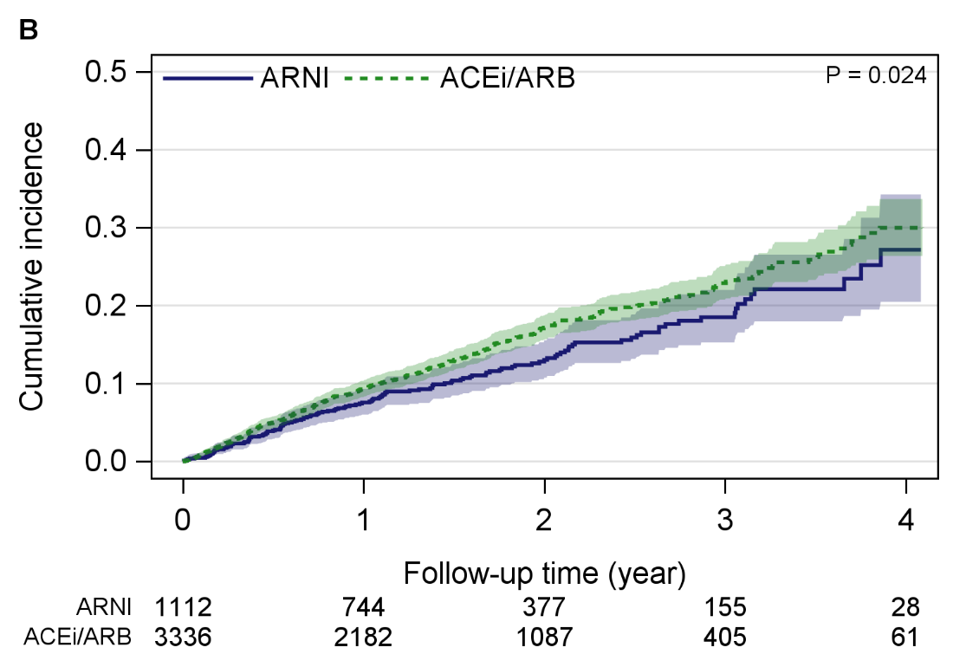

Supplementary Figure S2 Cumulative incidence estimates with 95% confidence intervals for cardiovascular-related mortality (handling other death as competing risk) for ARNI versus ACEi/ARB groups matched 1:1 ratio using propensity score matching including clinical variables (A) 1:2 ratio, (B) 1:3 ratio. ACEi, angiotensin-converting enzyme inhibitor; ARB, angiotensin receptor blockers; ARNI, angiotensin receptor–neprilysin inhibitor.
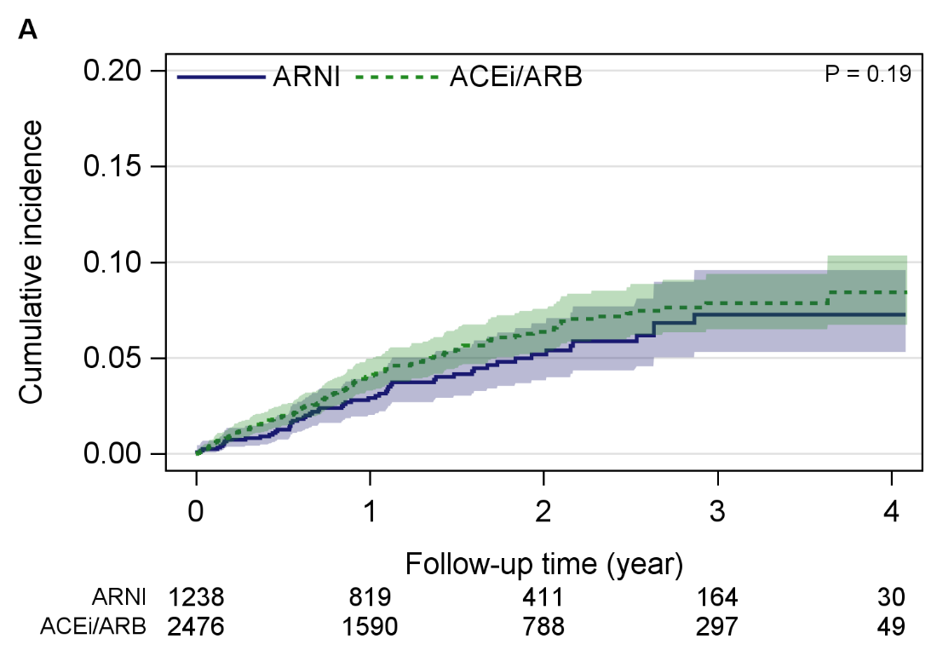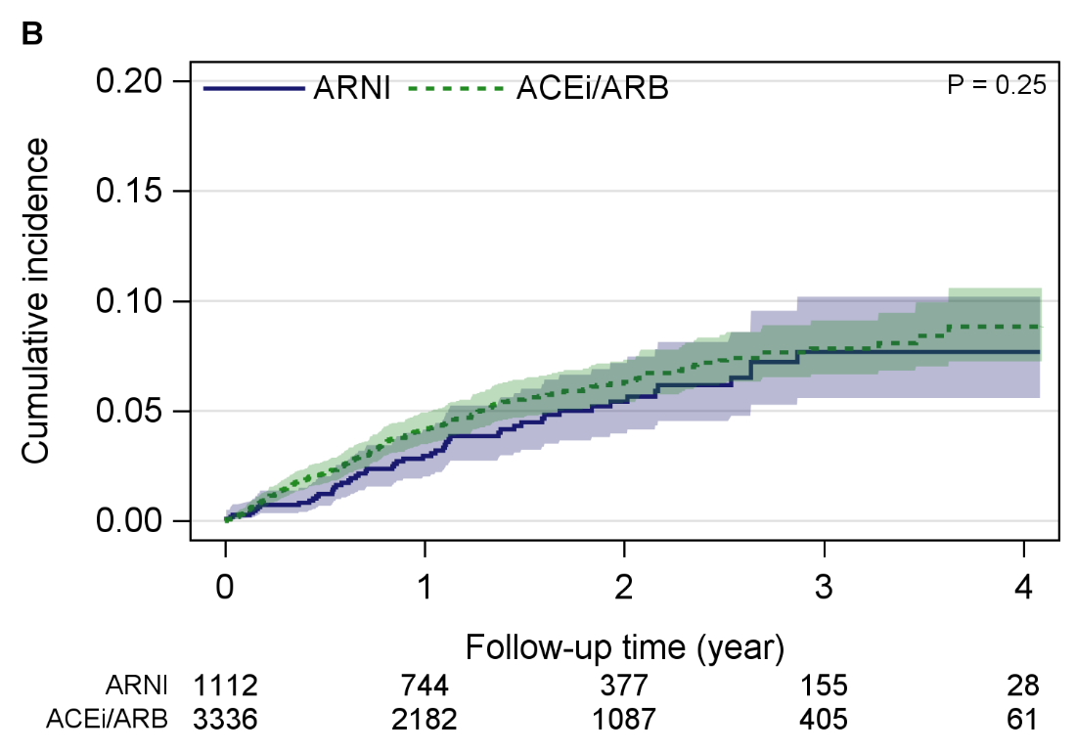

Supplementary Figure S3 Flow diagram detailing the selection of patients used in simple exact matching without clinical variables (sensitivity analysis).
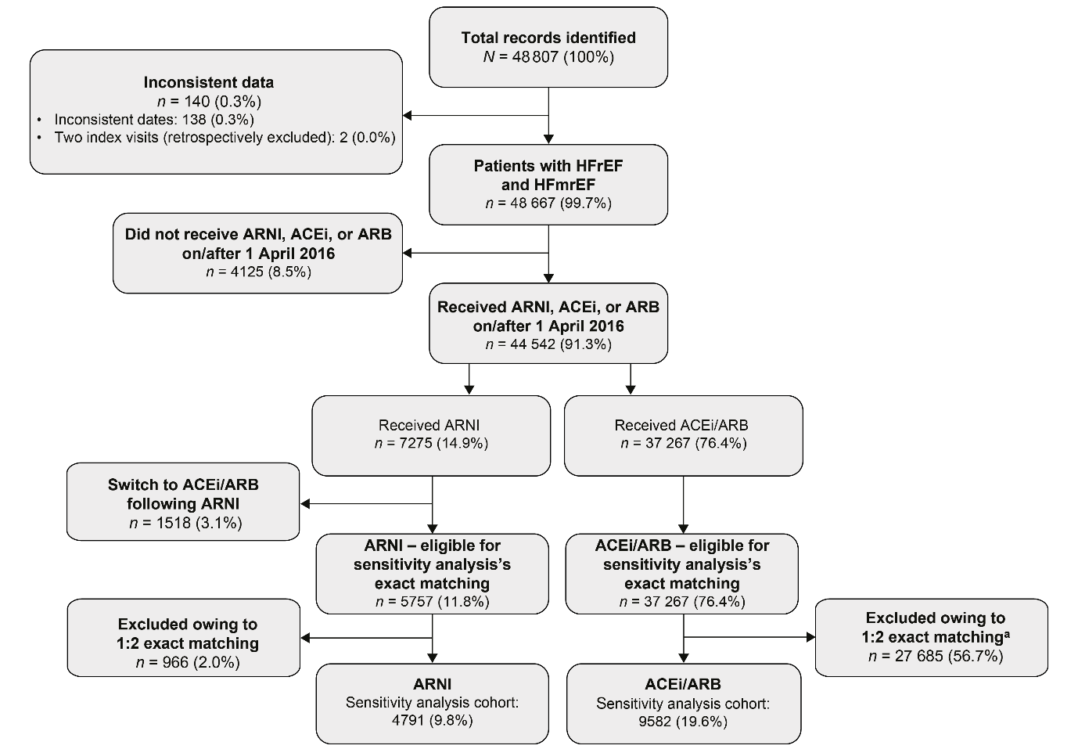
ACEi, angiotensin-converting enzyme inhibitor; ARB, angiotensin receptor blockers; ARNI, angiotensin receptor–neprilysin inhibitor; HFrEF, heart failure with reduced ejection fraction; LVEF, left ventricular ejection fraction.
ªPatients were excluded if they were not alive or not using medication on the defined starting date for the analysis.

Supplementary Figure S4 Cumulative incidence estimates with 95% confidence intervals for all-cause and cardiovascular-related mortality (handling other death as competing risk) for ARNI versus ACEi/ARB groups matched using 1:2 exact matching without clinical variables: (A) all-cause mortality, (B) cardiovascular-related mortality. ACEi, angiotensin-converting enzyme inhibitor; ARB, angiotensin receptor blockers; ARNI, angiotensin receptor–neprilysin inhibitor.


