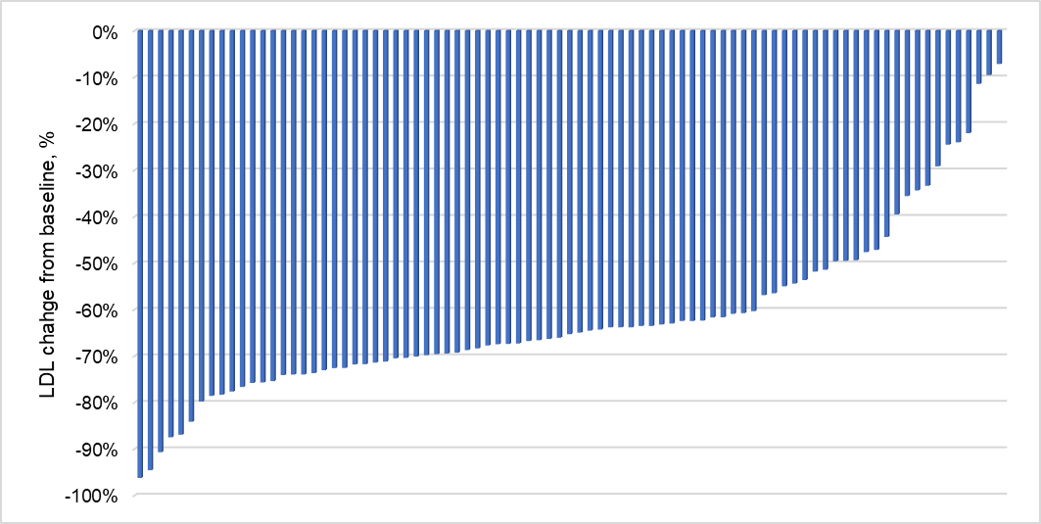
Supplementary material

Supplementary figure S1. Waterfall plot of LDL change from baseline.

