Temporal changes of patient characteristics over 12 years in a single-center transcatheter aortic valve implantation cohort
Till Joscha Demal¹ • Jessica Weimann² • Francisco Miguel Ojeda² • Oliver D. Bhadra¹ • Matthias Linder² • Sebastian Ludwig² • David Grundmann² • Lisa Voigtländer² • Lara Waldschmidt² • Johannes Schirmer¹ • Niklas Schofer² • Stefan Blankenberg² • Hermann Reichenspurner¹ • Lenard Conradi¹ • Moritz Seiffert² • Andreas Schaefer¹
¹ Department of Cardiovascular Surgery, University Heart & Vascular Center Hamburg, Martinistraße 52, D-20246 Hamburg, Germany
² Department of Cardiology, University Heart & Vascular Center Hamburg, D-20246 Hamburg, Germany

- Till Joscha Demal
t.demal@uke.de

SUPPLEMENTARY FIGURES
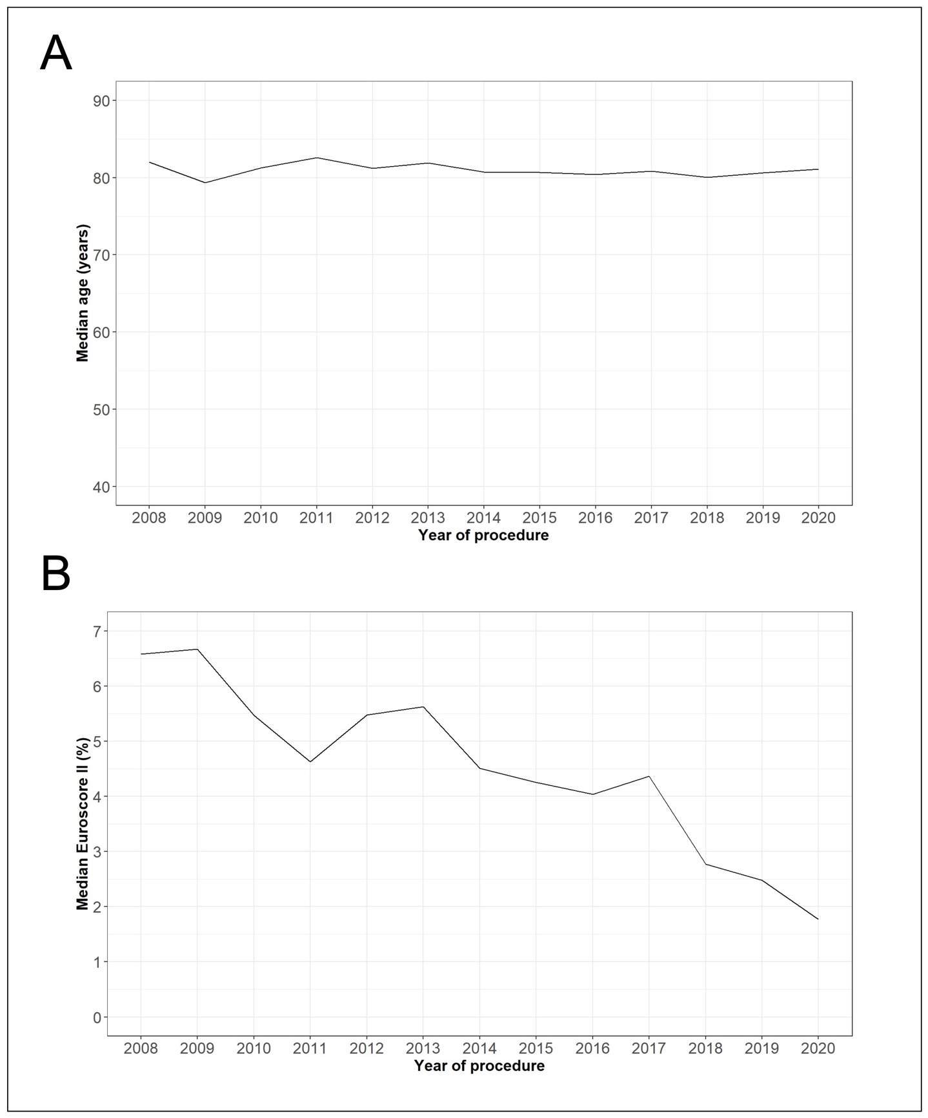Figure S1: Changes of median age and EuroSCORE II of the transcatheter aortic valve implantation cohort after exclusion of Valve-in-Valve patients over time. A: Changes of the median age of the cohort over time. The age of the patients stays stable within a tight range during the whole period of 12 years. B: Changes of EuroSCORE II of the cohort over time. The EuroSCORE II shows a strong decline over time.

Table S1 Baseline characteristics of sub cohort with EuroSCORE II < 4%
 | All  (N=1366) | 2008-2012  (N=247) | 2013-2017  (N=692) | 2018-2020  (N=427) | p-value
Age (years), median (IQR) | 80.1 (75.6, 83.7) | 80.2 (74.5, 83.8) | 79.9 (75.4, 83.5) | 80.6 (76.2, 84.0) | 0.052
Male Gender, n (%) | 709 (51.9) | 115 (46.6) | 365 (52.7) | 229 (53.6) | 0.17
EuroSCORE II, median (IQR) | 2.4 (1.8, 3.1) | 2.8 (1.9, 3.4) | 2.5 (1.9, 3.1) | 2.0 (1.5, 2.8) | <0.001
Ejection fraction (%), median (IQR) | 55.0 (50.0, 60.0) | 60.0 (50.8, 60.2) | 60.0 (55.0, 63.0) | 55.0 (50.0, 60.0) | 0.036
Arterial hypertension, n (%) | 1135 (83.1) | 197 (79.8) | 582 (84.1) | 356 (83.4) | 0.30
Diabetes mellitus, n (%) | 344 (25.2) | 59 (23.9) | 176 (25.4) | 109 (25.6) | 0.88
Coronary artery disease, n (%) | 763 (56.4) | 126 (51.0) | 395 (57.7) | 242 (57.3) | 0.17
Peripheral arterial disease, n (%) | 246 (18.0) | 50 (20.2) | 128 (18.5) | 68 (16.0) | 0.35
Prior stroke, n (%) | 172 (12.6) | 43 (17.4) | 74 (10.7) | 55 (12.9) | 0.024
Chronic lung disease, n (%) | 226 (16.5) | 53 (21.5) | 113 (16.3) | 60 (14.1) | 0.045
Creatinine (mg/dl), median (IQR) | 1.0 (0.8, 1.2) | 1.0 (0.8, 1.2) | 0.9 (0.8, 1.1) | 1.0 (0.9, 1.3) | <0.001
Any malignant disease, n (%) | 339 (24.9) | 89 (36.2) | 181 (26.2) | 69 (16.2) | <0.001
Prior cardiac surgery, n (%) | 42 (3.1) | 7 (2.8) | 21 (3.0) | 14 (3.3) | 0.96
Mean transvalvular gradient (mmHg), median (IQR) | 36.0 (27.0, 47.0) | 37.0 (27.0, 48.0) | 37.0 (27.3, 48.0) | 35.0 (26.0, 46.0) | 0.17
Effective orifice area (cm²), median (IQR) | 0.8 (0.6, 0.9) | 0.7 (0.6, 0.9) | 0.8 (0.7, 0.9) | 0.8 (0.6, 0.9) | <0.001
Perimeter derived valve diameter (mm), median (IQR) | 24.9 (23.1, 26.5) | 24.8 (23.0, 26.3) | 24.7 (23.0, 26.5) | 25.2 (23.2, 26.5) | 0.43
At least moderate aortic regurgitation, n (%) | 230 (17.5) | 67 (28.8) | 98 (14.7) | 65 (15.7) | <0.001
Categorical variables were summarized by frequencies and percentages. These were compared between study groups using Chi-squared test. Here, p-values were computed by Monte Carlo simulation. Continuous variables were described by median and interquartile range. They were compared between study groups using the Kruskal-Wallis test. IQR: Interquartile range.
 | Patients <75 years,  n = 685 | Patients ≥75 years,  n = 2,991 | p-value
EuroSCORE II (%), median (IQR) | 3.4 (1.9, 6.8) | 4.5 (2.7, 7.9) | <0.001
The p-value was computed using the Wilcoxon rank sum test. IQR: Interquartile range.
Table S2 EuroSCORE II in patients below and over 75 years

Table S3 EuroSCORE II in patients below 75 years over the three periods
 | 2008-2012,  n = 148 | 2013-2017,  n = 328 | 2018-2020,  n = 209 | p-value
EuroSCORE II (%), median (IQR) | 4.5 (2.1, 8.7) | 3.8 (2.1, 6.7) | 2.4 (1.3, 4.8) | <0.001
The p-value was computed using the Kruskal-Wallis rank sum test. IQR: Interquartile range.

Table S4 EuroSCORE II in patients ≥75 years over the three periods
 | 2008-2012,  n = 573 | 2013-2017,  n = 1,443 | 2018-2020,  n = 975 | p-value
EuroSCORE II (%), median (IQR) | 5.5 (3.5, 8.6) | 4.9 (2.9, 8.3) | 2.9 (1.8, 5.1) | <0.001
The p-value was computed using the Kruskal-Wallis rank sum test. IQR: Interquartile range.

Table S5 Multivariate regression model predicting 30-day mortality
 | OR (95% CI) | p-value
Transfemoral access | 0.56 (0.26, 1.19) | 0.13
Ejection fraction (%) | 0.97 (0.95, 0.99) | 0.011
Coronary artery disease | 1.45 (0.79, 2.67) | 0.23
Prior stroke | 0.48 (0.12, 1.88) | 0.29
Chronic lung disease | 1.60 (0.74, 3.44) | 0.23
Creatinine (mg/dl) | 1.08 (0.80, 1.44) | 0.63
Any malignant disease | 0.59 (0.26, 1.36) | 0.22
Prior cardiac surgery | 1.72 (0.80, 3.72) | 0.17
Age (years) | 1.04 (0.98, 1.11) | 0.18
Male Gender | 0.96 (0.52, 1.76) | 0.88

To evaluate possible risk factor for early mortality, we performed a multivariate regression model to predict 30-day mortality. Only ejection fraction was identified as predictor for 30-day mortality.

