Supplemental Figure 1: Adjusted* and unadjusted representation of the magnitude of the effect of QTc duration on the secondary outcomes (left: need of hospitalization; middle: in-hospital all-cause mortality; right: prolonged hospitalization) expressed in a dose-response manner expressed as odds ratio (OR) with 95% confidence intervals (CI) taking QTc duration of 450 msec as reference.

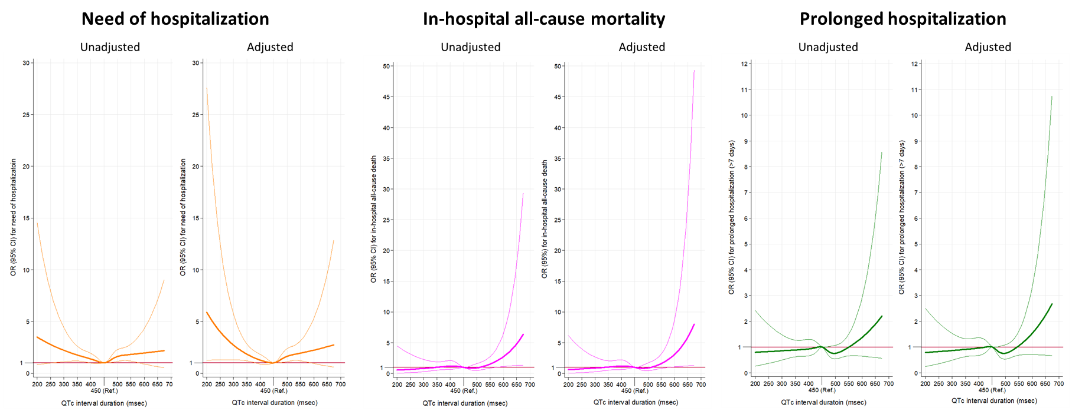

* Adjusted by baseline patient characteristics and characteristics of decompensation (Table 1)

