Supplementary Figure

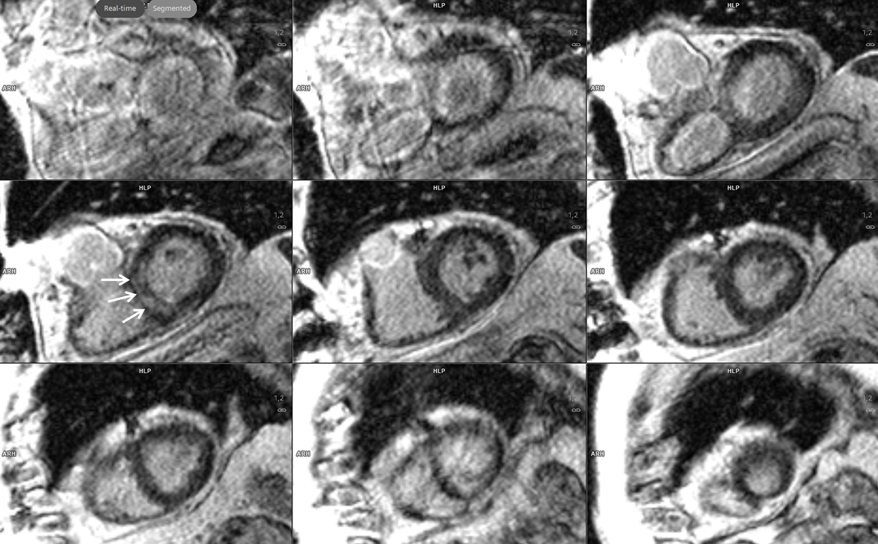

Supplementary Figure S1. Cardiac MRI. Late enhancement series, short axis view. Isolated, circumscript late enhancement, compatible with fibrosis, of the basal septum (arrows), the typical target region for endomyocardial biopsies.

Video still images and Legends

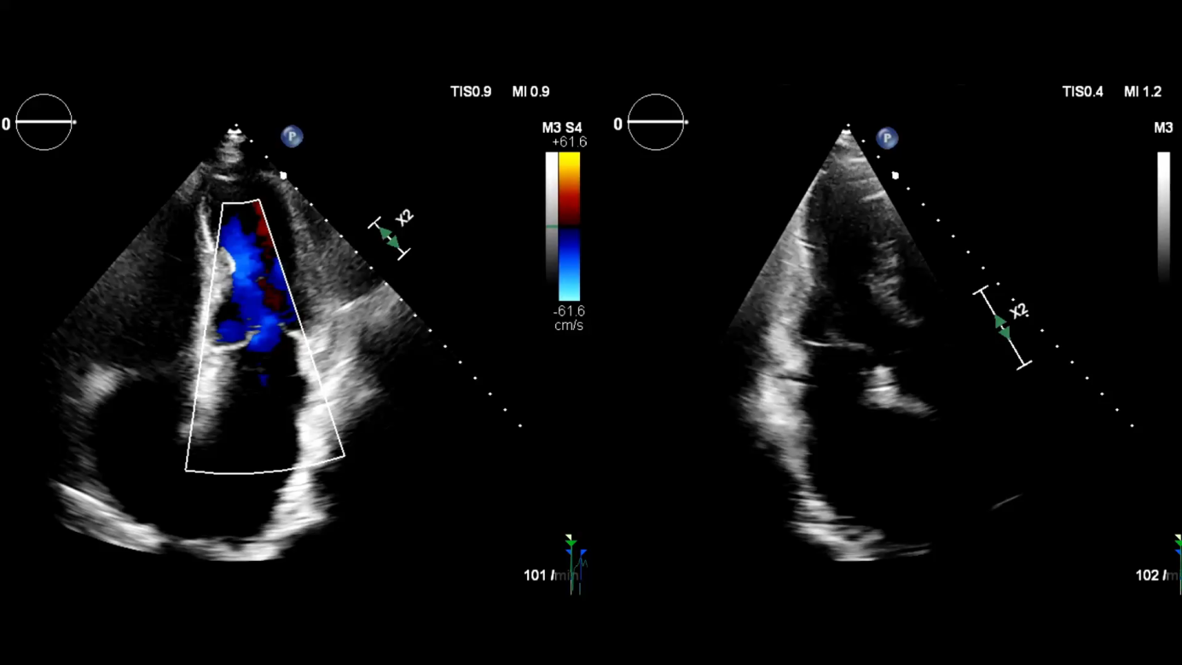

Video 1. Transthoracic 2D-Echocardiography. Color flow Doppler apical 4-chamber view (left) and 3-chamber view (right). A homogeneous left ventricular contraction and a normal ejection fraction of 65% is observed, no mitral regurgitation. Severely enlarged combined donor and recipient left and right atrium.

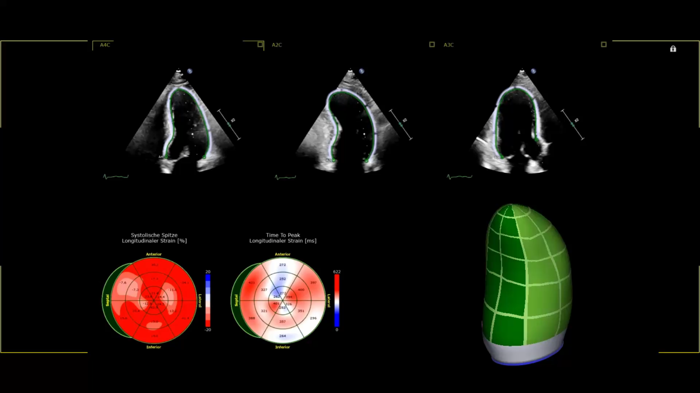

Video 2. Transthoracic Echocardiography: Strain Analysis and 3D-Imaging. Left ventricular apical 4-chamber view (left), 2-chamber view (middle) and 3-chamber view (right) showing endocardial tracing of speckle tracking echocardiography strain analysis (upper panel). Peak systolic global longitudinal strain is normal, amounting to -23% (bullseye analysis, lower panel, left). 3D-volume-imaging of left ventricle showing a normal, homogeneous contraction (lower panel, right)

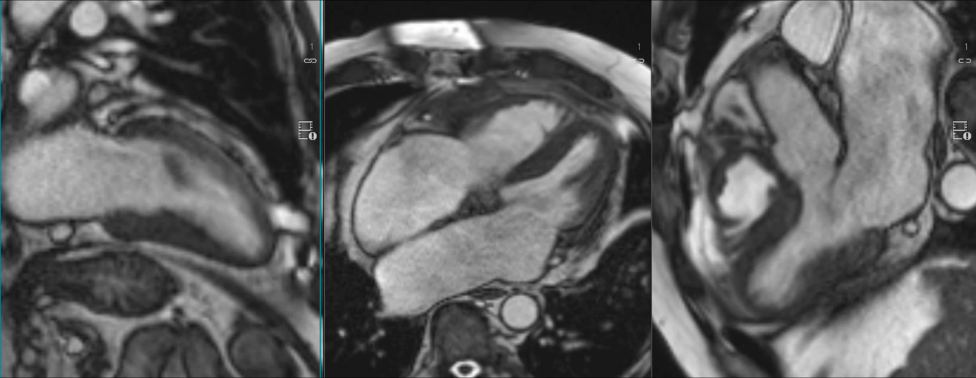

Video 3. Cardiac MRI. Left: 2-chamber view. Middle: 4-chamber view. Right: 3-chamber view. A normal, homogeneous contraction of both ventricles is seen, left ventricular EF amounts to 62%. Note the severely enlarged atria, best seen in the 4- and 3-chamber view, with atrial contraction in the donor part only, and non-contractile recipient remnants (posterior 2/3 of the atria). No mitral or tricuspid regurgitation is seen.

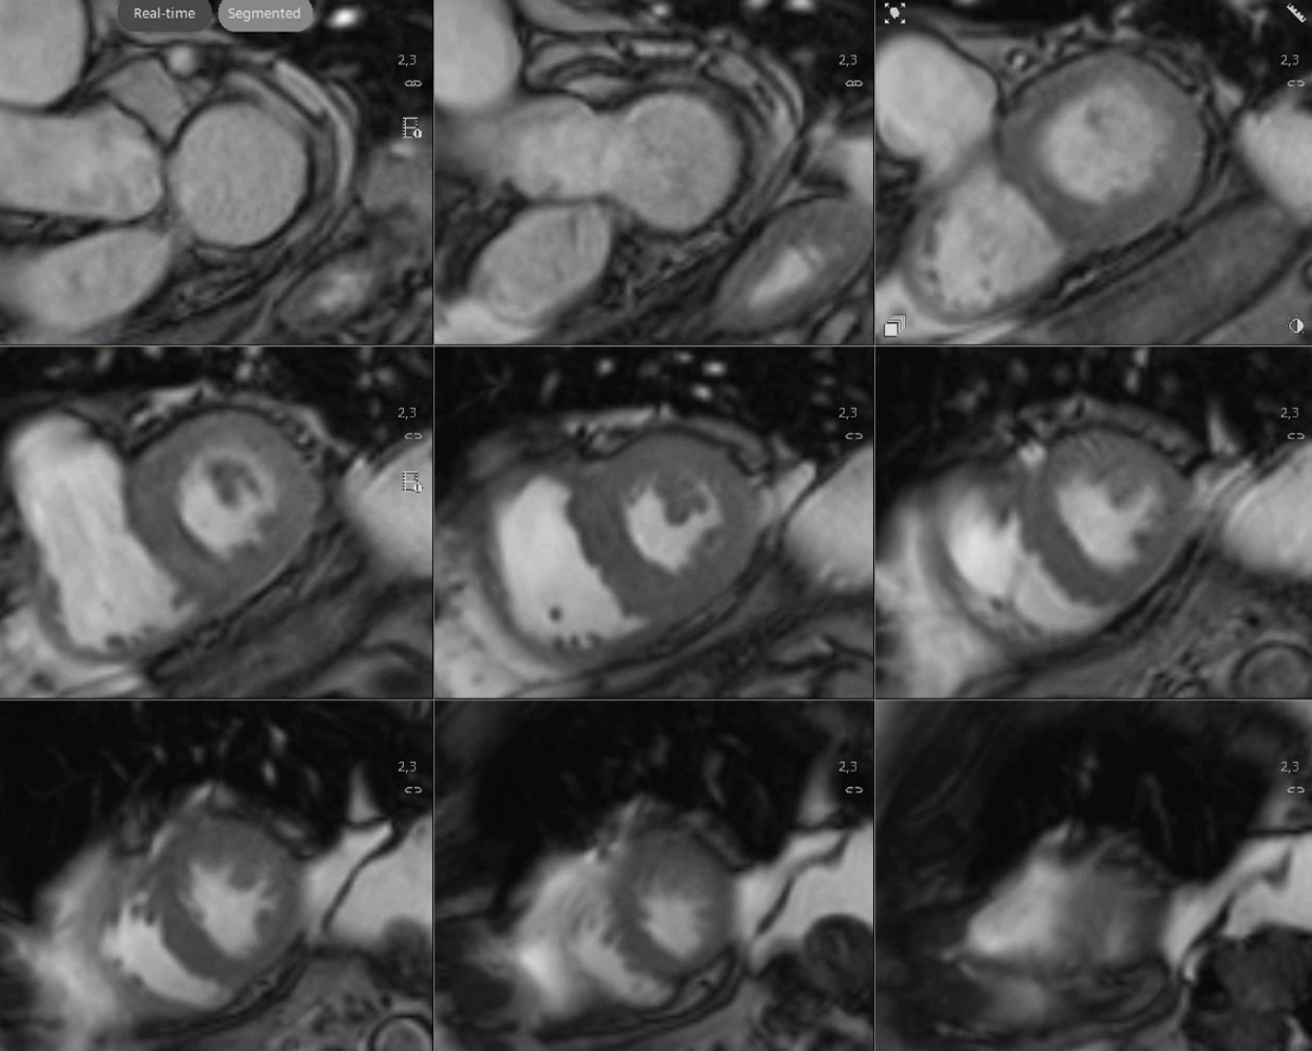

Video 4. Cardiac MRI. Short axis view of the left ventricle. A normal, homogeneous contraction is seen.

