Supplementary Information:

Supplementary table 1. Number of registered values in the study population
 | All patients  n=164 | Idiopathic  n=94 | Post cardiac injury n=49 | Post-Infectious n=21
Gender | 164 | 94 | 49 | 21
Age | 164 | 94 | 49 | 21
Clinical signs
Fever | 164 | 94 | 49 | 21
Pleural effusion | 164 | 94 | 49 | 21
Pericardial effusion | 164 | 94 | 49 | 21
Cardiac MRI | 68 | 49 | 11 | 8
ECG | 164 | 94 | 49 | 21
Smoking | 164 | 94 | 49 | 21
Biomarkers
CRP max | 162 | 92 | 49 | 21
CRP | 151 | 87 | 45 | 19
SAA | 88 | 53 | 25 | 10
Procalcitonin | 96 | 53 | 31 | 12
Troponin T | 132 | 77 | 37 | 18
Ferritin | 119 | 70 | 35 | 14
NT-BNP | 127 | 79 | 33 | 15
Leukocyte count | 107 | 64 | 31 | 12
Neutrophil count | 57 | 35 | 15 | 7
Lymphocyte count | 57 | 35 | 15 | 7
N/L-ratio | 57 | 35 | 15 | 7
ANA titer | 156 | 91 | 46 | 19
Course | 164 | 94 | 49 | 21
Treatment | 164 | 94 | 49 | 21

Number of patients with registered values for each variable compared to the total number of 164 patients. ANA (anti-nuclear antibody), N/L neutrophil/leukocyte).

Supplementary figure 1. SAA cutoff determination
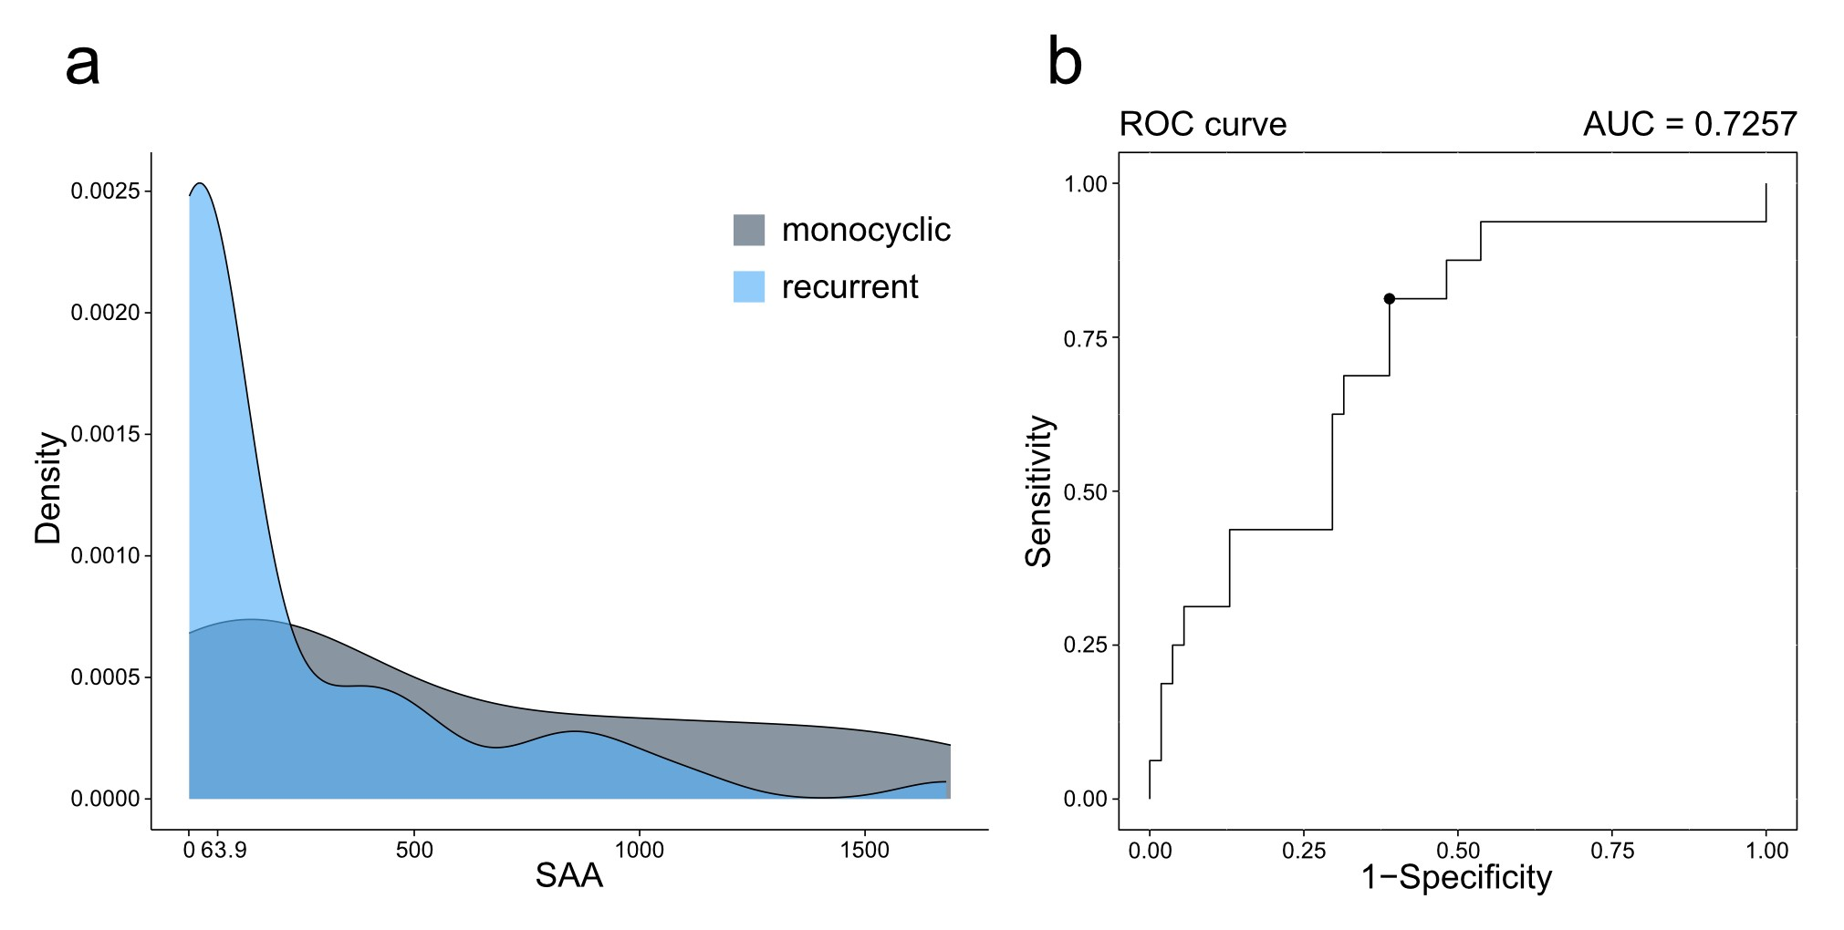
Suppl. Figure 1: SAA cutoff determination. (a) Density distribution of SAA values for patients with monocyclic (dark grey) and recurrent pleuropericarditis (light blue). Values are given in mg/l b) ROC-curve for SAA-cutoff determination. The AUC is 0.7257, the cutoff of 63.9 mg/l is denoted as a black dot.

