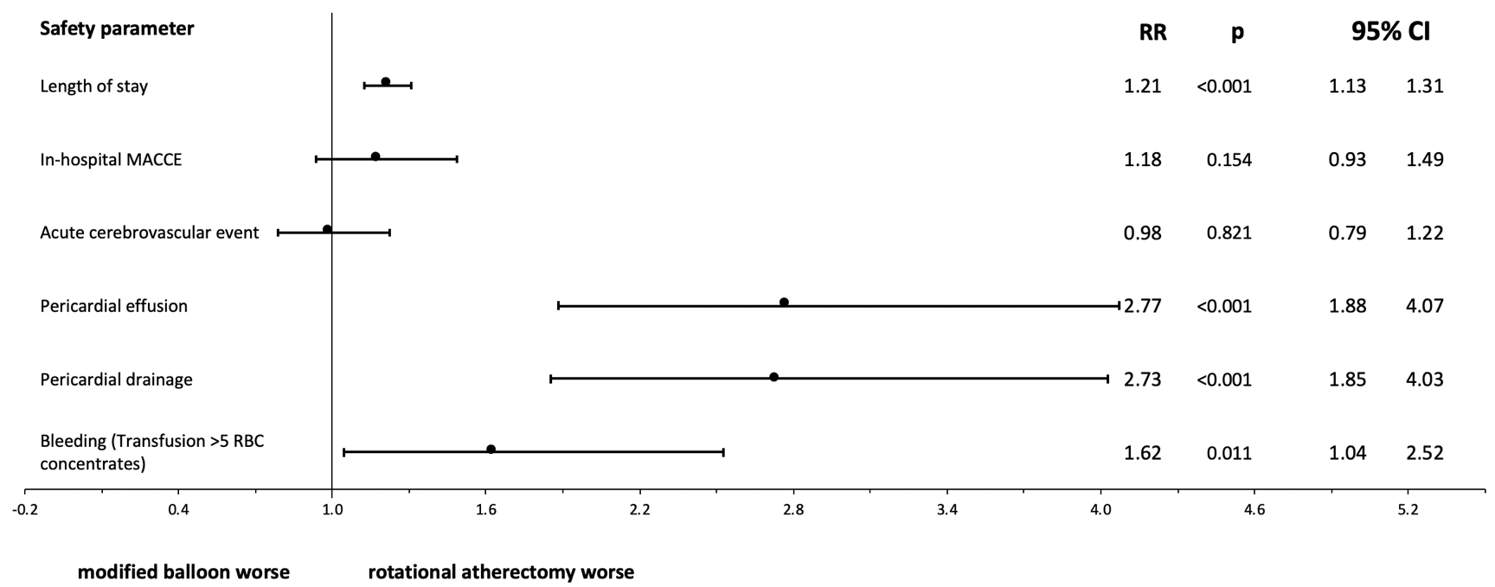
Supplemental Figure 1. Forest plot of propensity score approach to compare adjusted risks of in-hospital safety parameters excluding patients treated by both RA and MB.
CI: confidence interval, MACCE: major adverse cardiac and cerebrovascular events, RBC: red blood cell concentrate. For the propensity score estimation, we fit a logistic regression model controlling for 30 predetermined covariates (all variables listed in Table 1). Patients which were treated by both, modified balloon and rotational atherectomy were excluded from this analysis

Supplemental Table 1. Risk adjusted Poisson-regression analysis for pericardial effusion in rotational atherectomy.
Characteristic | RR | 95% CI | p
Women | 1.49 | 0.76 - 2.95 | 0.248
Age | 1.01 | 0.96 - 1.07 | 0.685
Charlson Comorbidity Index (CCI) | 1.00 | 0.72 - 1.38 | 0.997
NYHA III or IV | 4.24 | 2.10 - 8.54 | <0.001
Arterial hypertension | 0.71 | 0.30 - 1.68 | 0.436
Coronary artery disease | 0.48 | 0.04 - 5.45 | 0.552
Coronary 1-vessel disease | 0.66 | 0.17 - 2.62 | 0.554
Coronary 2-vessel disease | 1.25 | 0.36 - 4.28 | 0.723
Coronary 3-vessel disease | 1.00 | 0.28 - 3.56 | 0.999
Left main disease | 1.37 | 0.88 - 2.13 | 0.160
In-stent stenosis | 1.34 | 0.55 - 3.25 | 0.521
Previous myocardial infarction | 0.65 | 0.33 - 1.28 | 0.212
Previous cardiac surgery | 0.58 | 0.29 - 1.17 | 0.126
Atrial fibrillation | 1.82 | 1.21 - 2.75 | 0.004
CHA₂DS₂ VASC | 1.02 | 0.54 - 1.92 | 0.958
Peripheral vascular disease | 0.67 | 0.29 - 1.55 | 0.353
Carotid disease | 0.77 | 0.25 - 2.39 | 0.647
COPD | 1.09 | 0.49 - 2.40 | 0.832
Pulmonary hypertension | 0.91 | 0.45 - 1.84 | 0.797
Chronic renal disease | 1.08 | 0.52 - 2.23 | 0.845
Diabetes | 0.62 | 0.23 - 1.67 | 0.343
Previous stroke | 2.42 | 0.47 - 12.29 | 0.288
Hemiplegia or paraplegia | 0.00 | 0.00 - 0.00 | <0.001
Dementia | 0.67 | 0.09 – 4.91 | 0.697
Connective tissue disease | 0.88 | 0.12 - 6.71 | 0.906
Peptic ulcer disease | 0.00 | 0.00 - 0.00 | <0.001
Mild liver disease | 0.68 | 0.09 - 5.05 | 0.709
Moderate to severe liver disease | 0.00 | 0.00 - 0.00 | <0.001
Cancer | 1.29 | 0.29 - 5.68 | 0.737
Metastatic solid tumor | 0.00 | 0.00 - 0.00 | <0.001

Supplemental Table 2. Risk adjusted Poisson-regression analysis for pericardial drainage in rotational atherectomy
Characteristic | RR | 95% CI | p
NYHA III or IV | 4.28 | 2.13 - 8.60 | <0.001
Arterial hypertension | 0.69 | 0.29 - 1.65 | 0.401
Coronary artery disease | 0.47 | 0.04 - 5.35 | 0.543
Voronary 1-vessel disease | 0.65 | 0.16 - 2.57 | 0.538
Voronary 2-vessel disease | 1.23 | 0.36 - 4.18 | 0.742
Coronary 3-vessel disease | 1.00 | 0.28 - 3.54 | 0.995
Left main disease | 1.35 | 0.87 - 2.08 | 0.181
In-stent stenosis | 1.33 | 0.55 - 3.24 | 0.532
Previous myocardial infarction | 0.66 | 0.34 - 1.30 | 0.229
Previous cardiac surgery | 0.57 | 0.28 - 1.15 | 0.118
Atrial fibrillation | 1.86 | 1.24 - 2.78 | 0.003
CHA₂DS₂ VASC | 1.06 | 0.55 - 2.03 | 0.865
Peripheral vascular disease | 0.67 | 0.29 - 1.54 | 0.340
Carotid disease | 1.05 | 0.39 - 2.80 | 0.928
COPD | 1.09 | 0.49 - 2.39 | 0.837
Pulmonary hypertension | 1.01 | 0.53 - 1.95 | 0.970
Chronic renal disease | 1.09 | 0.53 - 2.26 | 0.814
Diabetes | 0.64 | 0.24 - 1.66 | 0.355
Previous stroke | 2.21 | 0.42 - 11.54 | 0.346
Hemiplegia or paraplegia | 0.00 | 0.00 - 0.00 | <0.001
Dementia | 0.68 | 0.09 - 4.98 | 0.706
Connective tissue disease | 0.89 | 0.12 - 6.72 | 0.912
Peptic ulcer disease | 0.00 | 0.00 - 0.00 | <0.001
Mild liver disease | 0.70 | 0.10 - 5.18 | 0.729
Moderate to severe liver disease | 0.00 | 0.00 - 0.00 | <0.001
Cancer | 1.34 | 0.31 - 5.87 | 0.696
Metastatic solid tumor | 0.00 | 0.00 - 0.00 | <0.001

Supplemental Table 3. Risk adjusted Poisson-regression analysis for bleeding in rotational atherectomy.
Characteristic | RR | 95% CI | p
Women | 1.67 | 0.70 - 3.99 | 0.250
Age | 0.97 | 0.91 - 1.03 | 0.343
Charlson Comorbidity Index (CCI) | 1.39 | 1.07 - 1.80 | 0.015
NYHA III or IV | 4.18 | 1.93 - 9.07 | <0.001
Arterial Hypertension | 0.44 | 0.19 - 1.03 | 0.060
Coronary artery disease | 0.32 | 0.05 - 2.09 | 0.232
coronary 1-vessel disease | 0.39 | 0.08 - 1.79 | 0.224
coronary 2-vessel disease | 0.42 | 0.12 - 1.52 | 0.187
coronary 3-vessel disease | 0.55 | 0.16 - 1.85 | 0.335
left main disease | 1.21 | 0.67 - 2.19 | 0.526
In-stent stenosis | 2.22 | 1.01 - 4.88 | 0.048
Previous myocardial infarction | 0.65 | 0.35 - 1.20 | 0.169
Previous cardiac surgery | 1.01 | 0.51 - 1.98 | 0.984
Atrial fibrillation | 1.86 | 1.20 - 2.88 | 0.005
CHA₂DS₂ VASC | 1.29 | 0.62 - 2.68 | 0.490
Peripheral vascular disease | 1.58 | 0.94 - 2.66 | 0.086
Carotid disease | 0.82 | 0.32 - 2.12 | 0.687
COPD | 0.59 | 0.26 - 1.36 | 0.214
Pulmonary hypertension | 1.61 | 0.86 - 3.01 | 0.138
Chronic renal disease | 0.41 | 0.21 - 0.78 | 0.007
Diabetes | 0.58 | 0.26 - 1.29 | 0.184
Previous Stroke | 0.31 | 0.02 - 4.16 | 0.378
Hemiplegia or paraplegia | 0.00 | 0.00 - 0.00 | <0.001
Dementia | 0.87 | 0.16 - 4.82 | 0.875
Connective tissue disease | 0.77 | 0.10 - 5.96 | 0.799
Peptic ulcer disease | 9.08 | 3.90 - 21.14 | <0.001
Mild liver disease | 2.99 | 1.41 - 6.33 | 0.004
Moderate to severe liver disease | 0.98 | 0.11 - 9.02 | 0.987
Cancer | 0.72 | 0.16 - 3.32 | 0.675
Metastatic solid tumor | 0.00 | 0.00 - 0.00 | <0.001

