Clinical Research in Cardiology
Evolving Trends and Persistent Challenges in Chronic Left Ventricular Heart Failure Management: Insights from a Nine-Year Analysis of In-Hospital Outcomes in Germany

Anastasia J. Hobbach¹, Jannik Feld², Jürgen R. Sindermann¹, Holger Reinecke¹
¹Department of Cardiology I, Coronary, Peripheral Vascular Disease and Heart Failure, University Hospital Münster, Münster, Germany
²Institute of Biostatistics and Clinical Research, University of Münster, Münster, Germany
Correspondence to Anastasia J. Hobbach
¹Department of Cardiology I, Coronary, Peripheral Vascular Disease and Heart Failure, University Hospital Münster, Albert-Schweizer Campus 1, 48149 Münster, Germany
ORCID: 0000-0001-6421-8429
Email: Anastasia.Hobbach@ukmuenster.de

Online Resource 1. Used Health Problems 10th Revision (ICD-10 GM) codes.
Health Problems 10th Revision (ICD-10 GM) | Code
Arterial hypertension (AHT) | I10.-, I11.-, I12.-, I13.-, I15.-
Diabetes mellitus (DM) | E10.-, E11.-,
Dyslipidemia | E78.-
Nicotine abuses | F17.-
Myocardial Infarction (MI) | I25.2, I24.1
Obesity | E66.-
Chronic right ventricular heart failure (CRHF) | I50.11- I50.14
Chronic left ventricular heart failure (CLHF) | I50.1-
Previous stroke | I69.3, I69.4
Coronary heart disease (CHD) | I25.-
Atrial flutter/fibrillation (AFL/AF) | I48.-
Peripheral artery disease (PAD) | I70.2-
Cerebrovascular disease (CeVD) | I65.-,
Chronic kidney disease (CKD) | N18.-, N19.-
Acute kidney injury (AKI) | N17
Cardiogenic shock | R57.0, T81.1
Cancer | C00–C97

Online Resource 2. Used German procedure classification system (OPS) codes.
German procedure classification system (OPS) | Code
Percutaneous coronary intervention (PCI) | 8-837
Left-heart-Catheterization (LCH) | 1-275
Biventricular intracoporal pump
  5-376.50
Univentricular intracoporal pump | 5-376.40
Impella | 8-83a.3
Artificial heart
  5-376.6
HTx heterotopic | 5-375.1
HTx orthotopic | 5-375.0
Heart- and Lung Tx | 5-375.2
Intra-aortic ballon pump (IABP) | 8-83a.0
Renal replacement therapy | 8-853, 8-855, 8-854, 8-857
Left ventricle support | 8-851, 8-852, 8-83a.0, 8-83a.3
Resuscitation | 8-771

Online Resource 3: Hospitalizations due to CLHF per year: absolute numbers, per 100,000 population, and total hospitalizations (2014–2022). Hospitalizations due to CHF per year are presented as absolute numbers, as hospitalizations per population (in n/100,000), and as per 100,000 total hospitalizations, irrespective of the reason for hospitalization, for the years 2014–2022. CLHF: Chronic left ventricular heart failure.
 | 2014 | 2015 | 2016 | 2017 | 2018 | 2019 | 2020 | 2021 | 2022
CLHF hospital admissions | 288,019 | 291,753 | 295,909 | 300,501 | 291,091 | 311,782 | 273,320 | 278,640 | 285,417
total hospital admissions | 19,148,626 | 19,239,574 | 19,532,779 | 19,442,810 | 19,392,466 | 19,415,555 | 16,793,962 | 16,742,344 | 16,802,693
hospitalization (n/100.000) | 1,504 | 1,516 | 1,515 | 1,546 | 1,501 | 1,606 | 1,627 | 1,664 | 1,699
population number | 81,197,537 | 82,175,684 | 82,521,653 | 82,792,351 | 83,019,213 | 83,166,711 | 83,155,031 | 83,237,124 | 84,358,845
frequenzy (n/100.000) | 355 | 355 | 359 | 363 | 351 | 375 | 329 | 335 | 339

Online Resource 4: Proportion of hospitalizations due to CLHF in relation to all hospitalizations and to cancer related hospitalization (2014–2022). The proportion of hospitalizations due to CLHF in relation to all hospitalizations (presented in blue) and to cancer related hospitalization (presented in orange) for the years 2014–2022. CLHF: chronic left ventricular heart failure.
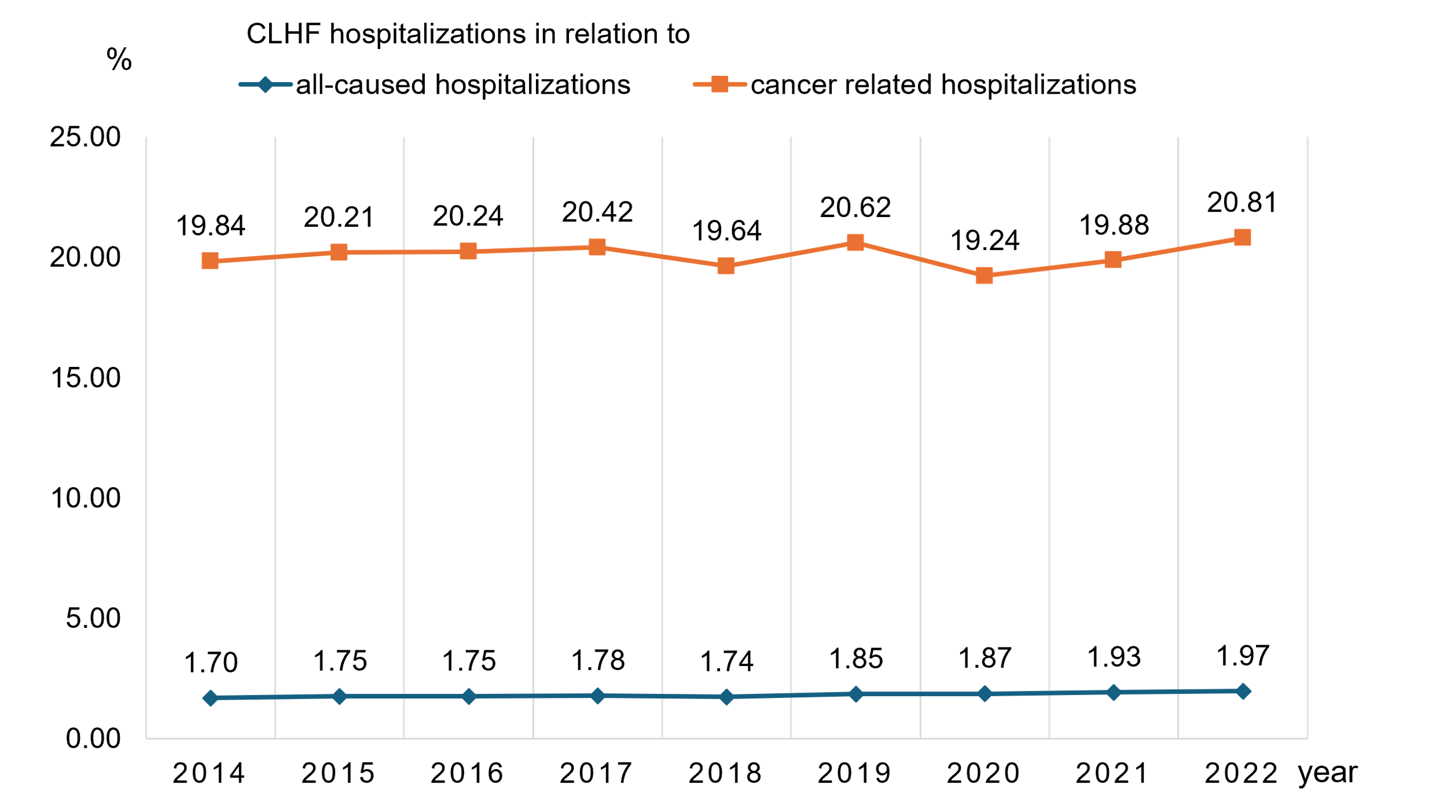

Online Resource 5: Proportion of CLHF hospitalization compared to all-caused hospitalizations and compared to cancer-related hospitalizations by various age groups in years. CLHF: Chronic left ventricular heart failure.
Age |  |  | 2014 | 2015 | 2016 | 2017 | 2018 | 2019 | 2020 | 2021 | 2022
<40 | CLHF:all |  | 0.05 | 0.05 | 0.05 | 0.01 | 0.06 | 0.06 | 0.06 | 0.07 | 0.07
<40 | CLHF:cancer |  | 2.70 | 2.87 | 2.95 | 3.13 | 3.03 | 3.27 | 2.96 | 3.28 | 3.30
40-49 | CLHF:all |  | 0.26 | 0.27 | 0.29 | 0.28 | 0.29 | 0.30 | 0.32 | 0.32 | 0.33
40-49 | CLHF:cancer |  | 4.11 | 4.32 | 4.65 | 4.72 | 4.72 | 5.04 | 4.79 | 4.99 | 5.01
50-59 | CLHF:all |  | 0.62 | 0.62 | 0.62 | 0.61 | 0.61 | 0.62 | 0.63 | 0.65 | 0.67
50-59 | CLHF:cancer |  | 5.88 | 5.97 | 6.01 | 5.96 | 5.94 | 6.02 | 5.64 | 5.90 | 6.12
60-69 | CLHF:all |  | 1.27 | 1.27 | 1.29 | 1.27 | 1.21 | 1.27 | 1.27 | 1.26 | 1.23
60-69 | CLHF:cancer |  | 9.30 | 9.39 | 9.57 | 9.40 | 8.94 | 9.25 | 8.57 | 8.55 | 8.66
70-79 | CLHF:all |  | 2.40 | 2.40 | 2.40 | 2.38 | 2.28 | 2.36 | 2.36 | 2.37 | 2.31
70-79 | CLHF:cancer |  | 20.22 | 20.51 | 20.37 | 19.90 | 18.79 | 19.05 | 17.52 | 17.50 | 17.64
80-89 | CLHF:all |  | 4.37 | 4.29 | 4.26 | 4.28 | 4.11 | 4.32 | 4.28 | 4.40 | 4.39
80-89 | CLHF:cancer |  | 20.22 | 20.51 | 20.37 | 19.90 | 18.79 | 19.05 | 17.52 | 17.50 | 17.64
>90 | CLHF:all |  | 5.73 | 5.62 | 5.72 | 5.79 | 5.69 | 6.17 | 6.10 | 6.56 | 6.77
>90 | CLHF:cancer |  | 134.53 | 138.40 | 137.73 | 137.96 | 135.94 | 143.33 | 139.65 | 144.79 | 159.02

Online Resource 6: Proportion of CLHF hospitalizations per year in relation to all-caused hospitalizations differentiated by federal state (2014-2022). CLHF: chronic left ventricular heart failure.
Federal state | 2014 | 2015 | 2016 | 2017 | 2018 | 2019 | 2020 | 2021 | 2022
Schleswig-Holstein | 1.61 | 1.64 | 1.60 | 1.68 | 1.65 | 1.74 | 1.73 | 1.79 | 1.92
Hamburg | 1.59 | 1.54 | 1.52 | 1.51 | 1.40 | 1.67 | 1.74 | 1.68 | 1.84
Lower Saxony | 1.86 | 1.85 | 1.85 | 1.96 | 1.95 | 2.10 | 2.13 | 2.25 | 2.38
Bremen | 1.26 | 1.49 | 1.50 | 1.40 | 1.43 | 1.68 | 2.04 | 2.18 | 2.35
North Rhine-Westphalia | 1.66 | 1.73 | 1.73 | 1.75 | 1.73 | 1.83 | 1.83 | 1.92 | 2.00
Hesse | 1.56 | 1.50 | 1.51 | 1.52 | 1.41 | 1.49 | 1.52 | 1.62 | 1.69
Rhineland-Palatinate | 1.76 | 1.76 | 1.69 | 1.77 | 1.77 | 1.82 | 1.86 | 1.94 | 1.90
Baden-Württemberg | 1.59 | 1.56 | 1.59 | 1.66 | 1.64 | 1.75 | 1.71 | 1.76 | 1.78
Bavaria | 1.51 | 1.47 | 1.45 | 1.43 | 1.37 | 1.44 | 1.40 | 1.46 | 1.43
Saarland | 1.49 | 1.41 | 1.41 | 1.39 | 1.37 | 1.44 | 1.44 | 1.51 | 1.62
Berlin | 1.57 | 1.48 | 1.48 | 1.53 | 1.52 | 1.66 | 1.68 | 1.84 | 1.88
Brandenburg | 2.31 | 2.39 | 2.34 | 2.36 | 2.27 | 2.46 | 2.60 | 2.59 | 2.57
Mecklenburg-Vorpomern | 2.45 | 2.56 | 2.51 | 2.55 | 2.50 | 2.62 | 2.58 | 2.59 | 2.53
Saxony | 2.35 | 2.43 | 2.50 | 2.47 | 2.34 | 2.49 | 2.53 | 2.48 | 2.51
Saxony-Anhalt | 2.32 | 2.39 | 2.37 | 2.40 | 2.42 | 2.62 | 2.74 | 2.76 | 2.77
Thuringia | 2.37 | 2.34 | 2.50 | 2.64 | 2.54 | 2.57 | 2.62 | 2.49 | 2.54

Online Resource 7: Complications in CLHF patients (2014–2022). Complications in patients during hospitalization for CHF over the observation period from 2014 to 2022, presented in absolute and relative numbers, differentiated by year. AKI: acute kidney failure, CLHF: Chronic left ventricular heart failure, HTx: heart transplantation, H+LTx: heart and lung transplantation, IABP: intra-aortic balloon pump, LV: left ventricular, ECLS: extracorporeal life support (ECLS).
 | 2014 | 2015 | 2016 | 2017 | 2018 | 2019 | 2020 | 2021 | 2022 | p-value
 | % (N) | % (N) | % (N) | % (N) | % (N) | % (N) | % (N) | % (N) | % (N)
cardiogenic  shock | 1.02% (2,940) | 1.07% (3,135) | 1.1% (3,268) | 1.1% (3,318) | 1.14% (3,328) | 1.18% (3,665) | 1.31% (3,576) | 1.31% (3,656) | 1.3% (3,706) | <0.0001
AKI | 6.47% (18,639) | 8.83% (25,754) | 9.31% (27,556) | 10.1% (30,363) | 10.7% (31,155) | 11.37% (35,442) | 12.33% (33,693) | 13.03% (36,303) | 12.48% (35,634) | <0.0001
renal replacement therapy | 2.09% (6,031) | 2.22% (6,486) | 2.18% (6,443) | 2.24% (6,731) | 2.21% (6,447) | 2.15% (6,704) | 2.43% (6,634) | 2.43% (6,772) | 2.31% (6,591) | <0.0001
resuscitation + LV support | 1.32% (3,815) | 1.4% (4,095) | 1.35% (4,007) | 1.33% (4,007) | 1.37% (3,977) | 1.37% (4,277) | 1.49% (4,072) | 1.45% (4,049) | 1.48% (4,219) | 0.003
Impella, ECLS, IABP | 0.07% (209) | 0.09% (255) | 0.09% (266) | 0.11% (324) | 0.13% (364) | 0.15% (480) | 0.16% (432) | 0.18% (489) | 0.17% (499) | <0.0001
ventilation | 6.26% (18,017) | 6.66% (19,435) | 6.54% (19,367) | 6.61% (19,867) | 6.49% (18,894) | 6.34% (19,755) | 6.46% (17,645) | 6.2% (17,271) | 6.11% (17,429) | <0.0001
univentricular intracorporeal pump | 0.09% (245) | 0.08% (223) | 0.09% (272) | 0.09% (277) | 0.1% (285) | 0.12% (360) | 0.11% (295) | 0.09% (262) | 0.08% (230) | <0.0001
biventricular intracorporeal pump | 0% (0) | 0% (0) | 0% (0) | 0% (0) | 0% (0) | 0% (0) | 0% (0) | 0% (0) | 0% (0) | <0.0001
artificial heart | 0% (0) | 0% (0) | 0% (0) | 0% (0) | 0% (0) | 0% (0) | 0% (0) | 0% (0) | 0% (0) | <0.0001
HTx orthotopic | 0.01% (31) | 0.02% (51) | 0% (0) | 0% (30) | 0% (0) | 0.02% (54) | 0.02% (52) | 0.02% (58) | 0.02% (59) | <0.0001
HTx heterotopic | 0% (0) | 0% (0) | 0% (0) | 0% (0) | 0% (0) | 0% (0) | 0% (0) | 0% (0) | 0% (0) | <0.0001
H+LTx | 0% (0) | 0% (0) | 0% (0) | 0% (0) | 0% (0) | 0% (0) | 0% (0) | 0% (0) | 0% (0) | <0.0001
death | 8.03% (23,137) | 8.54% (24,908) | 7.86% (23,246) | 7.92% (23,786) | 7.87% (22,898) | 7.61% (23,719) | 7.98% (21,819) | 8.27% (23,048) | 8.84% (25,220) | <0.0001

