Supplemental figure 1

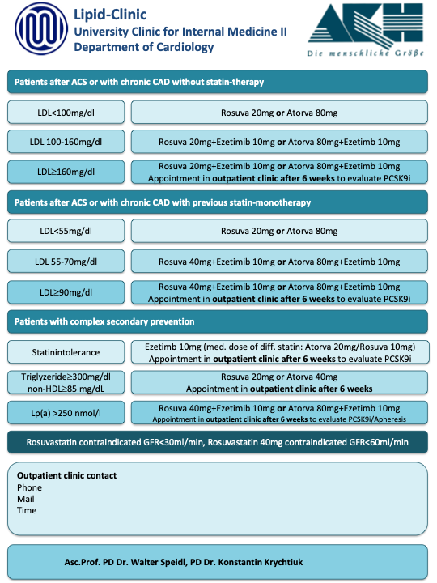

Supplemental Table 1 Definition of high-intensity and low-intensity lipid-lowering therapy
High intensity lipid lowering therapy
Atorvastatin 40 mg, 80 mg
Rosuvastatin 20 mg, 40 mg
Alirocumab 150 mg
Evolocumab 140 mg
Combination of any statin plus ezetimbe
Combination of any statin plus PCSK9 inhibitor
Combination of ezetimibe plus PCSK9 inhibitor
Combination of any statin, ezetimibe plus PCSK9 inhibitor
Low intensity lipid lowering therapy
Atorvastatin 10 mg, 20 mg
Fluvastatin 20 mg, 40 mg
Lovastatin 10 mg, 20 mg, 40 mg
Pravastatin 10 mg, 20mg, 40 mg
Rosuva 5 mg, 10 mg
Simvastatin 10 mg, 20 mg, 40 mg, 80 mg
Ezetimibe 10mg

Supplemental Table 2
 | Follow-Up LDL-C available  (n = 295) | Follow-Up LDL-C not available  (n = 396) | p Value
Age, median (IQR) | 62 (52-72) | 62 (54-72) | 0.545
Gender  Male, n (%)  Female, n (%) | 191 (64.7%)  104 (35.3%) | 275 (69.4%)  121 (30.6%) | 0.192  -  -
BMI, kg/m², median (IQR) | 26.8 (23.8-30.5) | 27.1 (24.7-31.2) | 0.075
Smoker, n (%)  former, n (%)  current, n (%) | 40 (14.7%)  116 (42.5%) | 30 (9.7%)  119 (38.4%) | 0.047  -  -
Diabetes mellitus, n (%) | 81 (27.5%) | 81 (20.6%) | 0.036
Family history of CAD, n (%) | 14 (11.1%) | 26 (18.7%) | 0,137
Previous myocardial infarction, n (%) | 78 (26.4%) | 70 (18%) | 0.019
PAD, n (%) | 56 (19%) | 34 (8.8%) | <0.001
Stroke, n (%) | 17 (5.8%) | 13 (3.4%) | 0.133
COPD, n (%) | 26 (9.6%) | 14 (4.3%) | 0.010
CKD, n (%) | 39 (14.4%) | 21 (6.4%) | 0.001
STEMI, n (%) | 170 (57.6%) | 235 (59.3%) | 0.650
Total cholesterol (mg/dl), median (IQR) | 190 (157-223) | 181.5 (152.75-213) | 0.006
HDL (mg/dl), median (IQR) | 43 (36-53.75) | 42 (35-52) | 0.110
LDL (mg/dl), median (IQR) † | 109.2 (80.5-138) | 107.4 (80.8-134.2) | 0.232
Triglycerides (mg/dL), median (IQR) | 150 (108-226) | 137.5 (100.8-199.3) | 0.062
HbA1c (%), median (IQR) | 5.7 (5.4-6.6) | 5.7 (5.4-6.3) | 0.260
Lipoprotein (a) | 30 (8-110) | 20 (8-64) | 0.066
Creatinine (mg/dl), median (IQR) | 0.97 (0.81-1.16) | 0.91 (0.79-1.1) | 0.039
IQR interquartile range, BMI body mass index, CAD coronary artery disease, PAD peripheral artery disease, COPD chronic obstructive pulmonary disease, CKD chronic kidney disease, STEMI ST-elevation myocardial infarction, HDL high-density lipoprotein, LDL low-density lipoprotein, † LDL value calculated with Friedewald formula;

