SReal-world use of direct oral anticoagulants in atrial fibrillation patients with moderate/severe chronic kidney disease: a propensity score matched analysis from the START registry.
Supplementary material

Supplementary Table 1. Summary of balance of propensity score matching.
Summary of Balance for All Data | Means Treated | Means Control | Std. Mean Diff. | Var. Ratio | eCDF Mean | eCDF Max
distance | 0.6166 | 0.4849 | 0.8540 | 0.7025 | 0.2051 | 0.2894
Age (years) | 82.8386 | 79.8477 | 0.4748 | 0.8340 | 0.0532 | 0.1685
Female | 0.5942 | 0.5591 | 0.0714 | . | 0.0351 | 0.0351
BMI | 25.0611 | 25.2258 | -0.0390 | 0.9777 | 0.0073 | 0.0264
Hypertension | 0.8501 | 0.8262 | 0.0667 | . | 0.0238 | 0.0238
Diabetes | 0.1920 | 0.2055 | -0.0342 | . | 0.0135 | 0.0135
CAD | 0.1603 | 0.2363 | -0.2074 | . | 0.0761 | 0.0761
Anaemia | 0.3353 | 0.3620 | -0.0565 | . | 0.0267 | 0.0267
eGFR | 45.0650 | 42.0145 | 0.3207 | 0.6346 | 0.0535 | 0.1033
Heart failure | 0.2485 | 0.3059 | -0.1328 | . | 0.0574 | 0.0574
PAD | 0.0591 | 0.0799 | -0.0882 | . | 0.0208 | 0.0208
COPD/OSAS | 0.1244 | 0.1289 | -0.0135 | . | 0.0045 | 0.0045
Antiplatelet | 0.1137 | 0.1658 | -0.1640 | . | 0.0521 | 0.0521
Class 1c AAD | 0.0783 | 0.0453 | 0.1228 | . | 0.0330 | 0.0330
Amiodarone | 0.1326 | 0.1471 | -0.0429 | . | 0.0146 | 0.0146
Lipid lowering therapy | 0.3438 | 0.3713 | -0.0580 | . | 0.0275 | 0.0275
RAASi | 0.5742 | 0.5493 | 0.0505 | . | 0.0249 | 0.0249
Beta blockers | 0.4092 | 0.5675 | -0.3220 | . | 0.1583 | 0.1583
Calcium channel blockers | 0.2230 | 0.2494 | -0.0634 | . | 0.0264 | 0.0264
Diuretics | 0.4594 | 0.4881 | -0.0576 | . | 0.0287 | 0.0287
Digoxin | 0.0883 | 0.1009 | -0.0445 | . | 0.0126 | 0.0126
PPI | 0.3630 | 0.4344 | -0.1484 | . | 0.0714 | 0.0714

Summary of Balance for Matched Data | Means Treated | Means Control | Std. Mean Diff. | Var. Ratio | eCDF Mean | eCDF Max | Std. Pair Dist.
distance | 0.5587 | 0.5444 | 0.0927 | 1.0648 | 0.0263 | 0.0568 | 0.0929
Age (years) | 81.5510 | 81.2474 | 0.0482 | 1.2890 | 0.0115 | 0.0585 | 0.9453
Female | 0.5886 | 0.5886 | 0.0000 | . | 0.0000 | 0.0000 | 0.4577
BMI | 25.0355 | 25.0457 | -0.0024 | 1.0635 | 0.0055 | 0.0185 | 1.0682
Hypertension | 0.8320 | 0.8320 | 0.0000 | . | 0.0000 | 0.0000 | 0.2827
Diabetes | 0.1958 | 0.1906 | 0.0132 | . | 0.0052 | 0.0052 | 0.8163
CAD | 0.1924 | 0.2080 | -0.0426 | . | 0.0156 | 0.0156 | 0.8102
Anaemia | 0.3302 | 0.3331 | -0.0061 | . | 0.0029 | 0.0029 | 0.9536
eGFR | 43.9925 | 43.9096 | 0.0087 | 0.8542 | 0.0117 | 0.0324 | 1.1654
Heart failure | 0.2735 | 0.2781 | -0.0107 | . | 0.0046 | 0.0046 | 0.8687
PAD | 0.0718 | 0.0707 | 0.0049 | . | 0.0012 | 0.0012 | 0.5455
COPD/OSAS | 0.1234 | 0.1333 | -0.0298 | . | 0.0098 | 0.0098 | 0.6968
Antiplatelet | 0.1344 | 0.1460 | -0.0365 | . | 0.0116 | 0.0116 | 0.7409
Class 1c AAD | 0.0632 | 0.0545 | 0.0324 | . | 0.0087 | 0.0087 | 0.4033
Amiodarone | 0.1385 | 0.1373 | 0.0034 | . | 0.0012 | 0.0012 | 0.6868
Lipid lowering therapy | 0.3476 | 0.3598 | -0.0256 | . | 0.0122 | 0.0122 | 0.9307
RAASi | 0.5597 | 0.5655 | -0.0117 | . | 0.0058 | 0.0058 | 1.0147
Beta blockers | 0.4867 | 0.5156 | -0.0589 | . | 0.0290 | 0.0290 | 0.8508
Calcium channel blockers | 0.2335 | 0.2370 | -0.0084 | . | 0.0035 | 0.0035 | 0.8796
Diuretics | 0.4641 | 0.4664 | -0.0047 | . | 0.0023 | 0.0023 | 0.9766
Digoxin | 0.1025 | 0.1072 | -0.0163 | . | 0.0046 | 0.0046 | 0.6495
PPI | 0.3928 | 0.4050 | -0.0253 | . | 0.0122 | 0.0122 | 0.9241
AAD: Antiarrhythmic drugs, BMI: body mass index, CAD: coronary artery disease, COPD/OSAS: chronic obstructive pulmonary disease/obstructive sleep apnoea syndrome; DOAC: direct oral anticoagulants, eCDF: empirical Cumulative Distribution Function; eGFR: estimated glomerular filtration rate; PAD: peripheral artery disease, PPI: proton pump inhibitors, RAASi: renin-angiotensin-aldosterone inhibitors, VKA: vitamin K antagonist.

Sample Sizes | Control | Treated
All | 2141 | 2708
Matched | 1726 | 1726
Unmatched | 415 | 982
Discarded | 0 | 0

Supplementary Table 2. Multivariable Cox regression analysis for all-cause mortality (Panel A) and Fine-Gray competing risk analysis for cardiovascular (CV) events (Panel B) and bleeding (Panel C) according to estimated glomerular filtration rate (eGFR) class.
A
Characteristic | HR | 95% CI | p-value
eGFR Class
eGFR 59-46 ml/min/1.73 m² | Ref | Ref | Ref
eGFR 45-30 ml/min/1.73 m² | 1.29 | 1.05-1.58 | 0.017
eGFR ≤29 ml/min/1.73 m² | 1.84 | 1.40-2.43 | <0.001
Age (years) | 1.09 | 1.07-1.11 | <0.001
Female | 0.64 | 0.53-0.78 | <0.001
BMI | 1.00 | 0.98-1.02 | >0.9
Hypertension | 1.08 | 0.83-1.42 | 0.600
Diabetes | 1.27 | 1.02-1.59 | 0.031
CAD | 1.32 | 1.05-1.65 | 0.017
Anaemia | 1.25 | 1.04-1.51 | 0.018
Heart failure | 1.13 | 0.92-1.38 | 0.200
PAD | 1.76 | 1.31-2.36 | <0.001
COPD/OSAS | 1.59 | 1.26-1.99 | <0.001
DOAC (vs VKA) | 0.42 | 0.34-0.51 | <0.001
Antiplatelet | 0.94 | 0.72-1.22 | 0.600
Class 1c AAD | 0.60 | 0.32-1.09 | 0.100
Amiodarone | 1.01 | 0.77-1.31 | >0.9
Lipid lowering therapy | 0.63 | 0.51-0.78 | <0.001
RAASi | 0.72 | 0.60-0.87 | <0.001
Beta blockers | 1.02 | 0.84-1.22 | 0.900
Calcium channel blockers | 1.01 | 0.82-1.25 | >0.9
Diuretics | 1.03 | 0.84-1.26 | 0.800
Digoxin | 1.26 | 0.97-1.63 | 0.086
PPI | 1.17 | 0.97-1.41 | 0.100
AAD: anti-arrhythmic drugs; BMI: body mass index; CAD: coronary artery disease; CI: Confidence Interval; COPD/OSAS: chronic obstructive pulmonary disease/obstructive sleep apnoea syndrome; DOAC: direct oral anticoagulants; HR: Hazard Ratio; PAD: peripheral artery disease; PPI: proton pump inhibitors; RAASi: renin-angiotensin-aldosterone inhibitors; VKA: vitamin K antagonist.
B
Characteristic | sHR | 95% CI | p-value
eGFR Class
eGFR 59-46 ml/min/1.73 m² | Ref | Ref | Ref
eGFR 45-30 ml/min/1.73 m² | 1.25 | 1.03-1.52 | 0.022
eGFR ≤29 ml/min/1.73 m² | 1.83 | 1.41-2.38 | <0.001
Age (years) | 1.08 | 1.06-1.10 | <0.001
Female | 0.65 | 0.55-0.78 | <0.001
BMI | 1.00 | 0.98-1.02 | 0.960
Hypertension | 1.03 | 0.80-1.32 | 0.810
Diabetes | 1.24 | 1.00-1.52 | 0.048
CAD | 1.32 | 1.07-1.63 | 0.009
Anaemia | 1.22 | 1.02-1.46 | 0.026
Heart failure | 1.16 | 0.95-1.40 | 0.140
PAD | 1.83 | 1.39-2.40 | <0.001
COPD/OSAS | 1.53 | 1.22-1.91 | <0.001
DOAC (vs VKA) | 0.56 | 0.47-0.68 | <0.001
Antiplatelet | 1.04 | 0.81-1.33 | 0.750
Class 1c AAD | 0.69 | 0.42-1.14 | 0.150
Amiodarone | 0.94 | 0.72-1.21 | 0.620
Lipid lowering therapy | 0.68 | 0.55-0.83 | <0.001
RAASi | 0.74 | 0.62-0.89 | 0.001
Beta blockers | 0.95 | 0.80-1.13 | 0.580
Calcium channel blockers | 0.94 | 0.77-1.15 | 0.550
Diuretics | 1.00 | 0.83-1.20 | 0.970
Digoxin | 1.21 | 0.93-1.56 | 0.150
PPI | 1.13 | 0.94-1.35 | 0.190
AAD: anti-arrhythmic drugs; BMI: body mass index; CAD: coronary artery disease; CI: Confidence Interval; COPD/OSAS: chronic obstructive pulmonary disease/obstructive sleep apnoea syndrome; DOAC: direct oral anticoagulants;PAD: peripheral artery disease; PPI: proton pump inhibitors; RAASi: renin-angiotensin-aldosterone inhibitors; sHR: subdistribution Hazard Ratio; VKA: vitamin K antagonist.

C
Characteristic | sHR | 95% CI | p-value
eGFR Class
eGFR 59-46 ml/min/1.73 m² | Ref | Ref | Ref
eGFR 45-30 ml/min/1.73 m² | 1.05 | 0.78, 1.42 | 0.750
eGFR ≤29 ml/min/1.73 m² | 0.97 | 0.60, 1.56 | 0.890
Age (years) | 1.01 | 0.99, 1.04 | 0.180
Female | 0.72 | 0.55, 0.94 | 0.015
BMI | 0.96 | 0.92, 0.99 | 0.020
Hypertension | 1.10 | 0.74, 1.64 | 0.640
Diabetes | 1.11 | 0.80, 1.54 | 0.530
CAD | 1.09 | 0.79, 1.51 | 0.590
Anaemia | 1.29 | 0.98, 1.69 | 0.068
Heart failure | 1.28 | 0.93, 1.76 | 0.130
PAD | 1.23 | 0.79, 1.92 | 0.370
COPD/OSAS | 1.40 | 0.99, 1.97 | 0.058
DOAC (vs VKA) | 1.25 | 0.95, 1.65 | 0.110
Antiplatelet | 1.44 | 1.02, 2.03 | 0.039
Class 1c AAD | 1.10 | 0.62, 1.93 | 0.750
Amiodarone | 1.11 | 0.76, 1.61 | 0.590
Lipid lowering therapy | 1.00 | 0.75, 1.33 | >0.999
RAASi | 0.96 | 0.73, 1.28 | 0.800
Beta blockers | 0.82 | 0.63, 1.07 | 0.140
Calcium channel blockers | 0.79 | 0.57, 1.10 | 0.160
Diuretics | 1.11 | 0.83, 1.49 | 0.490
Digoxin | 0.84 | 0.53, 1.33 | 0.450
PPI | 0.73 | 0.55, 0.96 | 0.023
AAD: anti-arrhythmic drugs; BMI: body mass index; CAD: coronary artery disease; CI: Confidence Interval; COPD/OSAS: chronic obstructive pulmonary disease/obstructive sleep apnoea syndrome; DOAC: direct oral anticoagulants;PAD: peripheral artery disease; PPI: proton pump inhibitors; RAASi: renin-angiotensin-aldosterone inhibitors; sHR: subdistribution Hazard Ratio; VKA: vitamin K antagonist.

Supplementary Table 3. Multivariable Cox regression analysis for all-cause mortality (Panel A) and Fine-Gray model analysis for cardiovascular events (CVEs) (Panel B) according to type of direct oral anticoagulant (DOAC) administrated.
A
Characteristic | HR | 95% CI | p-value
Treatment
Apixaban | Ref | Ref | Ref
Dabigatran | 0.86 | 0.52-1.43 | 0.563
Edoxaban | 0.76 | 0.47-1.23 | 0.259
Rivaroxaban | 0.91 | 0.60-1.37 | 0.655
Age (years) | 1.06 | 1.03-1.10 | <0.001
Female | 0.57 | 0.40-0.81 | 0.001
BMI | 1.00 | 0.96-1.04 | 0.932
Hypertension | 1.39 | 0.85-2.26 | 0.191
Diabetes | 1.47 | 0.99-2.20 | 0.059
CAD | 1.00 | 0.61-1.64 | 0.993
Anaemia | 1.48 | 1.05-2.08 | 0.024
Heart failure | 1.47 | 1.00-2.18 | 0.052
PAD | 1.49 | 0.81-2.73 | 0.202
COPD/OSAS | 2.23 | 1.49-3.34 | <0.001
eGFR Class
eGFR 59-46 ml/min/1.73 m² | Ref | Ref
eGFR 45-30 ml/min/1.73 m² | 1.41 | 0.97-2.05 | 0.070
eGFR ≤29 ml/min/1.73 m² | 1.29 | 0.63-2.64 | 0.490
Antiplatelet | 1.05 | 0.57-1.95 | 0.871
Class 1c AAD | 0.38 | 0.12-1.21 | 0.103
Amiodarone | 0.82 | 0.48-1.42 | 0.487
Lipid lowering therapy | 0.61 | 0.40-0.93 | 0.022
RAASi | 0.47 | 0.33-0.67 | <0.001
Beta blockers | 0.90 | 0.64-1.28 | 0.572
Calcium channel blockers | 1.05 | 0.70-1.60 | 0.803
Diuretics | 0.69 | 0.47-1.01 | 0.057
Digoxin | 1.14 | 0.69-1.88 | 0.598
PPI | 1.11 | 0.77-1.59 | 0.569
AAD: anti-arrhythmic drugs; BMI: body mass index; CAD: coronary artery disease; CI: Confidence Interval; COPD/OSAS: chronic obstructive pulmonary disease/obstructive sleep apnoea syndrome; DOAC: direct oral anticoagulants; eGFR: estimated glomerular filtration rate; HR: Hazard Ratio; PAD: peripheral artery disease; PPI: proton pump inhibitors; RAASi: renin-angiotensin-aldosterone inhibitors; VKA: vitamin K antagonist.
B
Characteristic | sHR | 95% CI | p-value
Treatment
Apixaban | — | —
Dabigatran | 0.93 | 0.61-1.43 | 0.746
Edoxaban | 0.79 | 0.52-1.21 | 0.276
Rivaroxaban | 0.96 | 0.68-1.37 | 0.836
Age (years) | 1.05 | 1.02-1.08 | <0.001
Female | 0.63 | 0.47-0.84 | 0.002
BMI | 1.00 | 0.96-1.03 | 0.837
Hypertension | 1.33 | 0.87-2.02 | 0.185
Diabetes | 1.34 | 0.94-1.90 | 0.102
CAD | 0.99 | 0.65-1.50 | 0.956
Anaemia | 1.32 | 0.98-1.77 | 0.067
Heart failure | 1.51 | 1.08-2.11 | 0.017
PAD | 1.44 | 0.86-2.40 | 0.167
COPD/OSAS | 2.07 | 1.45-2.96 | <0.001
eGFR Class
eGFR 59-46 ml/min/1.73 m² | Ref | Ref
eGFR 45-30 ml/min/1.73 m² | 1.39 | 1.01-1.92 | 0.043
eGFR ≤29 ml/min/1.73 m² | 1.48 | 0.81-2.71 | 0.200
Antiplatelet | 1.41 | 0.87-2.27 | 0.166
Class 1c AAD | 0.59 | 0.27-1.28 | 0.182
Amiodarone | 0.74 | 0.46-1.20 | 0.223
Lipid lowering therapy | 0.77 | 0.55-1.09 | 0.147
RAASi | 0.55 | 0.40-0.74 | <0.001
Beta blockers | 0.79 | 0.59-1.07 | 0.128
Calcium channel blockers | 0.81 | 0.55-1.18 | 0.264
Diuretics | 0.72 | 0.52-1.00 | 0.047
Digoxin | 1.11 | 0.72-1.72 | 0.640
PPI | 1.01 | 0.74-1.38 | 0.934
AAD: anti-arrhythmic drugs; BMI: body mass index; CAD: coronary artery disease; CI: Confidence Interval; COPD/OSAS: chronic obstructive pulmonary disease/obstructive sleep apnoea syndrome; DOAC: direct oral anticoagulants; eGFR: estimated glomerular filtration rate; PAD: peripheral artery disease; PPI: proton pump inhibitors; RAASi: renin-angiotensin-aldosterone inhibitors; sHR: subdistribution Hazard Ratio; VKA: vitamin K antagonist.

C
Characteristic | sHR | 95% CI | p-value
Treatment
Apixaban | Ref | Ref
Dabigatran | 1.19 | 0.72, 1.98 | 0.500
Edoxaban | 1.04 | 0.63, 1.72 | 0.870
Rivaroxaban | 0.77 | 0.46, 1.29 | 0.320
Age (years) | 1.01 | 0.97, 1.04 | 0.690
Female | 0.71 | 0.47, 1.05 | 0.085
BMI | 0.96 | 0.91, 1.01 | 0.130
Hypertension | 1.28 | 0.70, 2.35 | 0.420
Diabetes | 1.23 | 0.79, 1.93 | 0.360
CAD | 1.36 | 0.86, 2.14 | 0.180
Anaemia | 1.41 | 0.96, 2.08 | 0.077
Heart failure | 1.60 | 1.02, 2.50 | 0.039
PAD | 0.81 | 0.38, 1.74 | 0.600
COPD/OSAS | 1.08 | 0.64, 1.82 | 0.780
eGFR Class
eGFR 59-46 ml/min/1.73 m² | Ref | Ref
eGFR 45-30 ml/min/1.73 m² | 1.05 | 0.67, 1.63 | 0.830
eGFR ≤29 ml/min/1.73 m² | 1.05 | 0.46, 2.39 | 0.910
Antiplatelet | 1.28 | 0.73, 2.24 | 0.380
Class 1c AAD | 1.27 | 0.62, 2.60 | 0.510
Amiodarone | 1.00 | 0.58, 1.75 | 0.990
Lipid lowering therapy | 1.03 | 0.69, 1.54 | 0.890
RAASi | 0.80 | 0.53, 1.21 | 0.290
Beta blockers | 0.59 | 0.39, 0.87 | 0.009
Calcium channel blockers | 0.85 | 0.53, 1.36 | 0.500
Diuretics | 1.26 | 0.81, 1.96 | 0.320
Digoxin | 0.97 | 0.52, 1.83 | 0.930
PPI | 0.70 | 0.47, 1.06 | 0.089
AAD: anti-arrhythmic drugs; BMI: body mass index; CAD: coronary artery disease; CI: Confidence Interval; COPD/OSAS: chronic obstructive pulmonary disease/obstructive sleep apnoea syndrome; DOAC: direct oral anticoagulants; eGFR: estimated glomerular filtration rate; PAD: peripheral artery disease; PPI: proton pump inhibitors; RAASi: renin-angiotensin-aldosterone inhibitors; sHR: subdistribution Hazard Ratio; VKA: vitamin K antagonist.
Supplementary Figure 1. Love plot showing covariates balance before and after propensity score matching.
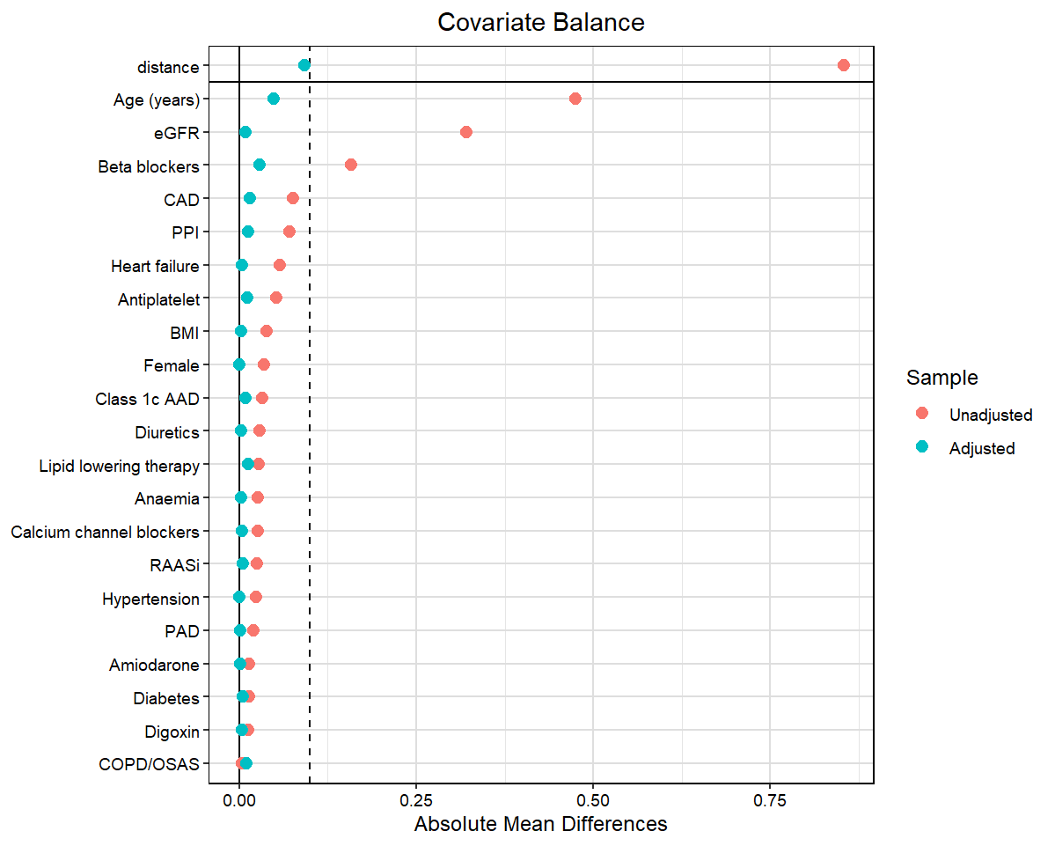

Supplementary Figure 2. Kaplan Meier Survival Curves of all-cause mortality (Panel A) and Cumulative Incidence Function plots for cardiovascular (CV) events (Panel B) and bleedings (Panel C). All analyses were stratified by estimated glomerular filtration rate (eGFR) class.
A
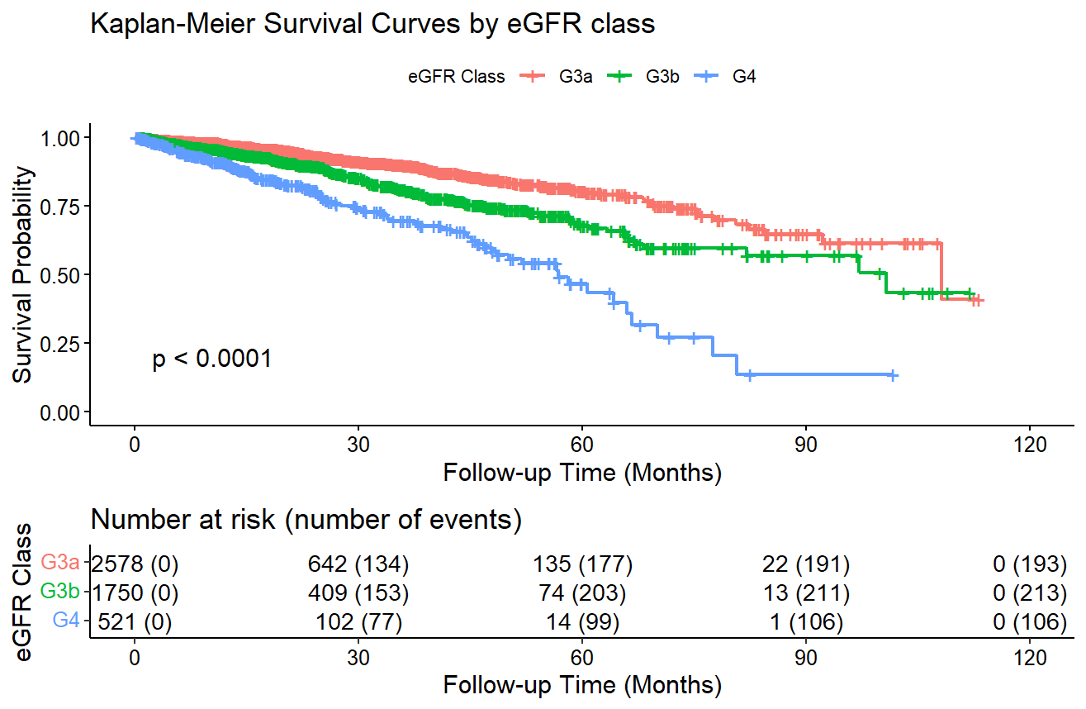
B
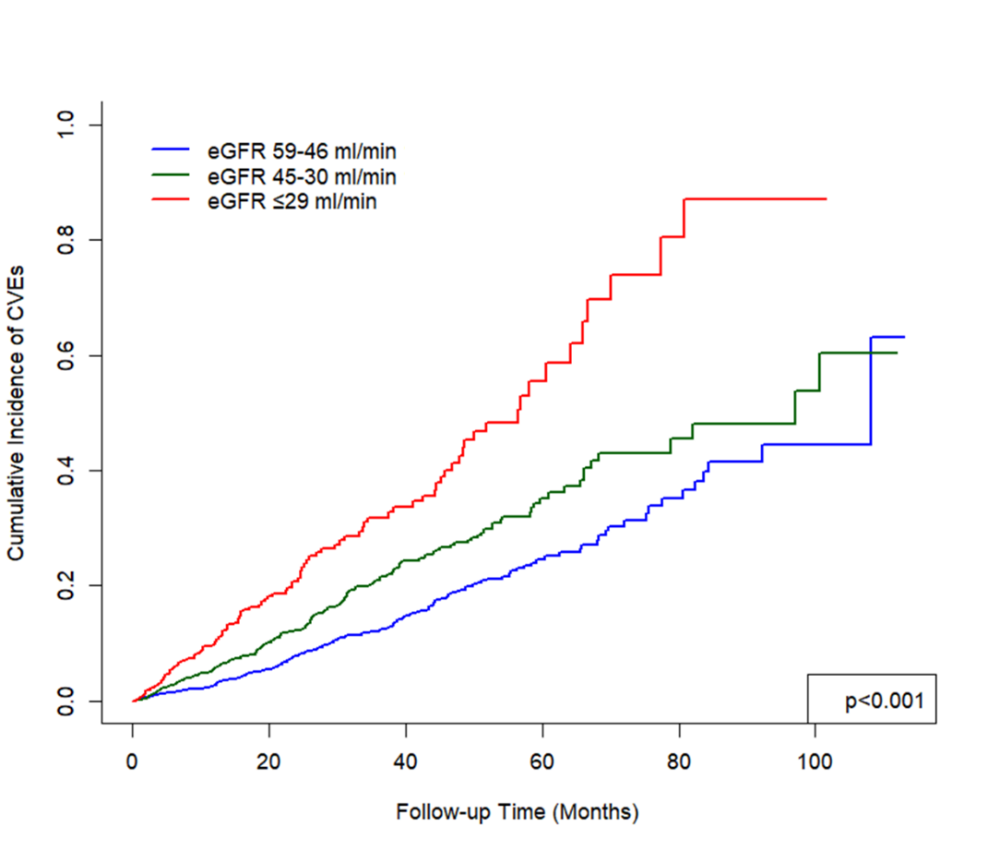
*There were no competing events for CVEs
C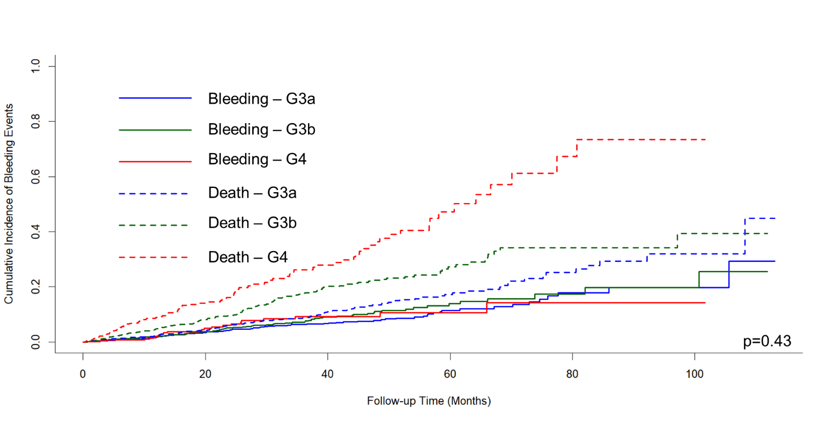

Supplementary Figure 3. Kaplan Meier Survival Curves of all-cause mortality (Panel A) and Cumulative Incidence Function plots for cardiovascular events (Panel B) and bleedings (Panel C) according to type of direct oral anticoagulant (DOAC). Patients on VKA were excluded.
A
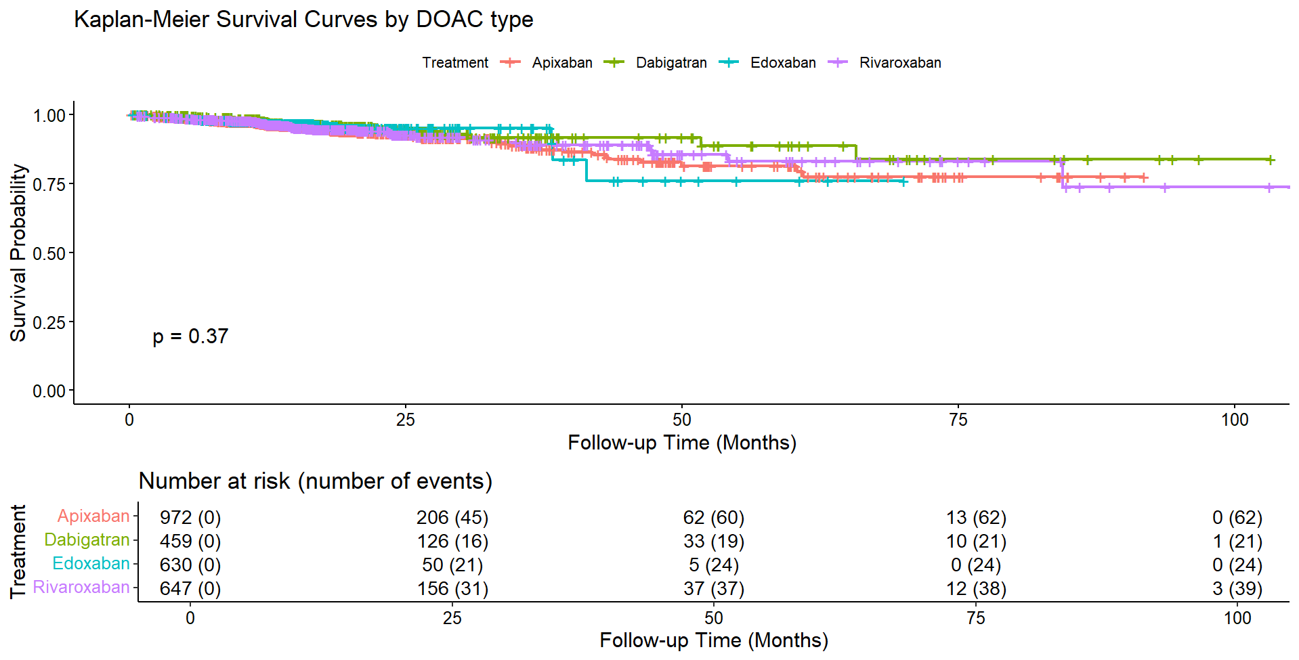
B
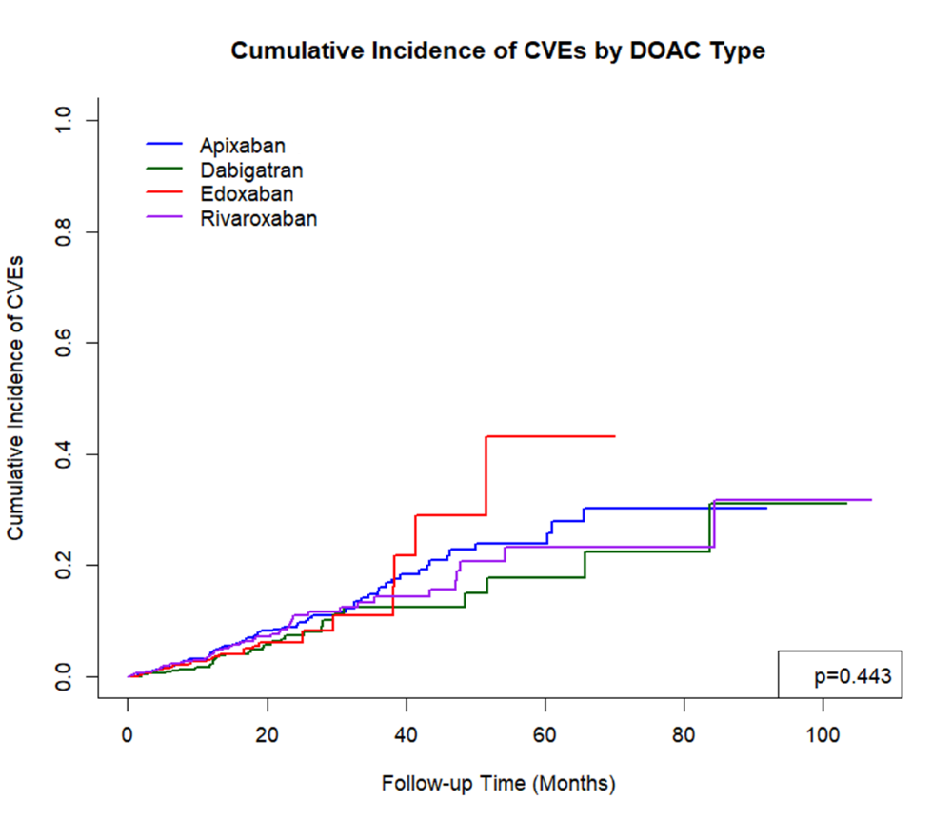
*There were no competing events for CVEs

C
