AF Treatment |  | Ablation (n=45) | Cardioversion (n=35) | p value
Age (years) | median (25-75%) | 72.0 (68.0-79.5) | 75.8 (72.0-82.0) | 0.03
Female gender | N (%) | 23 (51.1) | 20 (57.1) | 0.59
BMI (kg/m2) | mean ± SD | 25.9 ± 4.8 | 26.8 ± 6.3 | 0.22
CHA2DS2-VASc | median (25-75%) | 3.5 (2.0-4.0) | 4.0 (3.0-5.0) | 0.18
Arterial hypertension | N (%) | 27 (62.5) | 23 (65.7) | 0.60
Coronary artery disease | N (%) | 16 (35.6) | 9 (25.7) | 0.35
Myocardial infarction | N (%) | 5 (11.1) | 3 (8.6) | 0.70
Congestive heart failure | N (%) | 12 (26.7) | 16 (45.7) | 0.08
ICD/Pacemaker | N (%) | 7 (15.6) | 5 (14.3) | 0.96
Cardiac resynchronization therapy | N (%) | 1 (2.2) | 1 (2.9) | 0.88
COPD | N (%) | 5 (11.1) | 4 (11.4) | 0.96
Diabetes | N (%) | 4 (13.3) | 7 (20.0) | 0.42
Persistent AFL/AT | N (%) | 8 (17.8) | 0 (0.0) | 0.02
Echocardiographic parameters
Moderate to severe Mitral valve regurgitation (Grade 2-3) | N (%) | 30 (66.7) | 29 (82.9) | 0.13
Grade 2 MR | N (%) | 26 (57.7) | 21 (60.0) | 0.82
Grade 3 MR | N (%) | 4 (8.9) | 8 (22.8) | 0.09
Moderate to Severe Tricuspid valve regurgitation (Grade 2-5) | N (%) | 32 (71.1) | 23 (71.4) | 1.0
Grade 2 TR | N (%) | 24 (53.3) | 17 (48.6) | 0.29
Grade 3 TR | N (%) | 6 (13.3) | 6 (17.1) | 0.77
Grade 4 TR | N (%) | 1 (2.2) | 2 (5.7) | 0.58
Grade 5 TR | N (%) | 1 (2.2) | 0 (0.0) | 1.00
Baseline Symptoms
Dyspnea | N (%) | 31 (68.9) | 31 (88.6) | 0.04
EHRA Class I | N (%) | 4 (8.9) | 1 (2.9) | 0.36
EHRA Class IIA | N (%) | 6 (13.3) | 5 (14.3) | 1.00
EHRA Class IIB | N (%) | 15 (33.3) | 7 (20) | 0.20
EHRA Class III | N (%) | 18 (40.0) | 16 (46) | 0.66
EHRA Class IV | N (%) | 2 (4.4) | 6 (17) | 0.03
Medication after discharge
Class Ic AAD | N (%) | 1 (2.2) | 1 (2.2) | 1.0
Class III AAD | N (%) | 7 (15.6) | 13 (37.1) | 0.04
Beta Blocker | N (%) | 42 (93.3) | 31 (88.6) | 0.69
Digitoxin | N (%) | 1 (2.2) | 1 (2.2) | 1.00
Table S1: Baseline characteristics according to AF treatment; SD=standard deviation, BMI= Body mass index, COPD= chronic obstructive pulmonary disease, AF=Atrial fibrillation; AFL=atrial flutter; EHRA=European Heart Association; AAD=Antiarrhythmic drug

 | Baseline | 3 month FU | 12 month FU
Grade 3 | 12 (20.3%, 12.0–32.3%) | 8 (13.6%, 7.0–24.5%) | 8 (13.6%, 7.0–24.5%)
Grade 2 | 47 (79.7%, 67.7–88.0%) | 18 (30.5%, 20.3–43.1%) | 14 (23.7%, 14.7–36.0%)
Grade 1 | 0 | 33 (55.9%, 43.3–67.8%) | 33 (55.9%, 43.3–67.8%)
Table S2: Distribution of mitral regurgitation severity at baseline, 3 months and 12 months FU. Data are presented as number of patients (percentage) with 95% confidence intervals.

 | Baseline | 3 month FU | 12 month FU
Grade 5 | 1 (1.8%, 0.3–9.3%) | 1 (1.8%, 0.3–9.3%) | 0 (0.0%, 0.0–6.3%)
Grade 4 | 3 (5.3%, 1.8–14.4%) | 2 (3.5%, 1.0–11.9%) | 1 (1.8%, 0.3–9.3%)
Grade 3 | 12 (21.1%, 12.5–33.3%) | 2 (3.5%, 1.0–11.9%) | 7 (12.3%, 6.1–23.2%)
Grade 2 | 41 (71.9%, 59.2–81.9%) | 21 (36.8%, 25.5–49.8%) | 13 (22.8%, 13.8–35.2%)
Grade 1 | 0 | 31 (54.4%, 41.6–66.6%) | 29 (50.9%, 38.3–63.4%)
Table S3: Distribution of tricuspid regurgitation severity at baseline, 3 months and 12 months FU. Data are presented as number of patients (percentage) with 95% confidence intervals.

 | Rhythm at 3M follow up | Baseline | Follow up | p value  Baseline vs. follow up | p value  SR vs. AF/AFL
Heart rate | Sinus | 114±22 | 66±10 | <0.001
 | Recurrence | 108±24 | 87±18 | 0.006 | 0.001
LVEF [%], mean (±SD) | Sinus | 46±13 | 54±11 | <0.001
 | Recurrence | 49±13 | 51±12 | 0.548 | 0.387
LVEDD [mm], (±SD) | Sinus | 49.5 (41.75-56.25) | 49 (44.5-55) | 0.668
 | Recurrence | 45.5 (41.5-56.25) | 49 (44-55) | 0.419 | 0.728
Left atrial diameter [mm], median (IQR) | Sinus | 49.5 (45-56) | 46 (42-50) | 0.028
 | Recurrence | 49.5 (41-53.25) | 46 (39.25-49.75) | 0.53 | 0.596
Left atrial volume [ml], median (IQR) | Sinus | 107 (80-125) | 84.5 (67.3-111.5) | <0.001
 | Recurrence | 85 (68.5-103) | 82 (60-115) | 0.625 | 0.908
Vena contracta [mm], median (IQR) | Sinus | 6 (4-7) | 3 (2-4) | 0.001
 | Recurrence | 4.65 (3.9-5) | 5 (3.5-5.4) | 0.799 | 0.008
Mitral annulus diameter - 4CH [mm], mean (±SD) | Sinus | 42.2±4.8 | 41.8±4.3 | 0.439
 | Recurrence | 41.4±4.5 | 42.6±4.7 | 0.221 | 0.542
Mitral annulus diameter - PLAX [mm], mean (±SD) | Sinus | 41.1±3.8 | 40.9±4.6 | 0.788
 | Recurrence | 39.9±3.1 | 41.9±4 | 0.072 | 0.445
Coaption depth - PLAX [mm], median (IQR) | Sinus | 5 (4-6.8) | 4 (2-7) | 0.187
 | Recurrence | 4.6 (2-7) | 6 (3-8) | 0.411 | 0.422
Table S4: Comparison of MR patient characteristics between baseline and 3 months follow-up depending on rhythm at follow-up. SD = standard deviation; IQR = interquartile range; FU = Follow-up; SR=sinus rhythm, LVEF = left ventricular ejection fraction, LVEDD = left ventricular enddiastolic dimension, LAD = left atrial diameter, LAV = left atrial volume, 4CH = apical four chamber view, PLAX = parasternal long axis, NYHA = New York Heart Association.

 | Rhythm at 3M follow up | Baseline | Follow up | p value  Baseline vs. follow up | p value  SR vs. AF/AFL
Heart rate, n/min., mean (±SD) | Sinus | 109±24 | 69±11 | <0.001
 | Recurrence | 106±25 | 81±15 | 0.009 | 0.005
LVEF (%), median (IQR) | Sinus | 50 (35-60) | 55 (47-63) | <0.001
 | Recurrence | 50 (46-60) | 55 (64) | 0.35 | 0.953
RVIT (mm), median (IQR) | Sinus | 41 (35-47) | 39 (36-45) | 0.062
 | Recurrence | 39.5 (37-48) | 37.9 (34.3-46.5) | 0.13 | 0.943
TAPSE (mm), median (IQR) | Sinus | 16 (15-23) | 21 (18.5-24.5) | 0.025
 | Recurrence | 17 (14-19) | 17 (15-19) | 0.786 | 0.005
PAP (mmHg), mean (±SD) | Sinus | 41±12 | 40±11 | 0.741
 | Recurrence | 49.5±9.7 | 43.8±14.1 | 0.258 | 0.763
RAD (mm), median (IQR) | Sinus | 42.75 (38.25-51) | 38 (35-45) | 0.002
 | Recurrence | 44 (40.5-54) | 44.5(38.3-52.8) | 0.504 | 0.046
RAV (ml), median (IQR) | Sinus | 71 (56.25-90) | 54 (45-64) | <0.001
 | Recurrence | 73.5 (56.3-100.8) | 69 (46-107) | 0.021 | 0.15
Vena contracta (mm), median (IQR) | Sinus | 6 (5-7) | 3 (2-4) | <0.001
 | Recurrence | 5.8 (4.9-6.4) | 4 (2.8-4.9) | 0.2 | 0.3
Table S5: Comparison of TR patient characteristics between baseline and 3 months follow-up depending on rhythm at follow-up. SD = standard deviation; IQR = interquartile range; FU = Follow-up, LVEF = left ventricular ejection fraction, RVIT = right ventricular inflow tract, TAPSE = Tricuspid annular plane systolic excursion, PAP = pulmonary artery pressure RAD = right atrial diameter, RAV = right atrial volume, NYHA = New York Heart Association

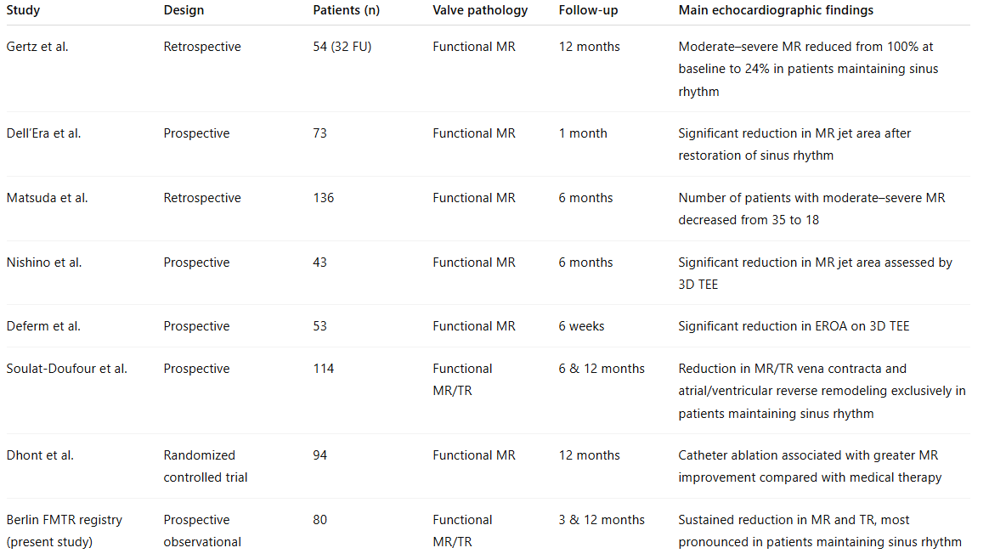
Table S6: Prior studies investigating the effect of sinus rhythm restoration on functional mitral and tricuspid regurgitation in patients with atrial fibrillation

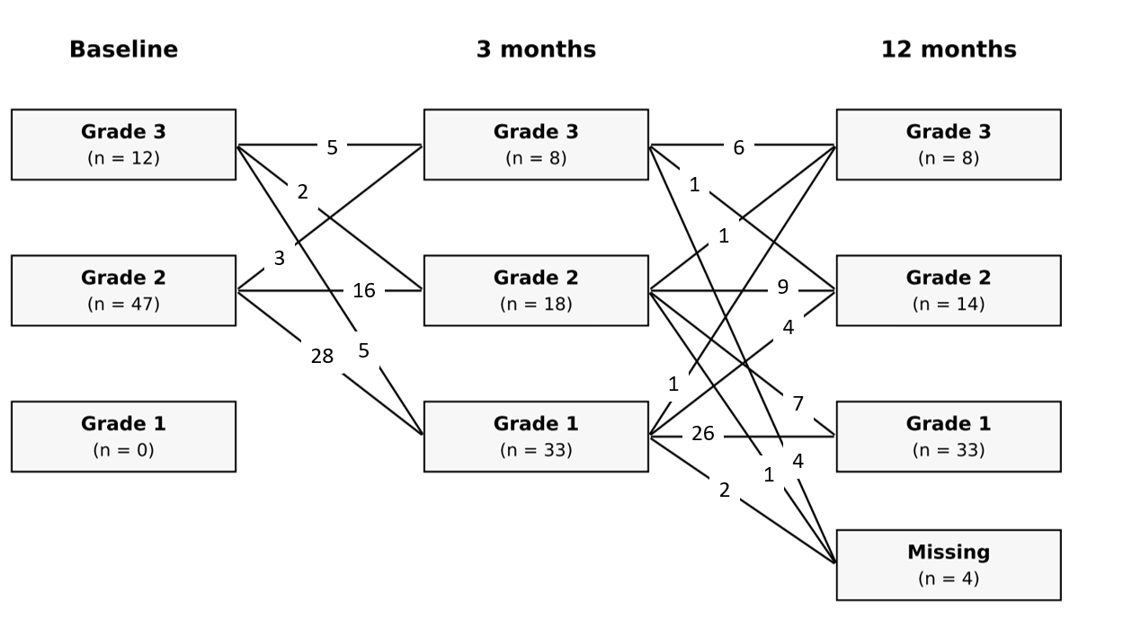
Figure S1: Shift Plot for patients presenting with at least moderate mitral insufficiency at baseline

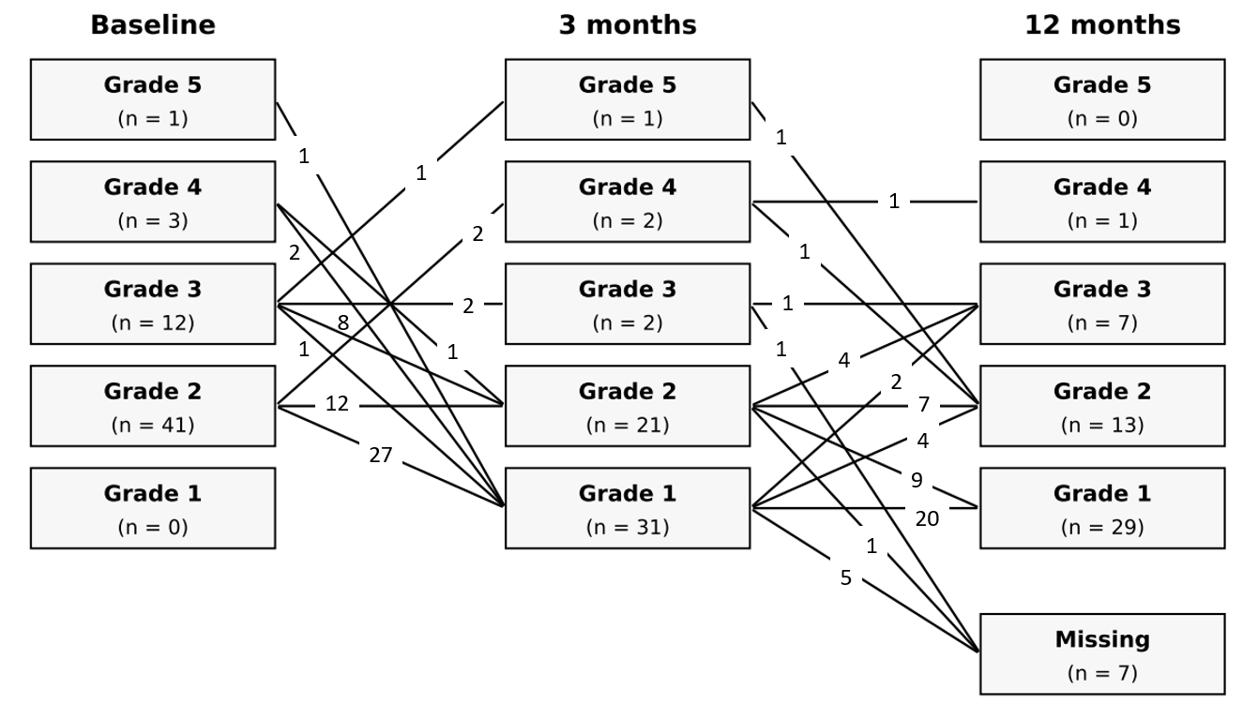
Figure S2: Shift Plot for patients presenting with at least moderate tricuspid insufficiency at baseline

Figure S4: MR severity at baseline and at 3 months follow-up in patients in SR vs. recurrent AF (shown in %). Patients lost to follow-up are excluded from the analysis)

Figure S5: TR severity at baseline and at 3 months follow-up in patients in SR vs. recurrent AF (shown in %). Patients lost to follow-up are excluded from the analysis)

