Transcatheter Mitral Valve Edge-to-edge Repair for Severe Mitral Regurgitation in Patients with HFpEF phenotype
Johannes Dohr¹, Clemens Metze¹, Maria Isabel Körber¹, Matthieu Schäfer¹, Stephan Nienaber¹, Jonathan Curio¹, Richard Nies¹, Stephan Baldus¹, Roman Pfister¹, Christos Iliadis¹

¹ University of Cologne, Faculty of Medicine and University Hospital Cologne, Department III for Internal Medicine, Cologne, Germany

Short title: TEER for Mitral Regurgitation in Patients with HFpEF phenotype

Corresponding author:
Christos Iliadis, MD
Department of Cardiology, Heart Center Cologne, Faculty of Medicine and University Hospital, University of Cologne, Cologne, Germany, Kerpener Straße 62, 50937 Cologne, Germany
E-mail: christos.iliadis@uk-koeln.de
Tel.: +49 221 478 32495

Supplementary Information

Supplementary Figure 1:
Clinically relevant improvement after TEER according to H2FPEF and HFA-PEFF definition a: MLWHFQ-score (all p<0.001), b: SF-PCS-score (all p<0.001), c: SF-MCS-score H2FPEF p=0.156, HFA-PEFF-score p=0.038, d: 6MWD (all p<0.001).

Supplementary Table 1:
Quantification of MV parameters with increasing complexity of TEER procedures for severe MR in patients available; MR = Mitral regurgitation, MV Mitral Valve, PML = Posterior Mitral Leaflet.

Supplementary Figure 1:
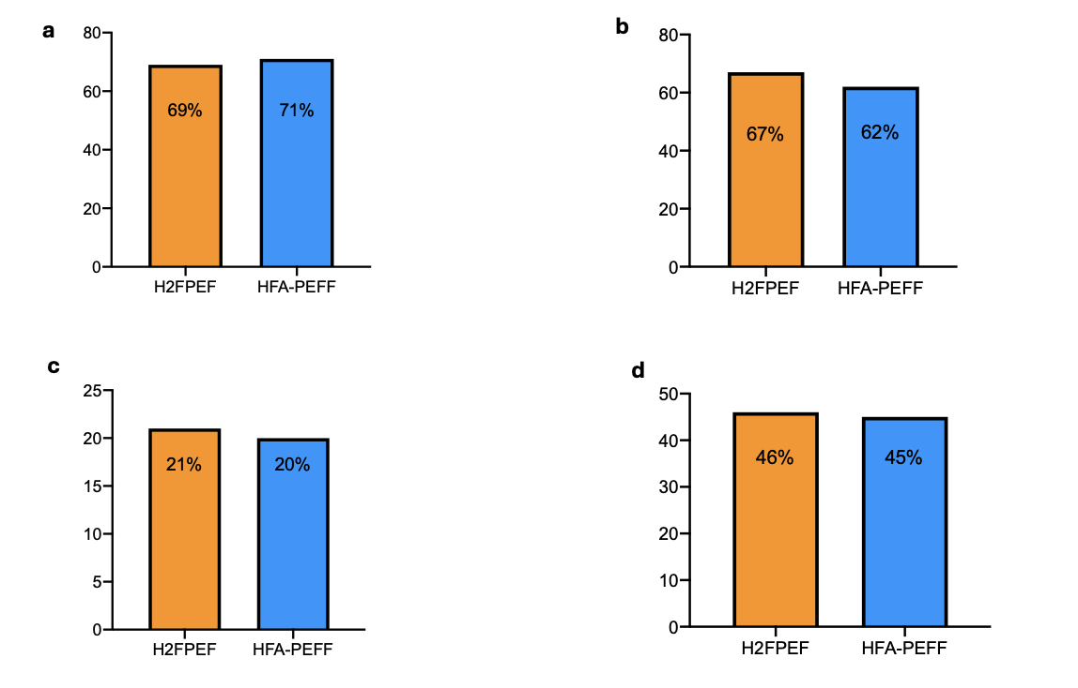

Supplementary Table 1:

MV criteria for complex TEER procedure | N
Total number of patients fulfilling ≥1 of criteria below | 57
Total number of patients fulfilling ≥2 of criteria below | 46
Flail width >15 mm | 11
Coaptation depth ≥11 mm | 3
Coaptation gap >2 mm | 2
MR jet in segment 1 or 3 | 11
MV orifice area <4 cm² | 19
PML length 7-10 mm | 36
Insufficient leaflet material | 11
More than two clips required due to jet across the entire commissure | 18
Systolic leaflet restriction | 22

