Supplementary Material, Clinical Research in Cardiology:
Head-to-Head Comparison of Non-Invasive Markers of Atrial Cardiomyopathy and Their Association With Arrhythmia Recurrence After Atrial Fibrillation Ablation
Laura Dippel^{1,2}, Denis Fedorov¹, Heiko Lehrmann¹, Julian Müller¹, Amir Jadidi ^{1,3}, Dirk Westermann¹, Thomas Arentz¹, Martin Eichenlaub¹

¹ Department of Cardiology and Angiology
University Heart Center Freiburg-Bad Krozingen,
Suedring 15, 79189 Bad Krozingen, Germany

² Peter Osypka Institute for Medical Technology
Offenburg University of Applied Sciences
Badstrasse 24, 77652 Offenburg, Germany

³ Arrhythmia and Electrophysiology Section
Heart Center Lucerne
Lucerne Cantonal Hospital
Spitalstrasse 31, 6000 Lucerne, Switzerland

Corresponding author:
Dr. Martin Eichenlaub
martin.eichenlaub@uniklinik-freiburg.de

Fig. S1 Correlation of invasive interatrial activation time with non-invasive AtCM markers
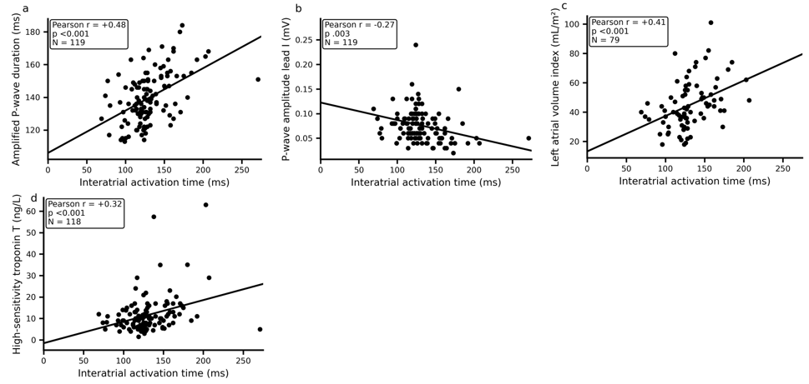
Scatter plots illustrate the relationship between interatrial activation time and (a) amplified P-wave duration, (b) P-wave amplitude in lead I, (c) left atrial volume index and (d) high-sensitivity troponin T. Pearson correlation coefficients (r), corresponding P-values, and sample sizes (N) are provided in each panel. Solid lines represent linear regression fits.

