Supplementary information
 | Observations
Treatment | Raw | Weighted
No-IABP (n) | 124 | 133.4
Non-rescue-IABP (n) | 213 | 131.8
Rescue-IABP (n) | 58 | 129.9
Total | 395 | 395.0
 |  | Standardized differences |  | Variance ratio
 |  | Raw | Weighted | Raw | Weighted
Non-rescue-IABP | Age | -0,505 | 0,074 | 1,141 | 0,674
 | Female gender | 0,171 | 0,054 | 1,129 | 1,039
 | AAR-category
 | 1 | 0,330 | -0,059 | 1,317 | 0,963
 | 2 | 0,115 | 0,085 | 1,063 | 1,062
 | PAD | 0,430 | 0,098 | 3,237 | 1,258
 | Nicotin use | -0,212 | 0,076 | 0,880 | 1,055
Rescue-IABP | Age | -0,452 | 0,085 | 0,874 | 0,530
 | Female gender | 0,152 | -0,018 | 1,132 | 0,986
 | AAR-category
 | 1 | 0,317 | -0,040 | 1,326 | 0,975
 | 2 | -0,136 | 0,094 | 0,900 | 1,068
 | PAD | 0,356 | 0,159 | 2,874 | 1,422
 | Nicotin use | 0,005 | 0,076 | 1,011 | 1,056
Supplementary Table 1: Covariate balance before and after augmented inverse-probability weighting (AIPW). Standardized differences are presented for all included covariates before and after AIPW adjustment. Following weighting, excellent covariate balance was achieved, with standardized differences <0.1 for all variables. Abbreviations: IABP, intra-aortic balloon pump; AAR, area at risk; PAD, peripheral artery disease.

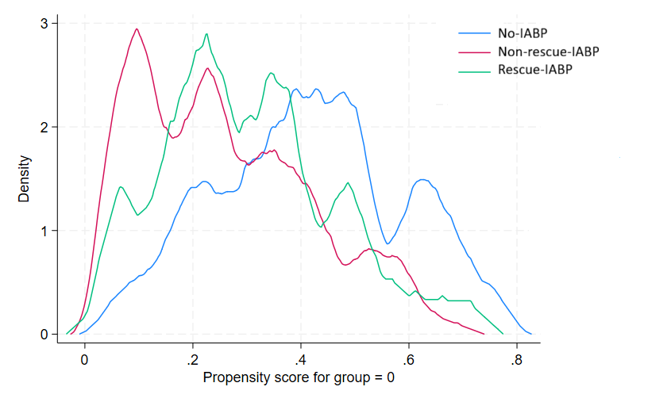
Supplementary Figure 1: Overlap plots demonstrating common support for propensity-based analyses. Adequate overlap between groups indicates sufficient common support, supporting the validity of the augmented inverse-probability weighting (AIPW) analysis. Abbreviation: IABP, intra-aortic balloon pump.

