Supplementary Material
Longitudinal EASIX Trajectories and Mortality Risk in Chronic Heart Failure
Author details
Bent Estler, Dr. med.¹, Hanna Fröhlich, Prof. Dr. med.¹, Tobias Täger, Prof. Dr. med.¹, Hauke Hund, Dipl. Info.², Jannick Heins, Dr. med.¹Norbert Frey, Prof. Dr. med.¹, Thomas Luft, Prof. Dr. Dr. med.^{3*}, Lutz Frankenstein, Prof. Dr. med.^{1*}
Affiliations
¹ Department of Cardiology, Angiology and Pulmology, University Hospital Heidelberg, Im Neuenheimer Feld 410, 69120 Heidelberg, Germany
² Research Data Warehouse, Department of Cardiology, Angiology and Pulmology, University Hospital Heidelberg, Im Neuenheimer Feld 410, 69120 Heidelberg, Germany
³ Department of Hematology, Oncology and Rheumatology, University Hospital Heidelberg, Im Neuenheimer Feld 410, 69120 Heidelberg, Germany
* Shared last authorship
Corresponding author
Prof. Dr. med. Lutz Frankenstein
Department of Cardiology, Angiology and Pulmology
University Hospital Heidelberg
Im Neuenheimer Feld 410, 69120 Heidelberg, Germany
Supplementary material structure
This supplement contains the additional supplementary figures first, followed by the supplementary tables.

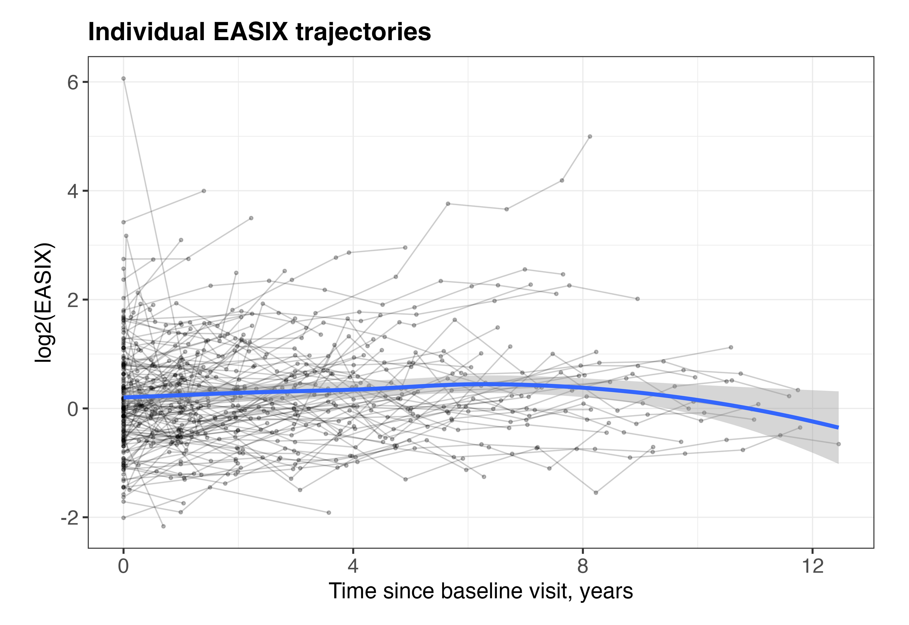Supplementary Figure 1. Individual longitudinal EASIX trajectories.
Individual log2(EASIX) trajectories are shown for a random sample of patients with chronic heart failure and at least two available EASIX measurements. Grey lines represent individual patient trajectories, and the blue line represents the smoothed overall trajectory with 95% confidence interval.
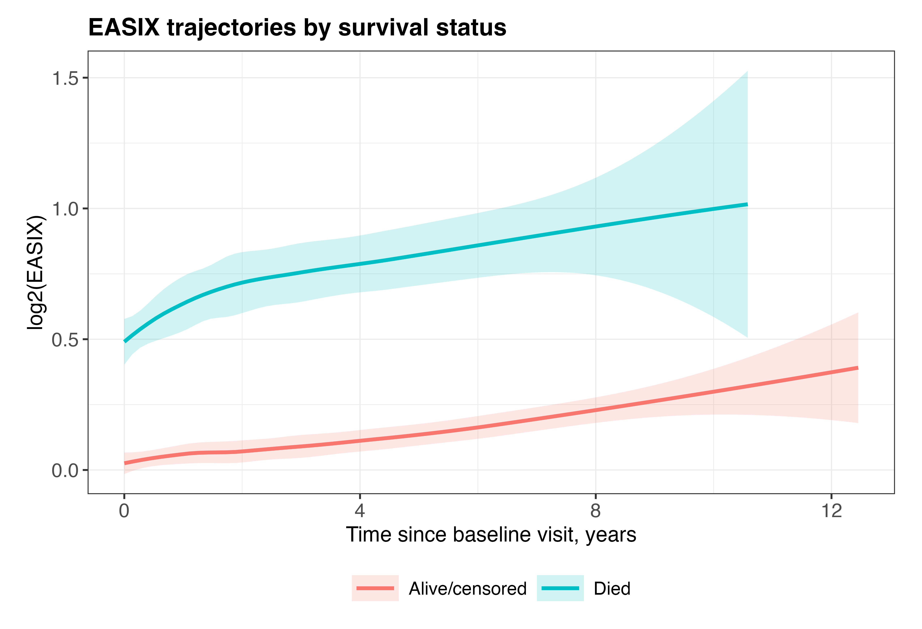
Supplementary Figure 2. Longitudinal EASIX trajectories by survival status.
Smoothed longitudinal log2(EASIX) trajectories are shown according to survival status during follow-up. Shaded areas indicate 95% confidence intervals.

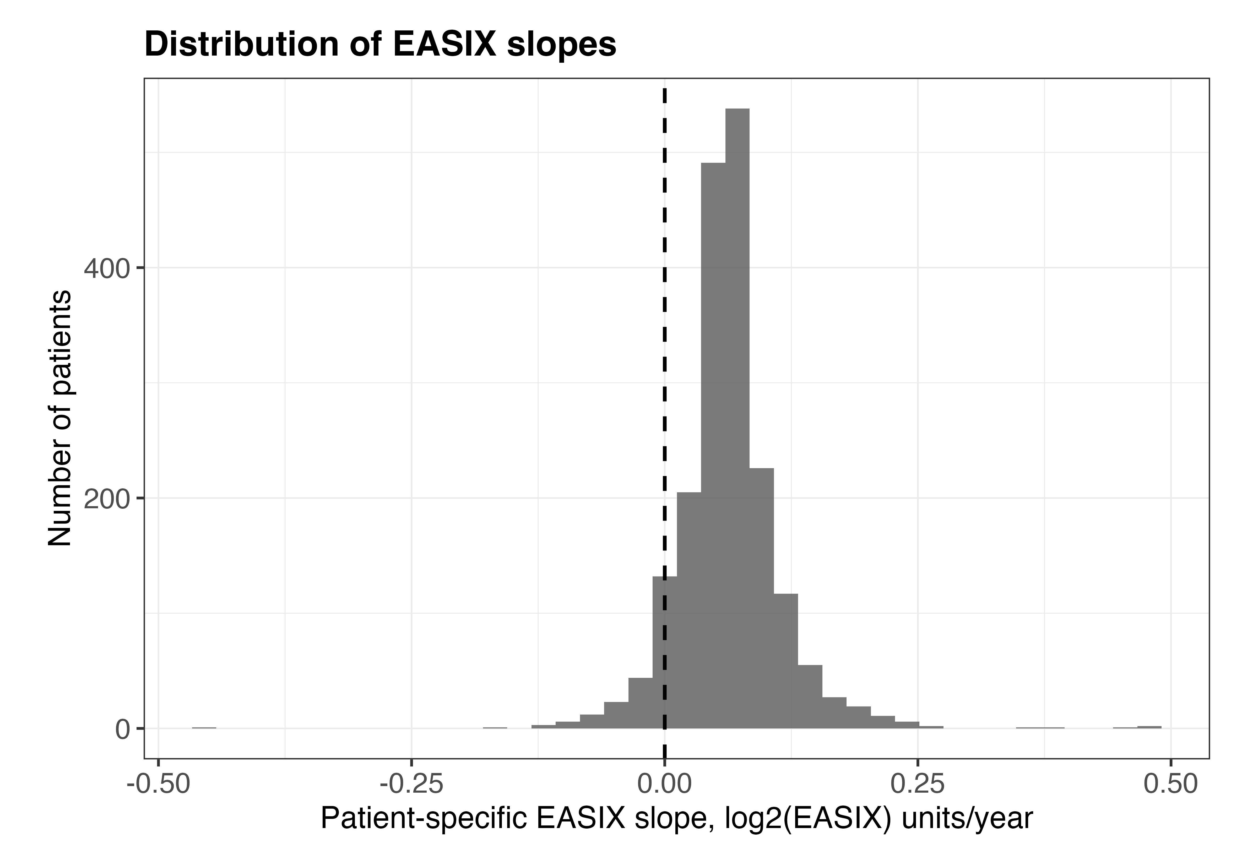Supplementary Figure 3. Distribution of patient-specific EASIX slopes.
Histogram showing the distribution of patient-specific EASIX slopes derived from the linear mixed-effects model. Slopes are expressed as change in log2(EASIX) units per year. The dashed vertical line indicates no longitudinal change.

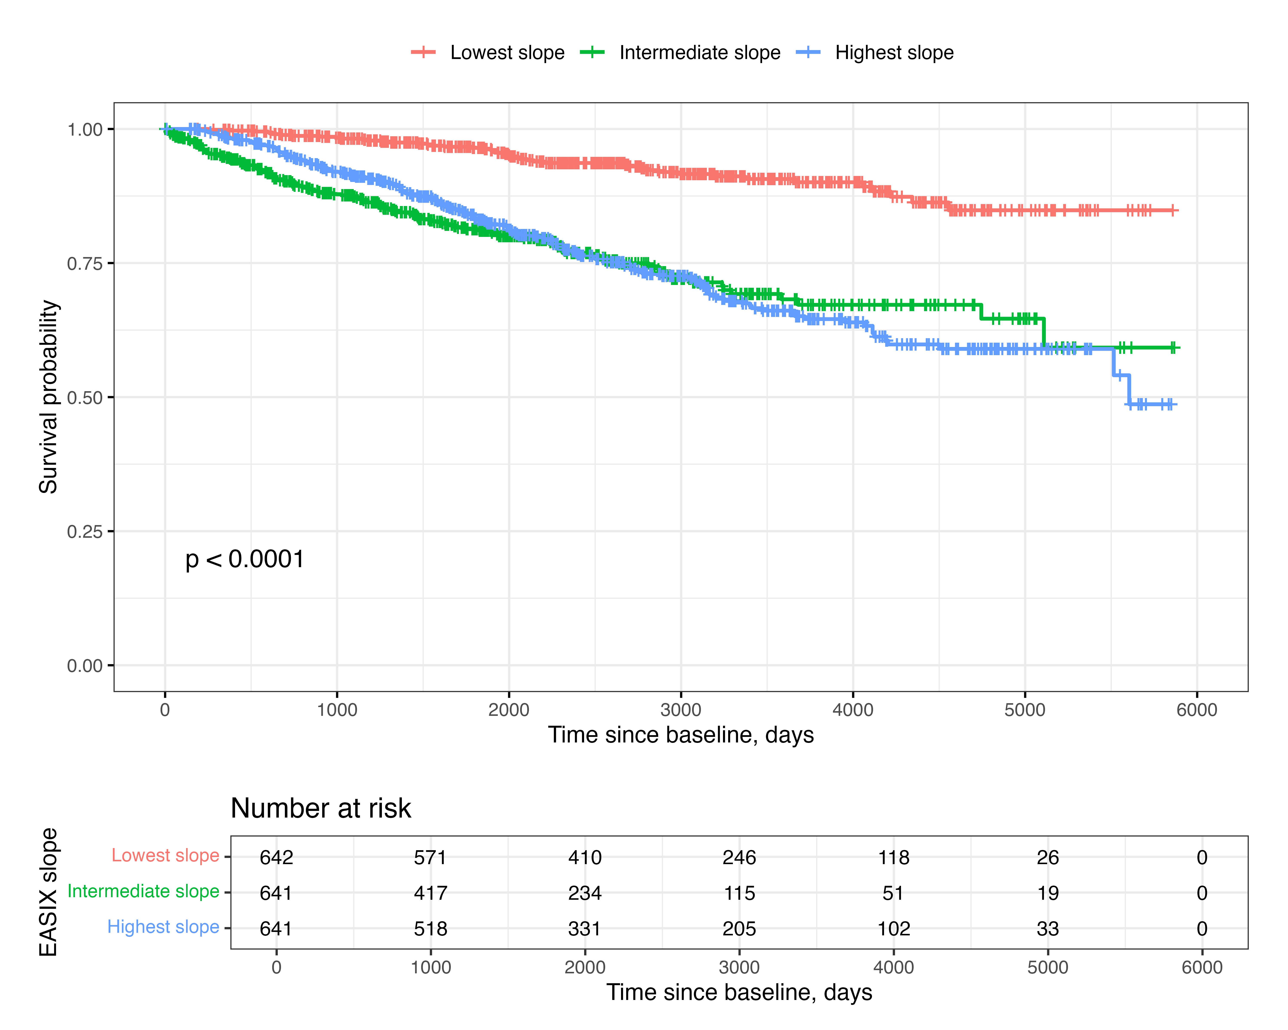Supplementary Figure 4. Survival according to EASIX slope tertiles.
Kaplan–Meier curves showing survival according to tertiles of patient-specific EASIX slope. Patients in the highest slope tertile showed the lowest survival probability during follow-up. The risk table indicates the number of patients at risk over time.

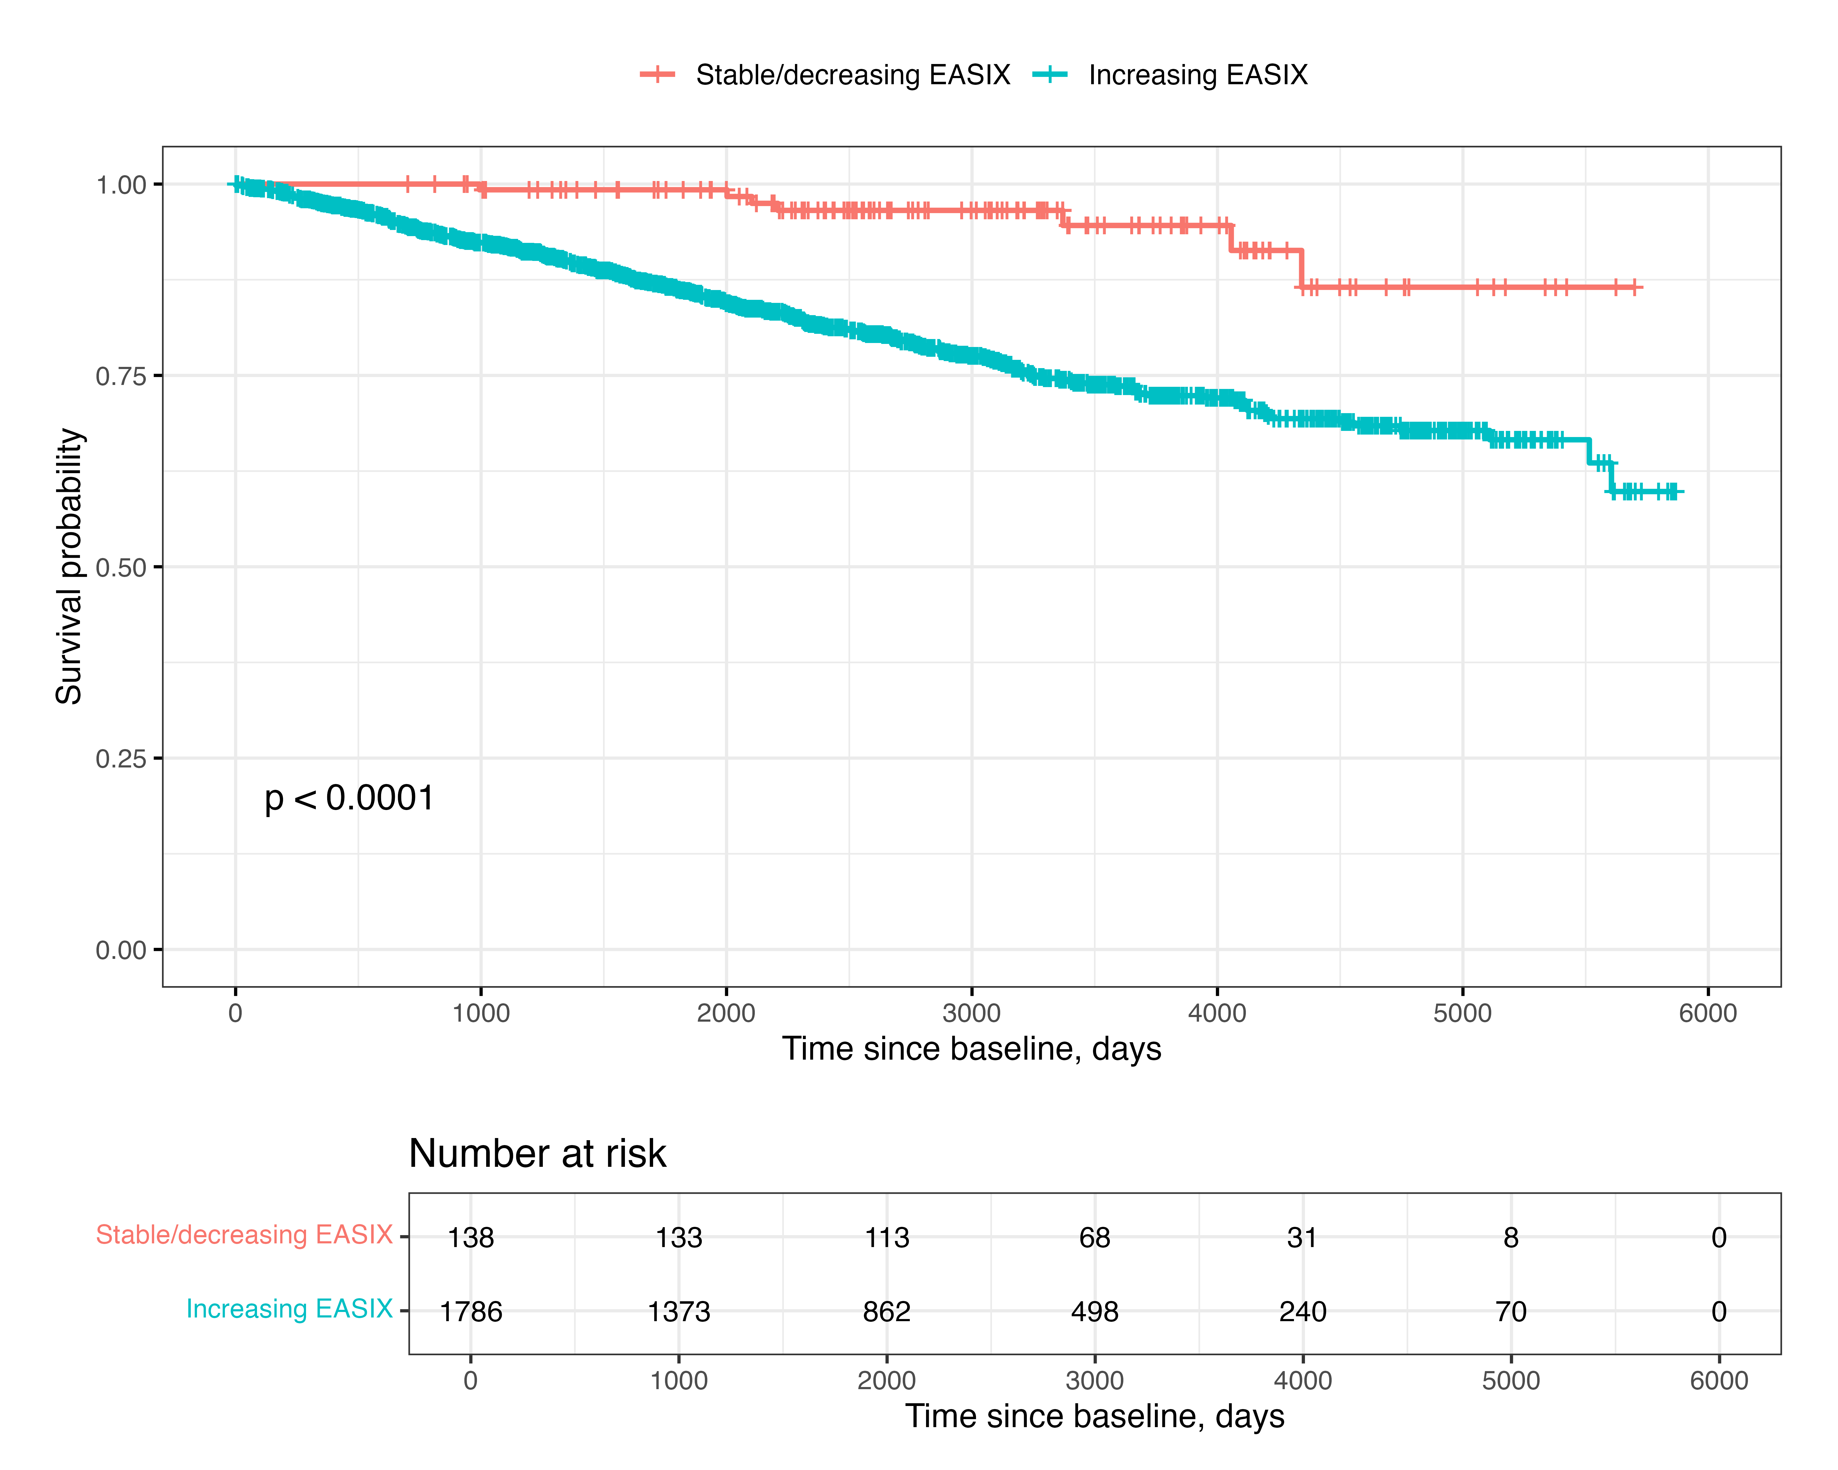Supplementary Figure 5. Survival according to increasing versus stable/decreasing EASIX.
Kaplan–Meier curves comparing patients with increasing EASIX slopes to those with stable or decreasing EASIX slopes. The risk table indicates the number of patients at risk over time.

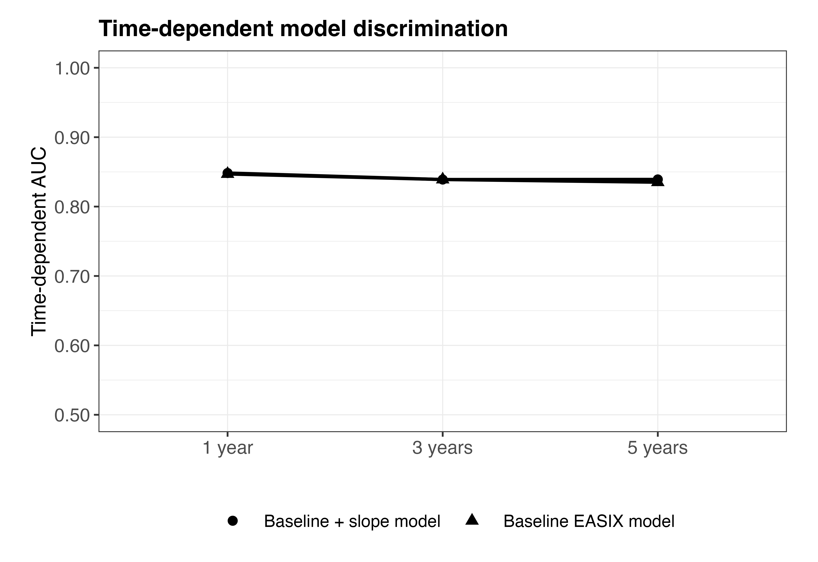Supplementary Figure 6. Time-dependent model discrimination.
Time-dependent area under the curve (AUC) at 1, 3, and 5 years is shown for the baseline EASIX model and the model including baseline EASIX plus patient-specific EASIX slope.

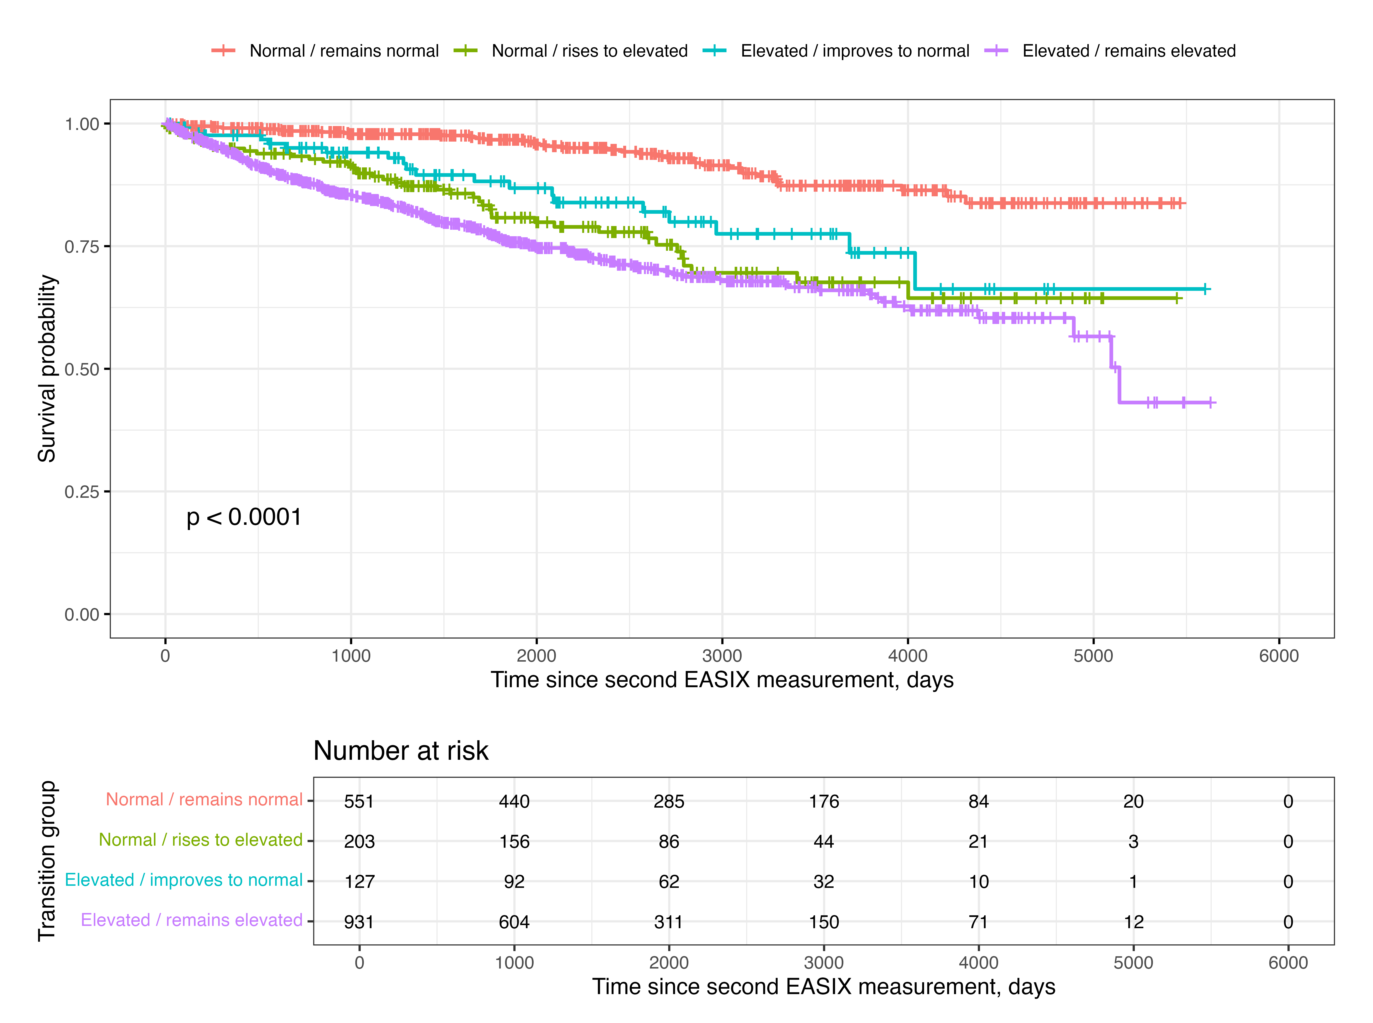Supplementary Figure 7. Survival according to early EASIX transition groups using the 0.88 cut-off.
Kaplan–Meier curves showing survival after the second EASIX measurement according to early transition groups defined using the established EASIX cut-off of 0.88. Follow-up was landmarked at the second EASIX measurement. The risk table indicates the number of patients at risk over time.

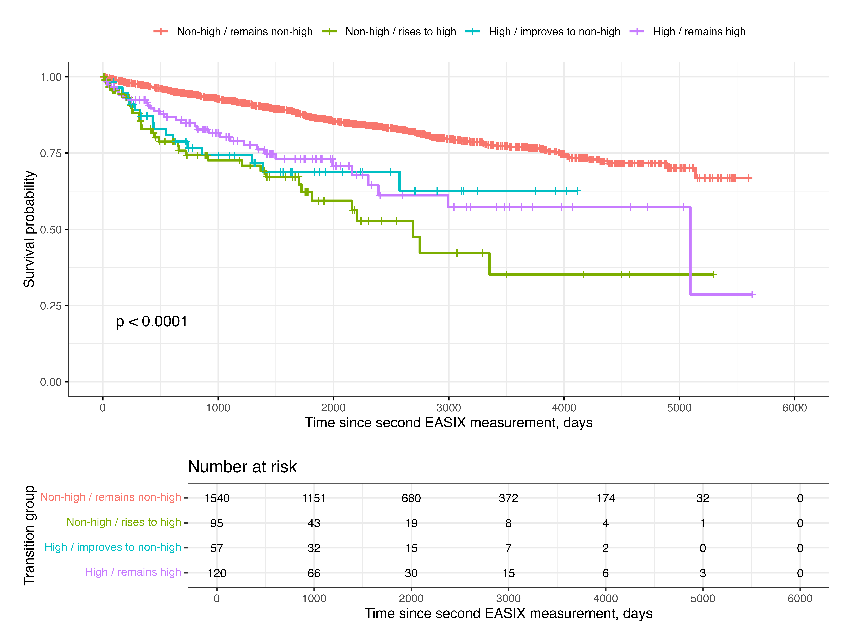Supplementary Figure 8. Survival according to early EASIX transition groups using the 2.32 cut-off.
Kaplan–Meier curves showing survival after the second EASIX measurement according to early transition groups defined using the established EASIX cut-off of 2.32. Follow-up was landmarked at the second EASIX measurement. The risk table indicates the number of patients at risk over time.

Supplementary Figure 9. Baseline phenotype by early EASIX transition group.
Baseline clinical phenotype across the four early EASIX transition groups. Panels show the distribution of NYHA functional class, left ventricular ejection fraction, log2-transformed NT-proBNP, and heart failure aetiology.
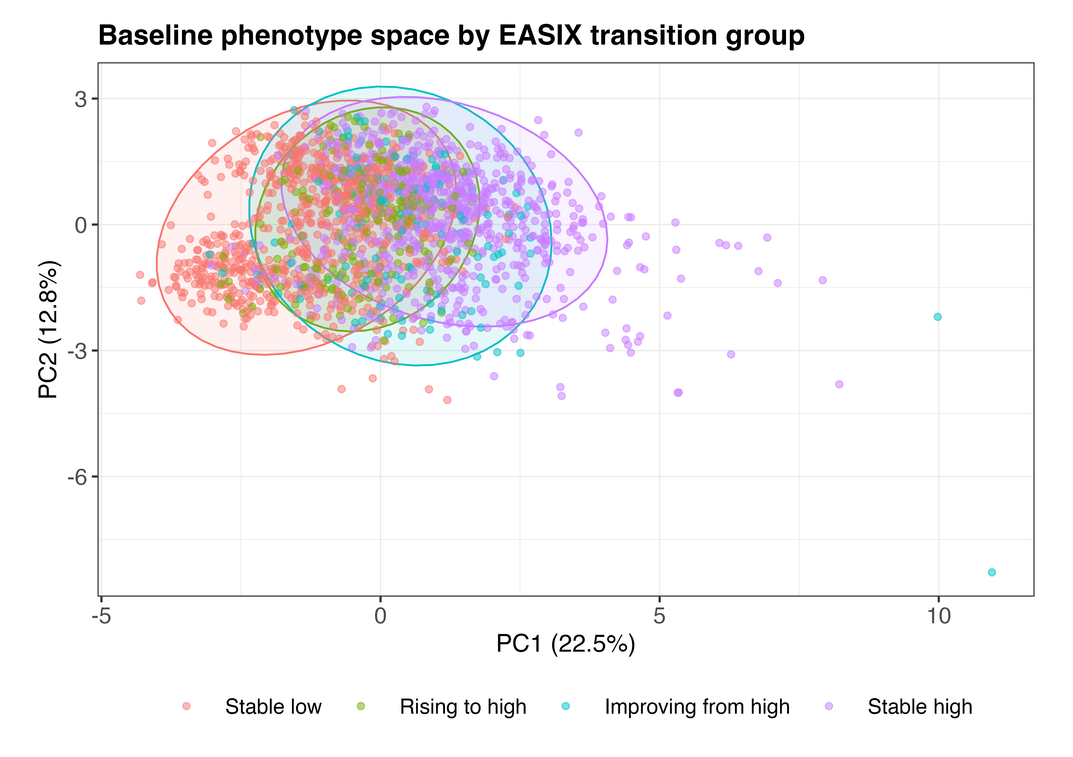
Supplementary Figure 10. Baseline phenotype space according to early EASIX transition group.
Principal component analysis of baseline clinical and biomarker variables. Patients are plotted according to the first two principal components and coloured by early EASIX transition group. Ellipses indicate group-level distributions.
Supplementary Figure 11. Principal component analysis of baseline phenotype.
The upper panel shows the proportion of variance explained by the first principal components. The lower panels show the main variable loadings for the first and second principal components, indicating the baseline clinical and biomarker variables contributing most strongly to the phenotype space.
Supplementary Figure 12. Incremental prognostic value of dynamic EASIX beyond creatinine alone.
Model comparison of first-to-second transition analyses showed that EASIX transition provided stronger model fit and discrimination than an analogous creatinine transition model. Likelihood-ratio testing demonstrated that adding EASIX transition to a model already containing creatinine transition significantly improved model fit, whereas the reverse was not significant. In the mutually adjusted Cox model, rising to high EASIX and stable high EASIX remained associated with mortality, supporting prognostic information beyond longitudinal creatinine changes alone.

Supplementary Table 1. Linear mixed-effects model for longitudinal log2(EASIX).
Characteristic | Beta | 95% CI | P value
Time since baseline, per year | 0.06 | 0.05, 0.07 | <0.001
Age, years | 0.01 | 0.01, 0.01 | <0.001
Sex
Male | — | —
Female | -0.54 | -0.61, -0.47 | <0.001
LVEF, % | 0.00 | 0.00, 0.01 | 0.002
NYHA class
NYHA class, linear trend | 0.22 | 0.02, 0.43 | 0.032
NYHA class, quadratic trend | -0.02 | -0.18, 0.13 | 0.800
NYHA class, cubic trend | -0.02 | -0.11, 0.07 | 0.700
log2(NT-proBNP + 1) | 0.17 | 0.15, 0.18 | <0.001
Beta coefficients are from the adjusted linear mixed-effects model with random intercepts and random slopes for time at the patient level. CI, confidence interval; EASIX, Endothelial Activation and Stress Index; LVEF, left ventricular ejection fraction; NT-proBNP, N-terminal pro-B-type natriuretic peptide; NYHA, New York Heart Association.

Supplementary Table 2. Full adjusted Cox model for patient-specific EASIX slope.
Characteristic | HR | 95% CI | P value
EASIX slope, per 0.10 log2 units/year | 1.43 | 1.22, 1.67 | <0.001
Baseline log2(EASIX) | 1.08 | 0.95, 1.22 | 0.200
Age, years | 1.02 | 1.01, 1.03 | <0.001
Sex
Male | — | —
Female | 0.79 | 0.60, 1.04 | 0.100
NYHA class
NYHA class, linear trend | 2.66 | 1.65, 4.32 | <0.001
NYHA class, quadratic trend | 0.85 | 0.59, 1.23 | 0.400
NYHA class, cubic trend | 0.91 | 0.72, 1.14 | 0.400
LVEF, % | 0.98 | 0.97, 1.0 | 0.004
log2(NT-proBNP + 1) | 1.28 | 1.20, 1.37 | <0.001
Hazard ratios are from the Cox model including patient-specific EASIX slope and clinical covariates. CI, confidence interval; EASIX, Endothelial Activation and Stress Index; HR, hazard ratio; LVEF, left ventricular ejection fraction; NT-proBNP, N-terminal pro-B-type natriuretic peptide; NYHA, New York Heart Association.

Supplementary Table 3. Time-updated Cox model.
Characteristic | HR | 95% CI | P value
Current log2(EASIX) | 1.16 | 1.03, 1.31 | 0.016
Age, years | 1.01 | 1.00, 1.02 | 0.110
Sex
Male | — | —
Female | 0.78 | 0.59, 1.03 | 0.086
NYHA class
NYHA class, linear trend | 5.15 | 3.15, 8.42 | <0.001
NYHA class, quadratic trend | 0.98 | 0.67, 1.45 | >0.9
NYHA class, cubic trend | 0.93 | 0.74, 1.18 | 0.600
LVEF, % | 0.99 | 0.98, 1.00 | 0.044
log2(NT-proBNP + 1) | 1.29 | 1.21, 1.38 | <0.001
Hazard ratios are from the time-updated Cox model using current log2(EASIX) as a time-varying covariate and robust standard errors clustered by patient. CI, confidence interval; EASIX, Endothelial Activation and Stress Index; HR, hazard ratio; LVEF, left ventricular ejection fraction; NT-proBNP, N-terminal pro-B-type natriuretic peptide; NYHA, New York Heart Association.

Supplementary Table 4. Model comparison.
Model | Akaike information criterion | Harrell C-index
Clinical model + baseline EASIX | 4161.8 | 0.80
Clinical model + EASIX slope | 4146.3 | 0.81
Clinical model + baseline EASIX + EASIX slope | 4146.8 | 0.81
Model comparison based on Akaike information criterion and concordance. Lower AIC indicates better model fit. AIC, Akaike information criterion; EASIX, Endothelial Activation and Stress Index.

Supplementary Table 5. Time-dependent AUC.
Time | AUC, baseline EASIX model | AUC, baseline + slope model | Delta AUC
1 year | 0.847 | 0.848 | 0.001
3 years | 0.839 | 0.839 | -0.000
5 years | 0.835 | 0.839 | 0.004
Time-dependent AUC was calculated at 1, 3, and 5 years. AUC, area under the receiver operating characteristic curve; EASIX, Endothelial Activation and Stress Index.

Supplementary Table 6. Univariable screening of baseline characteristics by transition group.
Variable | Test | P value | BH-adjusted P value
Baseline log2(EASIX) | Kruskal-Wallis | <0.001 | <0.001
Baseline EASIX | Kruskal-Wallis | <0.001 | <0.001
First EASIX | Kruskal-Wallis | <0.001 | <0.001
Second EASIX | Kruskal-Wallis | <0.001 | <0.001
Creatinine, mg/dL | Kruskal-Wallis | <0.001 | <0.001
Platelets, /nL | Kruskal-Wallis | <0.001 | <0.001
Change in log2(EASIX), first to second | Kruskal-Wallis | <0.001 | <0.001
LDH, U/L | Kruskal-Wallis | <0.001 | <0.001
NT-proBNP, ng/L | Kruskal-Wallis | <0.001 | <0.001
Age, years | Kruskal-Wallis | <0.001 | <0.001
hsTnT, ng/L | Kruskal-Wallis | <0.001 | <0.001
LVEF, % | Kruskal-Wallis | <0.001 | <0.001
Sex | Chi-square | <0.001 | <0.001
Heart failure aetiology | Chi-square | <0.001 | <0.001
CRP, mg/L | Kruskal-Wallis | <0.001 | <0.001
Interval between first and second EASIX measurements, days | Kruskal-Wallis | <0.001 | <0.001
NYHA class | Fisher exact test, simulated | <0.001 | <0.001
Leukocytes, /nL | Kruskal-Wallis | 0.878 | 0.878
P values are derived from Kruskal-Wallis tests for continuous variables and chi-squared or Fisher exact tests for categorical variables, as appropriate. BH, Benjamini-Hochberg.

Supplementary Table 7. Multinomial regression for EASIX transition group membership.
Transition comparison | Predictor | OR (95% CI) | P value
Rising to high | Intercept | 0.02 (0.01-0.08) | <0.001
Rising to high | Age, years | 1.02 (1.01-1.04) | <0.001
Rising to high | Female sex | 0.51 (0.35-0.73) | <0.001
Rising to high | Dilated vs ischaemic cardiomyopathy | 1.31 (0.83-2.08) | 0.252
Rising to high | Mixed ischaemic/dilated vs ischaemic cardiomyopathy | 1.19 (0.79-1.80) | 0.398
Rising to high | NYHA class II vs I | 1.41 (0.95-2.09) | 0.091
Rising to high | NYHA class III vs I | 1.65 (1.07-2.54) | 0.022
Rising to high | NYHA class IV vs I | 0.92 (0.09-9.24) | 0.945
Rising to high | LVEF, % | 0.99 (0.98-1.01) | 0.216
Rising to high | log2(NT-proBNP + 1) | 1.18 (1.08-1.28) | <0.001
Improving from high | Intercept | 0.03 (0.01-0.12) | <0.001
Improving from high | Age, years | 1.01 (1.00-1.03) | 0.145
Improving from high | Female sex | 0.35 (0.23-0.55) | <0.001
Improving from high | Dilated vs ischaemic cardiomyopathy | 1.44 (0.84-2.47) | 0.181
Improving from high | Mixed ischaemic/dilated vs ischaemic cardiomyopathy | 1.41 (0.87-2.28) | 0.158
Improving from high | NYHA class II vs I | 1.39 (0.88-2.19) | 0.162
Improving from high | NYHA class III vs I | 1.52 (0.92-2.51) | 0.104
Improving from high | NYHA class IV vs I | 5.99 (1.31-27.32) | 0.021
Improving from high | LVEF, % | 0.99 (0.97-1.00) | 0.128
Improving from high | log2(NT-proBNP + 1) | 1.21 (1.10-1.34) | <0.001
Stable high | Intercept | 0.00 (0.00-0.01) | <0.001
Stable high | Age, years | 1.04 (1.03-1.05) | <0.001
Stable high | Female sex | 0.21 (0.16-0.28) | <0.001
Stable high | Dilated vs ischaemic cardiomyopathy | 1.08 (0.77-1.53) | 0.646
Stable high | Mixed ischaemic/dilated vs ischaemic cardiomyopathy | 1.02 (0.75-1.37) | 0.913
Stable high | NYHA class II vs I | 1.60 (1.18-2.16) | 0.002
Stable high | NYHA class III vs I | 2.40 (1.74-3.31) | <0.001
Stable high | NYHA class IV vs I | 3.26 (0.85-12.52) | 0.085
Stable high | LVEF, % | 1.00 (0.99-1.01) | 0.580
Stable high | log2(NT-proBNP + 1) | 1.44 (1.35-1.54) | <0.001
Odds ratios are from multinomial regression models using stable low as the reference transition group. CI, confidence interval; EASIX, Endothelial Activation and Stress Index; OR, odds ratio.

Supplementary Table 8. PCA variance explained.
component | eigenvalue | variance_explained | cumulative_variance_explained
PC1 | 3.144 | 0.225 | 0.225
PC2 | 1.787 | 0.128 | 0.352
PC3 | 1.476 | 0.105 | 0.458
PC4 | 1.150 | 0.082 | 0.540
PC5 | 1.018 | 0.073 | 0.613
PC6 | 0.959 | 0.068 | 0.681
PC7 | 0.879 | 0.063 | 0.744
PC8 | 0.833 | 0.060 | 0.803
PC9 | 0.710 | 0.051 | 0.854
PC10 | 0.658 | 0.047 | 0.901
PC11 | 0.603 | 0.043 | 0.944
PC12 | 0.347 | 0.025 | 0.969
PC13 | 0.323 | 0.023 | 0.992
PC14 | 0.113 | 0.008 | 1.000
Variance explained by principal components in the exploratory baseline phenotype PCA. PCA, principal component analysis.

Supplementary Table 9. PCA loadings.
Variable | PC1 | PC2 | PC3 | PC4 | PC5
Age, years | 0.213 | 0.477 | -0.062 | 0.195 | -0.005
LVEF, % | -0.294 | 0.235 | 0.152 | -0.229 | 0.296
log2(NT-proBNP + 1) | 0.424 | -0.141 | -0.163 | 0.266 | 0.059
Creatinine, mg/dL | 0.299 | -0.110 | 0.209 | -0.079 | 0.316
LDH, U/L | 0.194 | -0.144 | -0.023 | -0.526 | 0.352
Platelets, /nL | -0.203 | -0.191 | -0.542 | -0.096 | 0.023
log2(CRP + 1) | 0.230 | -0.207 | -0.273 | -0.262 | -0.133
Leukocytes, /nL | 0.066 | -0.103 | -0.329 | -0.429 | -0.201
log2(hsTnT + 1) | 0.326 | -0.073 | -0.089 | 0.052 | -0.183
Baseline log2(EASIX) | 0.460 | -0.013 | 0.345 | -0.157 | 0.223
NYHA class | 0.289 | -0.042 | -0.286 | 0.340 | 0.072
Female sex | -0.153 | -0.088 | -0.324 | 0.286 | 0.708
Dilated cardiomyopathy | -0.190 | -0.576 | 0.218 | 0.074 | 0.081
Mixed ischaemic/dilated cardiomyopathy | 0.048 | 0.477 | -0.252 | -0.250 | 0.176
Loadings for the first five principal components in the exploratory baseline phenotype PCA. PCA, principal component analysis.

Supplementary Table 10. Five-year mortality sensitivity analysis.
Characteristic | HR | 95% CI | P value
EASIX slope, per 0.10 log2 units/year | 1.33 | 1.07, 1.65 | 0.009
Baseline log2(EASIX) | 1.08 | 0.93, 1.25 | 0.300
Age, years | 1.01 | 1.00, 1.02 | 0.053
Sex
Male | — | —
Female | 0.68 | 0.48, 0.98 | 0.041
NYHA class
NYHA class, linear trend | 2.08 | 0.99, 4.37 | 0.053
NYHA class, quadratic trend | 0.47 | 0.27, 0.83 | 0.010
NYHA class, cubic trend | 0.78 | 0.57, 1.07 | 0.130
LVEF, % | 0.98 | 0.97, 0.99 | 0.005
log2(NT-proBNP + 1) | 1.27 | 1.17, 1.38 | <0.001
Hazard ratios are from the adjusted Cox model with follow-up censored at 5 years. CI, confidence interval; EASIX, Endothelial Activation and Stress Index; HR, hazard ratio; LVEF, left ventricular ejection fraction; NT-proBNP, N-terminal pro-B-type natriuretic peptide; NYHA, New York Heart Association.

Supplementary Table 11. Sensitivity analysis in patients with at least three visits and at least 6 months longitudinal span.
Characteristic | HR | 95% CI | P value
EASIX slope, per 0.10 log2 units/year | 1.53 | 1.28, 1.84 | <0.001
Baseline log2(EASIX) | 1.08 | 0.91, 1.27 | 0.400
Age, years | 1.03 | 1.02, 1.04 | <0.001
Sex
Male | — | —
Female | 0.89 | 0.62, 1.27 | 0.500
NYHA class
NYHA class, linear trend | 2.53 | 1.36, 4.70 | 0.003
NYHA class, quadratic trend | 1.13 | 0.70, 1.81 | 0.600
NYHA class, cubic trend | 0.92 | 0.68, 1.24 | 0.600
LVEF, % | 0.99 | 0.97, 1.00 | 0.088
log2(NT-proBNP + 1) | 1.31 | 1.20, 1.43 | <0.001
Hazard ratios are from the adjusted Cox model restricted to patients with at least three EASIX measurements and at least 6 months of longitudinal observation. CI, confidence interval; EASIX, Endothelial Activation and Stress Index; HR, hazard ratio; LVEF, left ventricular ejection fraction; NT-proBNP, N-terminal pro-B-type natriuretic peptide; NYHA, New York Heart Association.

Supplementary Table 12. Transition summary using EASIX cut-off 0.88.
Transition group | n | Deaths after second, n | Mortality after second, % | Median first EASIX | Median second EASIX | Median first-to-second interval, days | Median follow-up after second EASIX, years
Normal / remains normal | 551 | 38 | 6.9 | 0.61 | 0.62 | 364 | 5.83
Normal / rises to elevated | 203 | 42 | 20.7 | 0.75 | 1.06 | 398 | 4.69
Elevated / improves to normal | 127 | 20 | 15.7 | 1.06 | 0.76 | 364 | 5.07
Elevated / remains elevated | 931 | 216 | 23.2 | 1.41 | 1.49 | 357 | 3.99
Sensitivity transition analysis using EASIX 0.88 as a fixed cut-off. Values are n, n (%), or median values as indicated. EASIX, Endothelial Activation and Stress Index.

Supplementary Table 13. Transition summary using EASIX cut-off 2.32.
Transition group | n | Deaths after second, n | Mortality after second, % | Median first EASIX | Median second EASIX | Median first-to-second interval, days | Median follow-up after second EASIX, years
Non-high / remains non-high | 1540 | 236 | 15.3 | 0.90 | 0.95 | 364 | 4.98
Non-high / rises to high | 95 | 32 | 33.7 | 1.76 | 2.87 | 357 | 2.25
High / improves to non-high | 57 | 16 | 28.1 | 2.74 | 1.76 | 273 | 3.54
High / remains high | 120 | 32 | 26.7 | 3.66 | 3.60 | 345 | 3.07
Sensitivity transition analysis using EASIX 2.32 as a fixed cut-off. Values are n, n (%), or median values as indicated. EASIX, Endothelial Activation and Stress Index.

Supplementary Table 14. Three-category first-to-second EASIX transition summary using cut-offs 0.88 and 2.32.
Transition group | n | Deaths after second, n | Mortality after second, % | Median first EASIX | Median second EASIX | Median first-to-second interval, days | Median follow-up after second EASIX, years
Elevated (>0.88 to <2.32) → Elevated (>0.88 to <2.32) | 675 | 140 | 20.7 | 1.23 | 1.31 | 360 | 4.50
Elevated (>0.88 to <2.32) → High (≥2.32) | 84 | 29 | 34.5 | 1.81 | 2.87 | 350 | 2.48
Elevated (>0.88 to <2.32) → Normal (≤0.88) | 122 | 19 | 15.6 | 1.05 | 0.76 | 364 | 4.97
High (≥2.32) → Elevated (>0.88 to <2.32) | 52 | 15 | 28.8 | 2.68 | 1.80 | 261 | 2.87
High (≥2.32) → High (≥2.32) | 120 | 32 | 26.7 | 3.66 | 3.60 | 345 | 3.07
High (≥2.32) → Normal (≤0.88) | 5 | 1 | 20.0 | 3.06 | 0.73 | 398 | 6.82
Normal (≤0.88) → Elevated (>0.88 to <2.32) | 192 | 39 | 20.3 | 0.75 | 1.04 | 393 | 4.80
Normal (≤0.88) → High (≥2.32) | 11 | 3 | 27.3 | 0.81 | 2.84 | 778 | 1.16
Normal (≤0.88) → Normal (≤0.88) | 551 | 38 | 6.9 | 0.61 | 0.62 | 364 | 5.83
Transition summary using the pre-established cut-offs 0.88 and 2.32 to define normal, elevated, and high EASIX categories. Values are n, n (%), or median values as indicated. EASIX, Endothelial Activation and Stress Index.

