Online Resource

Interleukin-8 and Other Neutrophil-related Biomarkers Are Associated with 1-Year Mortality in Patients with Acute Myocardial Infarction

Yu-Jen WANG, Michael A. MATTER, Valentina A. ROSSI, Dik HEG, Sarah COSTANTINO,
Francesco PANENI, Camilla GALLINO, Barbara E. STÄHLI, Lorenz RÄBER, Stephan WINDECKER,
François MACH, Baris GENCER, Roland KLINGENBERG, Nicolas RODONDI, David NANCHEN,
Mitchell P. LEVESQUE, Olga V. Demler, Frank RUSCHITZKA, Christian M. MATTER

Online Resource 1-6

Online Resource 1

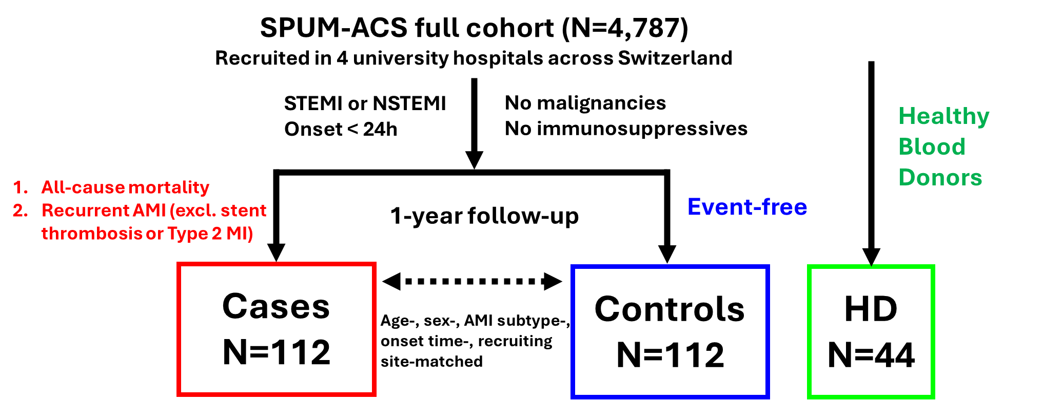
Online Resource 1. Study Design. Full SPUM-ACS cohort were screened using the inclusion criteria: 1. STEMI or NSTEMI patient 2. Symptom onset less than 24 hours and the exclusion criteria: known malignancy history or immunosuppressive usage. Cases were defined as the patients that either had all-cause mortality or recurrent AMI in 1-year follow-up, excluding stent thrombosis or Type 2 MI. Identified 112 cases were then 1:1 matched within cohort using age, sex, AMI subtype, symptom onset time, recruiting site (hospital) to those remained event-free at 1-year follow-up. 44 healthy blood donors that were cardiovascular disease-free participated in this study as well. ACS: acute coronary syndrome; STEMI: ST-elevation myocardial infarction; AMI: acute myocardial infarction; HD: healthy blood donors

Online Resource 2

LASSO
Additional variable selection was performed using LASSO (least absolute shrinkage and selection operator) regression via the glmnet package in R. To account for the 1:1 matched case-control design, we implemented a paired-difference binomial approach (mathematically equivalent to conditional logistic regression [CLR]) to objectively screen candidate confounders (e.g., medical history, medications, and lipid profiles). Pre-specified core variables (IL-8, eGFR, hsTnT, hsCRP, NT-proBNP, and Killip Class ≥2) were forced into the model by setting their penalty factors to zero. The optimal tuning parameter (λ) was determined via 10-fold cross-validation using the one-standard-error rule (λ_{1se}) to prioritize model parsimony.

LOOCV and IPW for ROC curves
We estimated the Receiver Operating Characteristic (ROC) curves of GRACE 2.0 score and models with addition of IL-8 and other parameters. CLR was cross-validated for potential overfitting and optimistic bias by Leave-one-out cross-validation (LOOCV). In each iteration, biomarker coefficients were estimated with CLR on N-1 pairs, and a risk score was predicted for the held-out pair by combining these coefficients with the parent cohort-derived offset. We reported both the apparent AUC (area under curve) from the training set and the LOOCV-corrected AUC. The inverse probability weighting (IPW) method proposed by Xu et al.[25] was used to account for the matched case-control design. Sampling weights were derived from the parent cohort by stratifying the propensity scores (PS) of matching variables into deciles; weights were calculated as the ratio of population to sample counts in each stratum. Risk scores were generated using a two-stage procedure: biomarker coefficients were estimated via CLR, while the effects of matching variables were incorporated as a fixed offset derived from the parent cohort PS. The 95% confidence intervals and the incremental value (Delta AUC) were assessed using 2,000 bootstrap resamples, with weights and AUCs recalculated in each iteration.

Online Resource 3

Online Resource 3 Characteristics of selected AMI patients and healthy blood donors (HD). Values are expressed as % or median [Q1-Q3]. Statistical significance is determined by Mann-Whitney U test or Fisher’s exact test. BMI, body mass index; AMI, acute myocardial infarction; CHF, chronic heart failure; ACE: Angiotensin-converting enzyme; NSAID: nonsteroidal anti-inflammatory drug; ARB: angiotensin II receptor blocker; LVEF, left ventricular ejection fraction; HDL-c, high-density lipoprotein cholesterol; LDL-c, low-density lipoprotein cholesterol; TG, triglycerides; eGFR, estimated glomerular filtration rate; NLR, neutrophil-to-lymphocyte ratio.
% or Median [IQR] | AMI | HD | p value
Patient N | 224 | 44
Age (y) | 73.4 [62.3-81.6] | 61.1 [54.7-64.2] | < 0.001
Sex (Male) | 174 (77.7%) | 30 (68.2%) | 0.181
BMI (kg/m²) | 26.1 [23.8-29] | 23.8 [22.8-25.9] | < 0.001
Smoking History | 123 (54.9%) | 7 (15.9%) | < 0.001
Current Smoker | 65 (29%) | 0% | < 0.001
History of AMI | 27 (12.1%) | 0% | 0.011
History of CHF | 3 (1.3%) | 0% | 1.000
Diabetes | 59 (26.3%) | 0% | < 0.001
Hypertension | 145 (64.7%) | 0% | < 0.001
Statin | 55 (24.6%) | 0% | < 0.001
ACE inhibitor | 43 (19.2%) | 0% | < 0.001
Beta-blocker | 69 (30.8%) | 0% | < 0.001
NSAID | 9 (4.0%) | 0% | 0.363
ARB | 49 (21.9%) | 0% | < 0.001
Cholesterol (mmol/L) | 4.6 [3.9-5.3] | 5.3 [4.9-6] | < 0.001
HDL-c (mmol/L) | 1.2 [0.9-1.4] | 1.6 [1.4-2.2] | < 0.001
LDL-c (mmol/L) | 2.9 [2.2-3.6] | 3.2 [2.6-3.8] | 0.071
TG (mmol/L) | 0.9 [0.7-1.3] | 0.8 [0.6-1.1] | 0.337
eGFR (mL/min/1.73 m²) | 76.3 [54.9-91.7] | 87.9 [75.4-93.9] | 0.003
Neutrophil (g/L) | 7.8 [5.5-9.7] | 3.5 [2.4-3.9] | < 0.001
Lymphocyte (g/L) | 1.5 [1-1.9] | 1.3 [1.2-1.7] | 0.537
NLR | 5.4 [3.4-8.9] | 2.3 [1.8-3] | < 0.001
Online Resource 4

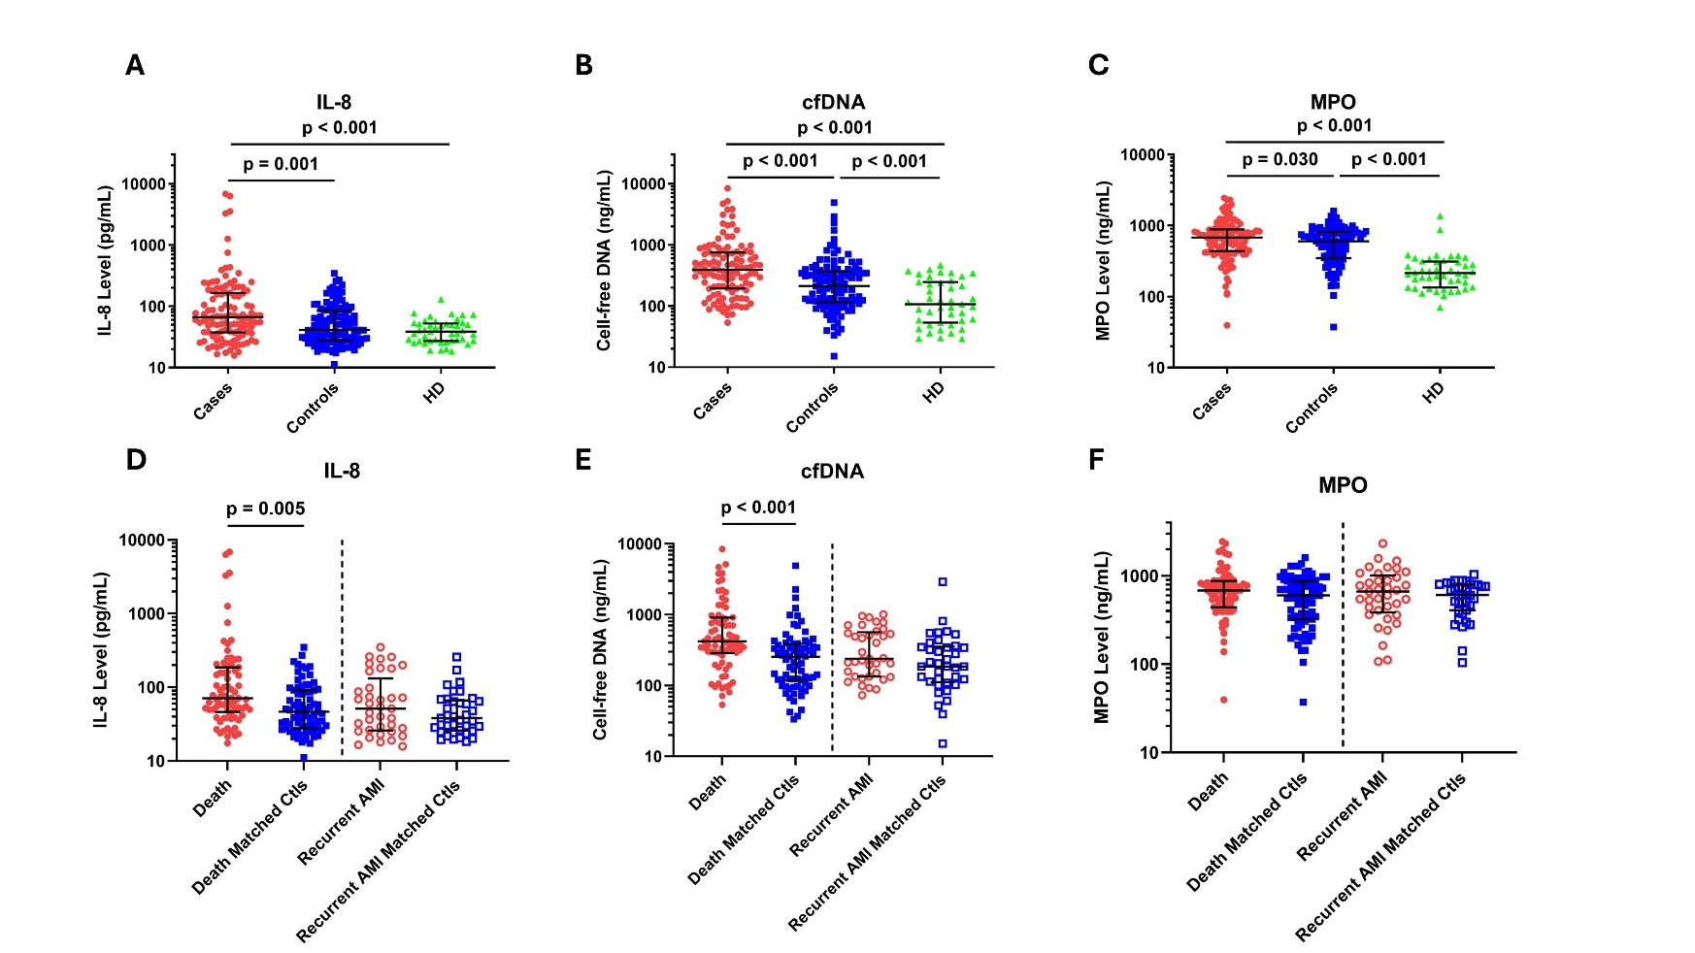
Online Resource 4. Neutrophil-related biomarkers of selected AMI patients and HD. Plasma biomarkers were measured and compared among groups. Concentration of each measurement was expressed in log scale. (A)&(D), IL-8; (B)&(E), cfDNA; (C)&(F), MPO. Statistical significance was determined by Wilcoxon signed-rank test between matched cases and controls or by Mann-Whitney U test between cases/controls and HD. AMI: acute myocardial infarction; HD: healthy blood donors; IL, interleukin; cfDNA, cell-free DNA; MPO, myeloperoxidase; Ctl: controls.

Online Resource 5
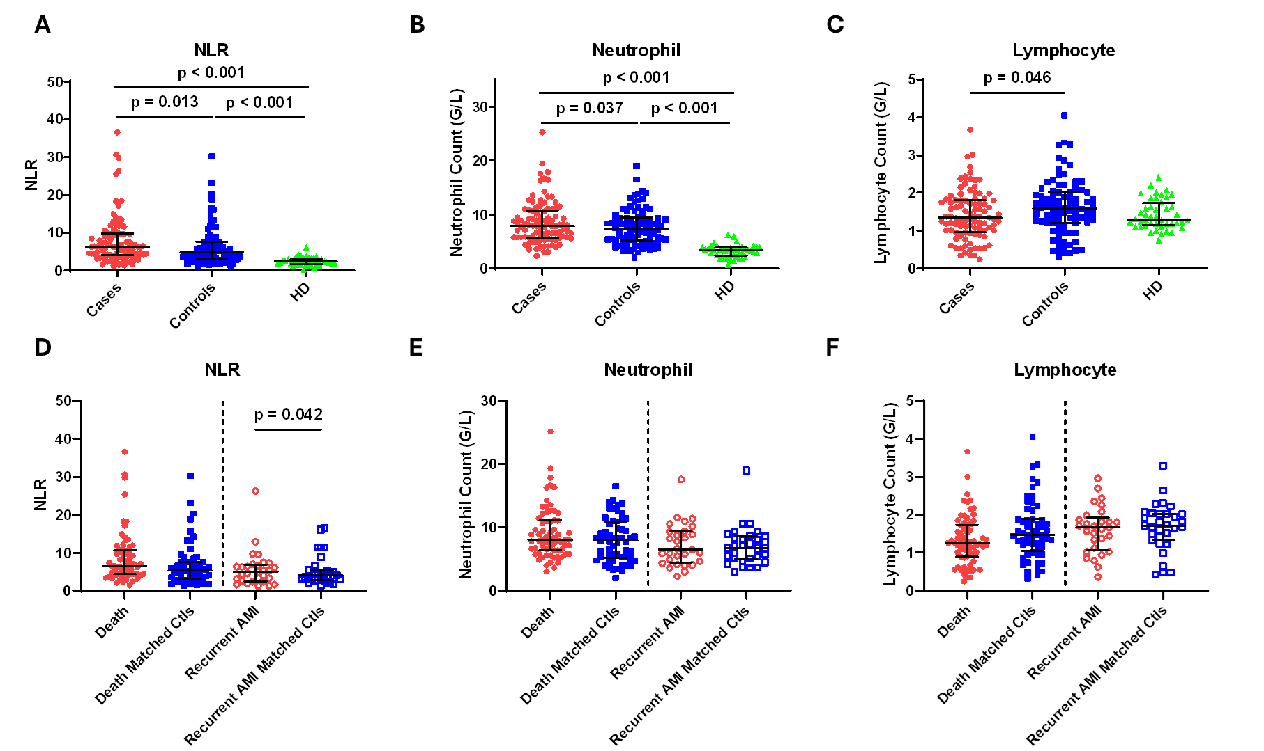
Online Resource 5. Blood cell counts of selected AMI patients and HD. NLR is calculated by dividing neutrophil counts by lymphocyte counts. (A)&(D), NLR; (B)&(E), neutrophil; (C)&(F), lymphocyte. Statistical significance was determined by Wilcoxon signed-rank test between matched cases and controls or by Mann-Whitney U test between cases/controls and HD. AMI: acute myocardial infarction; HD: healthy blood donor; NLR, neutrophil-to-lymphocyte ratio; Ctl: controls.
Online Resource 6
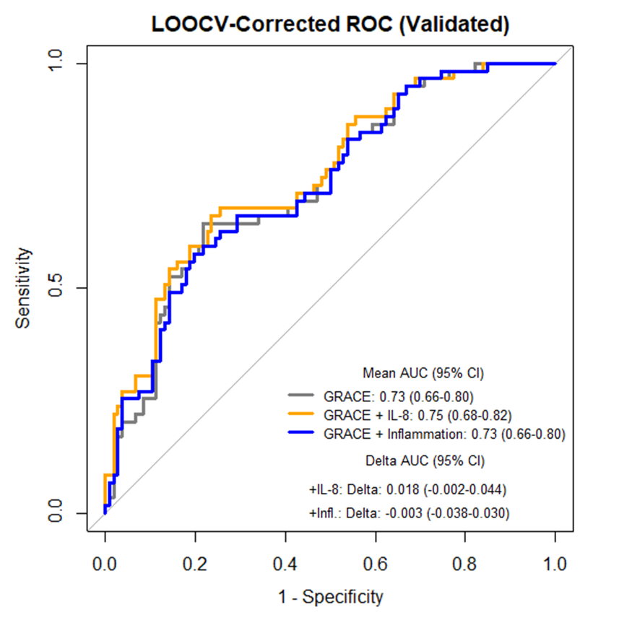
Online Resource 6. IL-8 and other inflammation components did not improve risk stratification for death in AMI patients. LOOCV method was utilized to cross-validate the ROC curves of GRACE 2.0 score or GRACE 2.0 score adding different components: IL-8 only, inflammation (IL-8+cfDNA+NLR+hsCRP) and afterwards inverse probability-weighted. 95% confidence interval of AUC and differences between models (Delta AUC) were estimated through 2,000 bootstrap resampling in both panels. ROC: receiver operating curve; AUC: area under curve; cfDNA, cell-free DNA; NLR: neutrophil-to-lymphocyte ratio; hsCRP: high-sensitivity C-reactive protein; LOOCV: leave-one-out cross-validation.

