ONLINE SUPPLEMENTAL MATERIALS

Supplemental Table 1: Pre-defined food groups for Principal Component Analysis
Food group | Food items included
Fruit (products) | Fresh fruits, dried fruits, fruit cocktail in syrup, fruit juices (unsweetened apple juice, grapefruit juice and orange juice)
Vegetable (products) | Vegetables raw or boiled, gherkins, vegetable juices, mushrooms
Pulses & legumes | Beans broad, Beans white or brown, Pea marrow fat legumes
Milk (products) | Buttermilk, (semi) skimmed and whole milk chocolate milk, coffee creamer, custards and puddings, dairy based ice cream and whipping cream
Yoghurts | Low fat, half fat and full fat yoghurt, plain and with fruits, fromage fraise
Cheese (products) | Cheese and cheese spreads varying in fat content (>48, >40 and >20% fat) and sodium content
Soy products | Soya chunks, Tahoe soya curd
Refined grains | Bread white, Currant bread, Macaroni cooked, Rice white boiled, Rusk Dutch
Whole grains | Bread brown wheat/ whole meal, crisp bread, Muesli, Rice brown Rye bread, Wheat bran & germ
Potatoes | Potatoes, boiled
Soft drinks & lemonades | Cola soft drink with/ without caffeine, fruit drink several flavors, carbonated mineral water
Eggs | Eggs, boiled
Unprocessed meat | Beef raw, Hamburger, Horsemeat, Lamb, Liver chicken/ ox/ pork, Mutton, Pork, Veal
Processed meat | Bacon, Beef salted and smoke dried, Corned beef, Croquette meat ragout deep  fat fried, ham, sausages and salami
Poultry | Chicken fillet with and without skin
Fatty fish | Eel, Fish, 2-10 g fat and > 10 g fat raw, Herring, Mackerel, Plaice Salmon Sardines/pilchards (fresh and canned)
Lean and battered fish | Cod, Fish fingers, Fish lean 0-2 g fat raw, Haddock fillet in batter fried
Shell fish | Mussels boiled, Shrimps, peeled, boiled
Savoury snacks | Biscuit salted average, Crisps, Liquorice Dutch type salted
Nuts and seeds | Nuts mixed unsalted, Peanut butter, Peanuts coated, Peanuts salted, Peanuts unsalted, Linseed
Mixed meals | Bami Goreng, Nasi, Pizza  (Bami and Nasi are traditional Indonesian dishes with meat, vegetables and  rice (Nasi) or pasta (Bami) and could reflect either home-made or take-away  food)
Soups and sauces | Salad dressings, salad creams
Sweets | Sweet bread toppings, pie, biscuits, cake, chocolate bars, spiced honey cake, gateau, honey, popsicle ice cream, candy, pancakes, praline and sugar
Coffee tea and water | Coffee or tea prepared, water
Vegetable oils and fats | Cooking or frying fat 0-50 mg cholesterol, Margarine, Oils (corn germ, olive, peanut, safflower, soy and sunflower)
Animal fats | Butter unsalted, Frying fat > 50 mg cholesterol
Alcoholic drinks | Beer pilsner, Gin young Dutch, Sherry, Wine
Porridges | Porridge buttermilk with wheat flour paste, Porridge oatmeal, Porridge rice pasteurized

Supplemental Table 2: Median intake of food groups in lowest and highest tertile of adherence to each pattern
 | “Traditional” |  |  | “Processed” |  |  |  | “Health conscious” |  |  | Full study population
 | 1st tertile | 3rd tertile |  | 1st tertile |  | 3rd tertile |  | 1st tertile |  | 3rd tertile
 | Intake of food groups that are frequently consumed in servings per day
Potatoes | 0.5 |  | 0.9 |  | 0.7 | 0.7 |  | 0.8 |  | 0.7 | 0.8
Fruit | 2.1 |  | 2.3 |  | 3.0 | 1.3 |  | 1.8 |  | 2.4 | 2.0
Vegetables | 5.8 |  | 7.8 |  | 6.6 | 5.8 |  | 5.2¹ |  | 7.2 | 6.1
Sweets | 3.5 |  | 4.0 |  | 3.8 | 2.5 |  | 4.0 |  | 2.8 | 3.6
Vegetable oils and fats | 1.8 |  | 2.7 |  | 1.9 | 2.2 |  | 1.9 |  | 2.0 | 2.3
Milk-and milk products | 1.4 |  | 1.3 |  | 1.6 | 1.1 |  | 1.3 |  | 1.4 | 1.3
Cheese products | 1.0 |  | 0.9 |  | 0.9 | 1.0 |  | 0.9 |  | 0.9 | 0.9
Yoghurt | 0.2 |  | 0.2 |  | 0.5 | 0.0 |  | 0.1 |  | 0.3 | 0.2
Total dairy intake² | 2.8 |  | 2.6 |  | 3.0 | 2.3 |  | 2.6 |  | 2.8 | 2.7
 | Intake of food groups that are frequently consumed in servings per week
Eggs | 1.0 |  | 2.0 |  | 1.5 | 2.0 |  | 1.0 |  | 2.0 | 2.0
Alcoholic drinks | 0.2 |  | 0.5 |  | 0.2 | 1.6 |  | 0.2 |  | 0.6 | 1.0
Unprocessed meat | 1.6 |  | 3.4 |  | 2.3 | 2.4 |  | 2.4 |  | 2.1 | 2.5
Processed meat | 0.6 |  | 1.4 |  | 0.7 | 1.2 |  | 0.8 |  | 0.9 | 1.1
 | Intake of food groups that are rarely consumed in servings per month
Poultry | 1.4 |  | 1.7 |  | 1.9 |  | 1.3 | 0.6 | 2.7 |  | 1.7
Fatty fish | 0.0 |  | 0.0 |  | 0.0 |  | 0.0 | 0.0 | 0.6 |  | 0.0
Lean /battered fish | 1.3 |  | 1.3 |  | 1.6 |  | 0.6 | 0.0 | 3.9 |  | 1.3
Animal fats | 0.0 |  | 12.0 |  | 0.0 |  | 1.7 | 0.0 | 0.0 |  | 0.0
Mixed meals | 0.0 |  | 0.0 |  | 0.0 |  | 0.7 | 0.0 | 0.0 |  | 0..0
Tofu | 0.5 |  | 0.0 |  | 0.0 |  | 0.4 | 0.0 | 0.0 |  | 0.0
Product groups with factor loadings >0.2 or < 0.2 for a specific dietary pattern are indicated in bold. ¹: A serving size equals 30 grams of vegetables (Donder-Engelen and van der Heijden, Maten, Gewichten en codenummers/ Measures, Weights and Codes (2003) Wageningen University, The Netherlands-CD Rom) ²: Summed intake of milk-and milk products, yoghurt and cheese products.

SUPPLEMENTAL FIGURES
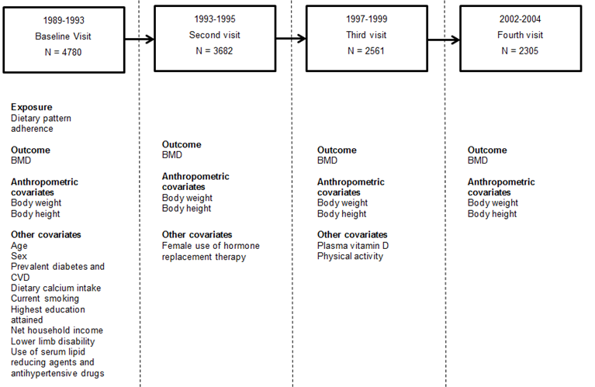
Supplemental Figure 1: Assessment of exposure, outcome and covariates

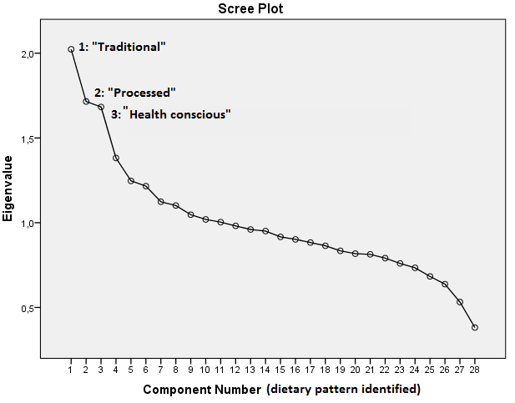

Total Variance Explained

Component | Initial Eigenvalues |  |  | Rotation Sums of Squared Loadings
 | Total | % of Variance | Cumulative % | Total | % of Variance | Cumulative %
1 “Traditional” | 2.023 | 7.226 | 7.226 | 1.651 | 5.895 | 5.895
2 “Processed” | 1.715 | 6.126 | 13.352 | 1.526 | 5.450 | 11.345
3 “Health conscious” | 1.683 | 6.010 | 19.362 | 1.449 | 5.174 | 16.519

Supplemental Figure 1: Scree plot showing the Eigenvalue (y-axis), a measure of explained variance, for each dietary pattern (x-axis) identified by principal component analysis.
Using a cut-off for the Eigenvalue of 1.5, we have selected three dietary patterns. Adherences to these three dietary patterns were studied in relation to bone mineral density.

