Supplementary figure 2a. Scree plot from principal component analysis in 12,463 women from the Malmö Diet and Cancer study (eigenvalues >1). Reduction of 33 energy-adjusted food groups into factors representing food patterns. 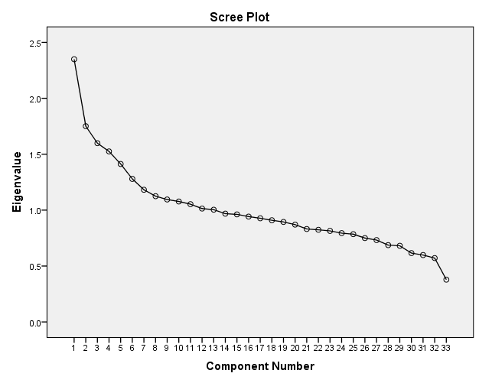

Supplementary figure 2b. Scree plot from principal component analysis in 8,037 men from the Malmö Diet and Cancer study (eigenvalues >1). Reduction of 33 energy-adjusted food groups into factors representing food patterns. 