Lower carbohydrate and higher fat intakes are associated with higher hemoglobin A1c: findings from the UK National Diet and Nutrition Survey 2008-2016.

European Journal of Nutrition

Chaitong Churuangsuk ¹, Michael E.J. Lean ¹ , Emilie Combet ^{1 *}

¹ Human Nutrition, School of Medicine, Dentistry and Nursing, College of Medical, Veterinary and Life Sciences, University of Glasgow, New Lister Building, Glasgow Royal Infirmary, 10-16 Alexandra Parade, Glasgow, G31 2ER, UK

Corresponding author *:
Dr Emilie Combet, Room 2.22, Level 2, New Lister Building, 10-16, Alexandra Parade, Glasgow Royal Infirmary, Glasgow, G31 2ER.
E-mail: Emilie.combetaspray@glasgow.ac.uk

Online Resource Table 1 Scoring systems for adherence to low-carbohydrate diet and UK recommendations.
Point | CHO % food E | Fat %food E
10 | ≤39.49 | >42.91
9 | ≤42.23 | ≤42.91
8 | ≤44.31 | ≤40.35
7 | ≤46.00 | ≤38.60
6 | ≤47.49 | ≤37.11
5 | ≤48.74 | ≤35.63
4 | ≤50.12 | ≤34.33
3 | ≤51.80 | ≤33.00
2 | ≤53.65 | ≤31.48
1 | ≤56.37 | ≤29.56
0 | >56.37 | ≤26.63
Each category contains equal number of participants

Online Resource Table 2 Scoring systems for adherence to UK recommendations.
Point | Carbohydrate (%E) | Non-starch polysaccharides (g/d) | Fruits & Vegetables (g/d) | Fish (g/d) | Sodium (mg/day) | Fat (%E) | Saturated Fat (%E) | Non-milk extrinsic sugar (%E)
0 | ≤47.50 | ≤17.10 | ≤380 | ≤38 | >2520 | >36.75 | >11.55 | >11.55
1 | ≤52.50 | ≤18.90 | ≤420 | ≤42 | ≤2520 | ≤36.75 | ≤11.55 | ≤11.55
2 | >52.50 | >18.90 | >420 | >42 | ≤2280 | ≤33.25 | ≤10.45 | ≤10.45

Online Resource Table 3 Prevalence of type 1 diabetes mellitus (in all patients with diabetes) stratified by age groups (National Diabetes Audit Report 2017-2018).
Age groups (years) | Prevalence of T1DM in all patients with diabetes (%) | Numbers of participants with diabetes in the NDNS dataset  (n=104) | Numbers of participants with diabetes to be excluded.  (n=10)
20-29 | 67.4 | 6 | 4
30-39 | 29.3 | 5 | 1
40-49 | 12.7 | 14 | 2
50-59 | 6.7 | 25 | 2
60-69 | 3.4 | 29 | 1
≥70 | - | 25 | -

Online Resource Table 4: Sensitivity analysis for Odds Ratio of T2DM.
 | Main analysis  (n=3234) |  |  |  | Sensitivity analysis 1  excluding participants with diabetes, aged ≤30 years  (n=3228) |  |  |  | Sensitivity analysis 2  running the logistic regression model 1000 times, each time randomly excluding 10% of participants with diabetes for possible T1DM  (n=3224)
Exposures | Odds Ratio¹ | 95%CI | P |  | Odds Ratio¹ | 95%CI | P |  | Mean  Odds Ratio¹ | 95%CI ⁴
Macronutrients ²
Carbohydrate | 0.88 | 0.78 - 0.99 | 0.030 |  | 0.88 | 0.78 – 0.99 | 0.031 |  | 0.8782 | 0.878 – 0.879
Fat | 1.17 | 1.02 - 1.33 | 0.022 |  | 1.17 | 1.03 – 1.34 | 0.019 |  | 1.1720 | 1.171 – 1.173
Saturated fat | 1.14 | 0.90 - 1.46 | 0.270 |  | 1.15 | 0.90 – 1.47 | 0.263 |  | 1.1536 | 1.152 – 1.155
Protein | 1.01 | 0.81 - 1.26 | 0.920 |  | 1.00 | 0.80 – 1.26 | 0.999 |  | 0.9974 | 0.996 – 0.999
Adherence score ³
LCHF score | 1.08 | 1.02 - 1.14 | 0.006 |  | 1.08 | 1.02 – 1.14 | 0.005 |  | 1.0801 | 1.0797 – 1.0804
DRV score | 0.95 | 0.85 - 1.06 | 0.350 |  | 0.95 | 0.85 – 1.06 | 0.354 |  | 0.9481 | 0.947 – 0.949
¹ adjusted for age, sex, BMI, ethnicity, smoking status, socioeconomic status, survey years, total energy intake.
² per 5% food energy increment.
³ per 2-point score increment.
⁴ 95%CI of the mean Odds Ratio

Online Resource Table 4: Sensitivity analysis for Odds Ratio of T2DM. (Continued)
 | Main analysis  (n=3234) |  |  |  | Sensitivity analysis 3  Unknown T2DM prevalence after excluding individual with known T2DM  (n=3130) |  |  |  | Sensitivity analysis 4  T2DM prevalence after excluding individual with T2DM who were on weight loss diet  (n=3198)
Exposures | Odds Ratio¹ | 95%CI | P |  | Odds Ratio¹ | 95%CI | P |  | Odds Ratio¹ | 95%CI | P
Macronutrients ²
Carbohydrate | 0.88 | 0.78 - 0.99 | 0.030 |  | 0.93 | 0.79 - 1.09 | 0.374 |  | 0.87 | 0.76 – 0.99 | 0.032
Fat | 1.17 | 1.02 - 1.33 | 0.022 |  | 1.15 | 0.95 - 1.38 | 0.142 |  | 1.19 | 1.04 – 1.38 | 0.015
Saturated fat | 1.14 | 0.90 - 1.46 | 0.270 |  | 1.16 | 0.82 - 1.62 | 0.405 |  | 1.19 | 0.92 – 1.54 | 0.175
Protein | 1.01 | 0.81 - 1.26 | 0.920 |  | 0.86 | 0.62 - 1.20 | 0.378 |  | 0.97 | 0.76 – 1.24 | 0.809
Adherence score ³
LCHF score | 1.08 | 1.02 – 1.14 | 0.006 |  | 1.06 | 0.98 - 1.14 | 0.155 |  | 1.08 | 1.02 – 1.14 | 0.010
DRV score | 0.95 | 0.85 - 1.06 | 0.350 |  | 0.99 | 0.84 - 1.15 | 0.858 |  | 0.91 | 0.80 – 1.02 | 0.111
¹ adjusted for age, sex, BMI, ethnicity, smoking status, socioeconomic status, survey years, total energy intake.
² per 5% food energy increment.
³ per 2-point score increment.
⁴ 95%CI of the mean Odds Ratio

Online Resource Table 5 Subgroup analysis in non-diagnosed diabetes participants (n=3130) with BMI <25, ≥25 kg/m² showing associations between %HbA1c level and macronutrients and diet scores.
 | HbA1c ≥5.5% |  |  |  | %HbA1c concentration
Predictors | Odds Ratio¹ | 95%CI | p-value |  | Β¹ | SE | Lower 95% CI | Upper 95% CI | p-value
BMI < 25 kg/m² (n=1258)
Macronutrients ²
Carbohydrate | 0.95 | 0.85 - 1.05 | 0.30 |  | -0.011 | 0.009 | -0.028 | 0.006 | 0.200
Fat | 1.10 | 0.98 – 1.23 | 0.11 |  | 0.018 | 0.009 | 0.000 | 0.037 | 0.053
Saturated fat | 1.19 | 0.97 – 1.46 | 0.09 |  | 0.039 | 0.017 | 0.006 | 0.072 | 0.021
Protein | 0.92 | 0.75 – 1.13 | 0.43 |  | -0.015 | 0.016 | -0.047 | 0.016 | 0.341
Adherence score ³
LCHF score | 1.02 | 0.98 – 1.07 | 0.37 |  | 0.006 | 0.004 | -0.002 | 0.013 | 0.122
DRV score | 0.95 | 0.87 – 1.04 | 0.25 |  | -0.010 | 0.008 | -0.025 | 0.004 | 0.164
BMI ≥ 25 kg/m² (n=1872)
Macronutrients ²
Carbohydrate | 0.91 | 0.84 – 0.99 | 0.024 |  | -0.020 | 0.009 | -0.038 | -0.002 | 0.031
Fat | 1.18 | 1.08 – 1.29 | <0.001 |  | 0.035 | 0.010 | 0.015 | 0.054 | 0.001
Saturated fat | 1.37 | 1.16 – 1.63 | <0.001 |  | 0.052 | 0.019 | 0.014 | 0.089 | 0.007
Protein | 0.87 | 0.75 – 1.00 | 0.053 |  | -0.029 | 0.016 | -0.061 | 0.004 | 0.081
Adherence score ³
LCHF score | 1.06 | 1.02 – 1.09 | 0.003 |  | 0.012 | 0.004 | 0.004 | 0.020 | 0.003
DRV score | 0.87 | 0.81 – 0.94 | <0.001 |  | -0.027 | 0.008 | -0.043 | -0.011 | 0.001
¹ adjusted for age, sex, BMI, ethnicity, smoking status, socioeconomic status, survey years, total energy intake.
² per 5% food energy increment.
³ per 2-point score increment.

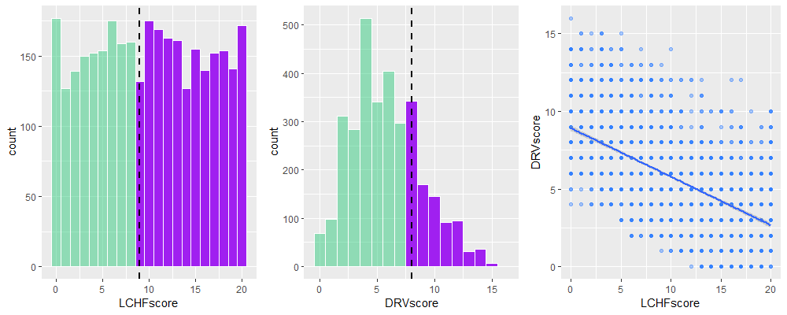
Online Resource Figure 1. Distributions of low-carbohydrate high fat score (LCHF) and dietary reference values score (DRV) and their correlation.
Colored area divides subjects who met recommendations: LCHF score of 9 and above reflects <50%food energy from carbohydrate and >35%food energy from fat; and DRV score of 8 and above reflects meeting each item of food and nutrient intakes in the UK recommendations.

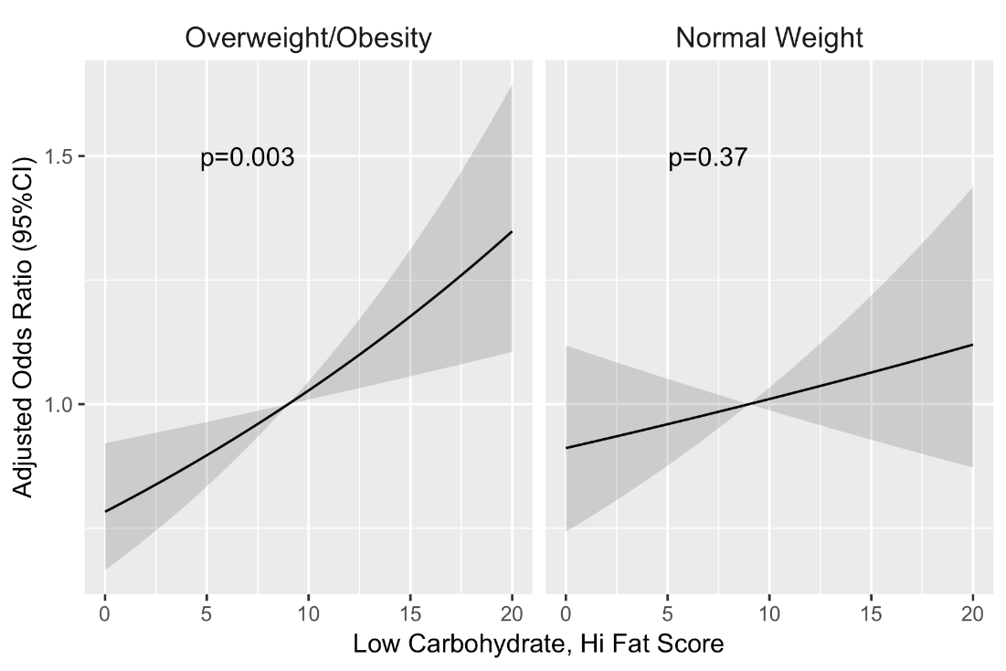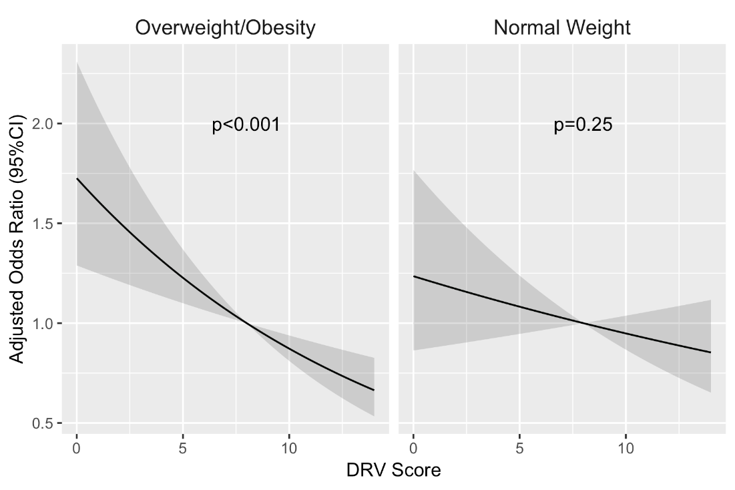

Online Resource Figure 2 Odds ratio of elevated HbA1c ≥5.5% by subgroup analysis in participants without diagnosed diabetes (n=3130) with BMI<25 kg/m² [n=1258], BMI≥ 25 kg/m² [n=1872]. Adjustment for age, sex, BMI, Ethnicity, smoking status, NS-SEC, total energy intake and survey years

