European Journal of Nutrition

SUPPLEMENTAL DATA

Dietary intake of choline and phosphatidylcholine and risk of type 2 diabetes in men: The Kuopio Ischaemic Heart Disease Risk Factor Study
Jyrki K Virtanen¹, Tomi-Pekka Tuomainen¹, Sari Voutilainen¹

¹University of Eastern Finland, Institute of Public Health and Clinical Nutrition, Kuopio, Finland.

Corresponding author: Jyrki K Virtanen, University of Eastern Finland, Institute of Public Health and Clinical Nutrition, Kuopio, Finland. Phone: +358-40-3552957, E-mail: jyrki.virtanen@uef.fi.

Supplemental Table 1 Dietary sources of choline and phosphatidylcholine
Choline  (total intake 430.9 mg/d) |  |  | Phosphatidylcholine  (total intake 187.9 mg/d)
Source | % of total intake |  | Source | % of total intake
Dairy | 26.5 |  | Eggs | 39.3
Meat | 24.0 |  | Meat | 36.4
Eggs | 18.6 |  | Fruits, berries, roots and other vegetables | 6.6
Grains | 11.0 |  | Fish | 5.2
Fruits, berries, roots and other vegetables | 10.9 |  | Grains | 4.8
Fish | 6.6 |  | Dairy | 4.6
Butter and margarines | 1.8 |  | Butter and margarines | 2.8
Other | 0.6 |  | Other | 0.3
Meat intake includes processed and unprocessed red meat, white meat and offal. There were no users of processed white meat.
Supplemental Table 2 Baseline characteristics according to quartiles of dietary choline intake: The Kuopio Ischaemic Heart Disease Risk Factor Study (n = 2,332)
 | Choline intake (mg/d)
 | 1 (<373) | 2 (373-423) | 3 (424-481) | 4 (>481)
Number of subjects | 583 | 583 | 583 | 583
Dietary intakes
Energy (kcal/d) | 2515 ± 667 | 2356 ± 586 | 2404 ± 576 | 2554 ± 622
Phosphatidylcholine (mg/d) | 131 ± 32 | 167 ± 34 | 195 ± 38 | 258 ± 66*
Choline (mg/d) | 329 ± 42 | 397 ± 15 | 450 ± 16 | 547 ± 67*
Eggs (g/d) | 18 ± 13 | 25 ± 16 | 32 ± 19 | 53 ± 33*
Meat (g/d) | 135 ± 71 | 145 ± 73 | 165 ± 77 | 186 ± 88*
Unprocessed red meat (g/d) | 54 ± 38 | 66 ± 44 | 75 ± 48 | 78 ± 55*
Processed red meat (g/d) | 69 ± 60 | 64 ± 56 | 68 ± 59 | 76 ± 63*
Offal (g/d) | 3 ± 9 | 2 ± 7 | 5 ± 11 | 10 ± 19*
White meat (g/d) | 6 ± 20 | 9 ± 24 | 11 ± 29 | 13 ± 33*
Dairy (g/d) | 615 ± 334 | 659 ± 330 | 736 ± 345 | 845 ± 387*
Fermented dairy (g/d) | 124 ± 147 | 181 ± 203 | 196 ± 212 | 247 ± 273*
Non-fermented dairy (g/d) | 491 ± 321 | 479 ± 312 | 540 ± 318 | 597 ± 361*
Grains (g/d) | 274 ± 100 | 251 ± 88 | 244 ± 88 | 251 ± 95*
Whole grains (g/d) | 170 ± 85 | 156 ± 71 | 154 ± 72 | 159 ± 75*
Fish (g/d) | 35 ± 41 | 40 ± 45 | 47 ± 49 | 62 ± 72*
Fruits, berries, roots and other vegetables (g/d) | 370 ± 162 | 408 ± 174 | 428 ± 175 | 452 ± 180*
Fats (g/d) | 62 ± 28 | 54 ± 22 | 53 ± 22 | 55 ± 24*
Butter and butter containing spreads (g/d) | 42 ± 33 | 35 ± 25 | 34 ± 25 | 35 ± 26*
Vegetable margarines (g/d) | 18 ± 19 | 17 ± 16 | 17 ± 15 | 18 ± 17
Vegetable oils (g/d) | 2 ± 4 | 2 ± 3 | 2 ± 4 | 2 ± 3
Coffee (mL/d) | 588 ± 303 | 554 ± 287 | 547 ± 288 | 579 ± 301
Protein (E%) | 13.8 ± 1.9 | 15.2 ± 1.9 | 16.3 ± 2.1 | 17.3 ± 2.4*
Saturated fatty acids (E%) | 18.9 ± 4.3 | 18.2 ± 4.0 | 17.8 ± 3.9 | 17.8 ± 3.9*
Polyunsaturated fatty acids (E%) | 4.3 ± 1.5 | 4.4 ± 1.4 | 4.6 ± 1.4 | 4.6 ± 1.3*
Monounsaturated fatty acids (E%) | 11.5 ± 2.2 | 11.6 ± 2.1 | 11.7 ± 2.2 | 11.9 ± 2.1*
Trans fatty acids (E%) | 1.1 ± 0.4 | 1.1 ± 0.3 | 1.0 ± 0.3 | 1.0 ± 0.4*
Cholesterol (mg/d) | 333 ± 78 | 371 ± 72 | 405 ± 85 | 495 ± 121*
Carbohydrates (E%) | 43.9 ± 6.6 | 41.5 ± 6.2 | 44.3 ± 6.7 | 41.5 ± 6.2*
Glycemic load | 179 ± 56 | 165 ± 51 | 163 ± 49 | 164 ± 50*
Glycemic index | 66 ± 6 | 65 ± 5 | 64 ± 5 | 63 ± 5*
Fiber (g/d) | 24.7 ± 8.0 | 25.6 ± 6.6 | 25.2 ± 6.7 | 24.9 ± 7.4
Age (y) | 52.8 ± 5.2 | 53.3 ± 5.1 | 53.2 ± 5.1 | 52.6 ± 5.2
Body mass index (kg/m²) | 26.4 ± 3.3 | 26.4 ± 3.2 | 26.6 ± 3.3 | 27.0 ± 3.6*
Leisure-time physical activity (kcal/d) | 136 ± 167 | 145 ± 181 | 139 ± 163 | 141 ± 185
Income (euro) | 12282 ± 7939 | 13894 ± 9192 | 14076 ± 9190 | 12944 ± 9331
Education (y) | 8.6 ± 3.5 | 8.7 ± 3.4 | 8.8 ± 3.4 | 8.6 ± 3.4
Alcohol intake (g/wk) | 86 ± 191 | 65 ± 96 | 64 ± 110 | 74 ± 108
Serum LDL cholesterol (mmol/L) | 4.06 ± 1.08 | 4.08 ± 1.01 | 4.01 ± 1.02 | 4.05 ± 0.98
Serum HDL cholesterol (mmol/L) | 1.30 ± 0.31 | 1.30 ± 0.30 | 1.29 ± 0.28 | 1.32 ± 0.32
Serum triglycerides (mmol/L) | 1.28 ± 0.76 | 1.31 ± 0.71 | 1.22 ± 0.66 | 1.26 ± 0.85
Blood glucose, mmol/L | 4.52 ± 0.40 | 4.51 ± 0.38 | 4.50 ± 0.40 | 4.55 ± 0.41
Serum insulin, mU/L | 10.27 ± 5.97 | 10.87 ± 6.02 | 10.65 ± 5.34 | 11.60 ± 7.06*
Serum C-reactive protein, | 2.55 ± 5.87 | 2.13 ± 2.79 | 2.21 ± 3.23 | 2.36 ± 3.47
Current smoker (%) | 36 | 30 | 30 | 33
Hypertension (%) | 60 | 57 | 59 | 57
Coronary heart disease (%) | 27 | 23 | 23 | 20*
Stroke (%) | 2 | 3 | 2 | 2
Family history of type 2 diabetes (%) | 27 | 26 | 26 | 28
Values are means ± SD or percentages.
*P for trend across quartiles <0.05.
E% = percent of energy.

Supplemental Table 3 Baseline characteristics according to quartiles of dietary phosphatidylcholine intake: The Kuopio Ischaemic Heart Disease Risk Factor Study (n = 2,332)
 | Phosphatidylcholine intake (mg/d)
 | 1 (<142) | 2 (142-179) | 3 (180-222) | 4 (>222)
Number of subjects | 583 | 583 | 583 | 583
Dietary intakes
Energy (kcal/d) | 2522 ± 673 | 2385 ± 596 | 2403 ± 582 | 2519 ± 608
Phosphatidylcholine (mg/d) | 117 ± 21 | 161 ± 11 | 199 ± 12 | 274 ± 53*
Choline (mg/d) | 350 ± 60 | 404 ± 54 | 442 ± 49 | 527 ± 83*
Eggs (g/d) | 14 ± 9 | 22 ± 12 | 33 ± 15 | 60 ± 30*
Meat (g/d) | 123 ± 68 | 149 ± 72 | 164 ± 70 | 195 ± 90*
Unprocessed red meat (g/d) | 48 ± 34 | 65 ± 42 | 75 ± 48 | 86 ± 56*
Processed red meat (g/d) | 64 ± 56 | 67 ± 60 | 67 ± 55 | 78 ± 66*
Offal (g/d) | 3 ± 9 | 4 ± 10 | 5 ± 12 | 8 ± 17*
White meat (g/d) | 4 ± 16 | 9 ± 26 | 11 ± 28 | 14 ± 35*
Dairy (g/d) | 815 ± 373 | 710 ± 359 | 660 ± 321 | 669 ± 365*
Fermented dairy (g/d) | 198 ± 235 | 199 ± 234 | 174 ± 181 | 177 ± 216*
Non-fermented dairy (g/d) | 617 ± 353 | 511 ± 320 | 486 ± 307 | 492 ± 329*
Grains (g/d) | 272 ± 102 | 256 ± 89 | 248 ± 88 | 246 ± 92*
Whole grains (g/d) | 177 ± 86 | 161 ± 70 | 153 ± 73 | 148 ± 71*
Fish (g/d) | 41 ± 45 | 44 ± 48 | 48 ± 56 | 50 ± 65*
Fruits, berries, roots and other vegetables (g/d) | 380 ± 169 | 409 ± 178 | 441 ± 173 | 427 ± 177*
Fats (g/d) | 61 ± 29 | 53 ± 21 | 54 ± 22 | 56 ± 23*
Butter and butter containing spreads (g/d) | 43 ± 34 | 34 ± 25 | 33 ± 25 | 34 ± 26*
Vegetable margarines (g/d) | 17 ± 18 | 17 ± 16 | 18 ± 16 | 19 ± 17*
Vegetable oils (g/d) | 2 ± 3 | 2 ± 4 | 3 ± 4 | 2 ±4
Coffee (mL/d) | 594 ± 321 | 551 ± 272 | 562 ± 279 | 561 ± 306
Protein (E%) | 14.5 ± 2.1 | 15.4 ± 2.2 | 16.1 ± 2.3 | 16.7 ± 2.6*
Saturated fatty acids (E%) | 19.0 ± 6.3 | 18.0 ± 3.9 | 17.7 ± 3.7 | 18.1 ± 3.7*
Polyunsaturated fatty acids (E%) | 4.0 ± 1.4 | 4.4 ± 1.4 | 4.7 ± 1.4 | 4.8 ± 1.4*
Monounsaturated fatty acids (E%) | 11.0 ± 2.1 | 11.5 ± 2.1 | 11.7 ± 2.2 | 12.3 ± 2.1*
Trans fatty acids (E%) | 1.1 ± 0.4 | 1.0 ± 0.4 | 1.0 ± 0.4 | 1.0 ± 0.4*
Cholesterol (mg/d) | 322 ± 75 | 362 ± 68 | 405 ± 71 | 515 ± 107*
Carbohydrates (E%) | 44.3 ± 6.7 | 44.1 ± 6.1 | 43.0 ± 6.0 | 40.7 ± 6.1*
Glycemic load | 177 ± 56 | 167 ± 50 | 165 ± 50 | 162 ± 51*
Glycemic index | 65 ± 6 | 65 ± 6 | 65 ± 5 | 64 ± 5
Fiber (g/d) | 25.6 ± 8.2 | 25.8 ± 7.0 | 25.2 ± 6.5 | 23.8 ± 7.0*
Age (y) | 53.6 ± 4.9 | 53.3 ± 5.1 | 53.0 ± 5.0 | 52.1 ± 5.4*
Body mass index (kg/m²) | 26.6 ± 3.5 | 26.6 ± 3.3 | 26.4 ± 3.1 | 26.8 ± 3.4
Leisure-time physical activity (kcal/d) | 130 ± 169 | 136 ± 161 | 156 ± 205 | 138 ± 157
Income (euro) | 11198 ± 7347 | 13124 ± 7944 | 15102 ± 10858 | 13778 ± 8861*
Education (y) | 7.9 ± 3.1 | 8.7 ± 3.5 | 9.1 ± 3.7 | 9.0 ± 3.5*
Alcohol intake (g/wk) | 74 ± 143 | 67 ± 153 | 68 ± 111 | 81 ± 116
Serum LDL cholesterol (mmol/L) | 4.07 ± 1.08 | 4.13 ± 1.02 | 4.02 ± 1.00 | 3.97 ± 0.97*
Serum HDL cholesterol (mmol/L) | 1.30 ± 0.31 | 1.29 ± 0.31 | 1.31 ± 0.30 | 1.31 ± 0.30
Serum triglycerides (mmol/L) | 1.32 ± 0.80 | 1.28 ± 0.70 | 1.20 ± 0.62 | 1.26 ± 0.85
Blood glucose, mmol/L | 4.53 ± 0.40 | 4.53 ± 0.39 | 4.49 ± 0.40 | 4.55 ± 0.41
Serum insulin, mU/L | 10.69 ±6.33 | 10.79 ± 6.09 | 10.50 ± 4.84 | 11.40 ± 7.07
Serum C-reactive protein, | 2.58 ± 4.63 | 2.31 ± 4.71 | 2.02 ± 3.01 | 2.34 ± 3.44
Current smoker (%) | 39 | 30 | 27 | 33
Hypertension (%) | 62 | 61 | 54 | 56*
Coronary heart disease (%) | 30 | 24 | 20 | 20*
Stroke (%) | 2 | 3 | 2 | 2
Family history of type 2 diabetes (%) | 25 | 28 | 26 | 29
Values are means ± SD or percentages.
*P for trend across quartiles <0.05.
E% = percent of energy.

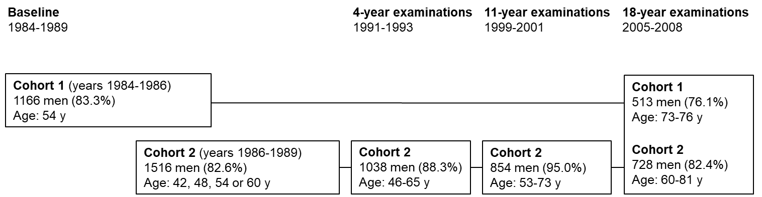

Supplemental Figure 1. The timeline of the Kuopio Ischaemic Heart Disease Risk Factor Study (KIHD). Percentages in brackets indicate the proportion of the eligible participants that participated in the study visits.

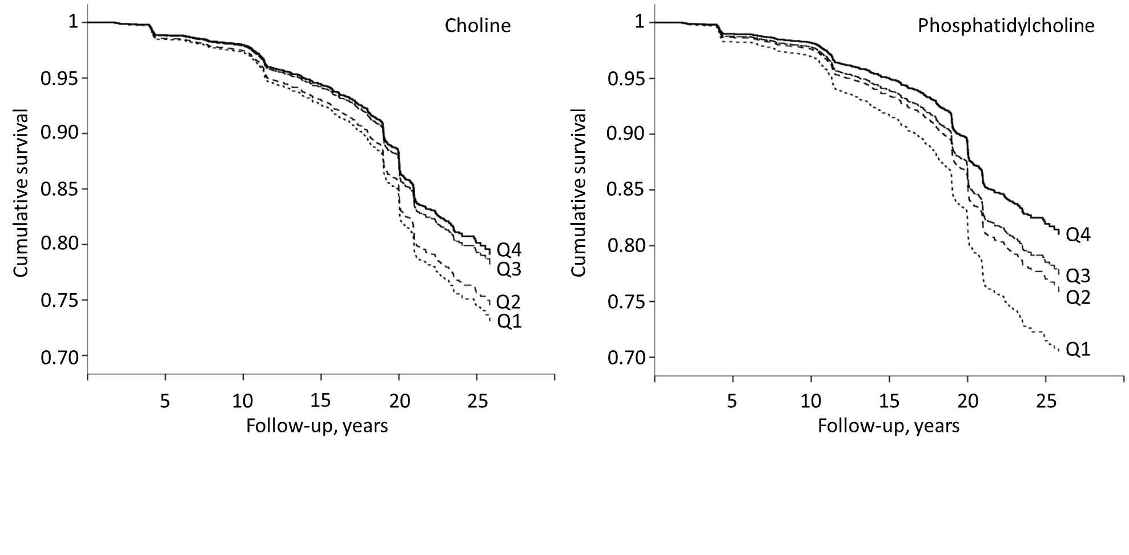
Supplemental Figure 2. Survival free of type 2 diabetes during the follow up of the Kuopio Ischaemic Heart Disease Risk Factor Study, according to the quartiles of baseline energy-adjusted dietary choline and phosphatidylcholine intakes in 2332 men. The model is adjusted for age, examination year, smoking (never smoker, previous smoker, current smoker <20 cigarettes/day and current smoker ≥20 cigarettes/day), body mass index (kg/m²), leisure-time physical activity (kcal/day), family history of type 2 diabetes (yes/no), and intakes of alcohol (g/day), energy (kcal/day), polyunsaturated fatty acids (percent of energy), and fiber (g/day). Q, quartile.

