ELECTRONIC SUPPLEMENTARY MATERIAL
Title: Prebiotic dietary fibre intervention improves fecal markers related to inflammation in obese patients: results from the Food4Gut randomized placebo-controlled trial

Authors: Audrey M. Neyrinck^{1#}, Julie Rodriguez^{1#}, Zhengxiao Zhang², Benjamin Seethaler³, Cándido Robles Sánchez¹, Martin Roumain⁴, Sophie Hiel¹, Laure B. Bindels¹, Patrice D. Cani^{1,5}, Nicolas Paquot⁶, Miriam Cnop^{7,8}, Julie-Anne Nazare⁹, Martine Laville⁹, Giulio G. Muccioli⁴, Stephan C. Bischoff³, Jens Walter^{2,10}, Jean-Paul Thissen¹¹ and Nathalie M. Delzenne^{1*}

Author affiliations
¹Metabolism and Nutrition Research Group, Louvain Drug Research Institute, UCLouvain, Université catholique de Louvain, Belgium
²Department of Medicine, University of Alberta, Edmonton, Canada
³Institute of Nutritional Medicine, University of Hohenheim, Germany
⁴Bioanalysis and Pharmacology of Bioactive Lipids Research Group, Louvain Drug Research Institute, UCLouvain, Université catholique de Louvain, Belgium.
⁵WELBIO- Walloon Excellence in Life Sciences and BIOtechnology, UCLouvain, Université catholique de Louvain, Brussels, Belgium.
⁶Laboratory of Diabetology, Nutrition and Metabolic disease, Liège, Université de Liège, Belgium;
⁷ULB Center for Diabetes Research, Université Libre de Bruxelles ; ⁸Division of Endocrinology, Erasmus Hospital, Université Libre de Bruxelles, Brussels, Belgium;
⁹Rhône-Alpes Research Center for Human Nutrition, Université-Lyon, CarMeN Laboratory, Hospices Civils de Lyon, France
¹⁰APC Microbiome Ireland, Department of Medicine, and School of Microbiology, University College Cork, Cork, Ireland
¹¹Pole of Endocrinology, Diabetes and Nutrition, Institut de Recherche Expérimentale et clinique, UCLouvain, Université catholique de Louvain, Brussels, Belgium
#These authors contributed equally to this work.

Corresponding author: Prof. Nathalie M. Delzenne, Metabolism and Nutrition Research Group, Louvain Drug Research Institute, UCLouvain, Université catholique de Louvain, avenue E. Mounier box B1.73.11, B-1200 Brussels, Belgium; E-mail address: nathalie.delzenne@uclouvain.be; Phone: +32 2 764 73 69

Table S1. Anthropometric and cardiometabolic risk factors in obese patients receiving prebiotic or placebo for 3 months¹
 | Placebo |  |  |  |  |  | Prebiotic
 | Baseline |  |  | 3 months |  |  | Baseline |  |  | 3 months
Body weight, kg | 105 | ± | 4 | 104 | ± | 3 | 104 | ± | 5 | 102 | ± | 6
BMI, kg/m² | 35 | ± | 2 | 35 | ± | 2 | 36 | ± | 1 | 36 | ± | 1
Fat mass, kg | 34 | ± | 4 | 34 | ± | 3 | 39 | ± | 3 | 38 | ± | 3
Waist, cm | 116 | ± | 3 | 114 | ± | 2 | 113 | ± | 3 | 112 | ± | 3
SBP, mm Hg | 138 | ± | 4 | 130 | ± | 5 | 134 | ± | 3§ | 135 | ± | 4
DBP, mm Hg | 85 | ± | 3 | 83 | ± | 2 | 85 | ± | 2 | 86 | ± | 3
Total chol, mg/dl | 169 | ± | 18 | 168 | ± | 17 | 194 | ± | 17 | 199 | ± | 22
LDL-chol, mg/dl | 89 | ± | 15 | 88 | ± | 14 | 114 | ± | 14 | 118 | ± | 18
HDL-chol, mg/dl | 45 | ± | 2 | 48 | ± | 4 | 47 | ± | 2 | 47 | ± | 3
TG, mg/dl | 177 | ± | 28 | 157 | ± | 24 | 163 | ± | 26 | 168 | ± | 32
Glycemia, mg/dl | 119 | ± | 8 | 116 | ± | 11 | 100 | ± | 6 | 101 | ± | 5
Insulin, mU/L | 18 | ± | 2 | 15 | ± | 2 | 18 | ± | 3 | 16 | ± | 3
HbA1c, % | 6.3 | ± | 0.3 | 6.1 | ± | 0.2 | 5.9 | ± | 0.2 | 5.9 | ± | 0.2
HOMA-IR | 5.3 | ± | 0.8 | 4.3 | ± | 0.6 | 4.7 | ± | 1.0 | 4.4 | ± | 0.9
CRP, mg/l | 3641 | ± | 1785 | 1792 | ± | 510 | 3166 | ± | 917 | 4750 | ± | 1542
¹Values are means ± SEM (placebo: n = 12; prebiotic: n = 12). Baseline data were analyzed by Mann-Whitney test (§p < 0.05 Prebiotic versus Placebo). Matched-pairs Wilcoxon signed-rank tests were performed to compare changes from baseline (within-group variations; p > 0.05). Between-groups variations were analysed by Mann–Whitney U-tests (p > 0.05). BMI, body mass index; Chol, cholesterol; CRP, C-reactive protein; DBP, diastolic blood pressure; HDL, High-density lipoprotein; HOMA-IR, homeostasis model assessment of insulin resistance; LDL, Low-density lipoprotein; SBP, systolic blood pressure; TG, Triglyceride.
Fig S1. Daily energy intakes in obese patients receiving prebiotic or placebo for 3 months. Values are means ± SEM (placebo: n = 11; prebiotic: n = 12). Baseline data were analyzed by Mann-Whitney test (p > 0.05 Prebiotic versus Placebo). Matched-pairs Wilcoxon signed-rank tests were performed to compare changes from baseline (within-group variations; *p < 0.05). Between-groups variations were analysed by Mann–Whitney U-tests (p > 0.05).

Table S2. Daily nutrient intakes in obese patients receiving prebiotic or placebo for 3 months¹
 | Placebo |  |  |  |  |  |  |  |  | Prebiotic
 | Baseline |  |  | 3 months |  |  | Change |  |  | Baseline |  |  | 3 months |  |  | Change
Energy (kcal) | 2171 | ± | 133 | 1862 | ± | 104* | -308 | ± | 76 | 1863 | ± | 102 | 1636 | ± | 118* | -227 | ± | 83
Protein (g) | 91 | ± | 6 | 82 | ± | 5* | -9 | ± | 3 | 85 | ± | 4 | 73 | ± | 4* | -12 | ± | 4
Carbohydrates (g) | 215 | ± | 13 | 196 | ± | 19 | -19 | ± | 12 | 202 | ± | 14 | 180 | ± | 19 | -22 | ± | 14
Sugars (g) | 82 | ± | 8 | 62 | ± | 8* | -19 | ± | 6 | 65 | ± | 7 | 73 | ± | 9 | 8 | ± | 8#
Starch (g) | 129 | ± | 10 | 131 | ± | 15 | 3 | ± | 12 | 134 | ± | 9 | 106 | ± | 12* | -28 | ± | 10#
Fat (g) | 88.1 | ± | 9.4 | 69.8 | ± | 5.4* | -18.3 | ± | 5.3 | 71.3 | ± | 5.5 | 61.8 | ± | 5.1 | -9.5 | ± | 4.9
SFA (g) | 32.3 | ± | 5.0 | 26.4 | ± | 3.2* | -5.8 | ± | 2.5 | 27.7 | ± | 3.1 | 23.0 | ± | 2.5* | -4.6 | ± | 2.2
MUFA (g) | 29.9 | ± | 3.6 | 25.3 | ± | 2.9 | -4.6 | ± | 1.9 | 18.4 | ± | 2.9§ | 16.7 | ± | 2.9 | -1.8 | ± | 3.4
PUFA (g) | 11.7 | ± | 2.9 | 7.5 | ± | 0.9 | -4.2 | ± | 2.5 | 5.9 | ± | 0.7§ | 7.1 | ± | 1.7 | 1.2 | ± | 1.5
PUFA n-3 (g) | 1.5 | ± | 0.3 | 1.0 | ± | 0.3* | -0.5 | ± | 0.2 | 0.9 | ± | 0.1 | 1.2 | ± | 0.3 | 0.3 | ± | 0.3
PUFA n-6 (g) | 8.5 | ± | 2.6 | 5.0 | ± | 0.7* | -3.5 | ± | 2.1 | 4.1 | ± | 0.6§ | 5.3 | ± | 1.3 | 1.1 | ± | 1.2
trans-FA (g) | 1.3 | ± | 0.4 | 0.7 | ± | 0.1* | -0.6 | ± | 0.3 | 0.8 | ± | 0.1 | 0.7 | ± | 0.1 | -0.1 | ± | 0.1
Cholesterol (mg) | 223 | ± | 32 | 187 | ± | 21 | -36 | ± | 20 | 176 | ± | 19 | 135 | ± | 17* | -40 | ± | 16
Fibre (g) | 25 | ± | 2 | 24 | ± | 2 | -1 | ± | 2 | 23 | ± | 3 | 25 | ± | 3 | 2 | ± | 3
Fructan (g) | 2.2 | ± | 0.4 | 2.7 | ± | 0.4 | 0.5 | ± | 0.5 | 2.9 | ± | 0.5 | 9.3 | ± | 2.2* | 6.3 | ± | 2.2°
¹Values are means ± SEM (placebo: n = 11; prebiotic: n = 12). Baseline data were analyzed by Mann-Whitney test (§p < 0.05 Prebiotic versus Placebo). Matched-pairs Wilcoxon signed-rank tests were performed to compare changes from baseline (within-group variations; *p < 0.05). Between-groups variations were analysed by Mann–Whitney U-tests (#p < 0.05; °p = 0.059).

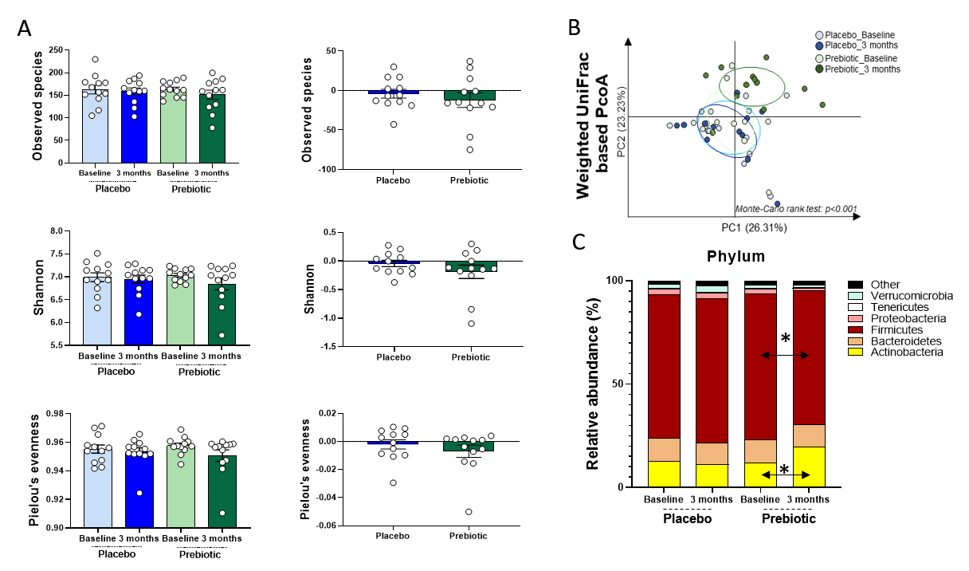

Fig S2. Overall composition of the gut microbiota in obese patients receiving prebiotic or placebo for 3 months. (a) Measures of alpha-diversity: Observed species, Pielou’s evenness measure and Shannon. Data are expressed as mean ± SEM. (b) Principal coordinates analysis (PCoA) of the beta-diversity index (Weighted UniFrac). p-values refer to Monte Carlo rank test performed on R software. (c) Barplots of percentage in the mean relative abundance of phyla accounting for more than 1%. Matched-pairs Wilcoxon signed-rank tests were performed to compare changes from baseline (within-group variations; *p < 0.05). Between-groups variations were analysed by Mann–Whitney U-tests (p > 0.05).

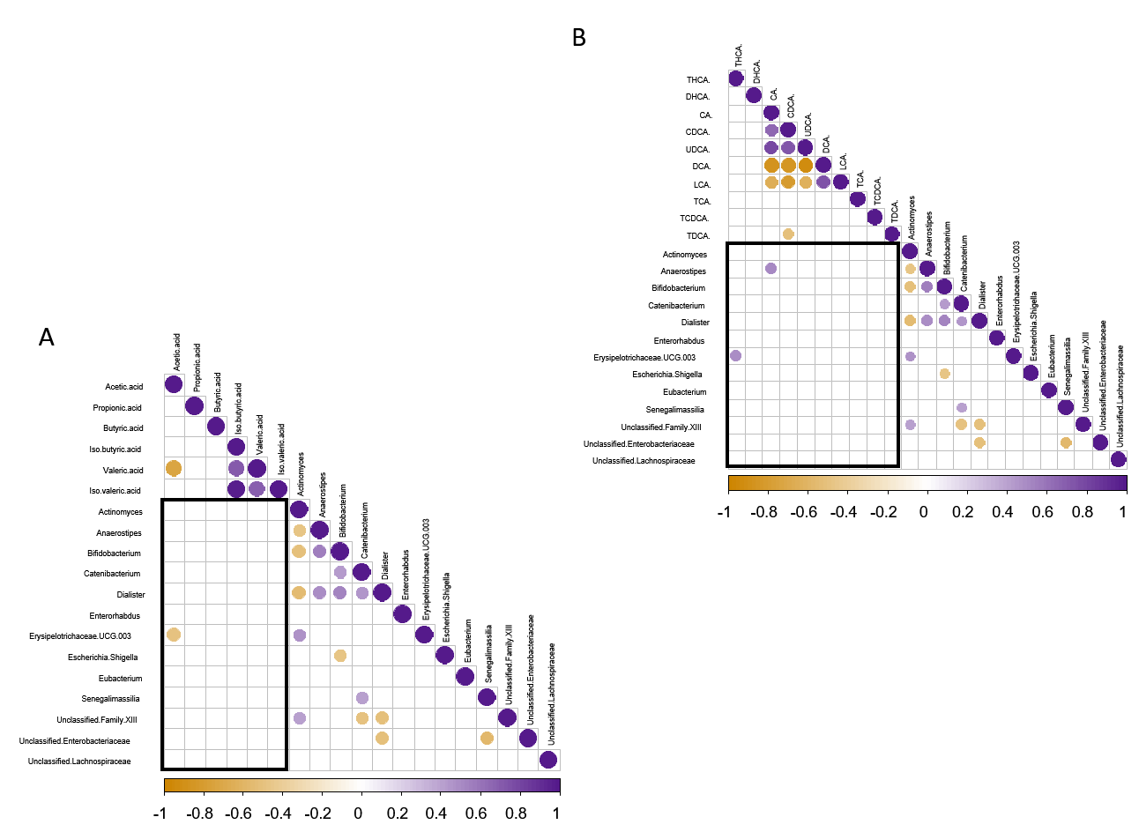

Fig S3. Heatmap of Spearman’s correlations between significant shift in bacteria due to intervention and the significant changes in the proportion of fecal SCFA (a) and of fecal BA (b). Orange circles indicate significant negative correlations whereas purple circles represent significant positive correlations (p < 0.05).

