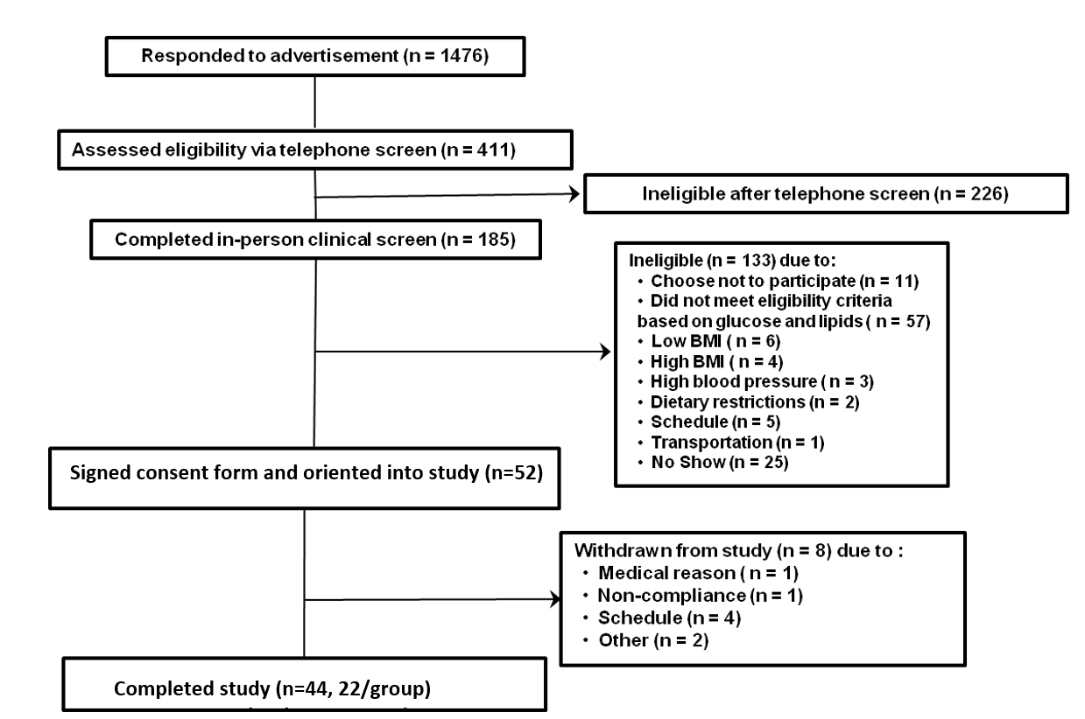

Supplemental Figure 1: CONSORT diagram representing the volunteers who were screened, consented, and completed the study. CONSORT, Consolidated Standards. In the current study completed study volunteers were used in analysis.

