Supplementary files

Supplementary Table 1 | Boron analysis using inductively coupled plasma mass spectrometry (ICP-MS).
Experimental conditions
Apparatus | ICAPQ (Thermo Fisher Scientific Waltham)
Method | DIN EN ISO 17294-2: 2017-01  Conducted by SYNLAB Analytics & Service,  Jena, Germany
Final sample dilution | 1 to 50 (2 % (v/v)) nitric acid
Internal standard | Rhodium (2 µg/L)
Limit of detection (LOD) | < 1.3 µg/L
Limit of quantification (LOQ) | 5 µg/L
Recovery | 101.8 % (n=6)
Intra-day precision, coefficient of variation | 2.35 % (n=6)

Supplementary Table 2 | Cox regression analysis of the 24h urinary boron excretion with all-cause mortality after exclusion of patients reporting current smoking (N = 612, 88.3% of total study population).
 | Tertiles of 24h urinary boron excretion# |  |  |  |  | Continuous analyses of  24h urinary boron excretion
 | 1 | 2  1040 to 1540 µg/day |  | 3  >1540 µg/day |  | Per doubling
Model |  | HR (95%CI) | P-value | HR (95% CI) | P-value | HR (95% CI) | P-value
Univariable | Ref. | 0.62 (0.42 – 0.91) | 0.016 | 0.38 (0.24 – 0.60) | <0.001 | 0.55 (0.42 – 0.71) | <0.001
+ age, sex, eGFR, CV history | Ref. | 0.75 (0.50 – 1.13) | 0.2 | 0.38 (0.24 – 0.61) | <0.001 | 0.53 (0.40 – 0.69) | <0.001
+ diabetes | Ref. | 0.66 (0.42 – 1.02) | 0.063 | 0.39 (0.24 – 0.64) | <0.001 | 0.52 (0.38 – 0.70) | <0.001
+ height, weight | Ref. | 0.67 (0.43 – 1.05) | 0.080 | 0.42 (0.25 – 0.69) | <0.001 | 0.53 (0.39 – 0.72) | <0.001
+ LDL cholesterol, HDL cholesterol, triglycerides | Ref. | 0.70 (0.44 – 1.09) | 0.1 | 0.44 (0.27 – 0.73) | 0.002 | 0.55 (0.41 – 0.75) | <0.001
+ dietary intake* | Ref. | 0.76 (0.48 – 1.19) | 0.2 | 0.54 (0.31 – 0.94) | 0.030 | 0.61 (0.43 – 0.87) | 0.007
# For consistency, tertiles were defined based upon the entire study population, prior to exclusion of current smokers. *In this model, we adjusted for age, sex, eGFR, CV history, diabetes, and energy intake-indexed fruit, nuts, fish, wine, plant protein and animal protein intake. Parameters of dietary intake were transformed using a square root. 117 patients (19%) died during a median follow-up time of 5.4y [4.9 – 6.1y]. Addition of log₂ 24h urinary boron excretion significantly augmented the model of sex, age, eGFR and history of cardiovascular disease (P_{likelihood ratio} < 0.001). Multiple imputation was used to account for 15 missing values (2.5%) of eGFR, 9 missing values (1.5%) of LDL and HDL cholesterol, 8 missing values (1.3%) of triglycerides, and 55 missing values (9.1%) for dietary intake parameters. CI, confidence interval; eGFR, estimated glomerular filtration rate as calculated using creatinine and cystatin C-based CKD-EPI equation; HR, hazard ratio; SD, standard deviation.
Supplementary Table 3 | Causal path analyses of the association of boron excretion with all-cause mortality after exclusion of patients reporting current smoking (N = 612, 88.3% of total study population). Defined models are cumulative, and add variables to the model in each step.
 | Tertiles of 24h urinary boron excretion# |  |  |  |  | Continuous analyses of  24h urinary boron excretion
 | 1 | 2  1040 to 1540 µg/day |  | 3  >1540 µg/day |  | Per doubling
Models |  | HR (95%CI) | P-value | HR (95% CI) | P-value | HR (95% CI) | P-value
Age, sex, eGFR, CV history, diabetes, height, weight | Ref. | 0.67 (0.43 – 1.05) | 0.080 | 0.42 (0.25 – 0.69) | <0.001 | 0.53 (0.39 – 0.72) | <0.001
+ hs-CRP ª | Ref. | 0.69 (0.44 – 1.08) | 0.1 | 0.42 (0.26 – 0.70) | <0.001 | 0.54 (0.40 – 0.73) | <0.001
+ homocysteine ª | Ref. | 0.70 (0.45 – 1.09) | 0.1 | 0.43 (0.26 – 0.72) | 0.001 | 0.55 (0.40 – 0.75) | <0.001
+ vitamin B6, B12, folic acid ª | Ref. | 0.70 (0.45 – 1.10) | 0.1 | 0.44 (0.27 – 0.73) | 0.002 | 0.56 (0.41 – 0.76) | <0.001
# For consistency, tertiles were defined based upon the entire study population, prior to exclusion of current smokers. 117 patients (19%) died during a median follow-up time of 5.4y [4.9 – 6.1y]. Multiple imputation was used to account for 15 missing values (2.5%) of eGFR, 7 missing values (1.2%) for vitamin B12 and folic acid, 11 missing values (1.8%) for vitamin B6 and 35 missing values (5.8%) of hs-CRP. ªvariables were log₂ transformed. CI, confidence interval; eGFR, estimated glomerular filtration rate as calculated using creatinine and cystatin C-based CKD-EPI equation; HR, hazard ratio; SD, standard deviation.

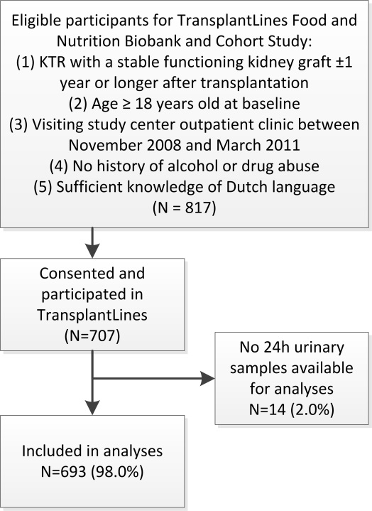
Supplementary Figure 1 | Flow of participants through the study.

