Supplementary Information

Olive pomace oil can improve blood lipid profile: a randomized, blind, crossover, controlled clinical trial in healthy and at-risk volunteers.

European Journal of Nutrition

Susana González-Rámila, Beatriz Sarriá, Miguel A. Seguido, Joaquín García-Cordero, Raquel Mateos, Laura Bravo*

Institute of Food Science, Technology and Nutrition (ICTAN-CSIC). Spanish National Research Council (CSIC), José Antonio Nováis 10, 28040 Madrid. Spain.

Supplementary Table 1S. Chemical composition of olive pomace oil (OPO), high oleic sunflower oil (HOSO) and sunflower oil (SO).
 | OPO | HOSO | SO
Fatty acids (%)
C 14:0 (Myristic) | 0.02 | 0.0 | 0.1
C 16:0 (Palmitic) | 11.63 | 4.2 | 6.4
C 16:1 (Palmitoleic) | 0.98 | 0.1 | 0.2
C 17:0 (Margaric) | 0.07 | 0.0 | 0.1
C 17:1 (Margaroleic) | 0.11 | 0.1 | 0.1
C 18:0 (Stearic) | 2.83 | 3.3 | 3.6
C 18:1 (Oleic) | 71.01 | 76.5 | 29.6
C 18:2 (Linoleic) | 11.5 | 13.9 | 58.6
C 20:0 (Arabic) | 0.49 | 0.3 | 0.3
C 18:3 (Linolenic) | 0.76 | 0.1 | 0.1
C 20:1 (Eicosenoic) | 0.34 | 0.2 | 0.2
C 22:0 (Behenic) | 0.19 | 1.0 | 0.7
C 24:0 (Lignoceric) | 0.07 | 0.3 | 0.2
Trans Oleic (t-C 18:1) | 0.32 | 0.0 | 0.0
Trans Linoleic + Trans Linolenic (t-C18:2 + t-C18:3) | 0.1 | 0.2 | 0.4
Triglycerides (%)
C 46 | <0.05 | <0.05 | <0.05
C 48 | 0.14 | <0.05 | <0.05
C 50 | 4.54 | 1.34 | 0.66
C 52 | 32.38 | 19.17 | 12.93
C 54 | 61.43 | 77.73 | 83.96
C 56 | 1.27 | 0.92 | 1.16
C 58 | 0.24 | 0.84 | 1.29
C 60 | <0.05 | <0.05 | <0.05
C 62 | <0.05 | <0.05 | <0.05
Squalene (ppm) | 799 | 87 | 117
Tocopherols (mg/kg)
α-Tocopherol (vit E) | 357 | 420 | 518
β-Tocopherol | <2 | 40 | 44
γ-Tocopherol | 32 | 72 | <2
δ-Tocopherol | <2 | 51 | <2
Sterols (%)
Cholesterol | 0.1 | 0.1 | 0.1
Brassicasterol | <0.1 | <0.1 | <0.1
24-Methylcholesterol | 0.2 | 0.2 | 0.3
Campesterol | 3.2 | 8.7 | 8.7
Campestanol | 0.1 | 0.1 | 0.1
Stigmasterol | 1.2 | 8.4 | 7.8
Δ7-Campesterol | <0.1 | 2.9 | 2.7
Δ5,23-Estigmastadienol | 0.8 | 0.2 | 0.1
Clerosterol | 1.5 | 0.8 | 0.7
β-Sitosterol | 86.1 | 54.1 | 54.6
Sitostanol | 1.7 | 0.6 | 0.5
Δ5-Avenasterol | 1.6 | 3.6 | 3.4
Δ5,24-Stigmastadienol | 2 | 1.1 | 1
Δ7-Stigmastenol | 0.4 | 13.5 | 14.5
Δ7-Avenasterol | 1 | 5.7 | 5.5
β-Sitosterol apparent | 93.8 | 60.5 | 60.3
Total Sterols (ppm) | 2839 | 3040 | 3315
Triterpenic alcohols (mg/kg)
Erythrodiol + Uvaol | 886.6 | <1.0 | <1.0
Phenols (mg/kg)
Total phenols | < 1.0 | < 1.0 | < 1.0
Triterpenic acids (mg/kg)
Oleanolic acid | 187.3 | <2.0 | <2.0
Ursolic acid | 6.9 | <2.0 | <2.0
Maslinic acid | 2.3 | <2.0 | <2.0
Aliphatic alcohols (mg/kg)
C22+C24+C26+C28 | 978 | 32 | 26

Chemical characterization of the study oils
The oils used in the study were analyzed according to the following standardized methods: ISO 12228-2:2014 method for the determination of sterols; Regulation (EEC) No. 2568/91 Annex V for determining triterpenic alcohols; Regulation (EEC) No. 2568/91 Annex XIX for determining aliphatic alcohols; Regulation (EEC) No. 2568/91 Annex X for determining fatty acid composition; and ISO 9936:2016 for determining tocopherols and tocotrienols. Triterpenic acids were analyzed following the method of Pérez-Camino & Cert (1999) (1), and squalene was determined by gas chromatography (Giacometti, 2001) (2). Phenols were analyzed by high-performance liquid chromatography with on-line diode array detection (HPLC-DAD) according to the procedure by Mateos et al. (2001) (3).

- Pérez-Camino MC, Cert A (1999) Quantitative determination of hydroxy pentacyclic triterpene acids in vegetable oils. J Agric Food Chem 47:1558-1562.
- Giacometti J (2001) Determination of aliphatic alcohols, squalene, alpha-tocopherol and sterols in olive oils: direct method involving gas chromatography of the unsaponifiable fraction following silylation. Analyst 126:472-475.
- Mateos R, Espartero JL, Trujillo M, Ríos JJ, León-Camacho M, Alcudia F, Cert A (2001) Determination of phenols, flavones, and lignans in virgin olive oils by solid-phase extraction and high-performance liquid chromatography with diode array ultraviolet detection. J Agric Food Chem 49:2185-2192.

Olive Pomace Oil (OPO)
High Oleic Sunflower Oil (HOSO)
Sunflower Oil (SO)
Run-in
Wash-out
Intervention 1
OPO
HOSO
SO
Intervention 2
Week 1
Week 3
Week 7
Week 10
Week 14

Supplementary Figure 1S Timeline of the nutritional intervention with olive pomace oil (OPO), high-oleic acid sunflower oil (HOSO). Normal sunflower oil (SO) was used during run-in and wash-out.

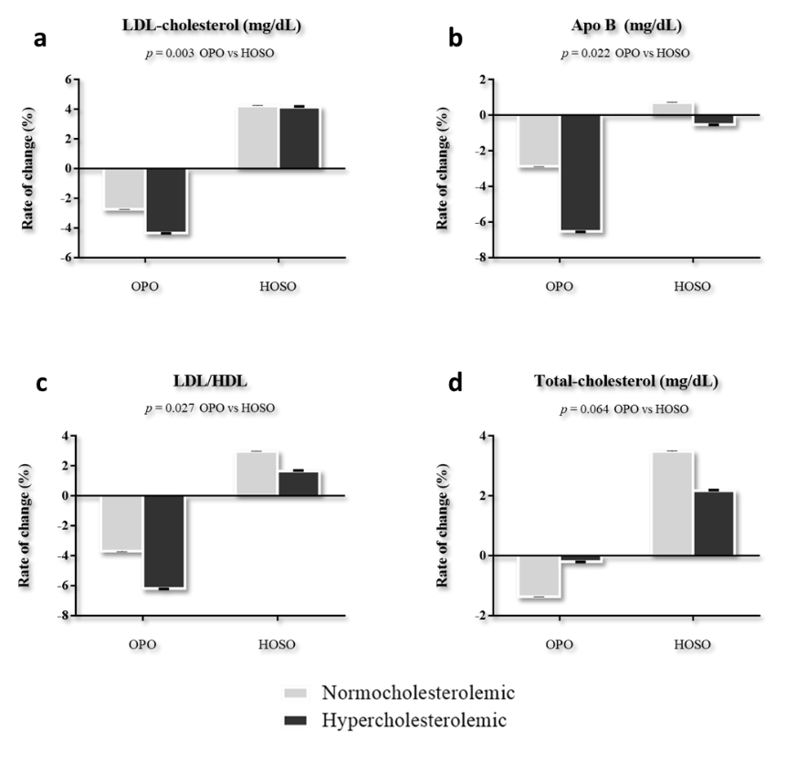
Supplementary Figure 2S Values represent mean ± SEM of (a) LDL-cholesterol, (b) Apolipoprotein B, (c) LDL/HDL and (d) Total-cholesterol. The rate of change was calculated from initial and final values as [(final value-initial value)/initial value]. Data were analyzed using a linear mixed model. p values in the first column correspond to the effect of taking the oil (olive pomace oil -OPO- or high oleic sunflower oil -HOSO-).

