SUPPLEMENTARY MATERIAL

Substituting meat for mycoprotein reduces genotoxicity and increases the abundance of beneficial microbes in the gut: Mycomeat, a randomised crossover control trial

Figure 1. Mycomeat CONSORT diagram
Table 1i. Nutrient profiles for Mycoprotein and Meat products
Table 1ii. Difference in nutritional composition between Mycoprotein and Meat products
Table 2. Difference in nutritional intake between diets, including provided study food (n = 20)
Table 3. Operational Taxonomic Units (OTUs) significantly affected by Meat and Mycoprotein (n = 20)
Figure 2. Comparison of faecal metabolome between Meat and Mycoprotein
Table 4. Faecal metabolites considered a VIP >1.5 between Meat and Mycoprotein.
Figure 3. Comparison of urine metabolome between Meat and Mycoprotein
Table 5. Urine metabolites considered a VIP >1.5 between Meat and Mycoprotein

Figure 1. Mycomeat CONSORT
3 Excluded
All 3 declined to participate
23 Individuals assessed for eligibility (n= 23)
20 Contributed to analyses

20 finished Phase 2
(Meat or Mycoprotein)
20 Randomly allocated to receive Meat or Mycoprotein in Phase 1
20 Randomised
20 finished Phase 1
(Meat or Mycoprotein)
20 Crossed over to receive Meat or Mycoprotein in Phase 2

Table 1i. Nutrient profiles for Mycoprotein and Meat products¹
Product^{2,3} |  | Calories, kcals | Carbohydrates, g | Protein, g | Total fat, g | Saturates, g | Fibre, g | Sodium, mg
Mycoprotein products
 | Peppered Steak | 269 | 12.0 | 28.1 | 11.8 | 5.3 | 13.0 | 1248
 | Sausage | 475 | 25.4 | 26.9 | 26.6 | 3.4 | 13.2 | 1152
 | Meat Free Ham Deli Slices | 295 | 12.5 | 39.8 | 6.5 | 2.9 | 13.0 | 864
 | Gammon Steaks | 298 | 4.1 | 36.2 | 12.5 | 6.2 | 12.7 | 1440
 | Bacon Style Slices | 514 | 13.0 | 24.2 | 37.7 | 2.6 | 13.4 | 1536
 | Mince | 252 | 10.8 | 34.8 | 4.8 | 1.2 | 13.2 | 288
 | Hot Dogs | 410 | 8.6 | 35.5 | 23.0 | 1.7 | 13.0 | 1248
Meat products
 | Beef Steak | 367 | 0 | 49.0 | 18.6 | 8.4 | 0 | 188
 | Pork Sausage | 390 | 13.2 | 28.8 | 23.0 | 8.3 | 4.2 | 768
 | Cold Cut Ham | 257 | 1.2 | 40.8 | 9.6 | 3.8 | 0 | 1536
 | Gammon Steak | 360 | 0.9 | 52.2 | 16.4 | 6.7 | 0 | 1800
 | Bacon Rashers | 272 | 0 | 30.7 | 16.3 | 6.6 | 0 | 1536
 | Beef Mince | 200 | 0 | 31.9 | 6.7 | 3.4 | 0 | 134
 | Hot Dogs | 540 | 1.2 | 31.2 | 45.6 | 19.7 | 0 | 1056
¹Nutritent profiles obtained from Quorn Foods for Mycoprotein products and Asda supermarket for Meat products.
² Products included in 7 day rotation.Each product repeated twice over the 14 day diet phases.
³All products were supplied as 240g uncooked servings.

Table 1ii. Difference in nutritional composition between Mycoprotein and Meat products¹.
 |  | Meat products | Mycoprotein products | Difference | P²
Energy
 | Content in daily portion, kcal | 341.00 ± 107.00 | 359.00 ± 102.00 | +18.00 ± 123 | 0.65
Protein
 | Content in daily portion, g | 37.80 ± 9.20 | 32.20 ± 5.56 | -5.60 ± 9.17 | 0.07
 | Contribution to energy total, % | 48.10 ± 15.60 | 39.40 ± 14.00 | -8.70 ± 10.60 | 0.13
Carbohydrates
 | Content in daily portion, g | 2.36 ± 4.64 | 12.30 ± 6.28 | +9.94 ± 3.35 | ˂ 0.001
 | Contribution to energy total, % | 2.48 ± 4.76 | 13.90 ± 5.64 | +11.42 ± 5.04 | ˂ 0.001
Fat
 | Content in daily portion, g | 19.50 ± 12.30 | 17.60 ± 11.50 | -1.90 ± 12.60 | 0.68
 | Contribution to energy total, % | 47.70 ± 14.80 | 40.10 ± 16.80 | -7.60 ± 11.2 | 0.22
Saturated Fat
 | Content in daily portion, g | 8.11 ± 5.25 | 3.33 ± 1.76 | -4.78 ± 5.80 | 0.01
Fibre
 | Content in daily portion, g | 0.60 ± 1.53 | 13.10 ± 0.22 | +12.50 ± 1.49 | ˂ 0.001
Sodium
 | Content in daily portion, mg | 987.06 ± 631.66 | 1093.36 ± 398.67 | +106.03 ± 522.33 | 0.60
¹ Daily averages for the intervention periods. Data is expressed as means ± SD. Differences between the supplied intervention food was tested with independent t-tests. The difference column shows the difference between the Mycoprotein products compared to the Meat products.
² P > 0.05 is considered NS.

Table 2. Difference in nutritional intake between Meat and Mycoprotein, including provided study food (n = 20)¹
Nutrient | Meat | Mycoprotein | Difference² | P³
Energy, kcal/d | 2355.18 ± 553.32 | 2567.44 ± 796.97 | +212.26 ± 242.63 | 0.47
Protein, g/d | 117.83 ± 31.26 | 115.03 ± 35.86 | -2.80 ± 11.92 | 0.78
Carbohydrate, g/d | 243.82 ± 48.81 | 298.20 ± 104.37 | +54.38 ± 28.86 | 0.06
Fat, g/d | 100.43 ± 39.95 | 98.98 ± 37.04 | -1.45 ± 13.51 | 0.68
Saturated fat, g/d | 36.96 ± 19.32 | 36.92 ± 14.64 | -0.04 ± 6.01 | 0.79
Fibre, g/d | 26.52 ± 8.40 | 43.26 ± 8.69 | +16.74 ± 2.92 | < 0.001
Sodium, mg/d | 2714.25 ± 979.59 | 3229.12 ± 1405.28 | +514.87 ± 424.95 | 0.32
¹Values are presented as means ± SDs. Nutritional intake calculated from 1-day food records using Nutritics nutritional analysis software.
² Differences between nutrient intake during Mycoprotein compared to Meat presented as least square means ± SEs.
³P values were calculated for differences between study phases using mixed effects models. A P ˂0.05 was considered significant.

Table 3. Operational Taxonomic Units (OTUs) significantly affected by Meat and Mycoprotein (n = 20)
Table includes OTU number as well as microbial genera assigned to OTU. For OTUs where genera not assigned, the closest available known taxa is assigned (i.e. family).
Operational Taxonomic Units (OTU’s) significantly different following Mycoprotein
No. Operational Taxonomic Unit (OTU) | Bacterial Taxonomic Classification | Change in relative abundance from baseline¹ | P³
1 | Bacteroides | +1.58 | 0.04
13 | Polaromonas | +1.80 | 0.03
15 | Parabacteroides | -1.54 | 0.01
19 | Prevotella | -1.48 | 0.006
25 | Alistipes | +1.11 | 0.001
27 | Lachnospiraceae family (unclassified) | +0.60 | 0.009
31 | Oscillibacter | +0.04 | 0.05
33 | Akkermansia | -1.66 | 0.007
34 | Barnesiella | +0.12 | 0.008
42 | Phascolarctobacterium | -0.07 | 0.01
44 | Parabacteroides | +0.56 | 0.002
50 | Bacteroides | +0.67 | 0.002
57 | Ruminococcaceae family (unclassified) | -0.046 | 0.03
91 | Clostridium Cluster IV (unclassified) | +0.001 | 0.01
95 | Lactobacillus | +0.02 | 0.05
102 | Pedobacter | +0.01 | 0.02
107 | Prevotella | -0.02 | 0.01
110 | Bacteroidetes phylum (unclassified) | -0.01 | 0.007
163 | Clostridiales family (unclassified) | -0.002 | 0.003
Table 3. (continued)
Operational Taxonomic Units (OTU’s) significantly different following Meat
No. Operational Taxonomic Unit (OTU) | Bacterial Taxonomic Classification | Change in relative abundance from baseline | P³
2 | Faecalibacterium | +3.77 | 0.02
5 | Bacteroides | -2.14 | 0.04
9 | Alistipes | +1.94 | 0.01
10 | Roseburia | -2.01 | < 0.01
12 | Bacteroides | +0.85 | 0.03
14 | Sutterella | -1.29 | 0.02
15 | Parabacteroides | -2.01 | < 0.01
21 | Bacteroides | +1.71 | 0.03
27 | Lachnospiraceae family (unclassified) | -0.65 | 0.03
31 | Oscillibacter | +0.70 | 0.001
37 | Prevotellaceae family (unclassified) | +0.06 | 0.02
40 | Ruminococcus | -0.46 | 0.02
45 | Paraprevotella | -0.20 | 0.005
47 | Alphaproteobacteria class (unclassified) | +0.16 | < 0.01
48 | Alphaproteobacteria class (unclassified) | +2.37 | 0.003
50 | Bacteroides | +012 | 0.04
58 | Bacteroidales order (unclassified) | +0.001 | 0.05
60 | Faecalibacterium | -0.29 | 0.05
65 | Lachnospiraceae family (unclassified) | +0.07 | 0.01
67 | Prevotella | -0.03 | 0.04
74 | Bacteroidales order (unclassified) | +0.03 | 0.007
91 | Clostridium Cluster IV (unclassified) | -0.001 | 0.01
115 | Clostridiales family (unclassified) | +0.008 | 0.007
210 | Bacteroidetes phylum (unclassified) | -0.001 | 0.02
238 | Lachnospiraceae family (unclassified) | +0.009 | 0.02
Table 3 (continued)
Operational Taxonomic Units (OTU’s) significantly different between Mycoprotein and Meat
No. Operational Taxonomic Unit (OTU) | Bacterial Taxonomic Classification | Difference in change in relative abundance between diets² | P³
3 | Faecalibacterium | -4.03 | 0.02
11 | Roseburia | +2.22 | 0.001
13 | Bacteroides | -3.00 | 0.01
15 | Sutterella | +1.35 | 0.03
20 | Prevotella | -2.86 | < 0.001
28 | Lachnospiraceae family (unclassified) | +1.25 | < 0.001
32 | Oscillibacter | -0.66 | 0.004
34 | Akkermansia | +1.66 | 0.02
35 | Barnesiella | +0.12 | 0.02
45 | Parabacteroides | +0.64 | 0.001
48 | Alphaproteobacteria class (unclassified) | -0.23 | 0.001
49 | Alphaproteobacteria class (unclassified) | -1.66 | 0.05
51 | Bacteroides | +0.58 | 0.02
66 | Lachnospiraceae family (unclassified) | -0.07 | 0.007
75 | Bacteroidales order (unclassified) | -0.02 | 0.03
92 | Clostridium Cluster IV (unclassified) | +0.001 | 0.001
108 | Prevotella | -0.02 | 0.008
116 | Clostridiales order (unclassified) | -0.008 | 0.007
156 | Clostridiales order (unclassified) | +0.02 | 0.02
239 | Lachnospiraceae family (unclassified) | -0.009 | 0.04
1 Results presented as least square mean change from baseline for the study phases.
2 Difference between diets calculated by subtracting change following Mycoprotein by change following Meat.
3 P values were calculated for changes within each study phase and differences between study phases using generalised mixed effects models. Differences regarded as significant at a P < 0.05.

Figure 2. Comparison of faecal metabolome between Meat and Mycoprotein.
A) Partial least square discriminant analysis (PLS-DA) of faecal metabolites profiles by the primary and secondary components, at study phase completion. The first two components accounted for ~27.4 % of variability (9.6% and 17.8% for the first and second components respectively). B) and C) Metabolic pathway enrichment using faecal metabolites considered a VIP >1.5 between B) Meat and C) Mycoprotein.

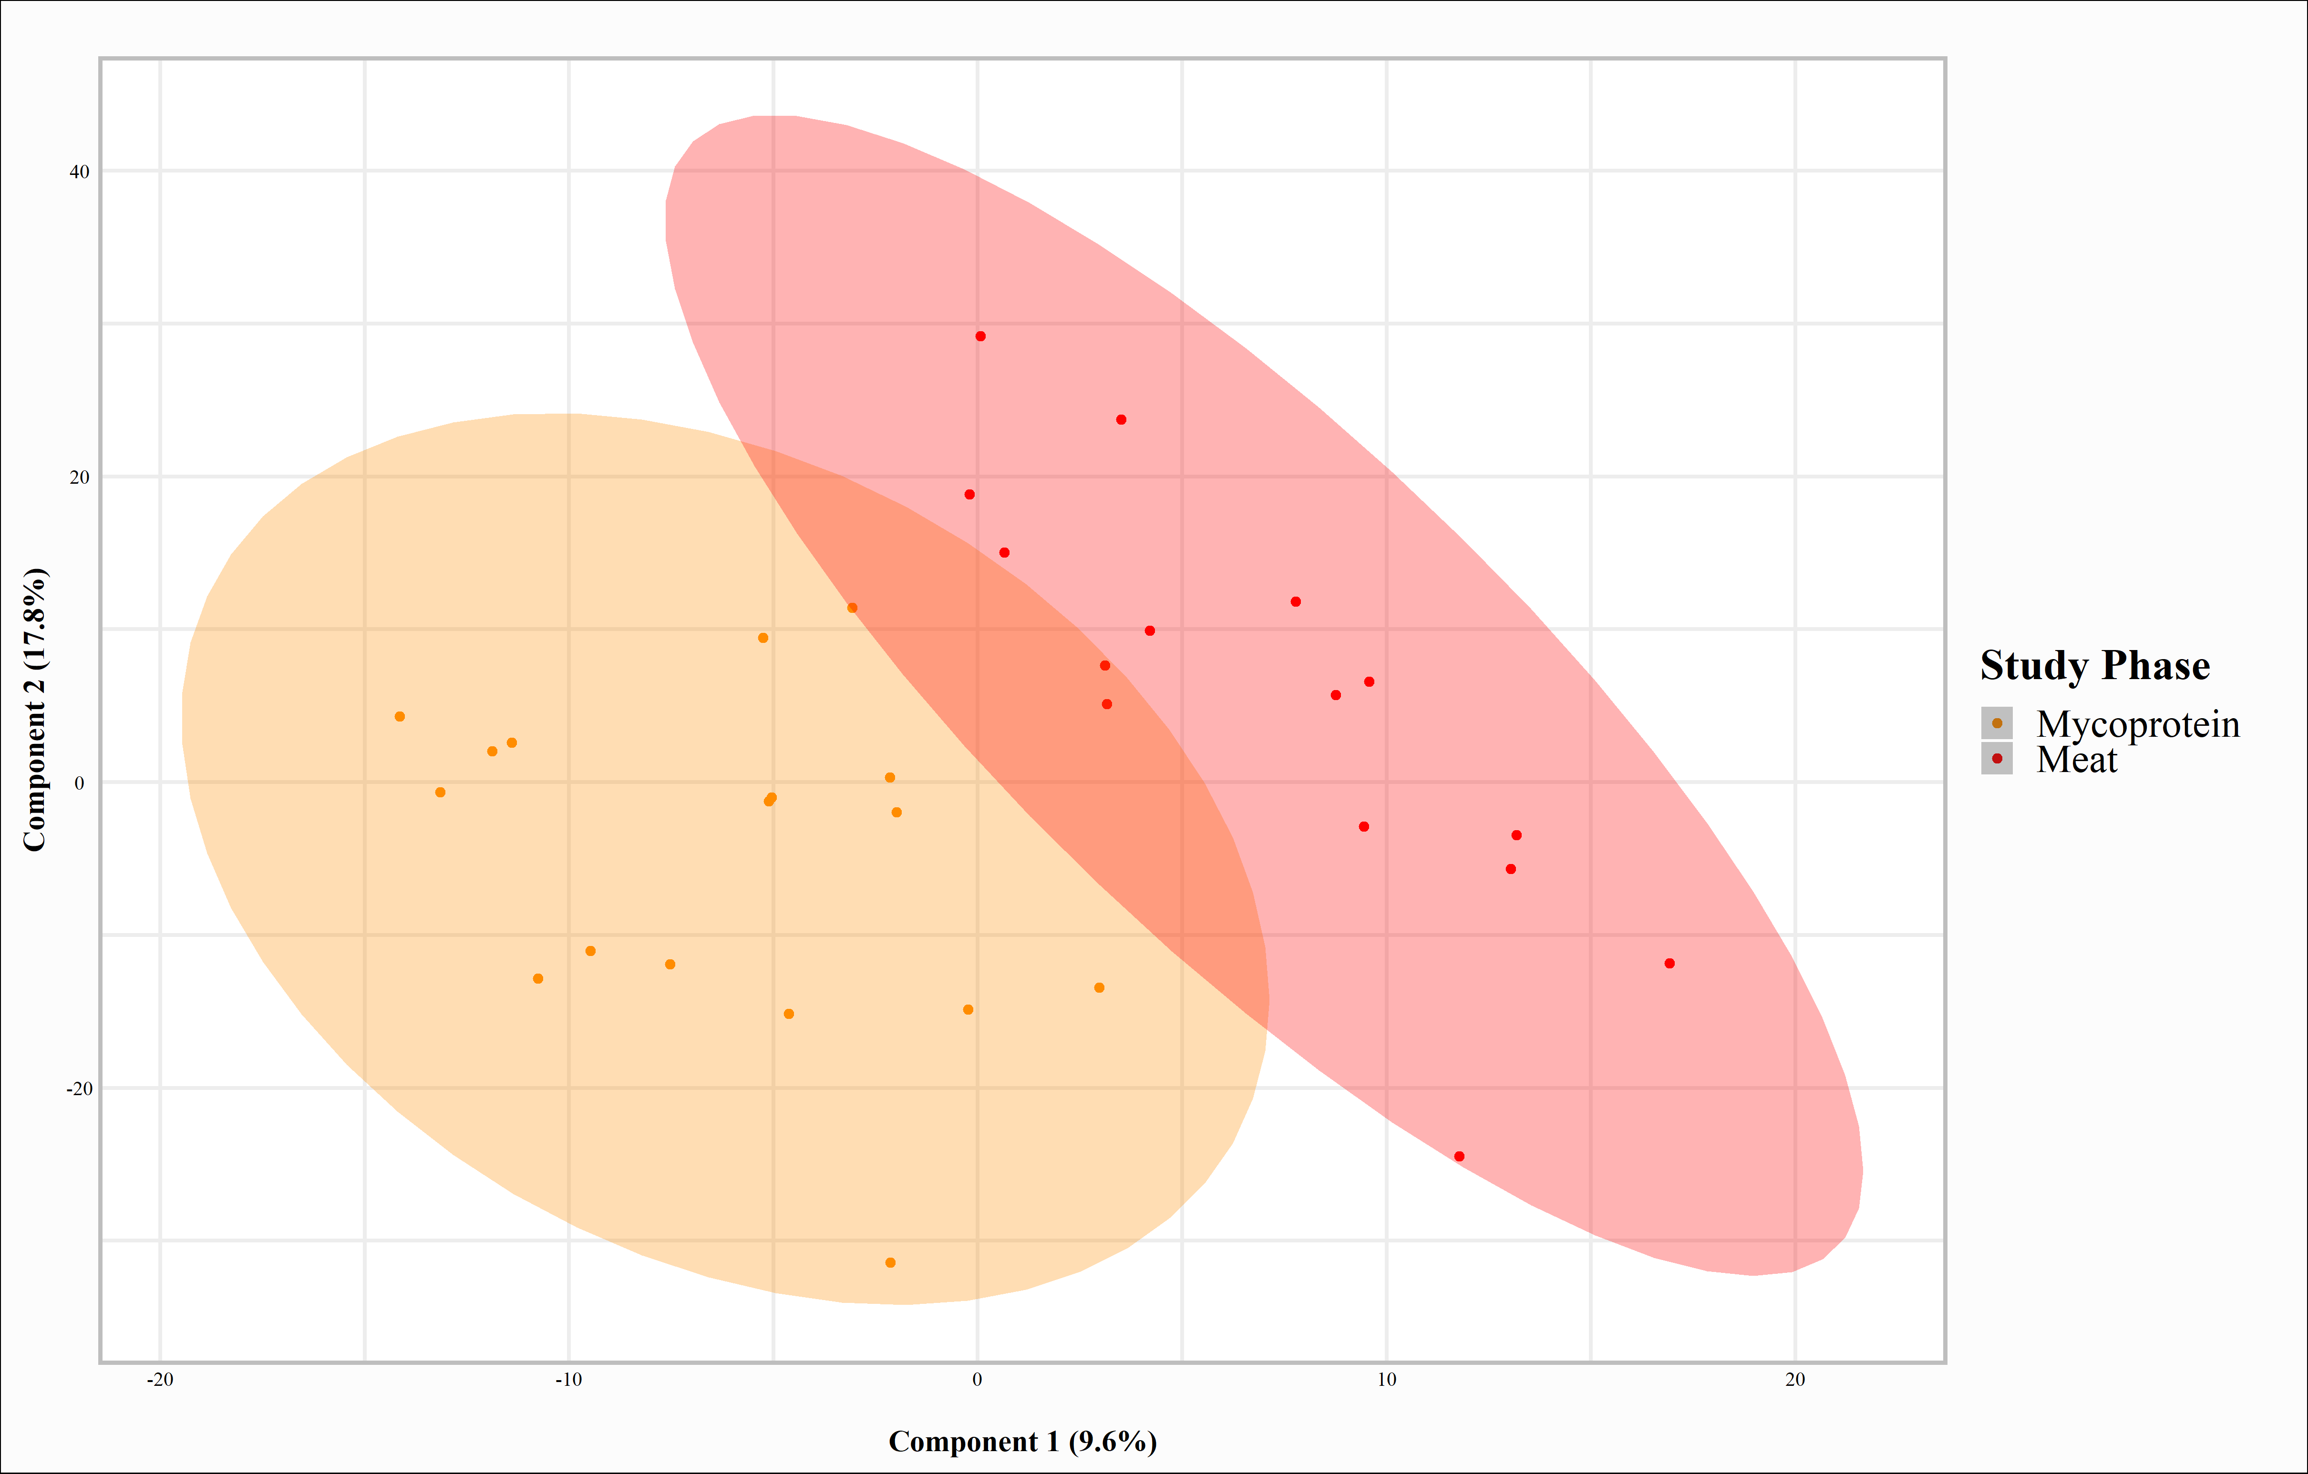
A

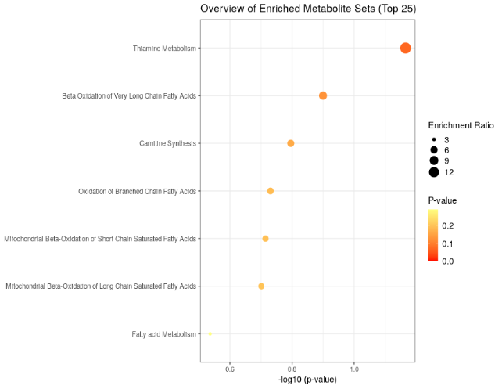
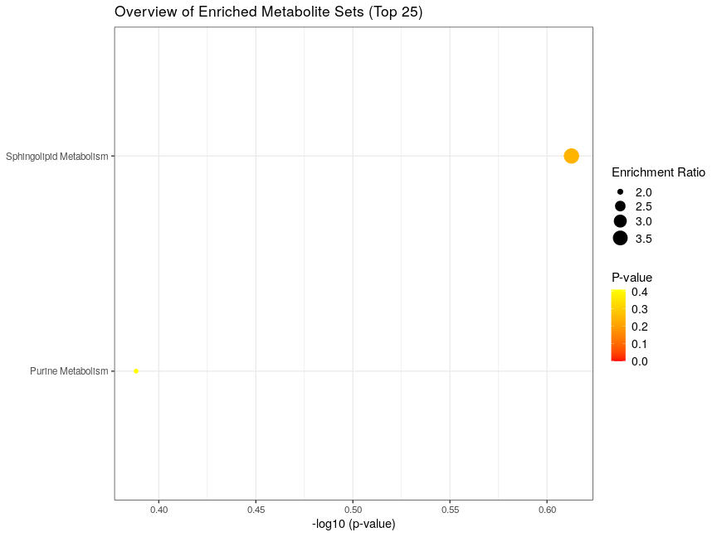
C
B

Table 4. Faecal metabolites considered a VIP >1.5 between Meat and Mycoprotein^{1,2}

Metabolite | VIP | Fold Change (Mycoprotein/Meat)
C22 H38 N4 O7 | 6.74 | 4.50
C7 H17 N O2.1 | 6.39 | 4.26
C15 H26 N2 O5 | 5.14 | 3.43
leucyl-4-hydroxyproline | 5.10 | 3.40
C14 H24 N2 O5 | 5.01 | 3.34
C16 H29 N O3 | 3.87 | 2.58
4-Hydroxyprolylleucine | 3.52 | -2.34
C10 H29 N6 O4 P | 3.43 | 2.29
C25 H36 N8 O4 | 3.33 | 2.22
N-[(2Z)-2-Hydroxy-2-octenoyl]glycine | 3.16 | 2.11
Ile-val | 3.00 | -2.00
Asparaginyl-4-hydroxyproline | 2.91 | -1.94
C8 H16 N2 O.1 | 2.87 | -1.92
C32 H60 N2 O14 | 2.84 | 1.90
C13 H26 N9 O7 P | 2.82 | 1.88
C32 H44 N2 O10 | 2.75 | 1.83
N~6~,N~6~-Dimethyllysine | 2.70 | -1.80
dinotefuran | 2.65 | -1.77
C7 H12 N4 O2 | 2.57 | -1.72
C9 H19 N2 O6 P | 2.51 | 1.67
Isoputreanine | 2.42 | -1.62
Glycylglutamine | 2.41 | -1.60
L(+)-Ornithine | 2.33 | 1.55
Gamma-Aminobutyric acid (GABA) | 2.26 | 1.51
C16 H34 N2 O4 | 2.15 | -1.43
C7 H14 N2 O | 2.14 | -1.43
4-[(3-Acetamidopropyl)amino]butanoic acid | 2.14 | -1.42
1,3-Dipropylxanthine | 2.13 | 1.42
C12 H26 N2 O4 | 2.08 | -1.39
Butenylcarnitine | 2.06 | 1.37
C10 H15 N O3 S | 2.04 | 1.36
C33 H54 N8 O9 P2 | 2.02 | 1.35
Table 4 (continued)

P-DMEA | 2.00 | -1.34
(2S)-2-Amino-8-hydroxyoctanoic acid.1 | 1.98 | -1.32
C6 H7 N3 | 1.93 | 1.29
Sorbic acid | 1.90 | 1.27
Valyl-4-hydroxyproline | 1.88 | -1.25
Thiamine | 1.88 | 1.25
4-Methyl-5-thiazoleethanol | 1.86 | 1.24
ISOXYL.1 | 1.85 | 1.24
Allysine | 1.81 | -1.21
C10 H18 N4 O3 | 1.80 | -1.20
porfiromycin | 1.79 | -1.19
C89 H135 N6 O18 P | 1.75 | 1.17
C28 H29 N5 O6 | 1.75 | 1.17
C20 H46 N5 O7 P | 1.67 | -1.11
C9 H18 N4 O | 1.65 | -1.10
C89 H149 N8 O15 P3 S | 1.63 | 1.09
C10 H16 N6 O2 | 1.62 | -1.08
Homocarnosine | 1.58 | -1.05
Fusicoccin H | 1.57 | -1.05
DL-Atenolol | 1.54 | 1.03
V594 | 1.54 | 1.03
C16 H27 N3 O7 | 1.53 | -1.02
C35 H71 N O4 | 1.52 | 1.01
L-gamma-Glutamyl-L-leucine | 1.50 | -1.00
¹VIP threshold set at >1.5.
²Unidentified metabolites presented as chemical formula (i.e., C8 H16 N2 0)
Positive fold change indicates greater Mycoprotein, negative fold change indicates greater Meat.
VIP, Variable importance in projection

Figure 3. Comparison of urine metabolome between Meat and Mycoprotein.
A) Partial least square discriminant analysis (PLS-DA) of urine metabolites profiles by the primary and secondary components, at study phase completion. The first two components accounted for ~15.27% of the variability (7.73% and 7.54% for the first and second components, respectively). B) and C) Metabolic pathway enrichment using urine metabolites considered a VIP >1.5 for B) Meat and C) Mycoprotein.

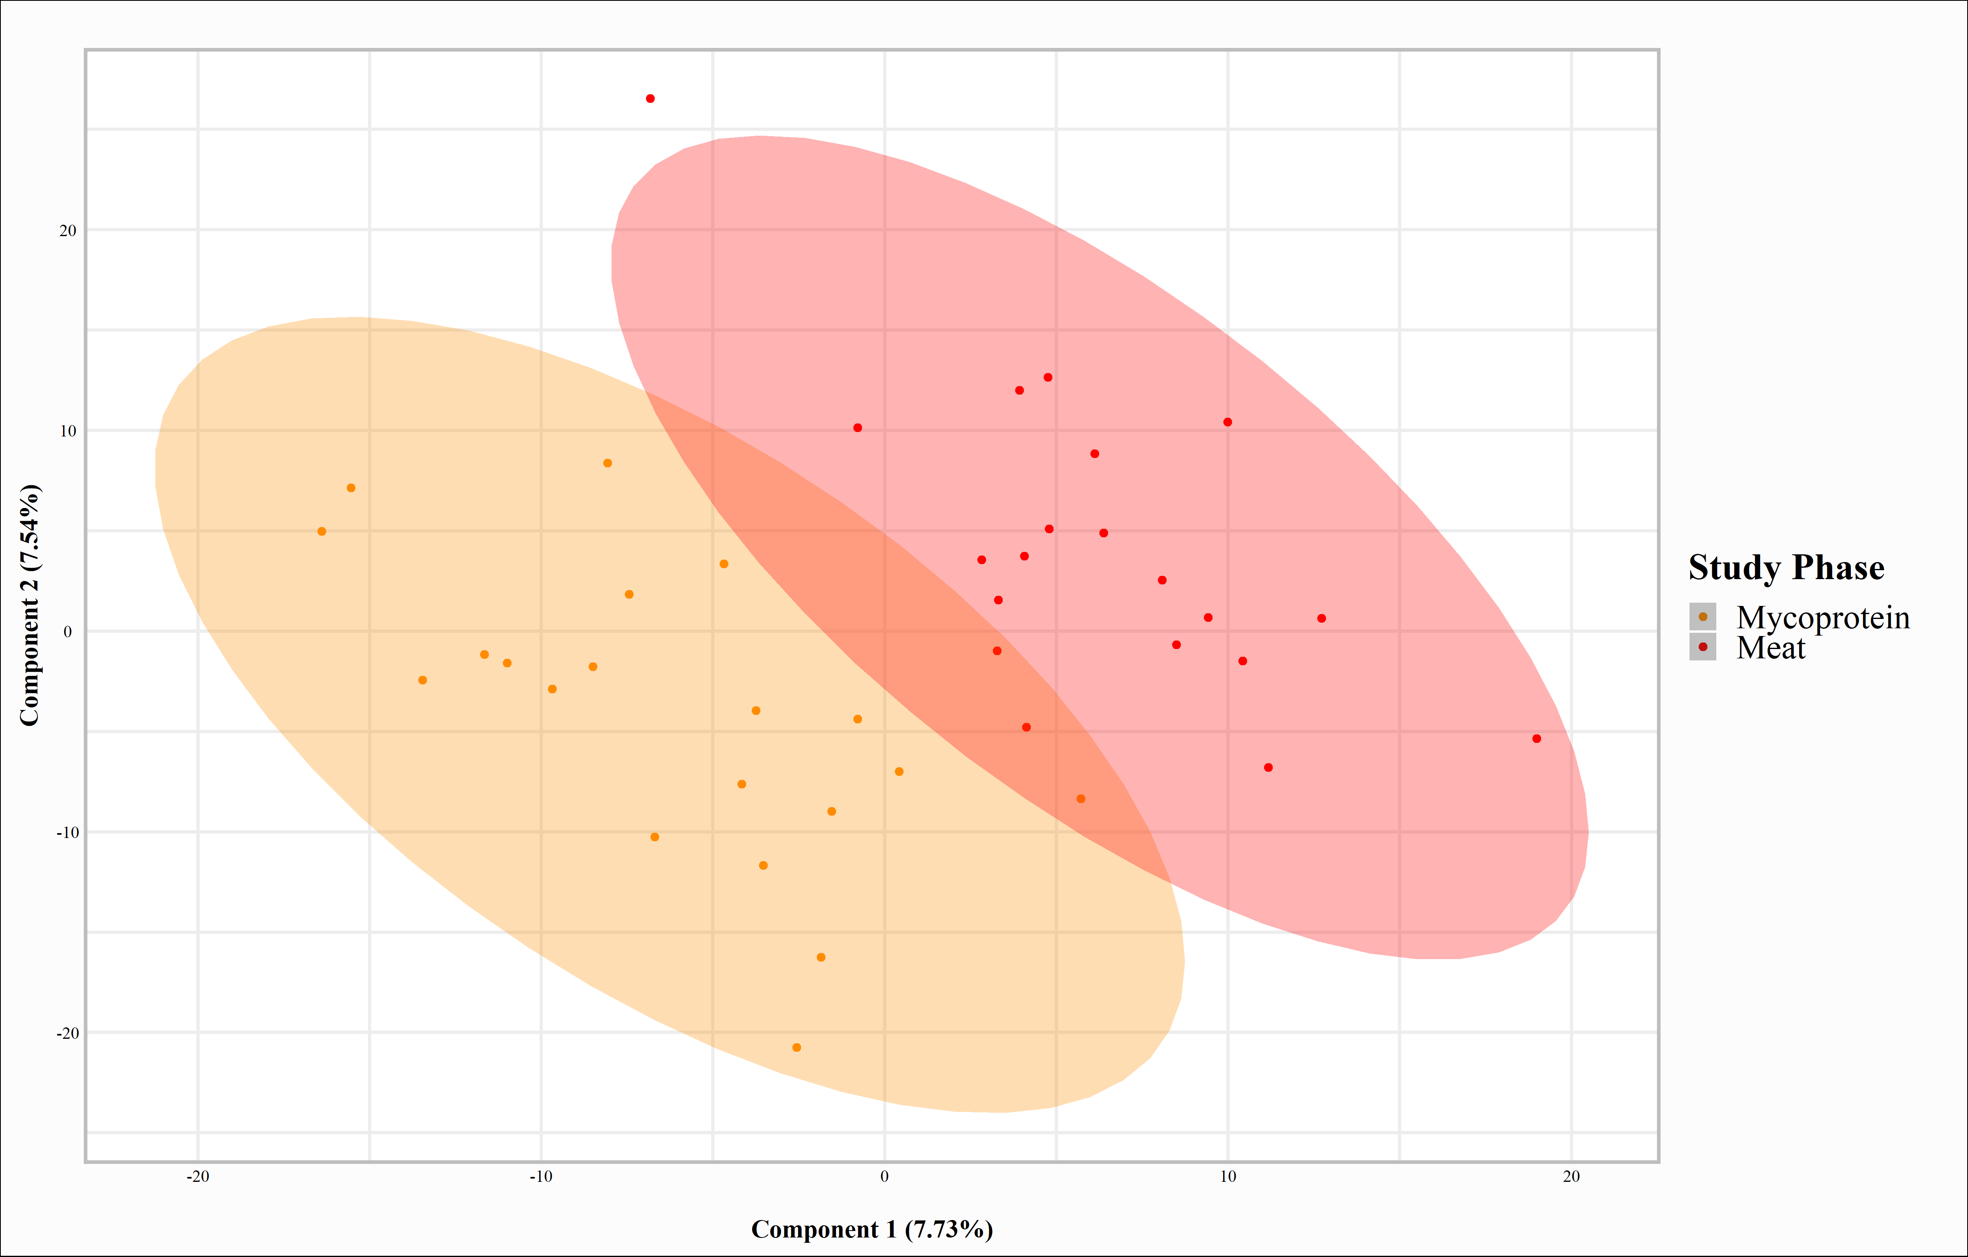
A

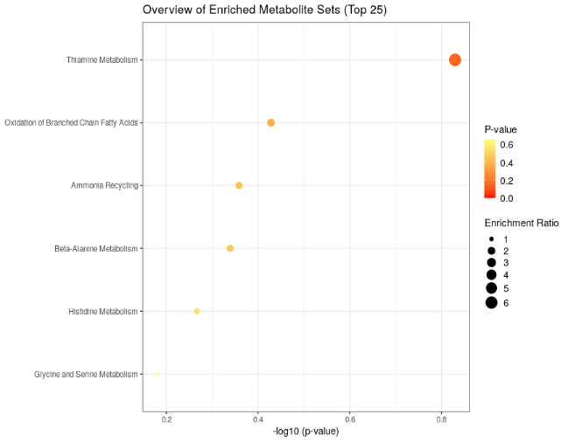
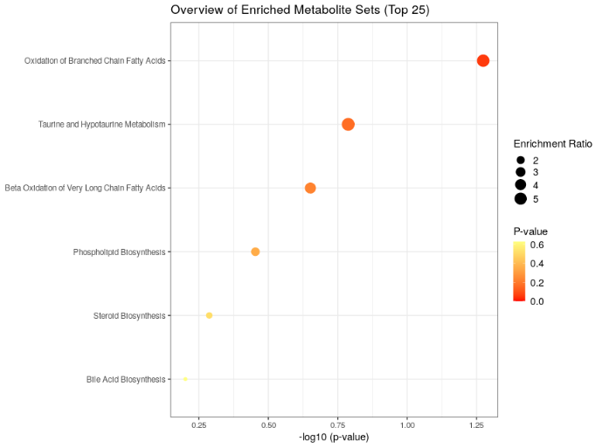
C
B
Table 5. Urine metabolites considered a VIP >1.5 between Meat and Mycoprotein^{1,2}

Metabolite | VIP | Fold Change (Mycoprotein/Meat)
balenine.1 | 5.65 | -3.65
C11 H18 N2 O6 | 4.52 | 2.92
C9 H15 N3 O | 4.11 | -2.66
C8 H14 N6 O7 | 4.08 | 2.64
C14 H30 N2 O6 | 3.99 | -2.58
C10 H21 N5 O3 | 3.82 | -2.47
C17 H31 N O3 | 3.76 | 2.43
l-Histidinal | 3.35 | -2.16
val-his | 3.20 | -2.07
N-[(2Z)-2-Hydroxy-2-octenoyl]glycine | 2.99 | 1.94
C12 H25 O6 P3 | 2.95 | -1.90
C13 H20 N2 O5 | 2.87 | -1.85
C7 H13 N3 O | 2.85 | 1.84
Miglitol | 2.70 | -1.75
C10 H19 N5 O2 | 2.66 | -1.72
C34 H44 N8 O2 | 2.62 | -1.70
C30 H51 N4 O2 P3 | 2.61 | -1.69
C29 H42 N10 O4 | 2.57 | -1.66
C19 H26 O9 | 2.57 | 1.66
Propionylcarnitine | 2.55 | -1.65
gamma-thiomethyl glutamate | 2.51 | 1.62
C10 H4 N3 O3 P | 2.51 | -1.62
Ibuprofen metabolite B | 2.48 | 1.60
(3S,6S)-3-(Hydroxymethyl)-6-{4-[(3-methyl-2-buten-1-yl)oxy]benzyl-2,5-piperazinedione | 2.46 | -1.59
TDIQ | 2.37 | -1.53
2-(6,10-Dimethyl-8-oxospiro[4.5]dec-6-en-2-yl)-2-hydroxypropyl hexopyranoside | 2.36 | 1.52
9-Nitrooleate | 2.32 | -1.50
N(alpha)-gamma-L-glutamylhistamine | 2.26 | -1.46
(5E)-7-methylidene-10-oxo-4-(propan-2-yl)undec-5-enoic acid | 2.20 | 1.42
Table 5 (continued)

C22 H33 N5 O4 | 2.19 | 1.42
C10 H18 N4 O3 | 2.19 | -1.41
C29 H47 N O8 S | 2.12 | 1.37
Allysine.1 | 2.11 | -1.36
C8 H13 N O4 S.1 | 2.07 | 1.34
C10 H13 N O5 S.1 | 2.05 | 1.33
Acetyl-Î²-methylcholine | 2.03 | -1.31
Acetylcholine | 2.03 | -1.31
Xanthotoxol | 2.01 | 1.30
3-Methylglutarylcarnitine | 2.00 | -1.29
Mevalonic acid | 1.99 | 1.29
C6 H8 O7 S.1 | 1.95 | -1.26
Sorbic acid | 1.92 | 1.24
Acronycidine | 1.92 | -1.24
C10 H27 N4 O3 P3 | 1.90 | 1.23
C11 H20 N2 O7 S3 | 1.88 | 1.21
C21 H31 N O9 | 1.87 | -1.21
5-(2,3-Dihydroxy-3-methylbutyl)-4-[(3,3-dimethyl-2-oxiranyl)acetyl]-3,4-dihydroxy-2-(3-methylbutanoyl)-2-cyclopenten-1-one | 1.85 | 1.20
DL-Î²-Leucine | 1.81 | -1.17
C8 H12 N2 O5 S | 1.81 | -1.17
C12 H21 N3 O4 S | 1.81 | 1.17
methoxyresorcinol | 1.81 | -1.17
C5 H10 N8 O S2 | 1.78 | 1.15
C15 H25 N7 O6 | 1.77 | 1.15
C10 H25 N6 O9 P S3.1 | 1.77 | -1.14
C16 H34 N O7 P3 | 1.76 | 1.14
C14 H20 N2 O8 | 1.76 | -1.14
Taurine | 1.75 | -1.13
C16 H19 N O6 S.1 | 1.74 | -1.12
Taurine.1 | 1.74 | -1.12
N-[2-Hydroxy-4-(sulfooxy)phenyl]acetamide | 1.72 | -1.11
C14 H18 N2 O3 S2 | 1.70 | 1.10
Table 5 (continued)

C7 H16 N8 O3 S3 | 1.70 | -1.10
C22 H19 N4 O3 P S | 1.70 | 1.10
ibufenac.1 | 1.70 | 1.10
2-methoxyacetaminophen sulfate | 1.69 | -1.10
paracetamol sulfate | 1.69 | -1.09
Arbusculin A | 1.68 | 1.09
5-Methylangelicin | 1.67 | -1.08
C6 H17 N4 O8 P | 1.67 | 1.08
C22 H35 N O8 | 1.67 | -1.08
C6 H14 N5 O7 P S | 1.65 | -1.07
Arsenobetaine | 1.65 | -1.06
3-[2-[(E)-[3-(2-carboxyethyl)-5-[(4-ethyl-3-methyl-5-oxo-pyrrolidin-2-yl)methyl]-4-methyl-pyrrol-2-ylidene]methyl]-5-[(3-ethyl-4-methyl-5-oxo-pyrrolidin-2-yl)methyl]-4-methyl-1H-pyrrol-3-yl]propanoic acid | 1.65 | -1.06
N-Acetyl-L-cysteine | 1.63 | 1.05
C24 H26 N6 O6 | 1.61 | 1.04
Succinylacetone | 1.59 | 1.03
C5 H4 O7 S | 1.56 | 1.01
L-Anserine | 1.55 | -1.00
C6 H12 N3 O3 P.1 | 1.54 | 1.00
C12 H24 N5 O6 P S | 1.54 | -0.99
Roxatidine | 1.54 | -0.99
N-Acetylleucylleucine | 1.50 | 0.97
¹VIP threshold set at >1.5.
²Unidentified metabolites presented as chemical formula (i.e., C8 H16 N2 0)
Positive fold change indicates greater Mycoprotein, negative fold change indicates greater Meat.
VIP, Variable importance in projection

