SUPPLEMENTARY INFORMATION
Association between an oxidative balance score and mortality: a prospective analysis in the SUN cohort
Irene Talavera-Rodríguez*, Cesar I Fernandez-Lazaro*, Ángela Hernández-Ruiz, María Soledad Hershey, Cristina Gallarregui, Mercedes Sotos-Prieto, Carmen de la Fuente-Arrillaga, Miguel Ángel Martínez-González, Miguel Ruiz-Canela
*both first and second authors contributed equally to this work

Supplemental Table s1: Criteria for scoring the oxidative balance score (OBS).
Supplemental Table s2: Pearson product-moment correlation coefficients between the dietary components of the OBS.
Supplemental Table s3: Competing risk analysis. Proportional subdistribution hazards models for the associations of the oxidative balance score (OBS) with cancer, cardiovascular, and other-cause mortality in the SUN cohort (n = 18,561).
Supplemental Table s4: Associations of the oxidative balance score (OBS) dietary and lifestyle components with all-cause, cancer, cardiovascular, other-cause mortality in the SUN cohort (n = 18,561). Hazard ratios (HR) and 95% confidence intervals (CI).
Supplemental Table s5. Associations of the items included in the oxidative balance score (OBS) with all-cause, cancer, cardiovascular, and other-cause mortality in the SUN cohort (n = 18,561). Hazard ratios (HR) and 95% confidence intervals (CI).
Supplemental Figure s1. Sensitivity analyses. Hazard Ratio (HR) and 95% Confidence Interval (CI) for the associations of the oxidative balance score (OBS) with all-cause, cancer, cardiovascular, and other-cause mortality under different assumptions: A) excluding participants with < 2years of follow-up (n= 18,082); B) truncating the participants’ follow-up at 10 years (n= 18,561); C) excluding participants with < 2 years of follow-up and truncating the follow-up at 10 years (n=18,082); D) excluding participants with < 40 years at the end of the follow-up (n=13,881); E) excluding participants with < 4 years of follow-up (n= 17,105); F) excluding participants with < 10 years of follow-up (n= 12,500); G) re-calculating the OBS according to total vitamin C, total vitamin E, beta-carotenes, selenium, total zinc, and heme iron sex-specific quintile values (n=18,561), in the SUN cohort (1999–2018).

TABLES
Supplemental Table 1. Criteria for scoring the oxidative balance score (OBS).
 | 0 points | 1 point | 2 points | 3 points | 4 points
¹Total Vitamin C (mg/d) | Q1 | Q2 | Q3 | Q4 | Q5
¹Total Vitamin E (mg/d) | Q1 | Q2 | Q3 | Q4 | Q5
Dietary Beta-carotenes (mcg/d) | Q1 | Q2 | Q3 | Q4 | Q5
Dietary Selenium (mcg/d) | Q1 | Q2 | Q3 | Q4 | Q5
¹Total Zinc (mg/d) | Q1 | Q2 | Q3 | Q4 | Q5
Dietary Heme Iron (mg/d) | Q5 | Q4 | Q3 | Q2 | Q1
²Dietary PAC score | Q1 | Q2 | Q3 | Q4 | Q5
Dietary TAC (mmol Fe⁺²/100g) | Q1 | Q2 | Q3 | Q4 | Q5
BMI (kg/m²) | ≥35 | <35 & ≥30 | <30 & ≥27 | <27 & ≥25 | <25
Alcohol Intake (g/d) | ♂ >75 | ≤75 & >50 | ≤50 & >20 | ≤20 & >10 | ≤10
Alcohol Intake (g/d) | ♀ >50 | ≤50 & >25 | ≤25 & >15 | ≤15 & >5 | ≤5
 | 0 points | 2 points |  | 4 points
Smoking status | Current | Former |  | Never
³PA score | 0-2 | 3-5 |  | 6-8
Abbreviations: BMI, body mass index; PAC, polyphenols antioxidant content score; TAC, total antioxidant capacity; PA, physical activity; Q, quartiles.
¹Total accounts for intakes from both dietary and supplemental sources.
²Score proposed by Pounis et al. (29)
³Score proposed by Alvarez-Alvarez et al. (38)

Supplemental Table s2. Pearson product-moment correlation coefficients between the dietary components of the OBS.
Components | Dietary TAC | Total Vitamin C | Total Vitamin E | Dietary Beta-carotenes | Dietary Selenium | Total Zinc | Dietary Heme Iron
¹Total Vitamin C (mg/d) | 0.635 | --
¹Total Vitamin E (mg/d) | 0.116 | 0.162 | --
Dietary Beta-carotenes (mcg/d) | 0.288 | 0.518 | 0.081 | --
Dietary Selenium (mcg/d) | 0.269 | 0.209 | 0.125 | 0.134 | --
¹Total Zinc (mg/d) | 0.238 | 0.304 | 0.097 | 0.201 | 0.246 | --
²Dietary PAC score | 0.702 | 0.662 | 0.184 | 0.414 | 0.283 | 0.247 | --
Dietary Heme Iron (mg/d) | 0.122 | 0.084 | 0.111 | 0.019 | 0.521 | 0.214 | 0.154
Abbreviations: d, day; mcg, micrograms; mg milligrams; OBS, oxidative balance score; PAC, polyphenol antioxidant content.
¹Total accounts for intakes from both dietary and supplemental sources.
²Score proposed by Pounis et al. (29)

Supplemental Table s3. Competing risk analyses. Proportional subdistribution hazards models for the associations of the oxidative balance score (OBS) with cancer, cardiovascular, and other-cause mortality in the SUN cohort (n = 18,561).
 | Quartiles of Oxidative Balance Score
 | Q1 | Q2 | Q3 | Q4 | p for trend
n (frequency) | 4976 | 4458 | 5223 | 3904
OBS range | 5-22 | 23-27 | 28-33 | 34-47
Person-years | 57291 | 52183 | 60727 | 43827
CVD mortality
Deaths | 31 | 23 | 18 | 8
Mortality rate/10000 person-years | 5.41 | 4.40 | 2.96 | 1.82
Crude model | 1 (Ref.) | 0.81 (0.47-1.39) | 0.54 (0.30-0.97) | 0.33 (0.15-0.72) | 0.001
Multivariable model | 1 (Ref.) | 0.80 (0.43-1.46) | 0.39 (0.17-0.86) | 0.27 (0.10-0.69) | 0.003
Cancer mortality
Deaths | 59 | 66 | 69 | 21
Mortality rate/10000 person-years | 10.30 | 12.65 | 11.36 | 4.79
Crude model | 1 (Ref.) | 1.22 (0.86-1.74) | 1.09 (0.77-1.54) | 0.45 (0.28-0.75) | 0.003
Multivariable model | 1 (Ref.) | 1.13 (0.77-1.67) | 0.89 (0.59-1.35) | 0.36 (0.19-0.68) | 0.002
Other-cause mortality
Deaths | 42 | 35 | 35 | 14
Mortality rate/10000 person-years | 7.33 | 6.71 | 5.76 | 3.19
Crude model | 1 (Ref.) | 0.92 (0.59-1.44) | 0.78 (0.50-1.22) | 0.43 (0.24-0.80) | 0.005
Multivariable model | 1 (Ref.) | 1.07 (0.65-1.78) | 0.84 (0.49-1.44) | 0.55 (0.25-1.20) | 0.124

Abbreviations: CVD, cardiovascular disease; OBS, oxidative balance score; Q, quartile; ref., reference.
Multivariable model: adjusted for age (underlying variable), family history of cardiovascular diseases (dichotomous), following special diet at baseline (dichotomous), marital status (married, single and others). Mediterranean adherence (continuous), prevalent cancer (dichotomous), prevalent depression (dichotomous), prevalent cardiovascular disease* (dichotomous), prevalent diabetes (dichotomous), prevalent dyslipidaemia (dichotomous), prevalent hypertension (dichotomous), sex (dichotomous), total energy intake (continuous), use of aspirin (dichotomous), years of higher education (continuous), and stratified by deciles of age and recruitment period (6 categories).
*Prevalent cardiovascular disease was considered as having at least one of the following events before entering the cohort: aneurysm, angina pectoris, atrial fibrillation, cardiac insufficiency, coronary bypass, deep vein thrombosis, intermittent claudication, myocardial infarction, pulmonary embolism, stroke, or tachycardia.

Supplemental Table s4. Associations of the oxidative balance score (OBS) dietary and lifestyle components with all-cause, cancer, cardiovascular, other-cause mortality in the SUN cohort (n = 18,561). Hazard ratios (HR) and 95% confidence intervals (CI).
 |  | Quartiles of Oxidative Balance Score
 |  | Dietary OBS |  |  |  |  |  |  | Lifestyle OBS
 |  | Q1 | Q2 | Q3 | Q4 | p for trend |  |  |  | Q1 | Q2 | Q3 | Q4 | p for trend
n (frequency) |  | 5019 | 4755 | 4688 | 4099 |  |  |  |  | 6989 | 5118 | 5185 | 1269
OBS range |  | 0-11 | 12-16 | 17-21 | 22-32 |  |  |  |  | 1-10 | 11-12 | 13-14 | 15-16
Person-years |  | 58111 | 55208 | 54788 | 45923 |  |  |  |  | 80815 | 58983 | 59784 | 14448
All-cause mortality
Deaths |  | 108 | 115 | 126 | 72 |  |  |  |  | 250 | 111 | 48 | 12
Mortality rate/10000 person-years |  | 18.59 | 20.83 | 23.00 | 15.68 |  |  |  |  | 30.93 | 18.82 | 8.03 | 8.31
Crude model |  | 1 (Ref.) | 1.13 (0.87-1.46) | 1.23 (0.95-1.59) | 0.84 (0.62-1.13) | 0.594 |  |  |  | 1 (Ref.) | 0.70 (0.56-0.87) | 0.41 (0.30-0.57) | 0.53 (0.29-0.95) | <0.001
Multivariable model |  | 1 (Ref.) | 1.18 (0.88-1.60) | 1.07 (0.75-1.52) | 0.68 (0.44-1.07) | 0.148 |  |  |  | 1 (Ref.) | 0.78 (0.61-0.99) | 0.47 (0.33-0.65) | 0.66 (0.36-1.19) | <0.001
CVD mortality
Deaths |  | 25 | 24 | 15 | 16 |  |  |  |  | 60 | 15 | 5 | -
Mortality rate/10000 person-years |  | 4.30 | 4.35 | 2.74 | 3.48 |  |  |  |  | 7.42 | 2.54 | 0.84 | -
Crude model |  | 1 (Ref.) | 0.81 (0.47-1.39) | 0.54 (0.30-0.97) | 0.33 (0.15-0.71) | 0.001 |  |  |  | 1 (Ref.) | 0.34 (0.19-0.59) | 0.11 (0.04-0.27) | -¹ | <0.001
Multivariable model |  | 1 (Ref.) | 0.95 (0.48-1.85) | 0.42 (0.17-1.01) | 0.39 (0.14-1.11) | 0.042 |  |  |  | 1 (Ref.) | 0.42 (0.22-0.80) | 0.20 (0.07-0.54) | -² | <0.001
Cancer mortality
Deaths |  | 47 | 61 | 71 | 36 |  |  |  |  | 123 | 60 | 25 | 7
Mortality rate/10000 person-years |  | 8.09 | 11.05 | 12.96 | 7.84 |  |  |  |  | 15.22 | 10.17 | 4.18 | 4.84
Crude model |  | 1 (Ref.) | 1.37 (0.94-2.00) | 1.59 (1.10-2.30) | 0.96 (0.62-1.48) | 0.641 |  |  |  | 1 (Ref.) | 0.65 (0.48-0.89) | 0.27 (0.17-0.41) | 0.31 (0.14-0.65) | <0.001
Multivariable model |  | 1 (Ref.) | 1.32 (0.86-2.02) | 1.29 (0.80-2.10) | 0.72 (0.39-1.34) | 0.441 |  |  |  | 1 (Ref.) | 0.86 (0.62-1.20) | 0.49 (0.31-0.78) | 0.73 (0.33-1.61) | 0.008
Other-cause mortality
Deaths |  | 36 | 30 | 40 | 20 |  |  |  |  | 67 | 36 | 18 | 5
Mortality rate/10000 person-years |  | 6.20 | 5.43 | 7.30 | 4.36 |  |  |  |  | 8.29 | 6.10 | 3.01 | 3.46
Crude model |  | 1 (Ref.) | 0.88 (0.54-1.43) | 1.17 (0.74-1.83) | 0.70 (0.41-1.22) | 0.513 |  |  |  | 1 (Ref.) | 0.72 (0.48-1.08) | 0.35 (0.21-0.60) | 0.40 (0.16-1.00) | <0.001
Multivariable model |  | 1 (Ref.) | 1.01 (0.57-1.79) | 1.17 (0.61-2.23) | 0.69 (0.30-1.63) | 0.636 |  |  |  | 1 (Ref.) | 0.92 (0.59-1.44) | 0.58 (0.32-1.06) | 1.03 (0.39-2.69) | 0.212
¹There was not any CVD death in Q4. We merged Q3+Q4 resulting in three categories (Q1, Q2, and Q3+Q4) with HR (95% CI) of 0.71 (0.42-1.20) for extreme categories.
²There was not any CVD death in Q4. We merged Q3+Q4 resulting in three categories (Q1, Q2, and Q3+Q4) with HR (95% CI) of 0.52 (0.11-2.40) for extreme categories.
Abbreviations: CVD, cardiovascular disease; OBS, oxidative balance score; Q, quartile; ref., reference.
Multivariable model: adjusted for age (underlying variable), family history of cardiovascular diseases (dichotomous), following special diet at baseline (dichotomous), marital status (married, single and others). Mediterranean adherence (continuous), prevalent cancer (dichotomous), prevalent depression (dichotomous), prevalent cardiovascular disease* (dichotomous), prevalent diabetes (dichotomous), prevalent dyslipidemia (dichotomous), prevalent hypertension (dichotomous), sex (dichotomous), total energy intake (continuous), use of aspirin (dichotomous), years of higher education (continuous), corresponding OBS components (dietary or lifestyle components), and stratified by deciles of age and recruitment period (6 categories).
*Prevalent cardiovascular disease was considered as having at least one of the following events before entering the cohort: aneurysm, angina pectoris, atrial fibrillation, cardiac insufficiency, coronary bypass, deep vein thrombosis, intermittent claudication, myocardial infarction, pulmonary embolism, stroke, or tachycardia

Table s5. Associations of the items included in oxidative balance score (OBS) with all-cause, cancer, cardiovascular, and other-cause mortality in the SUN cohort (n = 18,561). Hazard ratios (HR) and 95% confidence intervals (CI).
 | Points of the Oxidative Balance Score (OBS)
 | 0 points | 1 point |  | 2 points | 3 points |  | 4 points
All-cause mortality
¹Total Vitamin C (mg/d) | 1 (Ref.) | 0.83 (0.59-1.16) |  | 0.85 (0.59-1.22) | 0.84 (0.57-1.26) |  | 0.66 (0.41-1.06)
¹Total Vitamin E (mg/d) | 1 (Ref.) | 1.20 (0.88-1.64) |  | 1.11 (0.80-1.53) | 1.20 (0.85-1.71) |  | 1.03 (0.71-1.48)
Dietary Beta-carotenes (mcg/d) | 1 (Ref.) | 0.94 (0.69-1.28) |  | 0.95 (0.69-1.31) | 0.85 (0.61-1.20) |  | 0.89 (0.61-1.31)
Dietary Selenium (mcg/d) | 1 (Ref.) | 1.08 (0.78-1.48) |  | 0.86 (0.60-1.25) | 0.89 (0.61-1.30) |  | 0.99 (0.66-1.49)
¹Total Zinc (mg/d) | 1 (Ref.) | 0.89 (0.64-1.23) |  | 0.84 (0.58-1.21) | 0.90 (0.62-1.30) |  | 0.87 (0.61-1.25)
Dietary Heme Iron (mg/d) | 1 (Ref.) | 1.24 (0.87-1.77) |  | 0.97 (0.67-1.41) | 0.99 (0.67-1.46) |  | 1.25 (0.83-1.89)
²Dietary PAC score | 1 (Ref.) | 1.34 (0.93-1.94) |  | 1.35 (0.88-2.08) | 1.61 (1.02-2.55) |  | 1.62 (0.94-2.79)
Dietary TAC (mmol Fe⁺²/100g) | 1 (Ref.) | 1.12 (0.76-1.64) |  | 1.24 (0.82-1.87) | 1.11 (0.71-1.74) |  | 0.82 (0.49-1.36)
BMI (kg/m²) | 1 (Ref.) | 0.65 (0.29-1.43) |  | 0.59 (0.28-1.27) | 0.44 (0.20-0.94) |  | 0.59 (0.28-1.26)
Alcohol Intake (g/d) | 1 (Ref.) | 0.45 (0.20-1.01) |  | 0.25 (0.12-0.52) | 0.20 (0.09-0.42) |  | 0.17 (0.08-0.35)
 | 0 points |  | 2 points |  |  | 4points
Smoking status | 1 (Ref.) |  | 0.83 (0.64-1.08) |  |  | 0.67 (0.50-0.90)
³PA score | 1 (Ref.) |  | 0.68 (0.54-0.84) |  |  | 0.65 (0.45-0.92)
CVD mortality
¹Total Vitamin C (mg/d) | 1 (Ref.) | 0.63 (0.29-1.38) |  | 0.65 (0.28-1.49) | 0.43 (0.16-1.15) |  | 0.43 (0.14-1.35)
¹Total Vitamin E (mg/d) | 1 (Ref.) | 1.47 (0.68-3.18) |  | 0.86 (0.36-2.03) | 1.69 (0.71-4.03) |  | 1.62 (0.68-3.88)
Dietary Beta-carotenes (mcg/d) | 1 (Ref.) | 0.61 (0.29-1.29) |  | 0.61 (0.28-1.32) | 0.48 (0.21-1.10) |  | 0.61 (0.25-1.46)
Dietary Selenium (mcg/d) | 1 (Ref.) | 0.51 (0.24-1.08) |  | 0.51 (0.22-1.16) | 0.28 (0.10-0.76) |  | 0.43 (0.16-1.14)
¹Total Zinc (mg/d) | 1 (Ref.) | 1.14 (0.52-2.51) |  | 1.01 (0.40-2.56) | 1.06 (0.44-2.55) |  | 1.02 (0.44-2.34)
Dietary Heme Iron (mg/d) | 1 (Ref.) | 1.14 (0.46-2.79) |  | 1.13 (0.46-2.75) | 0.48 (0.18-1.32) |  | 0.75 (0.26-2.14)
²Dietary PAC score | 1 (Ref.) | 2.26 (0.89-5.75) |  | 3.16 (1.04-9.57) | 2.78 (0.87-8.89) |  | 2.20 (0.51-9.40)
Dietary TAC (mmol Fe⁺²/100g) | 1 (Ref.) | 1.90 (0.72-5.01) |  | 1.29 (0.45-3.70) | 1.48 (0.48-4.59) |  | 1.27 (0.36-4.53)
BMI (kg/m²) | 1 (Ref.) | 1.15 (0.13-10.41) |  | 1.02 (0.12-8.58) | 0.44 (0.05-3.79) |  | 0.53 (0.06-4.45)
Alcohol Intake (g/d) | 1 (Ref.) | 0.35 (0.06-1.86) |  | 0.11 (0.02-0.47) | 0.10 (0.02-0.50) |  | 0.09 (0.02-0.40)
 | 0 points |  | 2 points |  |  | 4points
Smoking status | 1 (Ref.) |  | 1.36 (0.65-2.84) |  |  | 0.68 (0.29-1.60)
³PA score | 1 (Ref.) |  | 0.86 (0.51-1.44) |  |  | 0.17 (0.04-0.78)
Cancer mortality
¹Total Vitamin C (mg/d) | 1 (Ref.) | 0.86 (0.54-1.39) |  | 0.93 (0.56-1.54) | 0.95 (0.55-1.64) |  | 0.61 (0.31-1.18)
¹Total Vitamin E (mg/d) | 1 (Ref.) | 1.37 (0.88-2.12) |  | 1.49 (0.96-2.33) | 1.14 (0.69-1.88) |  | 1.18 (0.70-1.97)
Dietary Beta-carotenes (mcg/d) | 1 (Ref.) | 0.88 (0.57-1.34) |  | 0.84 (0.54-1.32) | 0.68 (0.41-1.11) |  | 0.75 (0.44-1.28)
Dietary Selenium (mcg/d) | 1 (Ref.) | 1.44 (0.90-2.29) |  | 1.20 (0.71-2.02) | 1.35 (0.79-2.30) |  | 1.60 (0.90-2.87)
¹Total Zinc (mg/d) | 1 (Ref.) | 0.92 (0.59-1.42) |  | 0.75 (0.45-1.24) | 0.81 (0.48-1.36) |  | 0.79 (0.47-1.32)
Dietary Heme Iron (mg/d) | 1 (Ref.) | 1.26 (0.76-2.06) |  | 1.11 (0.66-1.87) | 1.19 (0.70-2.04) |  | 1.56 (0.88-2.77)
²Dietary PAC score | 1 (Ref.) | 1.59 (0.92-2.74) |  | 1.53 (0.83-2.83) | 2.11 (1.09-4.06) |  | 2.48 (1.17-5.25)
Dietary TAC (mmol Fe⁺²/100g) | 1 (Ref.) | 1.18 (0.66-2.12) |  | 1.66 (0.91-3.01) | 1.24 (0.65-2.36) |  | 1.02 (0.50-2.11)
BMI (kg/m²) | 1 (Ref.) | 0.46 (0.15-1.44) |  | 0.52 (0.18-1.51) | 0.46 (0.16-1.35) |  | 0.55 (0.19-1.58)
Alcohol Intake (g/d) | 1 (Ref.) | 0.37 (0.11-1.19) |  | 0.32 (0.11-0.88) | 0.22 (0.08-0.63) |  | 0.18 (0.07-0.50)
 | 0 points |  | 2 points |  |  | 4points
Smoking status | 1 (Ref.) |  | 0.65 (0.46-0.92) |  |  | 0.54 (0.36-0.80)
³PA score | 1 (Ref.) |  | 0.74 (0.55-1.01) |  |  | 0.85 (0.53-1.34)
Other-cause mortality
¹Total Vitamin C (mg/d) | 1 (Ref.) | 1.02 (0.54-1.91) |  | 0.96 (0.47-1.98) | 1.28 (0.59-2.77) |  | 1.30 (0.54-3.14)
¹Total Vitamin E (mg/d) | 1 (Ref.) | 0.82 (0.46-1.48) |  | 0.69 (0.36-1.31) | 1.03 (0.54-1.96) |  | 0.65 (0.32-1.33)
Dietary Beta-carotenes (mcg/d) | 1 (Ref.) | 1.46 (0.80-2.64) |  | 1.44 (0.77-2.69) | 1.70 (0.91-3.20) |  | 1.37 (0.65-2.87)
Dietary Selenium (mcg/d) | 1 (Ref.) | 1.04 (0.58-1.85) |  | 0.55 (0.26-1.14) | 0.73 (0.35-1.50) |  | 0.66 (0.30-1.47)
¹Total Zinc (mg/d) | 1 (Ref.) | 0.73 (0.38-1.40) |  | 0.94 (0.48-1.83) | 0.97 (0.49-1.92) |  | 0.86 (0.44-1.66)
Dietary Heme Iron (mg/d) | 1 (Ref.) | 1.29 (0.68-2.44) |  | 0.64 (0.31-1.33) | 0.92 (0.45-1.87) |  | 1.11 (0.53-2.35)
²Dietary PAC score | 1 (Ref.) | 0.74 (0.39-1.40) |  | 0.65 (0.29-1.45) | 0.66 (0.28-1.54) |  | 0.63 (0.23-1.78)
Dietary TAC (mmol Fe⁺²/100g) | 1 (Ref.) | 0.84 (0.43-1.63) |  | 0.79 (0.38-1.65) | 0.88 (0.40-1.96) |  | 0.43 (0.16-1.15)
BMI (kg/m²) | 1 (Ref.) | 0.66 (0.16-2.66) |  | 0.43 (0.11-1.69) | 0.31 (0.08-1.25) |  | 0.53 (0.14-2.02)
Alcohol Intake (g/d) | 1 (Ref.) | 0.78 (0.14-4.38) |  | 0.25 (0.05-1.35) | 0.23 (0.04-1.27) |  | 0.23 (0.05-1.21)
 | 0 points |  | 2 points |  |  | 4points
Smoking status | 1 (Ref.) |  | 0.99 (0.58-1.69) |  |  | 0.92 (0.52-1.62)
³PA score | 1 (Ref.) |  | 0.48 (0.32-0.73) |  |  | 0.59 (0.31-1.11)
Abbreviations: CVD, cardiovascular disease; OBS, oxidative balance score; ref., reference.
¹Total accounts for intakes from both dietary and supplemental sources.
²Score proposed by Pounis et al. (29)
³Score proposed by Alvarez-Alvarez et al. (38)
Multivariable model: adjusted for age (underlying variable), family history of cardiovascular diseases (dichotomous), following special diet at baseline (dichotomous), marital status (married, single and others). Mediterranean adherence (continuous), prevalent cancer (dichotomous), prevalent depression (dichotomous), prevalent cardiovascular disease* (dichotomous), prevalent diabetes (dichotomous), prevalent dyslipidaemia (dichotomous), prevalent hypertension (dichotomous), sex (dichotomous), total energy intake (continuous), use of aspirin (dichotomous), years of higher education (continuous), and stratified by deciles of age and recruitment period (6 categories). Additionally, the model was mutually adjusted for the other components of the OBS.
*Prevalent cardiovascular disease was considered as having at least one of the following events before entering the cohort: aneurysm, angina pectoris, atrial fibrillation, cardiac insufficiency, coronary bypass, deep vein thrombosis, intermittent claudication, myocardial infarction, pulmonary embolism, stroke, or tachycardia.

FIGURES

A) B)
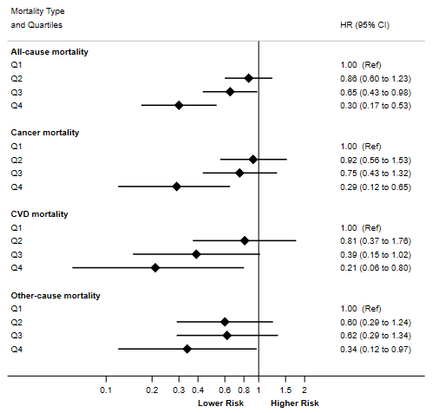
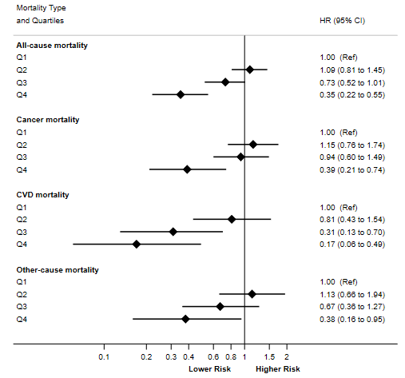

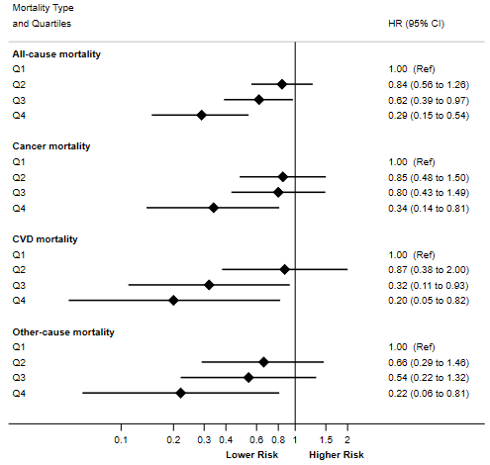
C) D)
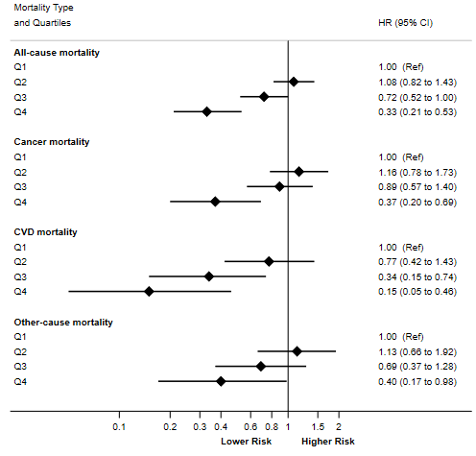

E) F)
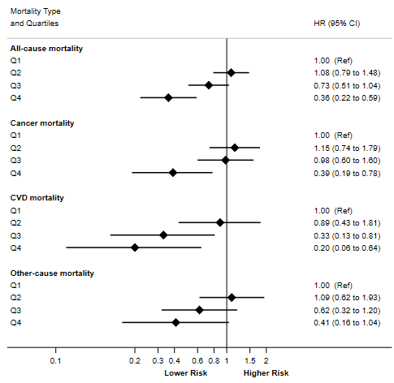
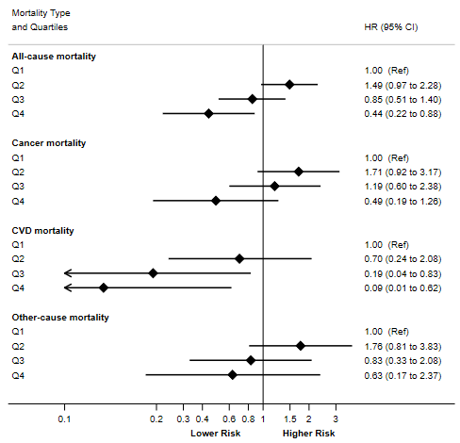

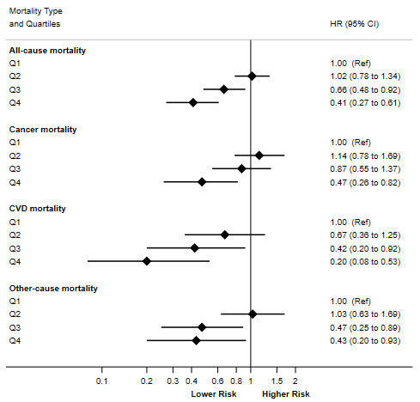
G)

Figure s1. Sensitivity analyses. Hazard Ratio (HR) and 95% Confidence Interval (CI) for the associations of the oxidative balance score (OBS) with all-cause, cancer, cardiovascular, and other-cause mortality under different assumptions: A) excluding participants with < 2years of follow-up (n= 18,082); B) truncating the participants’ follow-up at 10 years (n= 18,561); C) excluding participants with < 2 years of follow-up and truncating the follow-up at 10 years (n=18,082); D) excluding participants with < 40 years at the end of the follow-up (n=13,881); E) excluding participants with < 4 years of follow-up (n= 17,105); F) excluding participants with < 10 years of follow-up (n= 12,500); G) re-calculating the OBS according to total vitamin C, total vitamin E, beta-carotenes, selenium, total zinc, and heme iron sex-specific quintile values (n=18,561), in the SUN cohort (1999–2018).

Acknowledgments
We thank other members of the SUN Group: Aguilera-Buenosvinos I, Alonso A, Álvarez-Álvarez I, Balaguer A, Barbería-Latasa M, Barrio-López MT, Basterra-Gortari FJ, Battezzati A, Bazal P, Benito S, Bertoli S, Bes-Rastrollo M, Beunza JJ, Buil-Cosiales P, Carlos S, de Irala J, de la Fuente-Arrillaga C, de la O V, de la Rosa PA, Delgado-Rodríguez M, Díaz-Gutiérrez J, Díez Espino J, Domínguez L, Donat-Vargas C, Donazar M, Eguaras S, Fernández-Lázaro CI, Fernández-Montero A, Fresán U, Galbete C, García-Arellano A, Gardeazábal I, Gea A, Gutiérrez-Bedmar M, Gomes-Domingos AL, Gómez-Donoso C, Gómez-Gracia E, Goñi E, Goñi L, Guillén F, Hernández-Hernández A, Hershey MS, Hidalgo-Santamaría M, Hu E, Lahortiga F, Leone A, Llavero M, Llorca J, López del Burgo C, Marí A, Martí A, Martín-Calvo N, Martín-Moreno JM, Martínez JA, Martínez-González MA, Mendonça R, Menéndez C, Molendijk M, Molero P, Muñoz M, Navarro AM, Pano O, Pérez de Ciriza P, Pérez-Cornago A, Pérez de Rojas J, Pimenta AM, Ramallal R, Razquin C, Rico-Campà A, Romanos-Nanclares A, Ruiz L, Ruiz-Canela M, San Julián B, Sánchez D, Sánchez-Bayona R, Sánchez-Tainta A, Sánchez-Villegas A, Santiago S, Sayón-Orea C, Toledo E, Vázquez Z, Zazpe I.

