Figure S1: Batch order normalisation. (A) Representative PCA score plot before normalisation in WFM. (B) PCA score plot after batch normalisation using LOESS correction method in W4M.
Table S1: Class level identification
Metabolite | m/z | Theoretical Mass | Ion | Rt (mins) | Ionisation mode | Class | Interaction | HMDB
Urea | 61.0397 | 60.0553 | M+H | 7.51 | Positive | 1 | 3 | HMDB00294
Tyrosine | 182.0812 | 181.1885 | M+H | 11.35 | Positive | 1 | 3 | HMDB0000158
Valine | 119.0810 | 117.0790 | M+H | 9.51 | Positive | 1 | 3 | HMDB00883
Phenylalanine | 166.0861 | 166.0863 | M+H | 10.11 | Positive | 1 | 3 | HMDB00159
Leucine | 132.1022 | 132.1022 | M+H | 10.17 | Positive | 1 | 3 | HMDB00687
Tryptophan | 205.0967 | 205.0969 | 2M+H | 10.69 | Positive | 1 | 3 | HMDB00929
5-Methoxytryptamine | 192.1001 | 190.2417 | M+H | 10.80 | Positive | 2 | 2S | HMDB0004095
Carnitine | 162.0842 | 161.1989 | M+H | 10.94 | Positive | 2 | 3 | HMDB0000062
Proline | 116.0708 | 116.0706 | M+H | 11.05 | Positive | 1 | 2M | HMDB00162
Imidazole | 69.0449 | 68.0773 | M+H | 11.19 | Positive | 1 | 2M | HMDB01525
Methionine | 150.0771 | 150.0586 | M+H | 11.39 | Positive | 1 | 2S | HMDB00696
Creatine | 132.0764 | 132.0768 | M+H | 12.26 | Positive | 1 | 2S | HMDB00064
Alanine | 90.0552 | 90.0558 | M+H | 12.42 | Positive | 1 | 2M | HMDB00161
Dihydrothymine | 129.0656 | 128.0585 | M+H | 12.86 | Positive | 2 | 2M | HMDB00079
Threonine | 120.0655 | 120.0655 | M+H | 12.89 | Positive | 1 | 2S | HMDB00167
Arginine | 175.1194 | 175.1191 | M-H | 17.00 | Negative | 1 | 3 | HMDB00517
Uridine | 243.0628 | 243.0617 | M-H | 9.22 | Negative | 1 | 2M | HMDB0000296
Uric acid | 167.0208 | 168.1103 | M-H | 10.10 | Negative | 2 | 2M | HMDB0000289
Lactic acid | 89.0248 | 89.0239 | M-H | 1.71 | Negative | 1 | 3 | HMDB0000190
Unknown M141T616 | 141.1072 |  | M+H |  | Positive | 4 | 3
Unknown M188T630 | 188.1281 |  | M+H |  | Positive | 4 | 3
Unknown M302T793 | 171.0769 |  | M+H |  | Positive | 4 | 2S
Unknown M230T588 | 230.0961 |  |  |  | Negative | 4 | 3
Abbreviations; m/z, mass-to-charge ratio; Class 1: Identified marker confirmed by an authentic standard; Class 2: putatively identified marker based on elemental composition; Class 4: Unknown compound. Four levels of identification based on Metabolomics Standard Initiative
3: Three way interaction (status × meal × time)
2M: Meal × time interaction
2S: Status × time interaction

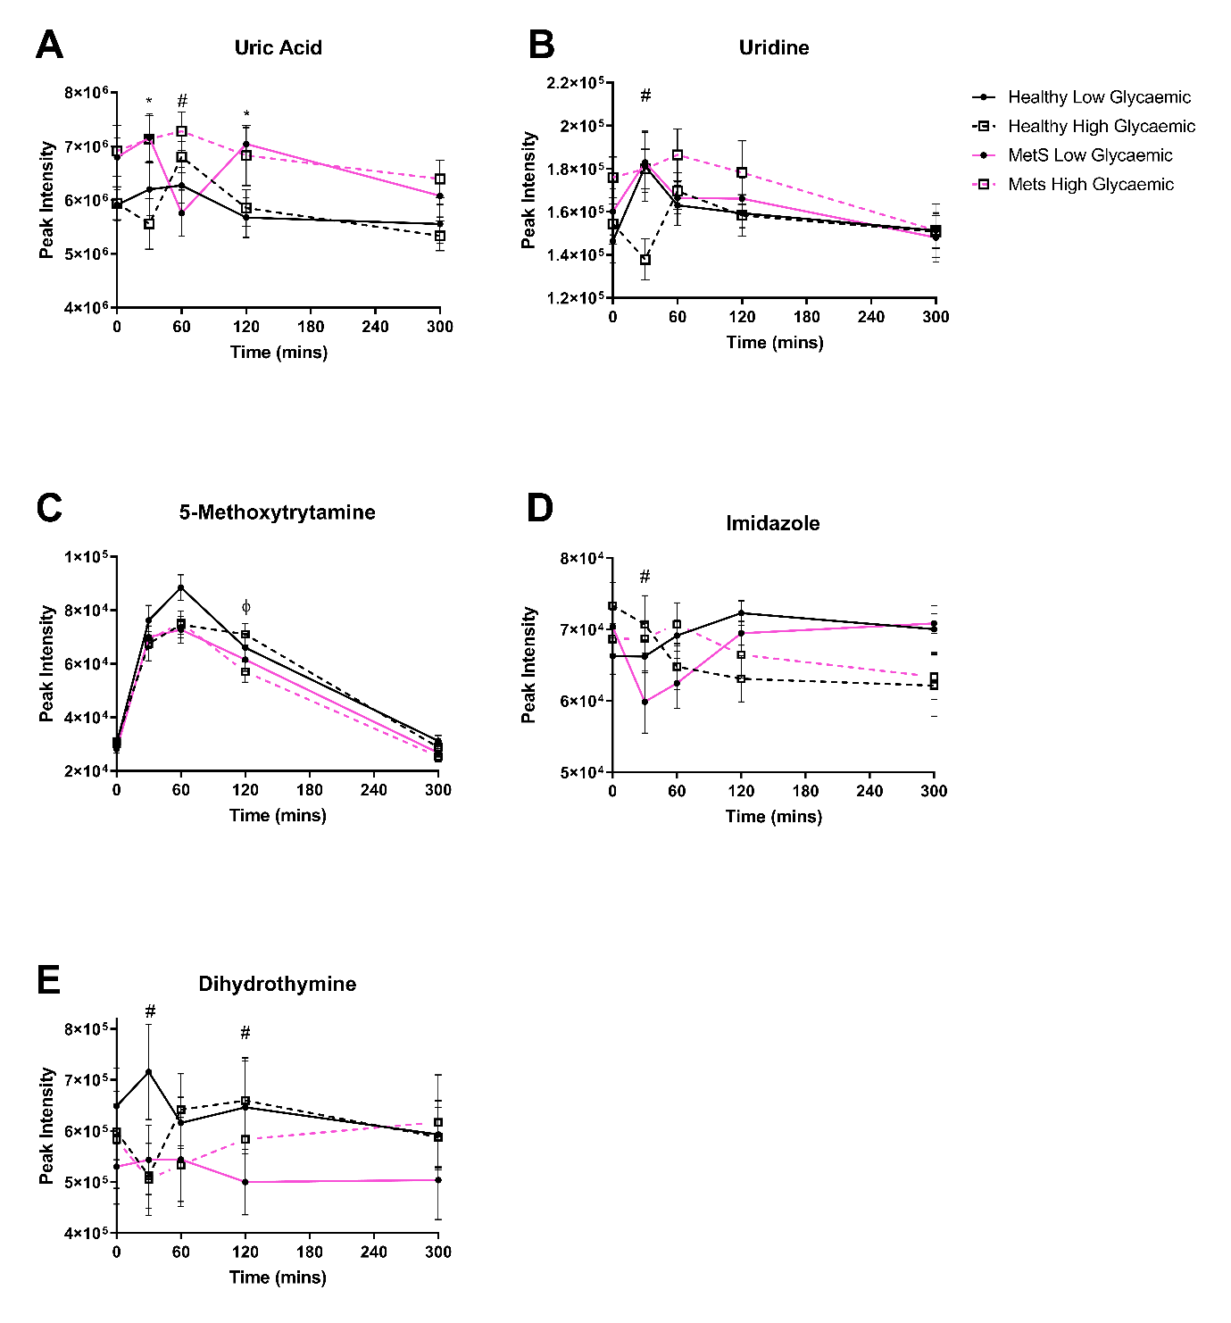
Figure S2: Polar metabolites which exhibit two way interactions. * p< 0.05 between Healthy and MetS. # p<0.05 between LGI and HGI. Error bars represent standard error of mean.

