Supplementary figure 1. Area under the curve for phenylalanine.

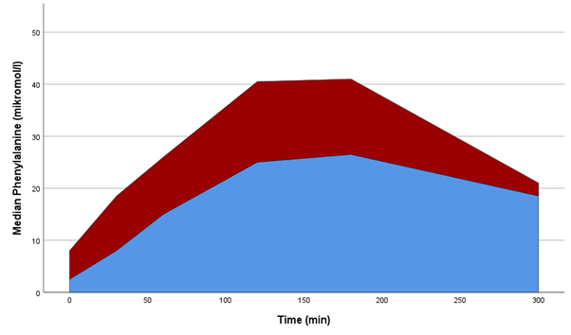

Area under the curve based on median values at each timepoint for phenylalanine. Concentrations at each timepoint is calculated by subtracting the minimum value from the concentration at the time for each individual. Women with RA in red and without in blue.

