aSupplementary Material

Ultra-processed foods, adiposity and risk of head and neck cancer and oesophageal adenocarcinoma in the European Prospective Investigation into Cancer and Nutrition study: a mediation analysis

Fernanda Morales-Berstein^{1,2}, Carine Biessy³, Vivian Viallon³, Ana Goncalves-Soares^{1,2}, Corinne Casagrande³, Bertrand Hémon³, Nathalie Kliemann^{3,4}, Manon Cairat^{3,5}, Jessica Blanco Lopez³, Aline Al Nahas³, Kiara Chang⁶, Eszter Vamos⁶, Fernanda Rauber^{7,8}, Renata Bertazzi Levy^{7,8}, Diana Barbosa Cunha⁹, Paula Jakszyn¹⁰⁻¹², Pietro Ferrari³, Paolo Vineis^{13,14}, Giovanna Masala¹⁵, Alberto Catalano¹⁶, Emily Sonestedt¹⁷, Yan Borné¹⁷, Verena Katzke¹⁸, Rashmita Bajracharya¹⁸, Claudia Agnoli¹⁹, Marcela Guevara²⁰⁻²², Alicia Heath²³, Loredana Radoï⁵, Francesca Mancini⁵, Elisabete Weiderpass²⁴, José María Huerta^{25,21}, María-José Sánchez^{26-28,21}, Anne Tjønneland^{29,30}, Cecilie Kyrø²⁹, Matthias B Schulze^{31,32}, Guri Skeie³³, Marko Lukic³³, Tonje Braaten³³, Marc Gunter^{23,3}, Christopher Millett^{6,34}, Antonio Agudo^{10,11}, Paul Brennan³⁵, M Carolina Borges^{1,2}, Rebecca C Richmond^{1,2}, Tom G Richardson^{1,2}, George Davey Smith^{1,2}, Caroline L Relton^{1,2}, Inge Huybrechts³, on behalf of the EPIC Network

¹MRC Integrative Epidemiology Unit, University of Bristol, Bristol, United Kingdom.
²Population Health Sciences, Bristol Medical School, University of Bristol, Bristol, United Kingdom.
³Nutrition and Metabolism Branch, International Agency for Research on Cancer/World Health Organization, Lyon, France.
⁴Cancer Research Center of Santa Catarina, CEPON, Florianópolis, Brazil.
⁵Paris-Saclay University, UVSQ, Inserm "Exposome, heredity, cancer and health" team, CESP U1018, Gustave Roussy, Villejuif, France.
⁶Public Health Policy Evaluation Unit, School of Public Health, Imperial College London, London, United Kingdom.
⁷Preventive Medicine Department of the Medical School, University of São Paulo, São Paulo, Brazil.
⁸Center for Epidemiological Research in Nutrition and Health, University of São Paulo, São Paulo, Brazil.
⁹Hésio Cordeiro Institute of Social Medicine, Department of Epidemiology, Rio de Janeiro State University, Rio de Janeiro, RJ, Brazil.
¹⁰Unit of Nutrition and Cancer, Catalan Institute of Oncology-ICO, L'Hospitalet de Llobregat, Spain.
¹¹Nutrition and Cancer Group; Epidemiology, Public Health, Cancer Prevention and Palliative Care Program; Bellvitge Biomedical Research Institute - IDIBELL, L'Hospitalet de Llobregat, Spain.
¹²Blanquerna Faculty of Health Sciences, Ramon Llull University, Barcelona, Spain
¹³MRC Centre for Environment and Health, School of Public Health, Imperial College London, Norfolk Place, W2 1PG London, UK.
¹⁴Italian Institute of Technology, Genova, Italy.
¹⁵Institute for Cancer Research, Prevention and Clinical Network (ISPRO), Florence Italy.
¹⁶Centre for Biostatistics, Epidemiology, and Public Health, Department of Clinical and Biological Sciences, University of Turin, 10043 Orbassano (TO), Italy.
¹⁷Nutrition Epidemiology, Department of Clinical Sciences Malmö, Faculty of Medicine, Lund University, Lund, Sweden.
¹⁸Department of Cancer Epidemiology, German Cancer Research Center (DKFZ), Heidelberg, Germany.
¹⁹Epidemiology and Prevention Unit, Fondazione IRCCS Istituto Nazionale dei Tumori, Milan, Italy.
²⁰Instituto de Salud Pública y Laboral de Navarra, 31003 Pamplona, Spain.
²¹Centro de Investigación Biomédica en Red de Epidemiología y Salud Pública (CIBERESP), 28029 Madrid, Spain.
²²Navarra Institute for Health Research (IdiSNA), 31008 Pamplona, Spain.
²³Department of Epidemiology and Biostatistics, School of Public Health, Imperial College London, London, United Kingdom.
²⁴International Agency for Research on Cancer, World Health Organization, Lyon, France.
²⁵Department of Epidemiology, Murcia Regional Health Council-IMIB, Murcia, Spain.
²⁶Escuela Andaluza de Salud Pública (EASP), 18011 Granada, Spain.
²⁷Instituto de Investigación Biosanitaria ibs.GRANADA, 18012 Granada, Spain.
²⁸Department of Preventive Medicine and Public Health, University of Granada, 18071 Granada, Spain.
²⁹Danish Cancer Society Research Center, Diet, Cancer and Health, Strandboulevarden 49, DK-2100 Copenhagen, Denmark.
³⁰Department of Public Health, University of Copenhagen, DK-2200 Copenhagen, Denmark.
³¹Department of Molecular Epidemiology, German Institute of Human Nutrition Potsdam-Rehbruecke, Nuthetal, Germany.
³²Institute of Nutritional Science, University of Potsdam, Nuthetal, Germany.
³³Department of Community Medicine, Faculty of Health Sciences, UiT The Arctic University of Norway, Tromsø, Norway.
³⁴NOVA National School of Public Health, Public Health Research Centre, Comprehensive Health Research Center, CHRC, NOVA University Lisbon, Lisbon, Portugal.
³⁵Genetic Epidemiology Group, International Agency for Research on Cancer, World Health Organization, Lyon, France.

For correspondence: dy20206@bristol.ac.uk

Supplementary Figures
- Flowchart of European Prospective Investigation into Cancer and Nutrition (EPIC) participants included in the study.
- Histogram of the relative intake of ultra-processed foods in grams per day.
- Log-log survival plot for ultra-processed food consumption and head and neck cancer risk.
- Log-log survival plot for ultra-processed food consumption and oesophageal adenocarcinoma risk.
- Schoenfeld residuals for the association between ultra-processed food consumption and head and neck cancer risk.
- Schoenfeld residuals for the association between ultra-processed food consumption and oesophageal adenocarcinoma risk.
- Correlation plot for ultra-processed food consumption models.
- Non-linearity assessment for the relative intake of ultra-processed foods in grams per day and head and neck cancer risk.
- Forest plots for associations between the intake of ultra-processed foods (in %g/d, g/d, %kcal/d and kcal/d) and the risk of head and neck cancer and oesophageal adenocarcinoma.

Supplementary Tables
- Food categories contributing to each NOVA group.
- Variance inflation factor (VIF) for the assessment of multicollinearity.
- Associations between the relative intake of ultra-processed foods (in %g/d) and the risk of head and neck cancer and oesophageal adenocarcinoma.
- Associations between the relative intake of ultra-processed foods (in %g/d) and the risk of head and neck cancer subtypes.
- Stratified analyses for the associations between ultra-processed foods (in %g/d) and the risk of head and neck cancer and oesophageal adenocarcinoma.
- Identification of possible mediators of the associations between ultra-processed food consumption (in %g/d) and the risk of head and neck and oesophageal adenocarcinoma.
- Associations between the relative intake of ultra-processed foods (in %g/d) and the risk of head and neck cancer and oesophageal adenocarcinoma, accounting for total water intake (including water in foods).
- Associations between relative intake of ultra-processed foods (in %g/d) and the risk of head and neck cancer and oesophageal adenocarcinoma, accounting for energy intake.
- Associations between the relative intake of ultra-processed foods (in %g/d) and the risk of head and neck cancer and oesophageal adenocarcinoma, excluding participants censored in the first two years of follow-up.
- Complete case analysis for the associations between the relative intake of ultra-processed foods (in %g/d) and the risk of head and neck cancer and oesophageal adenocarcinoma.
- Multivariate imputation by chained equations analyses for the associations between the relative intake of ultra-processed foods (in %g/d) and the risk of head and neck cancer and oesophageal adenocarcinoma.
- Associations between the absolute (in g/d and kcal/d) and relative intake (in %kcal/d) of ultra-processed foods and the risk of head and neck cancer and oesophageal adenocarcinoma.
- Negative control outcome analysis for the association between the relative intake of ultra-processed foods (in %g/d) and the risk of accidental deaths.

Supplementary Figure 1. Flowchart of European Prospective Investigation into Cancer and Nutrition (EPIC) participants included in the study.
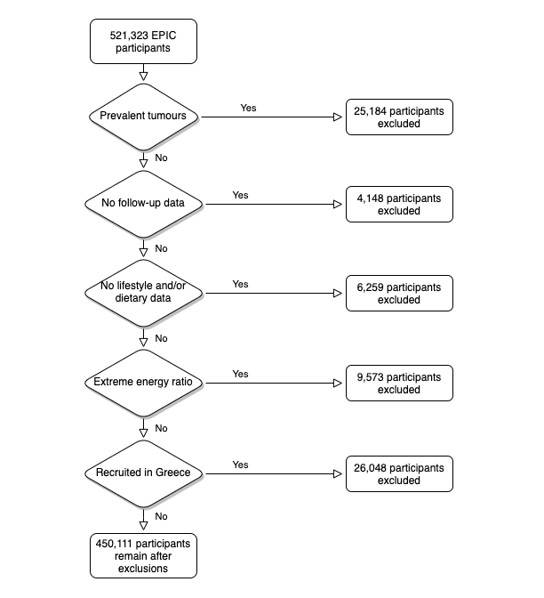

Supplementary Figure 2. Histogram of the relative intake of ultra-processed foods in grams per day.
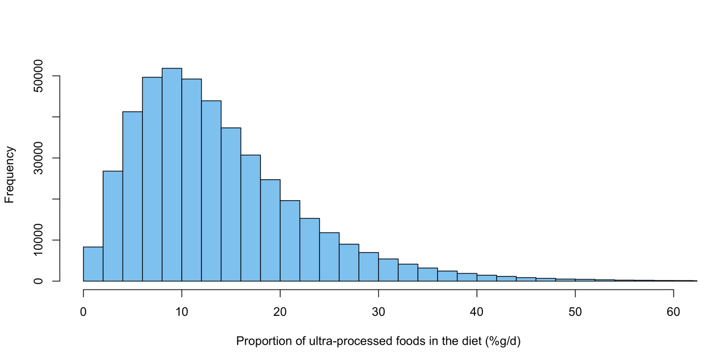Min. 1st Qu. Median Mean 3rd Qu. Max.
0.000 7.473 11.912 13.713 17.895 90.533

Supplementary Figure 3. Log-log survival plot for ultra-processed food consumption and head and neck cancer risk.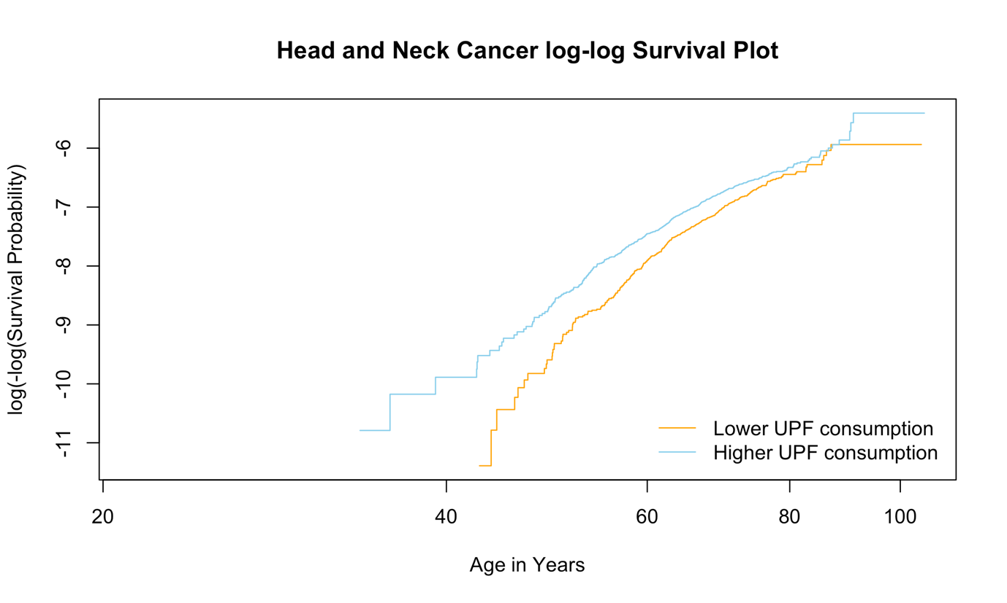

Supplementary Figure 4. Log-log survival plot for ultra-processed food consumption and oesophageal adenocarcinoma risk.
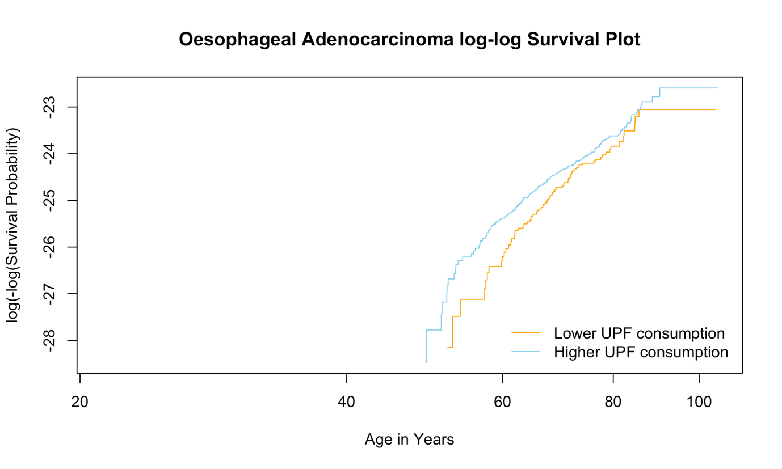

Supplementary Figure 5. Schoenfeld residuals for the association between ultra-processed food consumption and head and neck cancer risk.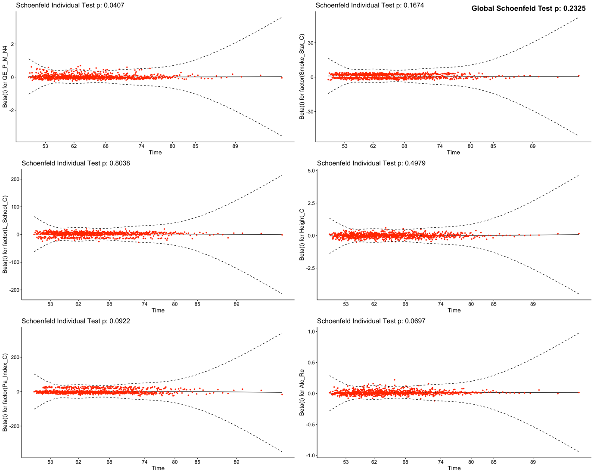

Supplementary Figure 6. Schoenfeld residuals for the association between ultra-processed food consumption and oesophageal adenocarcinoma risk.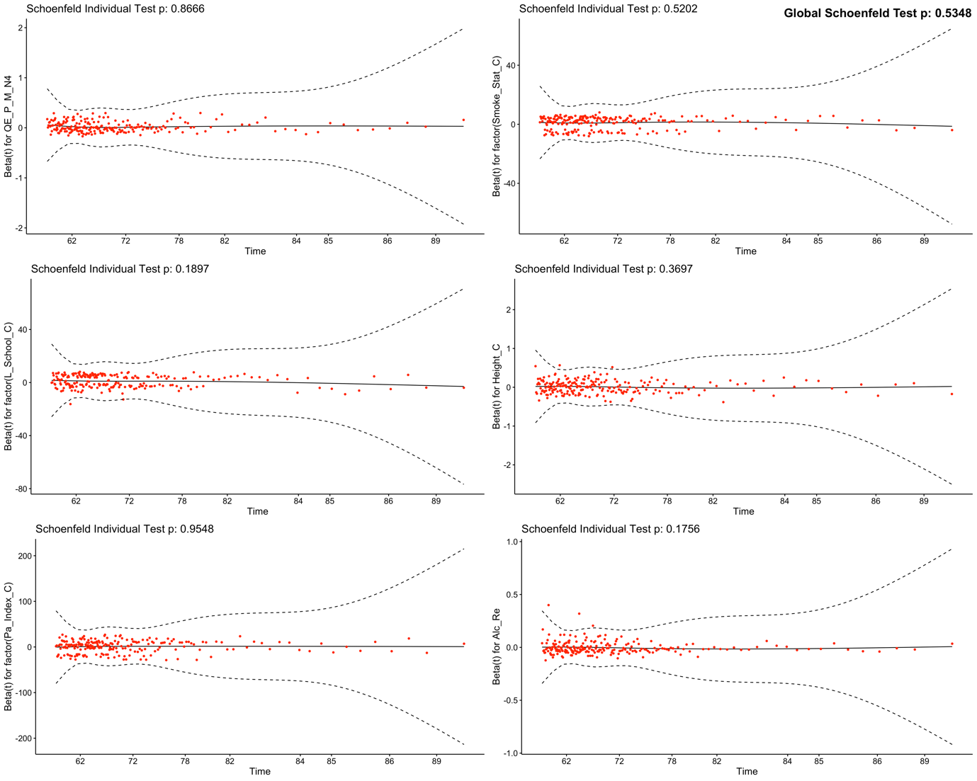

Supplementary Figure 7. Correlation plot for ultra-processed food consumption models.
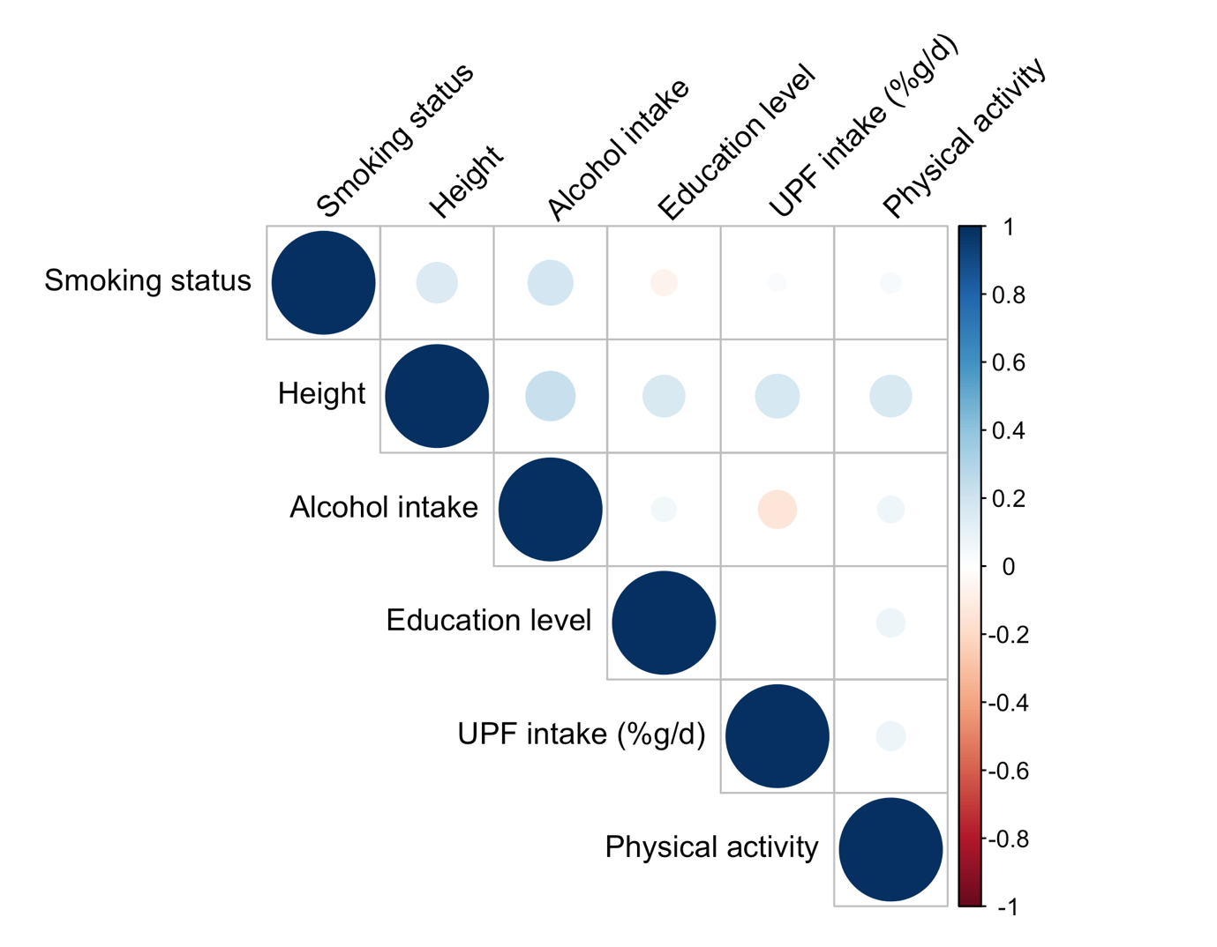Abbreviations: UPF, ultra-processed food.

Supplementary Figure 8. Non-linearity assessment for the relative intake of ultra-processed foods in grams per day and head and neck cancer risk.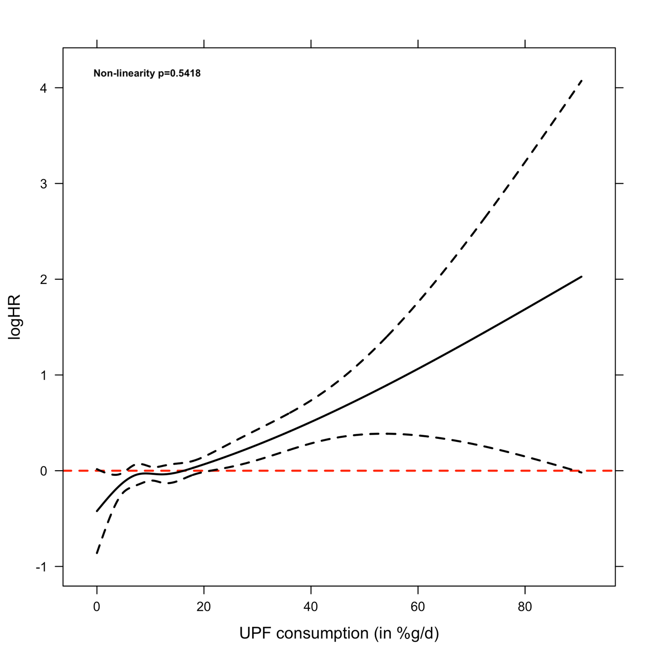

Supplementary Figure 9. Forest plots for associations between the intake of ultra-processed foods (in %g/d, g/d, %kcal/d and kcal/d) and the risk of head and neck cancer and oesophageal adenocarcinoma.
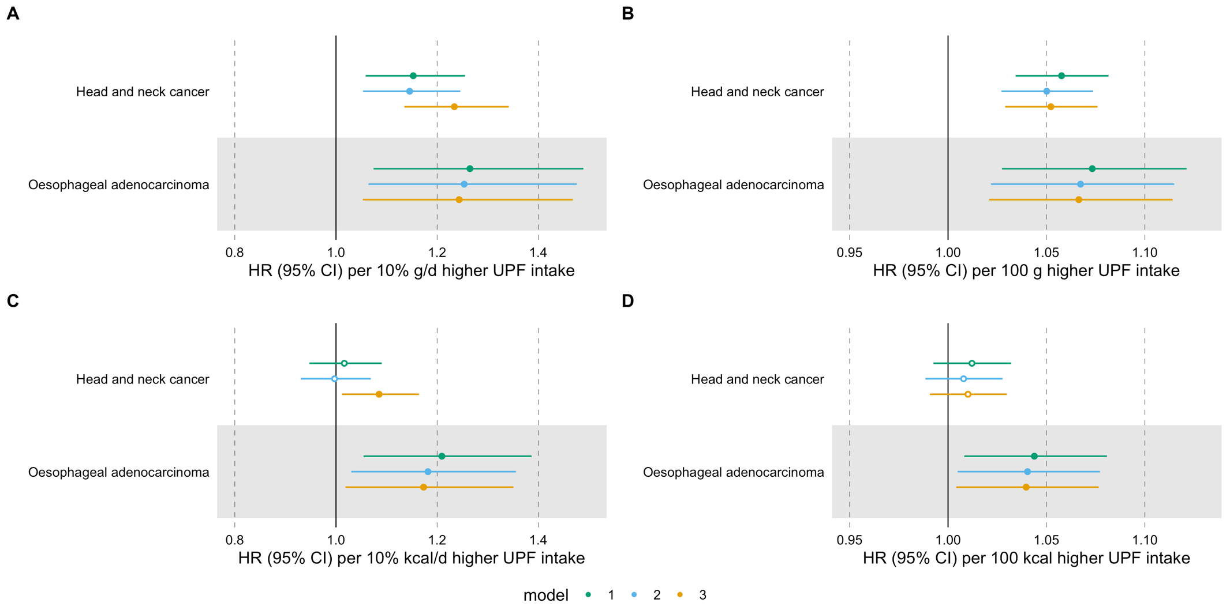
Hazard ratios per A) 10% g/d, B) 100 g/d, C) 10% kcal/d and D) 100 kcal/d higher ultra-processed food intake. Time of entry was defined as age at recruitment, while time of exit was defined as age at first cancer diagnosis (excluding non-melanoma skin cancer) or age at last follow-up (i.e., death, emigration, loss to follow-up or end of follow-up), whichever came first. Model 1 was stratified by age at recruitment in 1-year categories, sex, and sub-centre. Model 2 was additionally adjusted for education, physical activity, height, and smoking status. Model 3 was additionally adjusted for alcohol intake. N=450,111 participants, including 910 cases of head and neck cancer and 215 cases of oesophageal adenocarcinoma. Abbreviations: HR, hazard ratio; CI, confidence interval; UPF, ultra-processed foods.

Supplementary Table 1. Food categories contributing to each NOVA group.

 | Relative intake (%g/d) | Absolute intake (g/d)
Total unprocessed/minimally processed foods, mean (SD) | 71.5 (12.10) | 1960 (833)
Water, mean (SD) | 10.30 (13.70) | 340 (498)
Fruit, mean (SD) | 8.95 (7.61) | 220 (178)
Milk and plain yoghurt, mean (SD) | 9.20 (7.81) | 243 (222)
Cereal, grains and flour, mean (SD) | 1.65 (2.01) | 41.9 (53.40)
Potatoes, mean (SD) | 3.32 (2.76) | 85.0 (69.40)
Pasta, mean (SD) | 1.66 (2.46) | 37.7 (49.60)
Beans, lentils and chickpeas, mean (SD) | 0.80 (1.20) | 19.10 (26.20)
Vegetables, mean (SD) | 6.90 (4.75) | 175 (117)
Nuts and seeds, mean (SD) | 0.08 (0.21) | 2.14 (5.36)
Eggs, mean (SD) | 0.71 (0.68) | 18.00 (17.20)
Poultry, mean (SD) | 0.76 (0.87) | 18.30 (18.90)
Red meat, mean (SD) | 1.81 (1.50) | 46.70 (38.20)
Fish, mean (SD) | 1.00 (1.39) | 22.70 (27.00)
Seafood, mean (SD) | 0.127 (0.25) | 2.91 (5.57)
Fungi, mean (SD) | 0.21 (0.31) | 5.73 (8.64)
Coffee/tea, mean (SD) | 22.00 (13.70) | 632 (481)
Fresh fruit juice and smoothies, mean (SD) | 0.37 (1.00) | 9.71 (24.70)
Pasteurised fruit juice, mean (SD) | 1.56 (2.65) | 41.60 (71.60)
Homemade broth, mean (SD) | 0.10 (0.27) | 2.99 (7.81)
Total processed ingredients, mean (SD) | 1.19 (1.04) | 28.70 (23.50)
Sugar, mean (SD) | 0.39 (0.58) | 9.47 (14.10)
Plant-based oil, mean (SD) | 0.46 (0.65) | 10.00 (13.10)
Animal fats, mean (SD) | 0.30 (0.41) | 7.75 (10.60)
Other processed culinary ingredients, mean (SD) | 0.04 (0.08) | 1.03 (2.41)
Salt, mean (SD) | 0.02 (0.02) | 0.48 (0.84)
Total processed foods, mean (SD) | 13.6 (10.00) | 357 (308)
Cheese, mean (SD) | 1.47 (1.42) | 36.60 (33.50)
Salted, smoked and canned meat, mean (SD) | 0.33 (0.76) | 7.41 (15.40)
Salted, smoked and canned meat with additives, mean (SD) | 0.29 (0.44) | 7.37 (10.80)
Processed bread, mean (SD) | 3.39 (4.01) | 81.00 (90.50)
Preserved vegetables and other plant-based foods, mean (SD) | 0.73 (1.24) | 18.00 (28.00)
Preserved legumes, mean (SD) | 0.18 (0.60) | 4.27 (12.50)
Preserved fruit, mean (SD) | 0.62 (0.88) | 16.60 (24.00)
Salted nuts and nut spreads, mean (SD) | 0.07 (0.20) | 1.79 (5.00)
Beer and wine, mean (SD) | 5.73 (8.10) | 165 (276)
Condensed milk and sweetened yoghurt, mean (SD) | 0.23 (0.63) | 6.29 (18.10)
Breadcrumbs, mean (SD) | 0.01 (0.03) | 0.31 (0.77)
Artisanal meringue, mean (SD) | 0.35 (0.72) | 8.73 (19.10)
Artisanal sweet/savoury sauces, mean (SD) | 0.17 (0.36) | 3.83 (7.82)
Total ultra-processed foods, mean (SD) | 13.7 (8.76) | 364 (264)
Ultra-processed breads, mean (SD) | 1.67 (2.78) | 43.60 (67.40)
Pastries, buns and cakes, mean (SD) | 0.87 (1.22) | 22.10 (29.20)
Biscuits, mean (SD) | 0.59 (0.88) | 14.20 (18.60)
Breakfast cereals, mean (SD) | 0.18 (0.38) | 5.03 (10.30)
Ice cream, ice pops and frozen yoghurts, mean (SD) | 0.31 (0.55) | 7.50 (12.30)
Industrial desserts, mean (SD) | 0.07 (0.40) | 1.68 (10.90)
Packaged salty snacks, mean (SD) | 0.08 (0.22) | 2.05 (5.82)
Potato products, mean (SD) | 0.32 (0.65) | 8.83 (17.80)
Pizza and focaccia dough, mean (SD) | 0.27 (0.51) | 6.33 (11.00)
Filled pasta, mean (SD) | 0.14 (0.39) | 3.17 (8.10)
Instant and canned soups, mean (SD) | 0.37 (0.82) | 9.72 (21.60)
Dairy substitutes, mean (SD) | 0.13 (1.33) | 3.26 (33.50)
Ultra-processed cheese, mean (SD) | 0.13 (0.31) | 2.96 (6.86)
Sauces, dressing and gravies (liquid, powder, dehydrated and condensed), mean (SD) | 0.37 (0.45) | 10.60 (13.50)
Vegetable spreads, mean (SD) | 0.01 (0.05) | 0.23 (1.45)
Fizzy drinks, mean (SD) | 1.95 (4.40) | 51.20 (123)
Ultra-processed dairy desserts and drinks, mean (SD) | 1.62 (2.42) | 43.70 (69.30)
Fruit drinks, iced tea and other sweetened beverages, mean (SD) | 1.47 (3.69) | 44.00 (123)
Beverages (dry weight), mean (SD) | 0.03 (0.15) | 0.92 (3.81)
Alcoholic distilled drinks, mean (SD) | 0.30 (0.70) | 8.42 (21.00)
Artificial sweeteners, mean (SD) | 0.01 (0.07) | 0.36 (2.18)
Sweet snacks, mean (SD) | 0.43 (0.70) | 12.00 (19.50)
Ultra-processed meats (beef, pork and fish), mean (SD) | 1.46 (1.46) | 36.20 (33.50)
Meat alternatives, mean (SD) | 0.03 (0.15) | 0.81 (3.85)
Nutrition powders and drinks, mean (SD) | 0.00 (0.02) | 0.01 (0.53)
Margarine, mean (SD) | 0.50 (0.66) | 13.10 (16.80)
Ready meals, mean (SD) | 0.18 (0.40) | 5.68 (12.90)
Alcohol-free versions of alcoholic beverages, mean (SD) | 0.09 (0.93) | 2.66 (31.20)
Ultra-processed vegetables and legumes, mean (SD) | 0.13 (0.46) | 3.53 (13.00)
Ultra-processed rice-based dishes, mean (SD) | 0.00 (0.01) | 0.00 (0.29)
- The contribution of each food category to its corresponding NOVA group can be calculated as follows: mean absolute intake of food category of interest * 100 / mean absolute intake of all foods in corresponding NOVA group.

Supplementary Table 2. Variance inflation factor (VIF) for the assessment of multicollinearity.

 | VIF for head and neck cancer | VIF for oesophageal adenocarcinoma
Ultra-processed food consumption in %g/d | 1.04 | 1.04
Smoking status | 1.02 | 1.02
Education level | 1.04 | 1.04
Height | 1.03 | 1.02
Physical activity index | 1.01 | 1.01
Alcohol intake | 1.05 | 1.05

Supplementary Table 3. Associations between the relative intake of ultra-processed foods (in %g/d) and the risk of head and neck cancer and oesophageal adenocarcinoma.
Exposure | Outcome | Model | N events | HR | 95% CI | P-value
Ultra-processed foods | Head and neck cancer | 1 | 910 | 1.15 | 1.06-1.26 | 0.001
Ultra-processed foods | Head and neck cancer | 2 | 910 | 1.15 | 1.05-1.25 | 0.001
Ultra-processed foods | Head and neck cancer | 3 | 910 | 1.23 | 1.14-1.34 | <0.001
Ultra-processed foods | Oesophageal adenocarcinoma | 1 | 215 | 1.26 | 1.07-1.49 | 0.005
Ultra-processed foods | Oesophageal adenocarcinoma | 2 | 215 | 1.25 | 1.06-1.48 | 0.007
Ultra-processed foods | Oesophageal adenocarcinoma | 3 | 215 | 1.24 | 1.05-1.47 | 0.01
Hazard ratios per 10% g/d higher ultra-processed food intake. Time of entry was defined as age at recruitment, while time of exit was defined as age at first cancer diagnosis (excluding non-melanoma skin cancer) or age at last follow-up (i.e., death, emigration, loss to follow-up or end of follow-up), whichever came first. Model 1 was stratified by age at recruitment in 1-year categories, sex, and sub-centre. Model 2 was additionally adjusted for education, physical activity, height, and smoking status. Model 3 was additionally adjusted for alcohol intake. N=450,111 participants.

Supplementary Table 4. Associations between the relative intake of ultra-processed foods (in %g/d) and the risk of head and neck cancer subtypes.
Exposure | Outcome | Model | N events | HR | 95% CI | P-value | P-value for heterogeneity*
Ultra-processed foods | Oral cavity cancer | 1 | 234 | 1.01 | 0.84-1.22 | 0.887 | 0.107
Ultra-processed foods | Oral cavity cancer | 2 | 234 | 1.01 | 0.84-1.22 | 0.899 | 0.107
Ultra-processed foods | Oral cavity cancer | 3 | 234 | 1.10 | 0.91-1.32 | 0.333 | 0.107
Ultra-processed foods | Oropharynx cancer | 1 | 235 | 1.15 | 0.98-1.35 | 0.090 | 0.107
Ultra-processed foods | Oropharynx cancer | 2 | 235 | 1.15 | 0.98-1.34 | 0.095 | 0.107
Ultra-processed foods | Oropharynx cancer | 3 | 235 | 1.24 | 1.05-1.45 | 0.009 | 0.107
Ultra-processed foods | Hypopharynx cancer | 1 | 66 | 1.48 | 1.16-1.90 | 0.002 | 0.107
Ultra-processed foods | Hypopharynx cancer | 2 | 66 | 1.43 | 1.12-1.82 | 0.004 | 0.107
Ultra-processed foods | Hypopharynx cancer | 3 | 66 | 1.61 | 1.26-2.06 | <0.001 | 0.107
Ultra-processed foods | Larynx cancer | 1 | 310 | 1.21 | 1.05-1.39 | 0.010 | 0.107
Ultra-processed foods | Larynx cancer | 2 | 310 | 1.20 | 1.04-1.38 | 0.011 | 0.107
Ultra-processed foods | Larynx cancer | 3 | 310 | 1.28 | 1.11-1.47 | <0.001 | 0.107
Ultra-processed foods | Unspecified/  overlapping cancer | 1 | 65 | 0.96 | 0.66-1.39 | 0.819 | 0.107
Ultra-processed foods | Unspecified/  overlapping cancer | 2 | 65 | 0.95 | 0.66-1.36 | 0.766 | 0.107
Ultra-processed foods | Unspecified/  overlapping cancer | 3 | 65 | 0.99 | 0.69-1.43 | 0.978 | 0.107
Hazard ratios per 10% g/d higher ultra-processed food intake. Time of entry was defined as age at recruitment, while time of exit was defined as age at first cancer diagnosis (excluding non-melanoma skin cancer) or age at last follow-up (i.e., death, emigration, loss to follow-up or end of follow-up), whichever came first. Model 1 was stratified by age at recruitment in 1-year categories, sex, and sub-centre. Model 2 was additionally adjusted for education, physical activity, height, and smoking status. Model 3 was additionally adjusted for alcohol intake. N=450,111 participants.
*The P-value for heterogeneity across subtypes was calculated for Model 3 (the fully adjusted model)

Supplementary Table 5. Stratified analyses for the associations between the consumption of ultra-processed foods (in %g/d) and the risk of head and neck cancer and oesophageal adenocarcinoma.
Subgroup variable | Outcome | Subgroup level | N total | N events | HR | 95% CI | P-value | P-value for interaction
Alcohol intake | Head and neck cancer | No/light alcohol intake | 191,805 | 278 | 1.21 | 1.07-1.38 | 0.003 | 0.456
Alcohol intake | Head and neck cancer | Moderate alcohol intake | 188,881 | 286 | 1.23 | 1.05-1.43 | 0.011 | 0.456
Alcohol intake | Head and neck cancer | Heavy alcohol intake | 69,425 | 346 | 1.08 | 0.91-1.27 | 0.399 | 0.456
Alcohol intake | Oesophageal adenocarcinoma | No/light alcohol intake | 191,805 | 98 | 1.19 | 0.94-1.50 | 0.150 | 0.179
Alcohol intake | Oesophageal adenocarcinoma | Moderate alcohol intake | 188,881 | 67 | 1.60 | 1.20-2.15 | 0.002 | 0.179
Alcohol intake | Oesophageal adenocarcinoma | Heavy alcohol intake | 69,425 | 50 | 1.00 | 0.63-1.58 | 0.998 | 0.179
Physical activity index | Head and neck cancer | Inactive | 88,032 | 212 | 1.34 | 1.15-1.56 | <0.001 | 0.484
Physical activity index | Head and neck cancer | Moderately inactive | 158,765 | 297 | 1.19 | 1.02-1.39 | 0.029 | 0.484
Physical activity index | Head and neck cancer | Moderately active | 120,199 | 203 | 1.14 | 0.94-1.38 | 0.183 | 0.484
Physical activity index | Head and neck cancer | Active | 83,115 | 198 | 1.19 | 0.99-1.44 | 0.067 | 0.484
Physical activity index | Oesophageal adenocarcinoma | Inactive | 88,032 | 58 | 1.26 | 0.92-1.74 | 0.152 | 0.937
Physical activity index | Oesophageal adenocarcinoma | Moderately inactive | 158,765 | 69 | 1.28 | 0.94-1.75 | 0.118 | 0.937
Physical activity index | Oesophageal adenocarcinoma | Moderately active | 120,199 | 47 | 1.27 | 0.89-1.82 | 0.191 | 0.937
Physical activity index | Oesophageal adenocarcinoma | Active | 83,115 | 41 | 1.09 | 0.74-1.60 | 0.680 | 0.937
Smoking status | Head and neck cancer | Never | 227,717 | 194 | 1.06 | 0.86-1.30 | 0.570 | 0.458
Smoking status | Head and neck cancer | Former | 122,680 | 232 | 1.23 | 1.04-1.45 | 0.017 | 0.458
Smoking status | Head and neck cancer | Current | 99,714 | 484 | 1.30 | 1.16-1.45 | <0.001 | 0.458
Smoking status | Oesophageal adenocarcinoma | Never | 227,717 | 57 | 1.23 | 0.89-1.72 | 0.210 | 0.989
Smoking status | Oesophageal adenocarcinoma | Former | 122,680 | 94 | 1.22 | 0.93-1.60 | 0.148 | 0.989
Smoking status | Oesophageal adenocarcinoma | Current | 99,714 | 64 | 1.30 | 0.97-1.73 | 0.080 | 0.989
Sex | Head and neck cancer | Male | 131,425 | 603 | 1.34 | 1.22-1.48 | <0.001 | 0.006
Sex | Head and neck cancer | Female | 318,686 | 307 | 1.03 | 0.87-1.21 | 0.745 | 0.006
Sex | Oesophageal adenocarcinoma | Male | 131,425 | 169 | 1.29 | 1.07-1.54 | 0.008 | 0.436
Sex | Oesophageal adenocarcinoma | Female | 318,686 | 46 | 1.07 | 0.73-1.58 | 0.731 | 0.436
Education | Head and neck cancer | Primary school or less | 143,488 | 394 | 1.29 | 1.15-1.46 | <0.001 | 0.312
Education | Head and neck cancer | Secondary or technical/professional school | 197,692 | 365 | 1.19 | 1.04-1.37 | 0.012 | 0.312
Education | Head and neck cancer | Higher education | 108,931 | 151 | 1.11 | 0.87-1.42 | 0.394 | 0.312
Education | Oesophageal adenocarcinoma | Primary school or less | 143,488 | 104 | 1.17 | 0.92-1.47 | 0.195 | 0.834
Education | Oesophageal adenocarcinoma | Secondary or technical/professional school | 197,692 | 72 | 1.26 | 0.95-1.69 | 0.114 | 0.834
Education | Oesophageal adenocarcinoma | Higher education | 108,931 | 39 | 1.35 | 0.86-2.10 | 0.192 | 0.834
Hazard ratios per 10% g/d higher ultra-processed food intake. Time of entry was defined as age at recruitment, while time of exit was defined as age at first cancer diagnosis (excluding non-melanoma skin cancer) or age at last follow-up (i.e., death, emigration, loss to follow-up or end of follow-up), whichever came first. Models were stratified by age at recruitment in 1-year categories, sex and sub-centre and additionally adjusted for education, physical activity, height, smoking status and alcohol intake. Models were not adjusted for the stratification variable.

Supplementary Table 6. Identification of possible mediators of the associations between ultra-processed food consumption (in %g/d) and the risk of head and neck cancer and oesophageal adenocarcinoma.
Potential mediators | Association between UPF and M, Odds ratio (95%CI) | UPF-adjusted association between M and head and neck cancer, Hazard ratio (95%CI) | UPF-adjusted association between M and oesophageal adenocarcinoma, Hazard ratio (95%CI)
Waist-to-hip ratio | ✓ (+)  0.41 (0.38 to 0.43) | ✓ (+)  1.02 (1.01 to 1.03) | ✓ (+)  1.06 (1.04 to 1.08)
Body mass index | ✓ (+)  0.24 (0.22 to 0.26) | ✓ (-)  0.98 (0.96 to 0.99) | ✓ (+)  1.08 (1.04 to 1.11)
Ticks represent evidence of an association. Pluses and minuses represent positive and inverse associations, respectively. Mean change in waist-to-hip ratio and body mass index per 10% g/d higher ultra-processed food intake. Hazard ratios per 0.01 higher waist-to-hip ratio and per 1 kg/m² higher body mass index. Cox models for the mediator-outcome associations were stratified by age at recruitment in 1-year categories, sex, and sub-centre and additionally adjusted for education, physical activity, height, smoking status, and alcohol intake. Linear models for the exposure-mediator associations were adjusted for the same confounders. Waist-to-hip ratio models included 336,858 participants, of which 828 and 195 had head and neck cancer and oesophageal adenocarcinoma, respectively. Body mass index models included 365,549 participants, of which 864 and 212 had head and neck cancer and oesophageal adenocarcinoma, respectively. Abbreviations: NA, not applicable as there is no evidence of an association between the exposure and the outcome after accounting for all confounders; UPF, ultra-processed foods; M, mediator; CI, confidence interval.

Supplementary Table 7. Associations between the relative intake of ultra-processed foods (in %g/d) and the risk of head and neck cancer and oesophageal adenocarcinoma, accounting for total water intake (including water in foods).
Exposure | Outcome | Model | N events | HR | 95% CI | P-value
Ultra-processed foods | Head and neck cancer | 1 | 910 | 1.19 | 1.10-1.30 | <0.001
Ultra-processed foods | Head and neck cancer | 2 | 910 | 1.17 | 1.08-1.28 | <0.001
Ultra-processed foods | Head and neck cancer | 3 | 910 | 1.24 | 1.14-1.34 | <0.001
Ultra-processed foods | Oesophageal adenocarcinoma | 1 | 215 | 1.29 | 1.10-1.52 | 0.002
Ultra-processed foods | Oesophageal adenocarcinoma | 2 | 215 | 1.27 | 1.08-1.50 | 0.003
Ultra-processed foods | Oesophageal adenocarcinoma | 3 | 215 | 1.26 | 1.07-1.48 | 0.006
Hazard ratios per 10% g/d higher ultra-processed food intake. Time of entry was defined as age at recruitment, while time of exit was defined as age at first cancer diagnosis (excluding non-melanoma skin cancer) or age at last follow-up (i.e., death, emigration, loss to follow-up or end of follow-up), whichever came first. Model 1 was stratified by age at recruitment in 1-year categories, sex, and sub-centre, and adjusted for water intake (including water in foods). Model 2 was additionally adjusted for education, physical activity, height, and smoking status. Model 3 was additionally adjusted for alcohol intake. N=450,111 participants.

Supplementary Table 8. Associations between the relative intake of ultra-processed foods (in %g/d) and the risk of head and neck cancer and oesophageal adenocarcinoma, accounting for energy intake.
Exposure | Outcome | Model | N events | HR | 95% CI | P-value
Ultra-processed foods | Head and neck cancer | 1 | 910 | 1.14 | 1.05-1.25 | 0.003
Ultra-processed foods | Head and neck cancer | 2 | 910 | 1.13 | 1.04-1.24 | 0.004
Ultra-processed foods | Head and neck cancer | 3 | 910 | 1.27 | 1.17-1.39 | <0.001
Ultra-processed foods | Oesophageal adenocarcinoma | 1 | 215 | 1.25 | 1.06-1.48 | 0.009
Ultra-processed foods | Oesophageal adenocarcinoma | 2 | 215 | 1.24 | 1.04-1.47 | 0.014
Ultra-processed foods | Oesophageal adenocarcinoma | 3 | 215 | 1.22 | 1.02-1.45 | 0.027
Hazard ratios per 10% g/d higher ultra-processed food intake. Time of entry was defined as age at recruitment, while time of exit was defined as age at first cancer diagnosis (excluding non-melanoma skin cancer) or age at last follow-up (i.e., death, emigration, loss to follow-up or end of follow-up), whichever came first. Model 1 was stratified by age at recruitment in 1-year categories, sex, and sub-centre, and adjusted for energy intake. Model 2 was additionally adjusted for education, physical activity, height, and smoking status. Model 3 was additionally adjusted for alcohol intake. N=450,111 participants.

Supplementary Table 9. Associations between the relative intake of ultra-processed foods (in %g/d) and the risk of head and neck cancer and oesophageal adenocarcinoma, excluding participants censored in the first two years of follow-up.
Exposure | Outcome | Model | N events | HR | 95% CI | P-value
Ultra-processed foods | Head and neck cancer | 1 | 818 | 1.14 | 1.04-1.24 | 0.006
Ultra-processed foods | Head and neck cancer | 2 | 818 | 1.13 | 1.03-1.24 | 0.008
Ultra-processed foods | Head and neck cancer | 3 | 818 | 1.21 | 1.11-1.33 | <0.001
Ultra-processed foods | Oesophageal adenocarcinoma | 1 | 196 | 1.26 | 1.06-1.49 | 0.009
Ultra-processed foods | Oesophageal adenocarcinoma | 2 | 196 | 1.25 | 1.05-1.48 | 0.012
Ultra-processed foods | Oesophageal adenocarcinoma | 3 | 196 | 1.23 | 1.03-1.46 | 0.020
Hazard ratios per 10% g/d higher ultra-processed food intake. Time of entry was defined as age at recruitment, while time of exit was defined as age at first cancer diagnosis (excluding non-melanoma skin cancer) or age at last follow-up (i.e., death, emigration, loss to follow-up or end of follow-up), whichever came first. Model 1 was stratified by age at recruitment in 1-year categories, sex, and sub-centre. Model 2 was additionally adjusted for education, physical activity, height, and smoking status. Model 3 was additionally adjusted for alcohol intake. N=442,536 participants, since 7575 participants were excluded from the analysis because they were censored during the first two years of follow-up.

Supplementary Table 10. Complete case analysis for the associations between the relative intake of ultra-processed foods (in %g/d) and the risk of head and neck cancer and oesophageal adenocarcinoma.
Exposure | Outcome | Model | N events | HR | 95% CI | P-value
Ultra-processed foods | Head and neck cancer | 1 | 851 | 1.15 | 1.06-1.26 | 0.002
Ultra-processed foods | Head and neck cancer | 2 | 851 | 1.15 | 1.05-1.25 | 0.002
Ultra-processed foods | Head and neck cancer | 3 | 851 | 1.24 | 1.14-1.35 | <0.001
Ultra-processed foods | Oesophageal adenocarcinoma | 1 | 191 | 1.26 | 1.06-1.50 | 0.009
Ultra-processed foods | Oesophageal adenocarcinoma | 2 | 191 | 1.25 | 1.05-1.49 | 0.013
Ultra-processed foods | Oesophageal adenocarcinoma | 3 | 191 | 1.24 | 1.04-1.48 | 0.016
Hazard ratios per 10% g/d higher ultra-processed food intake. Centre-, age- and sex-specific imputed height was used as a covariate, as this is standard practice when dealing with anthropometric variables as confounders in EPIC. Time of entry was defined as age at recruitment, while time of exit was defined as age at first cancer diagnosis (excluding non-melanoma skin cancer) or age at last follow-up (i.e., death, emigration, loss to follow-up or end of follow-up), whichever came first. Model 1 was stratified by age at recruitment in 1-year categories, sex, and sub-centre. Model 2 was additionally adjusted for education, physical activity, height, and smoking status. Model 3 was additionally adjusted for alcohol intake. N= 419,590.

Supplementary Table 11. Multivariate imputation by chained equations analyses for the associations between the relative intake of ultra-processed foods (in %g/d) and the risk of head and neck cancer and oesophageal adenocarcinoma.
Exposure | Outcome | Model | N events | HR | 95% CI | P-value
Ultra-processed foods | Head and neck cancer | 1 | 910 | 1.15 | 1.06-1.26 | 0.001
Ultra-processed foods | Head and neck cancer | 2 | 910 | 1.15 | 1.06-1.25 | 0.001
Ultra-processed foods | Head and neck cancer | 3 | 910 | 1.24 | 1.14-1.34 | <0.001
Ultra-processed foods | Oesophageal adenocarcinoma | 1 | 215 | 1.26 | 1.07-1.49 | 0.005
Ultra-processed foods | Oesophageal adenocarcinoma | 2 | 215 | 1.25 | 1.07-1.48 | 0.007
Ultra-processed foods | Oesophageal adenocarcinoma | 3 | 215 | 1.24 | 1.05-1.47 | 0.011
Hazard ratios per 10% g/d higher ultra-processed food intake. Multivariate imputation by chained equations (MICE) was used to impute physical activity, education level and smoking status five times using predictive mean matching. Models were fit using the MICE imputed data sets and then pooled to obtain single estimates and standard errors for each model. Centre-, age- and sex-specific imputed height was used as a covariate, as this is standard practice when dealing with anthropometric variables as confounders in EPIC. Time of entry was defined as age at recruitment, while time of exit was defined as age at first cancer diagnosis (excluding non-melanoma skin cancer) or age at last follow-up (i.e., death, emigration, loss to follow-up or end of follow-up), whichever came first. Model 1 was stratified by age at recruitment in 1-year categories, sex, and sub-centre. Model 2 was additionally adjusted for education, physical activity, height, and smoking status. Model 3 was additionally adjusted for alcohol intake. N= 450,111.

Supplementary Table 12. Associations between the absolute (in g/d and kcal/d) and relative intake (in %kcal/d) of ultra-processed foods and the risk of head and neck cancer and oesophageal adenocarcinoma.
Exposure | Outcome | Model | N events | HR | 95% CI | P-value
Ultra-processed foods in g/d ª | Head and neck cancer | 1 | 910 | 1.06 | 1.03-1.08 | <0.001
Ultra-processed foods in g/d ª | Head and neck cancer | 2 | 910 | 1.05 | 1.03-1.07 | <0.001
Ultra-processed foods in g/d ª | Head and neck cancer | 3 | 910 | 1.05 | 1.03-1.08 | <0.001
Ultra-processed foods in g/d ª | Oesophageal adenocarcinoma | 1 | 215 | 1.07 | 1.03-1.12 | 0.002
Ultra-processed foods in g/d ª | Oesophageal adenocarcinoma | 2 | 215 | 1.07 | 1.02-1.11 | 0.003
Ultra-processed foods in g/d ª | Oesophageal adenocarcinoma | 3 | 215 | 1.07 | 1.02-1.11 | 0.004
Ultra-processed foods in %kcal/d ^{b} | Head and neck cancer | 1 | 910 | 1.02 | 0.95-1.09 | 0.649
Ultra-processed foods in %kcal/d ^{b} | Head and neck cancer | 2 | 910 | 1.00 | 0.93-1.07 | 0.936
Ultra-processed foods in %kcal/d ^{b} | Head and neck cancer | 3 | 910 | 1.09 | 1.01-1.16 | 0.022
Ultra-processed foods in %kcal/d ^{b} | Oesophageal adenocarcinoma | 1 | 215 | 1.21 | 1.05-1.39 | 0.007
Ultra-processed foods in %kcal/d ^{b} | Oesophageal adenocarcinoma | 2 | 215 | 1.18 | 1.03-1.36 | 0.017
Ultra-processed foods in %kcal/d ^{b} | Oesophageal adenocarcinoma | 3 | 215 | 1.17 | 1.02-1.35 | 0.026
Ultra-processed foods in kcal/d ^{c} | Head and neck cancer | 1 | 910 | 1.01 | 0.99-1.03 | 0.225
Ultra-processed foods in kcal/d ^{c} | Head and neck cancer | 2 | 910 | 1.01 | 0.99-1.03 | 0.427
Ultra-processed foods in kcal/d ^{c} | Head and neck cancer | 3 | 910 | 1.01 | 0.99-1.03 | 0.307
Ultra-processed foods in kcal/d ^{c} | Oesophageal adenocarcinoma | 1 | 215 | 1.04 | 1.01-1.08 | 0.015
Ultra-processed foods in kcal/d ^{c} | Oesophageal adenocarcinoma | 2 | 215 | 1.04 | 1.00-1.08 | 0.026
Ultra-processed foods in kcal/d ^{c} | Oesophageal adenocarcinoma | 3 | 215 | 1.04 | 1.00-1.08 | 0.028
Hazard ratios per ª100 g/d, ^{b}10% kcal/d and ^{c}100 kcal/d higher ultra-processed food intake. Time of entry was defined as age at recruitment, while time of exit was defined as age at first cancer diagnosis (excluding non-melanoma skin cancer) or age at last follow-up (i.e., death, emigration, loss to follow-up or end of follow-up), whichever came first. Model 1 was stratified by age at recruitment in 1-year categories, sex, and sub-centre. Model 2 was additionally adjusted for education, physical activity, height, and smoking status. Model 3 was additionally adjusted for alcohol intake. N=450,111 participants.

Supplementary Table 13. Negative control outcome analysis for the association between the relative intake of ultra-processed foods (in %g/d) and the risk of accidental deaths.
Exposure | Outcome | Model | N events | HR | 95% CI | P-value
Ultra-processed foods | Accidental death | 1 | 871 | 1.11 | 1.01-1.22 | 0.029
Ultra-processed foods | Accidental death | 2 | 871 | 1.10 | 1.00-1.21 | 0.041
Ultra-processed foods | Accidental death | 3 | 871 | 1.12 | 1.02-1.23 | 0.020
Hazard ratios per 10% g/d higher ultra-processed food intake. Time of entry was defined as age at recruitment, while time of exit was defined as age at death, emigration, loss to follow-up or end of follow-up, whichever came first. Model 1 was stratified by age at recruitment in 1-year categories, sex, and sub-centre. Model 2 was additionally adjusted for education, physical activity, height, and smoking status. Model 3 was additionally adjusted for alcohol intake. N=450,111 participants.

