Supplementary Material

Iterative assessment of a sports rehydration beverage containing a novel amino acid formula on water uptake kinetics

European Journal of Nutrition

Mark P. Funnell, Loris A. Juett, Kirsty M. Reynolds, Drusus A. Johnson, Ruth M. James, Stephen A. Mears, Samuel N. Cheuvront, Robert W. Kenefick & Lewis J. James

National Centre for Sport and Exercise Medicine, School of Sport, Exercise and Health Sciences, Loughborough University, Leicestershire, UK, LE11 3TU.

Corresponding Author

Dr. Lewis J. James

L.James@lboro.ac.uk

School of Sport, Exercise and Health Sciences

Loughborough University
Supplementary Material
Plasma Amino Acid Concentration
Study 1: There were no significant interaction effects for plasma concentration for arginine, histidine, lysine, glutamine, cysteine, alanine, leucine, methionine, and tryptophan (P≥0.066). There were significant interaction effects for plasma concentration for aspartic acid, serine, valine, isoleucine, threonine, tyrosine, glutamic acid, asparagine, glycine, proline, phenylalanine, and total amino acids (P≤0.026). Significant post-hoc analyses are displayed in Supplementary Fig. 1.
Study 2: There were no significant interaction effects for plasma concentration for aspartic acid, arginine, histidine, lysine, glutamic acid, asparagine, cysteine, alanine, methionine, and tryptophan (P≥0.054). There were significant interaction effects for plasma concentration for serine, valine, isoleucine, threonine, tyrosine, glutamine, glycine, proline, leucine, phenylalanine, and total amino acids (P≤0.048). Significant post-hoc analyses are displayed in Supplementary Fig. 2.
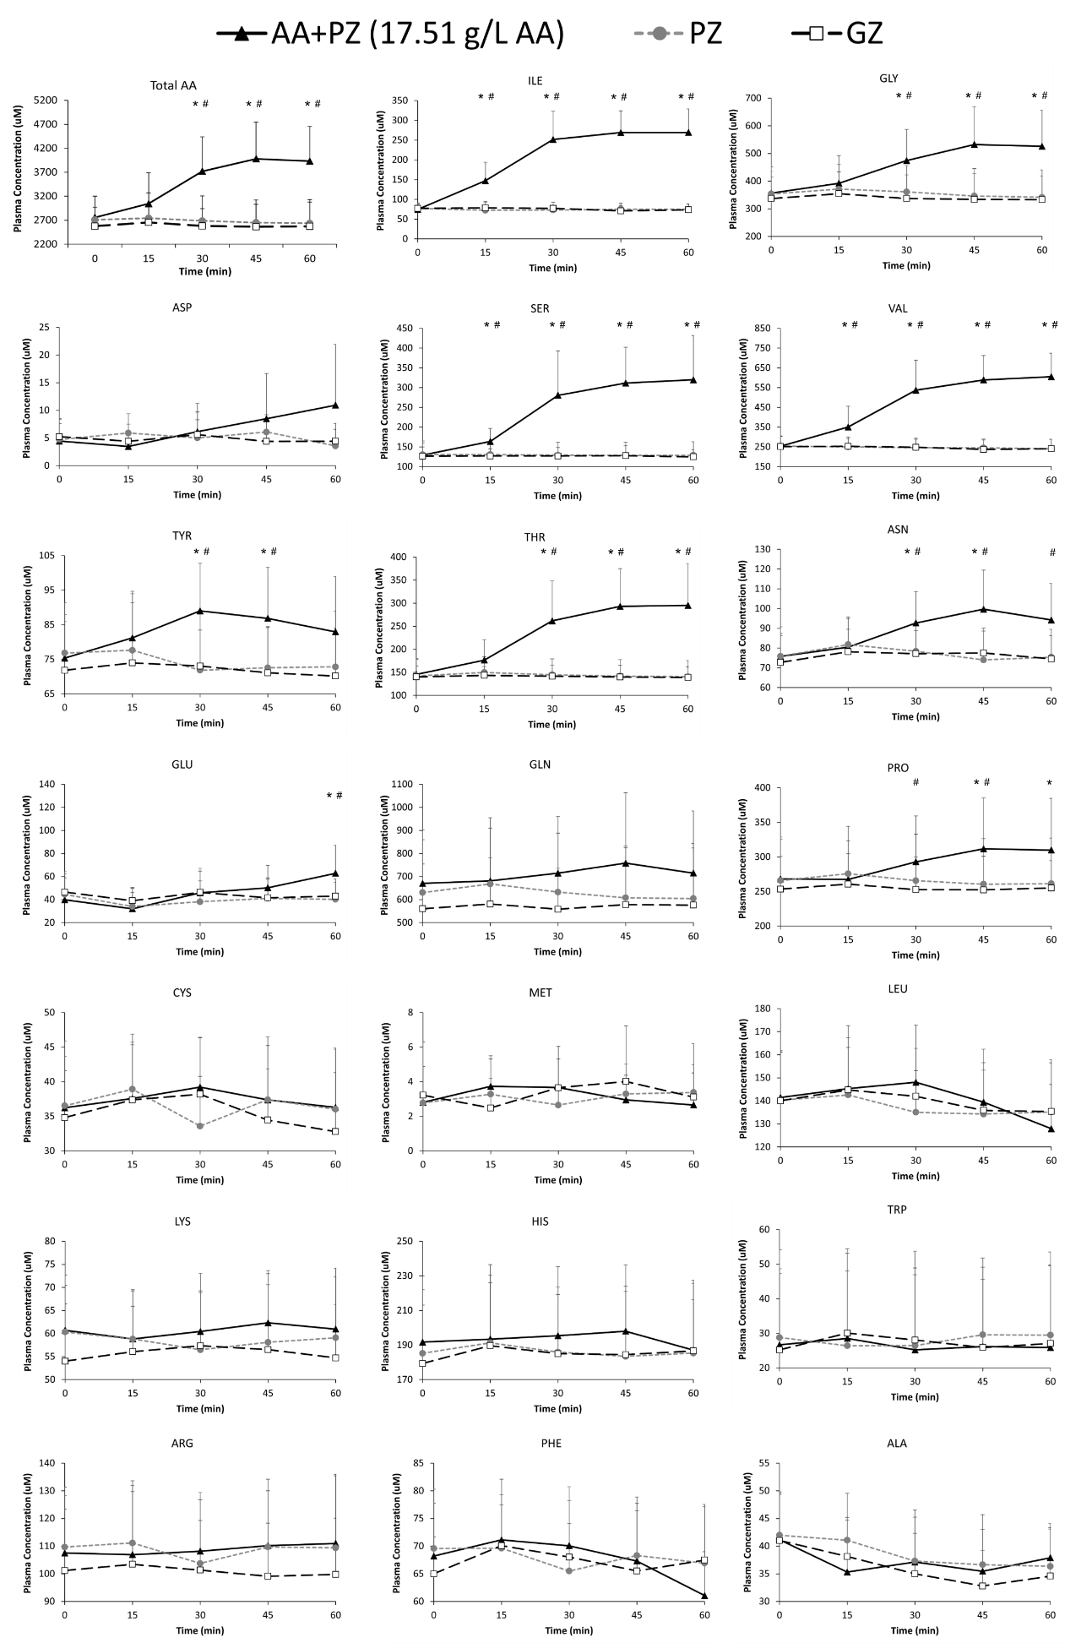Supplementary Fig. 1. Total and individual plasma amino acid concentration (µM) over time after ingesting the three experimental beverages for Study 1. * = AA+PZ significantly different to PZ. # = AA+PZ significnatly different to GZ. AA+PZ = a sugar-free rehydration beverage (PZ) containing 17.51 g/L of a novel amino acid formula. PZ = Powerade Zero™. GZ = Gatorade Zero™.
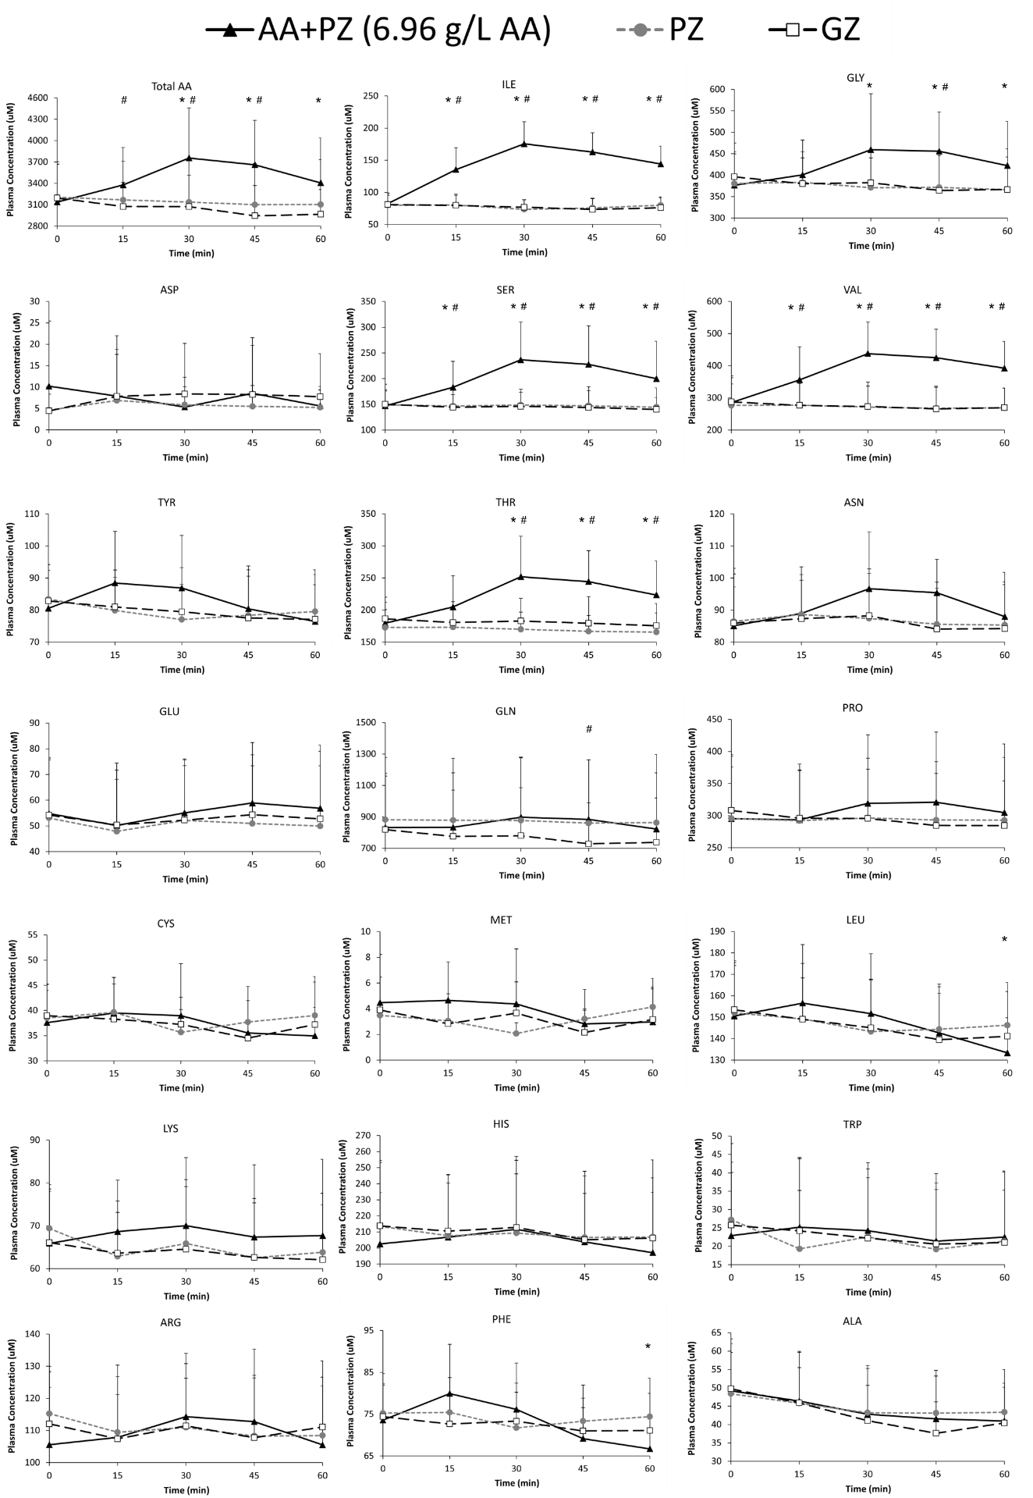Supplementary Fig. 2. Total and individual plasma amino acid concentration (µM) over time after ingesting the three experimental beverages for Study 2. * = AA+PZ significantly different to PZ. # = AA+PZ significnatly different to GZ. AA+PZ = a sugar-free rehydration beverage (PZ) containing 6.96 g/L of a novel amino acid formula. PZ = Powerade Zero™. GZ = Gatorade Zero™.
Plasma Glucose
Study 1: There were main effects for time and trial (both P<0.001), but no trial by time interaction effect (P=0.064) for plasma glucose, however, mean plasma glucose altered by <0.4 mmol/L across all time points and trials (Supplementary Fig. 3A).
Study 2: There was a main effect of time for plasma glucose (P<0.001), but there were no trial (P=0.135) or trial by time interaction (P=0.541) effects for plasma glucose (Supplementary Fig. 3B).

Supplementary Fig. 3. Plasma glucose (mmol/L) over time after ingesting the three experimental beverages for Study 1 (A) and Study 2 (B). AA+PZ = a sugar-free rehydration beverage (PZ) containing differing amounts of a novel amino acid formula. PZ = Powerade Zero™. GZ = Gatorade Zero™.

Plasma Lactate
Study 1: There were main effects for time (P=0.004), trial (P<0.001), and a trial by time interaction effect (P<0.001) for plasma lactate, however, mean plasma lactate altered by <0.2 mmol/L across all time points and trials (Supplementary Fig. 4A).
Study 2: There were no time, trial, or trial by time interaction effects for plasma lactate (P≥0.247; Supplementary Fig. 4B).

Supplementary Fig. 4. Plasma lactate (mmol/L) over time after ingesting the three experimental beverages for Study 1 (A) and Study 2 (B). AA+PZ = a sugar-free rehydration beverage (PZ) containing differing amounts of a novel amino acid formula. PZ = Powerade Zero™. GZ = Gatorade Zero™.

Plasma Creatinine
Study 1: For plasma creatinine, there was a main effect of time (P<0.001), but no trial (P=0.414) or trial by time interaction (P=0.217) effects (Supplementary Fig. 5A).
Study 2: For plasma creatinine, there was a main effect of time (P=0.001), but no trial (P=0.683) or trial by time interaction (P=0.381) effects (Supplementary Fig. 5B).

Supplementary Fig. 5. Plasma creatinine (mmol/L) over time after ingesting the three experimental beverages for Study 1 (A) and Study 2 (B). AA+PZ = a sugar-free rehydration beverage (PZ) containing differing amounts of a novel amino acid formula. PZ = Powerade Zero™. GZ = Gatorade Zero™.

Plasma Electrolytes
Study 2: There was a main effect of time (P<0.001), but there were no trial (P=0.933) or trial by time interaction (P=0.404) effects for plasma sodium (Supplementary Fig. 6A). There was a main effect of time (P=0.008), but there were no trial (P=0.978) or trial by time interaction (P=0.397) effects for plasma potassium (Supplementary Fig. 6B).

Supplementary Fig. 6. Plasma (A) sodium (mmol/L) and (B) potassium (mmol/L) over time after ingesting the three experimental beverages for Study 2. AA+PZ = a sugar-free rehydration beverage (PZ) containing differing amounts of a novel amino acid formula. PZ = Powerade Zero™. GZ = Gatorade Zero™.
Urine D₂O Concentration
Study 2: Post-trial (60 min) urine D₂O enrichment was not different between trials (AA+PZ: 451 ± 137 δ‰ vs. VSMOW, PZ: 463 ± 130 δ‰ vs. VSMOW, GZ: 448 ± 155 δ‰ vs. VSMOW; P=0.708).

