Supplementary data
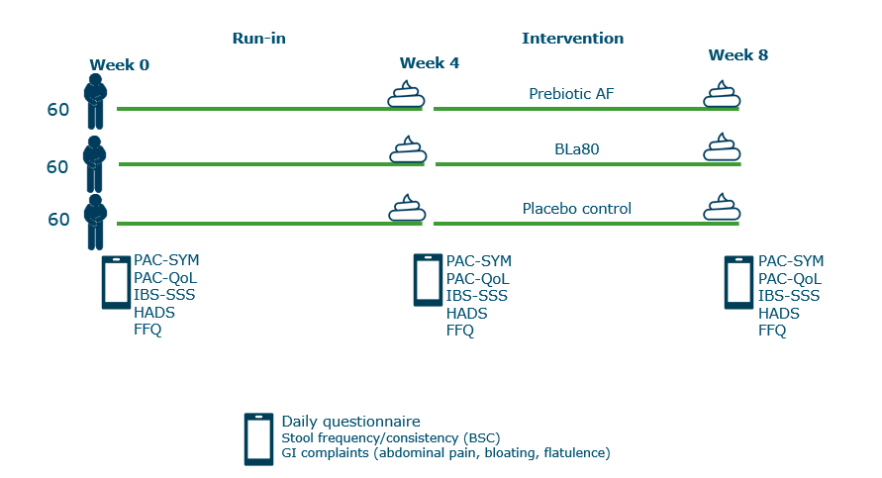

Fig S1 Schematic overview of the study design

