Online Supplementary material

Title: Dietary and genetic determinants of non-alcoholic fatty liver disease in coronary heart disease patients.
Authors: Heerkens, Geleijnse, Van Duijnhoven

Supplementary tables |  | Page
Supplementary table 1 | Summary of NAFLD-related genetic variants. | 2
Supplementary table 2 | Prevalence ratios (95% CI) for DHD15 (in quintiles) in relation to NAFLD in post-MI patients of the Alpha Omega Cohort without obesity (n=2623) and without diabetes (n=2738). | 3
Supplementary figures
Supplementary figure 1 | Flowchart for selection of 3437 post-MI patients of the Alpha Omega Cohort who are available for analysis. | 4
Supplementary figure 2 | Venn diagram presenting overlapping liver (blue), inflammatory (green), and cardiometabolic (red) traits among NAFLD-associated loci. | 5
Supplementary figure 3 | Prevalence Ratios (95% CI) for adherence to DHD15 as continuous exposure in relation to NAFLD in the total cohort (A) and stratified by gender (B) in 3437 post-MI patients of the Alpha Omega Cohort. | 6
Supplementary figure 4 | Prevalence ratios (95% CI) for adherence to individual DHD15 components (as z-scores (except for coffee consumption)) in relation to NAFLD in 3437 post-MI patients of the Alpha Omega Cohort. | 7

Supplementary table 1. Summary of NAFLD-related genetic variants.
rsID | Chr | Position | EA | Effect | MAF | Gene
rs1337101 | 1 | 219726100 | G | 0.0509 | 0.3 | LYPLAL1;SLC30A10
rs1497406 | 1 | 16505320 | G | 0.0415 | 0.4282 | EPHA2
rs2642438 | 1 | 220970028 | G | 0.0786 | 0.2946 | MTARC1
rs74816838 | 1 | 161643560 | T | 0.0871 | 0.1116 | FCGR2A;FCGR2B
rs10195619 | 2 | 112765562 | T | 0.0484 | 0.3908 | MERTK
rs10201587 | 2 | 202202791 | A | 0.0454 | 0.4988 | CASP8
rs13409360 | 2 | 113838102 | G | 0.0586 | 0.4052 | IL1RN
rs2138157 | 2 | 227103717 | C | 0.064 | 0.356 | IRS1;MIR5702
rs6717858 | 2 | 165539661 | T | 0.0497 | 0.3909 | COBLL1;SCN2A
rs7604422 | 2 | 233509761 | A | 0.0529 | 0.3997 | EFHD1
rs4684847 | 3 | 12386337 | C | 0.0725 | 0.1203 | PPARG
rs9867368 | 3 | 136147771 | G | 0.0731 | 0.2355 | PCCB
rs12500824 | 4 | 77416627 | A | 0.0461 | 0.3503 | SHROOM3
rs71633358 | 4 | 88183817 | T | 0.0835 | 0.2739 | HSD17B13
rs4148824 | 7 | 87075362 | A | 0.0569 | 0.1851 | ABCB4
rs2954038 | 8 | 126507389 | C | 0.1394 | 0.3062 | TRIB1
rs4484649 | 8 | 10571491 | C | 0.0454 | 0.4126 | RP1L1;SOX7
rs4734654 | 8 | 103669991 | A | 0.0517 | 0.362 | KLF10
rs4841133 | 8 | 9183664 | A | 0.1295 | 0.088 | PPP1R3B;TNKS;MFHAS1
rs10883451 | 10 | 101924418 | T | 0.1607 | 0.4766 | ERLIN1
rs2792751 | 10 | 113940329 | T | 0.0752 | 0.2901 | GPAM
rs11601507 | 11 | 5701074 | A | 0.0884 | 0.0729 | TRIM5
rs174535 | 11 | 61551356 | T | 0.0606 | 0.3369 | FADS1;FADS2;FADS3
rs7117339 | 11 | 93870338 | C | 0.1283 | 0.1198 | PANX1
rs1169292 | 12 | 121426478 | T | 0.0434 | 0.3914 | P2RX7;HNF1A
rs148015593 | 12 | 122523668 | T | 0.0424 | 0.4687 | MLXIP
rs4919741 | 12 | 53272920 | G | 0.057 | 0.3415 | KRT84;KRT74
rs11621792 | 14 | 24871926 | T | 0.0422 | 0.453 | NFATC4
rs168144 | 15 | 60914262 | C | 0.0472 | 0.3857 | RORA;ANXA2
rs55868793 | 15 | 73956856 | G | 0.0595 | 0.408 | CD276
rs72754571 | 15 | 90350888 | C | 0.068 | 0.1044 | ANPEP
rs112128680 | 16 | 72054052 | A | 0.0498 | 0.2454 | DHODH;HP;HPR
rs3810367 | 19 | 4342847 | G | 0.0451 | 0.3763 | SIRT6;STAP2
rs429358 | 19 | 45411941 | T | 0.08 | 0.2221 | APOE;APOC1
rs58542926 | 19 | 19379549 | T | 0.2219 | 0.0749 | TM6SF2
rs7599 | 19 | 36038390 | A | 0.049 | 0.3819 | TMEM147;ATP4A
rs2377957 | 20 | 32554473 | A | 0.0473 | 0.5 | AHCY;ITCH
rs132665 | 22 | 36564170 | A | 0.0691 | 0.1544 | APOL3
rs1547014 | 22 | 29100711 | C | 0.0642 | 0.3024 | CHEK2
Summary statistics are based on GWAS for NAFLD (Vujkovic et al. Nat Genet. 2022. 10.1038/s41588-022-01078-z. rsID: reference single-nucleotide polymorphism cluster ID; Chr: chromosome; EA: effect allele; MAF; minor allele frequency.

Supplementary table 2. Prevalence ratios (95% CI) for DHD15 (in quintiles) in relation to NAFLD in post-MI patients of the Alpha Omega Cohort without obesity (n=2623) and without diabetes (n=2738).
 | DHD15
 | Q1 | Q3 | Q5
No obesity
N/cases | 517/108 | 528/83 | 550/67
Model 1 | REF | 0.88 (0.67, 1.15) | 0.71 (0.53, 0.95)
Model 2 | REF | 0.90 (0.68, 1.19) | 0.74 (0.55, 0.99)
No diabetes
N/cases | 552/180 | 541/154 | 572/125
Model 1 | REF | 0.94 (0.76, 1.16) | 0.67 (0.53, 0.85)
Model 2 | REF | 0.95 (0.77, 1.19) | 0.69 (0.55, 0.88)
Prevalence ratio (95% confidence interval) obtained from Cox proportional hazards models, using the first quintile of DHD15 as the reference. NAFLD is predicted using sex-specific FLI tertile 3 (F ≥ 77, M ≥ 79). DHD15, Dutch Healthy Diet index; FLI, Fatty Liver Index; NAFLD, non-alcoholic fatty liver disease; PR, prevalence ratio.
Model 1, adjusted for age and sex
Model 2, as model 1 plus energy intake, physical activity, and smoking status.

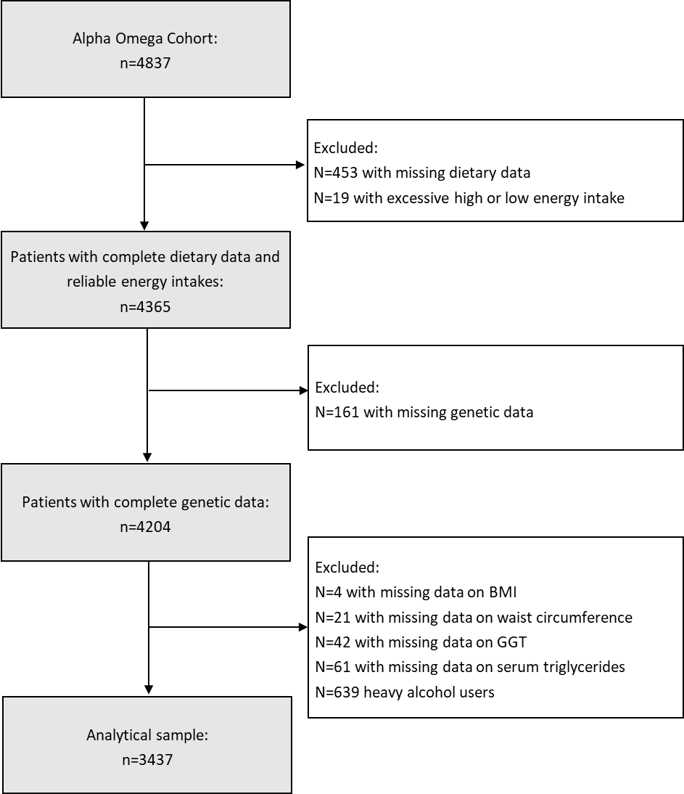
Supplementary figure 1. Flowchart for selection of 3437 post-MI patients of the Alpha Omega Cohort who are available for analysis.
Excessive high or low energy intake is defined as<600 or >6000 kcal/d for females and <800 or >8000 kcal/d for males. BMI, Body mass index; GGT, gamma-glutamyltransferase.

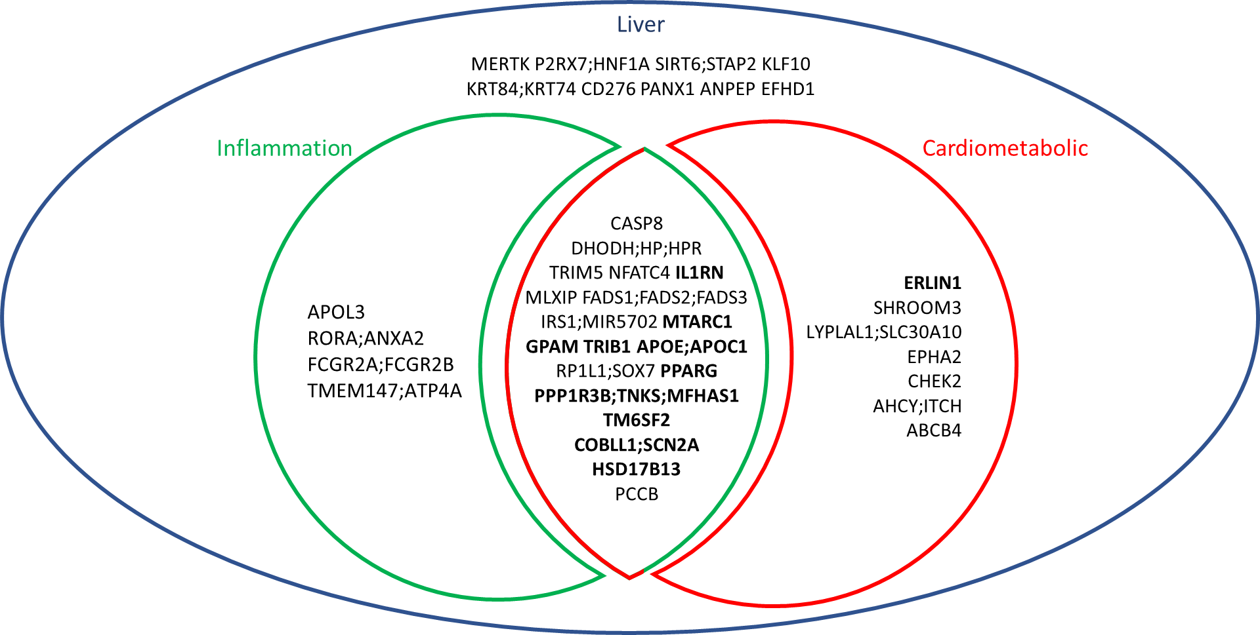
Supplementary figure 2. Venn diagram presenting overlapping liver (blue), inflammatory (green), and cardiometabolic (red) traits among NAFLD-associated loci.
Genetic variant-trait associations are based on the GWAS of Vujkovic et a. (2022). Loci depicted in bold represent replicated genetic variants, also based on the GWAS of Vujkovic et al. (2022).

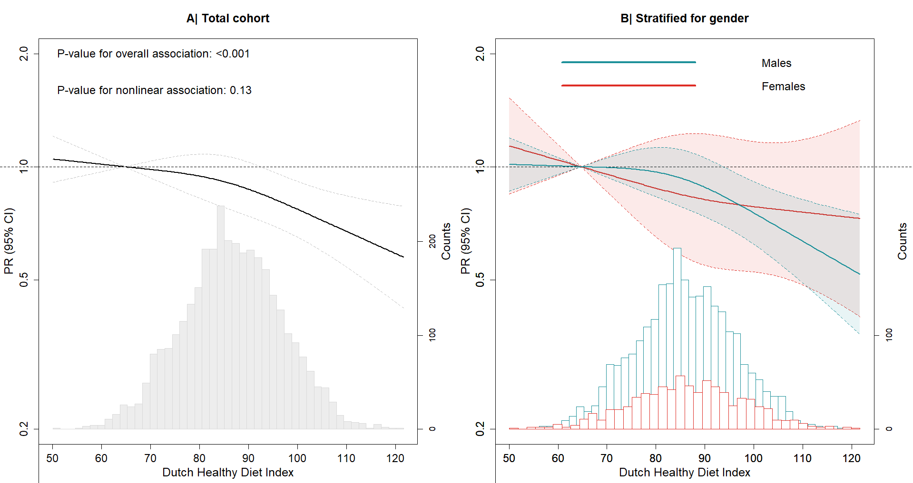
Supplementary figure 3. Prevalence Ratios (95% CI) for adherence to DHD15 as continuous exposure in relation to NAFLD in the total cohort (A) and stratified by gender (B) in 3437 post-MI patients of the Alpha Omega Cohort.
Prevalence ratios with 95% CIs (dotted line) were modeled using restricted cubic splines. Three knots for DHD15 are located at the 10th, 50th, and 90th percentiles. Prevalence ratios are adjusted for age, sex, energy intake, physical activity, and smoking status. NAFLD is predicted using sex-specific FLI tertile 3 (F ≥ 77, M ≥ 79).

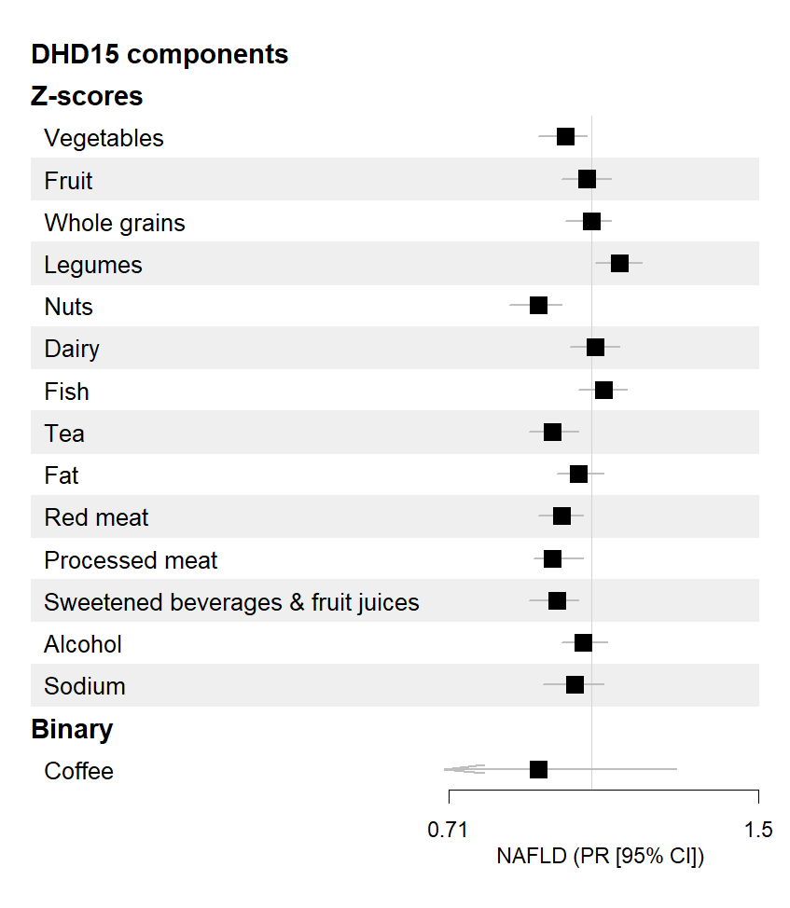
Supplementary figure 4. Prevalence ratios (95% CI) for adherence to individual DHD15 components (as z-scores (except for coffee consumption)) in relation to NAFLD in 3437 post-MI patients of the Alpha Omega Cohort. Prevalence ratios are adjusted for age, sex, energy intake, physical activity, and smoking status. NAFLD is predicted using sex-specific FLI tertile 3 (F ≥ 77, M ≥ 79).

