Online Supplemental Materials:

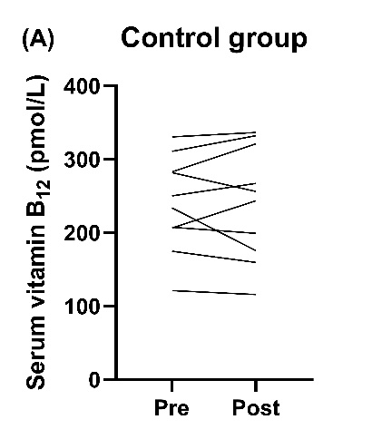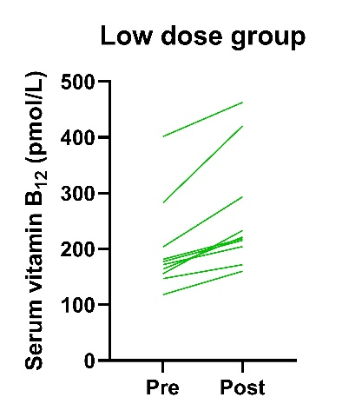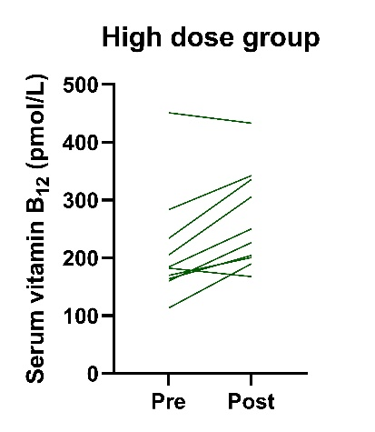

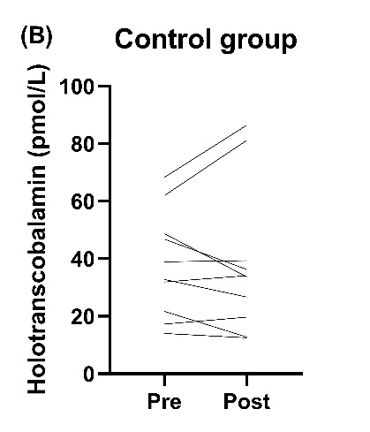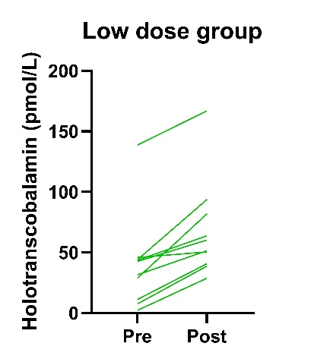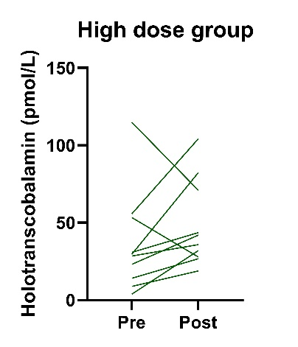

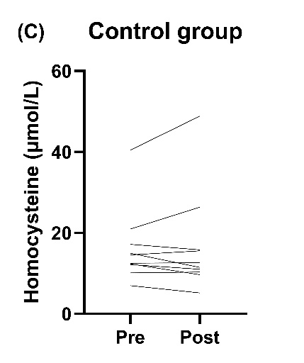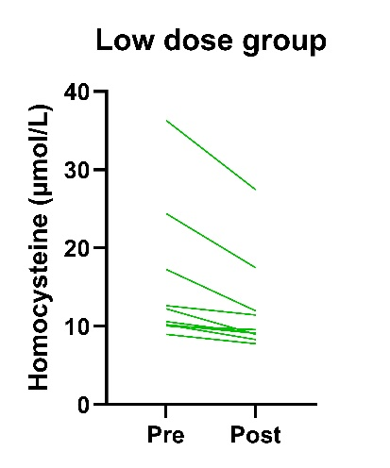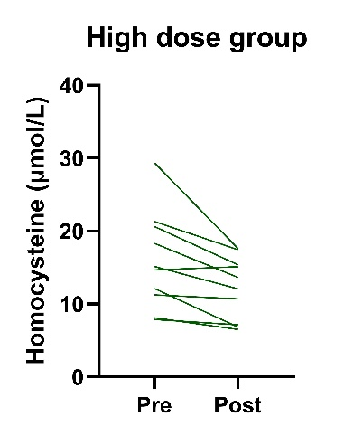
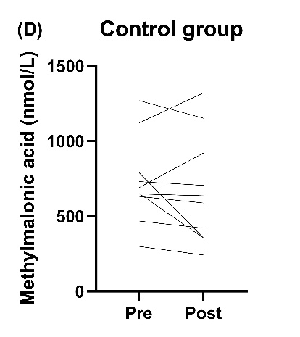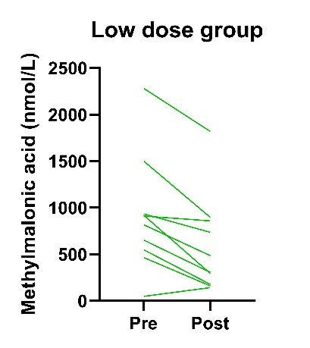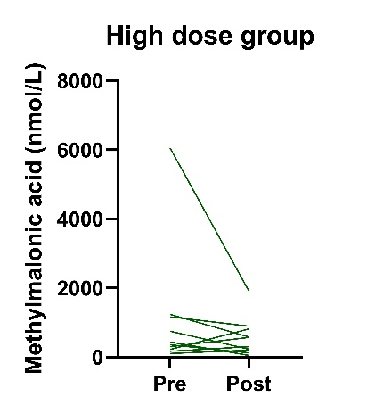

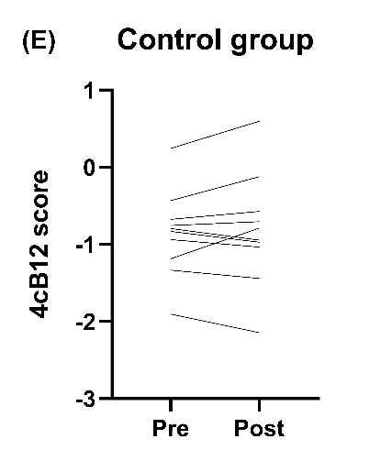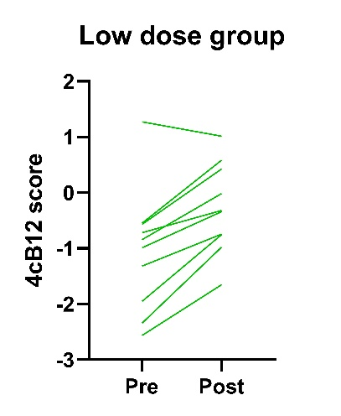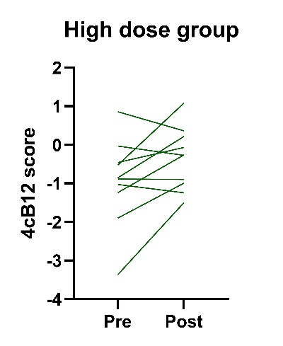

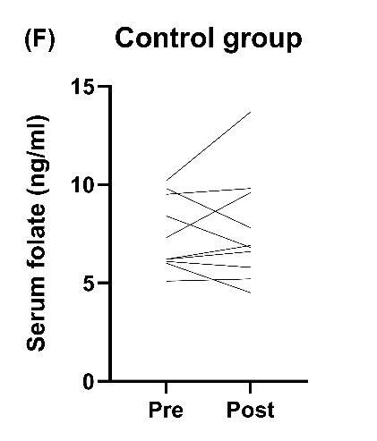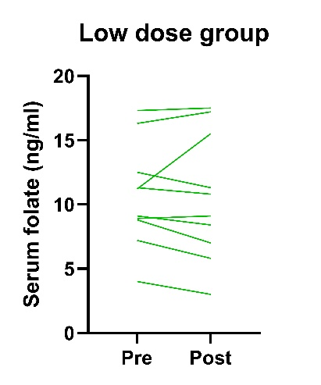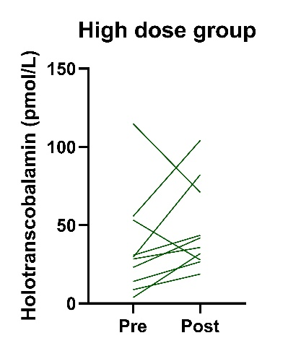

Fig. S1 Individual pre- and post-intervention changes for serum levels of (A) vitamin B₁₂, (B) holotranscobalamin, (C) homocysteine, (D) methylmalonic acid, (E) four combined index of vitamin B12 score (4cB12 score), and (F) folate, stratified by groups.

Table S1. Vitamin B₁₂ content in different brands of nori in Taiwan
Nori purchased in Taiwan | Vitamin B₁₂ content (μg/100 g DW)
Brand A | 34.1
Brand B | 42.8
Brand C# | 48.4
Brand D | 31.3
Fresh purple laver harvested from Penghu Island, lyophilized | 65.5
#Brand C was chosen for intervention in the present study Abbreviations: DW, dry weight.

Table S2. Vitamin B₁₂ content in the brand C nori from different batches
Purchase date | Vitamin B₁₂ content (μg/100 g DW)
2020.10.19 | 52.8
2021.04.21 | 25.8
2021.08.10 | 23.2
2022.02.24 | 23.1
2022.09.29 | 48.8
2022.10.13 | 38.6*
Average content | 35.4 ± 13.3
Value is expressed as mean ± SD for average content. Abbreviations: DW, dry weight.
*Batch used for the current study.

