ONLINE SUPPLEMENTARY INFORMATION - APPENDIX A
EUROPEAN JOURNAL OF NUTRITION

Is underweight associated with poorer diet, nutrient status, bone and cardiometabolic health, and school performance in Danish 8-11-year-olds?
Anne V. Aurup^{1,*}, Katrine Strandberg-Larsen², Rikke Andersen³, Anja Biltoft-Jensen³, Lotte Lauritzen¹ & Camilla T. Damsgaard¹

¹Department of Nutrition, Exercise and Sports, University of Copenhagen, Frederiksberg C, Denmark;
²Department of Public Health, University of Copenhagen, Copenhagen K, Denmark
³National Food Institute, Technical University of Denmark, Kgs. Lyngby, Denmark
*Corresponding author

*Corresponding Author Information
Anne V. Aurup, ava@nexs.ku.dk.

Supplementary Fig. 1 Participant flow chart
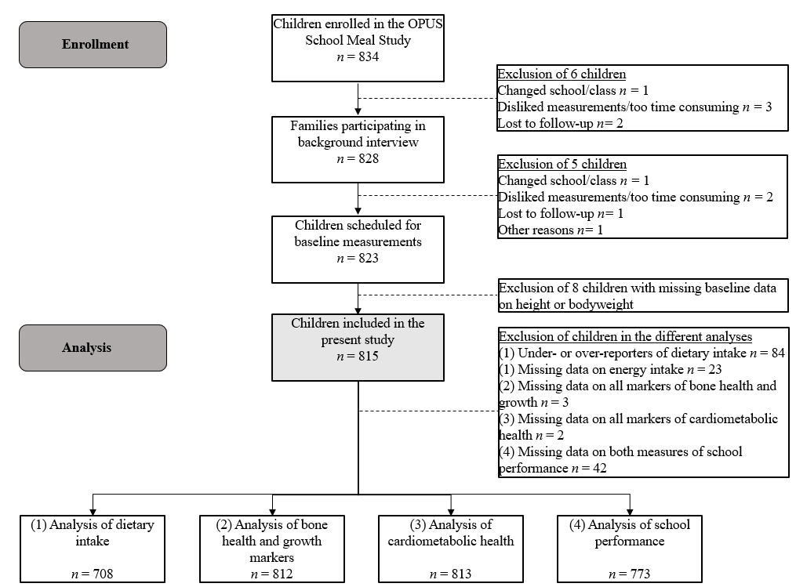
Supplementary Table 1 Weight status of children in the study population
 | All  (n = 815) | Girls  (n = 388) | Boys  (n = 427) | P†
Weight group‡, n (%)
Underweight  Grade 1 | 83 (10.2)  74 (9.1) | 45 (11.6)  40 (10.3) | 38 (8.9)  34 (8.0) | 0.39
Normalweight | 622 (76.3) | 289 (74.5) | 333 (78.0)
Overweight incl. obesity | 110 (13.5) | 54 (13.9) | 56 (13.1)
Obesity | 16 (2.0) | 6 (1.5) | 10 (2.3)
†Pearson’s chi-squared test conducted with weight group defined by underweight, normalweight and overweight/obesity
‡Weight group was categorized as underweight, normalweight, overweight and obesity according to the age- and sex specific cut-offs defined by centiles passing through a BMI of 18.5, 25 and 30 kg/m² at the age of 18, proposed by Cole and Lobstein [1] and the International Obesity Task Force (IOTF) classification [2]. Underweight was further subdivided into grade 3, grade 2 and grade 1 corresponding to BMI cut-offs of 16, 17 and 18.5 kg/m² at 18 years [3]. Due to small numbers only results for underweight grade 1 are presented in this table

Supplementary Table 2 Crude and adjusted dichotomized analysis of any weekly fish intake (yes / no)
 |  | Crude analysis† |  |  |  |  | Adjusted analysis‡
 |  | UW vs. NW |  | UW vs. OW |  |  | UW vs. NW | UW vs. OW
 | n | $OR$ [95% CI] | P | $OR$ [95% CI] | P | n | $OR$ [95% CI] | P | $OR$ [95% CI] | P
Any fish intake, yes | 708 | 1.40 [0.76;2.74] | 0.30 | 2.11 [0.99;4.67] | 0.06 | 707 | 1.41 [0.74;2.68] | 0.29 | 2.01 [0.90-4.46] | 0.09
UW underweight, NW normalweight, OW overweight/obesity, OR odds ratio, CI confidence interval
†Data are presented as odds ratios (OR) for any weekly intake of fish with 95% confidence intervals (CIs) and P values derived from unadjusted generalized linear
models with logit link function and weight group as independent variable
‡Data are presented as odds ratios (OR) for any weekly intake of fish with 95% confidence intervals (CI) and P values derived from generalized linear mixed-effects
models with logit link function and weight group, sex, age (continuous), height (continuous) and parental education as fixed effects and class and school as random effects

Supplementary Table 3 The number and proportion of children in each weight group with intakes below the AR as defined by NNR2023 for selected micronutrients
 | AR/provisional AR reference value† | Underweight  (n = 69) | Normalweight  (n = 563) | Overweight/obesity  (n = 76) | P‡
Vitamins and minerals, n (%) < AR
Vitamin D | 7.5 µg/d | 64 (92.8) | 531 (94.3) | 73 (96.1) | 0.69
Vitamin B12§ | ≤10 y: 2.0 µg/d  ≥11 y girls: 2.8 µg/d  ≥11 y boys: 2.6 µg/d | 7 (10.1)^{[a]} | 18 (3.2)^{[b]} | 2 (2.6)^{[b]} | 0.015
Calcium | ≤10 y: 675 mg/d  ≥11 y: 980 mg/d | 21 (30.4) | 106 (18.8) | 16 (21.1) | 0.08
Iron | ≤10 y: 7 mg/d  ≥11 y girls: 10 mg/d  ≥11 y boys: 9 mg/d | 18 (26.1) | 109 (19.4) | 16 (21.1) | 0.41
Zinc | ≤10 y: 6.4 mg/d  ≥11 y girls: 9.0 mg/d  ≥11 y boys: 9.2 mg/d | 9 (13.0) | 38 (6.8) | 4 (5.3) | 0.13
Selenium³ | ≤10 y: 35 µg/d  ≥11 y: 50 µg/d | 36 (52.2) | 229 (40.7) | 32 (42.1) | 0.19
NNR2023 the Nordic Nutrition Recommendations 2023 [4], AR average requirement
†Only cut-offs for AR and provisional AR values relevant for the age range in this study are presented in the table
‡Pearson’s chi-square test
§Provisional AR values
^{[a],[b],[c]}Values with dissimilar superscript letters were different between groups (P < 0.05)
Supplementary Table 4 Crude and adjusted associations between weight group and dietary intake, bone health, growth and markers of cardiometabolic health
 |  |  | Crude analysis† |  |  |  |  |  | Adjusted analysis‡
 | UW vs. NW |  |  |  |  | UW vs. OW |  |  |  | UW vs. NW |  | UW vs. OW
 | n | $β$ [95% CI] |  |  | P | $β$ [95% CI] |  | P | n | $β$ [95% CI] | P value | $β$ [95% CI] | P
Dietary intake
Energy, kJ/d | 708 | -556 [-904;-208] |  |  | 0.002 | -578 [-1032;-125] |  | 0.013 | 707 | -387 [-697;-77] | 0.015 | -243 [-657;171] | 0.25
Protein, E% | 708 | -0.7 [-1.2;-0.2] |  |  | 0.007 | -1.0 [-1.7;-0.4] |  | 0.002 | 707 | -0.7 [-1.2;-0.2] | 0.008 | -1.0 [-1.7;-0.4] | 0.003
Added sugar, E% | 708 | 1.1 [0.04;2.2] |  |  | 0.042 | 1.8 [0.4;3.2] |  | 0.011 | 707 | 1.2 [0.2;2.2] | 0.025 | 2.2 [0.8;3.5] | 0.002
Zinc§, mg/10 MJ | 708 | -0.8 [-1.3;-0.3] |  |  | 0.002 | -1.3 [-1.9;-0.6] |  | <0.001 | 707 | -0.8 [-1.2;-0.3] | 0.003 | -1.2 [-1.9;-0.6] | <0.001
Meat & meat products§, g/10 MJ | 708 | -22 [-35;-9] |  |  | 0.001 | -39 [-56;-22] |  | <0.001 | 707 | -21 [-34;-8] | 0.002 | -38 [-56;-21] | <0.001
Fish & fish products§,††, g/10 MJ | 532 | 1 [-5;7] |  |  | 0.63 | 9 [1;18] |  | 0.022 | 531 | 1 [-5;7] | 0.77 | 8 [0;17] | 0.05
Bone health & growth factors
BMC, g | 812 | -150 [-193;-109] |  |  | <0.001 | -394 [-446;-342] |  | <0.001 | 809 | -128 [-151;-106] | <0.001 | -263 [-292;-233] | <0.001
BMD, g/cm³ | 812 | -0.05 [-0.06;-0.04] |  |  | <0.001 | -0.11 [-0.13;-0.10] |  | <0.001 | 809 | -0.05 [-0.06;-0.04] | <0.001 | -0.09 [-0.10;-0.07] | <0.001
BA, cm² | 812 | -121 [-158;-84] |  |  | <0.001 | -321 [-367;-275] |  | <0.001 | 809 | -100 [-117;-83] | <0.001 | -199 [-220;-177] | <0.001
IGF-I§,¶, ng/mL | 776 | -28 [-42;-13] |  |  | <0.001 | -60 [-78;-41] |  | <0.001 | 773 | -33 [-47;-20] | <0.001 | -59 [-76;-42] | <0.001
Cardiometabolic markers
Systolic blood pressure, mmHg | 813 | -1.0 [-2.8;0.9] |  |  | 0.29 | -3.4 [-5.7;-1.1] |  | 0.003 | 810 | -0.9 [-2.6;0.9] | 0.35 | -2.1 [-4.4;0.2] | 0.08
Heart rate, beats/min | 813 | 4 [1;6] |  |  | 0.005 | 3 [-1;6] |  | 0.11 | 810 | 3 [1;6] | 0.012 | 2 [-2;5] | 0.31
Insulin§,¶, pmol/L | 746 | -9 [-14;-5] |  |  | <0.001 | -28 [-33;-22] |  | <0.001 | 743 | -10 [-14;-5] | <0.001 | -26 [-32;-21] | <0.001
HDL cholesterol, nmol/L | 791 | 0.1 [-0.01;0.1] |  |  | 0.10 | 0.2 [0.1;0.3] |  | <0.001 | 788 | 0.1 [-0.01;0.1] | 0.08 | 0.2 [0.1;0.3] | <0.001
LDL cholesterol, nmol/L | 791 | -0.01 [-0.1;0.1] |  |  | 0.89 | -0.2 [-0.4;-0.1] |  | 0.004 | 788 | -0.02 [-0.2;0.1] | 0.80 | -0.3 [-0.4;-0.1] | 0.003
TAG§, mmol/L | 791 | -0.02 [-0.08;0.03] |  |  | 0.43 | -0.15 [-0.22;-0.09] |  | <0.001 | 788 | -0.02 [-0.07;0.03] | 0.44 | -0.14 [-0.20;-0.07] | <0.001
UW underweight, NW normalweight, OW overweight/obesity, CI confidence interval, BMC bone mineral content, BMD bone mineral density, BA bone area, IGF-I insulin-like growth factor-1, TAG triacylglycerol, E% percentage of energy intake, MJ megajoules
†Data are presented as regression coefficients ($β$) with 95% confidence intervals (CI) and P values derived from unadjusted linear regression models
‡Data are presented as regression coefficients ($β$) with 95% confidence intervals (CI) and P values derived from linear mixed-effects models with weight group, sex, age (continuous), height (continuous) and parental education level as fixed effects and class and school as random effects
§Dependent variable was ln-transformed to meet model assumptions and the table presents back-transformed estimates on the original scale based on the method by Laursen et al. [5]
¶The adjusted analysis did not include height as fixed effect
††Analysis conducted only among eaters of fish, i.e. children with weekly fish intake > 0 g/d

REFERENCES
1. Cole TJ, Lobstein T (2012) Extended international (IOTF) body mass index cut-offs for thinness, overweight and obesity: Extended international BMI cut-offs. Pediatr Obes 7(4):284–94. doi:10.1111/j.2047-6310.2012.00064.x
2. Cole TJ, Bellizzi MC, Flegal KM et al (2000) Establishing a standard definition for child overweight and obesity worldwide: international survey. BMJ 6;320(7244):1240–1240. doi:10.1136/bmj.320.7244.1240
3. Cole TJ, Flegal KM, Nicholls D et al (2007) Body mass index cut offs to define thinness in children and adolescents: international survey. BMJ 28;335(7612):194. doi:10.1136/bmj.39238.399444.55
4. Blomhoff R, Andersen R, Arnesen EK et al (2023) Nordic Nutrition Recommendations 2023. Copenhagen: Nordic Council of Ministers. https://pub.norden.org/nord2023-003. Accessed 4 March 2024
5. Laursen RP, Dalskov SM, Damsgaard CT, Ritz C (2014) Back-transformation of treatment differences—an approximate method. Eur J Clin Nutr 68(2):277–80. doi:10.1038/ejcn.2013.259

