Supplementary Information

Association and Substitution Analyses of Dietary Sugars, Starch and Fiber for Indices of Body Fat and Cardiometabolic Risk – A NoHoW Sub-Study
Karen A. Della Corte¹, Dennis Della Corte², David Camacho^{1,2}, Graham Horgan³, Antonio L. Palmeira^{4,5}, James Stubbs⁶, Berit L. Heitmann⁷

¹Department of Nutrition, Dietetics, and Food Science, Brigham Young University, Provo, UT, USA. (KDC, DC)
²Data Science, College of Computational, Mathematical, and Physical Sciences, Brigham Young University, Provo, UT, USA. (DDC, DC)
³Biomathematics and Statistics Scotland, Aberdeen, UK. (GH)
⁴ University Lusófona de Humanidades e Tecnologias, Lisbon, Portugal. (ALP)
⁵ Faculty of Human Kinetics, Technical University of Lisbon, Lisbon, Portugal. (ALP)
⁶ Rowett Research Institute, Greenburn Road, Bucksburn, Aberdeen, AB21 9SB, UK. (JS)
⁷Department of Public Health, Section for General Practice, University of Copenhagen, Copenhagen, Denmark. (BLH)
Corresponding authors: Karen Della Corte, karen_dellacorte@byu.edu; Berit Lilienthal Heitmann, Berit.Lilienthal.Heitmann@regionh.dk

Table of Contents
Table S1 Associations of free sugars, intrinsic sugars, starch and fiber intakes with LDL, HDL and HbA1c 3
Table S2 Sensitivity analyses for free and intrinsic sugars 4
Figure S1 Directed Acyclic Graphs 4
Bayesian Model Specification for Model 3 5
Table S3 Substitution effects for carbohydrate components and key outcomes 9
Analysis of changes in nutrient intake 11
Table S4 and Figure S2 11
1. Magnitude of Dietary Change (Euclidean Distance): 11
2. Pattern Similarity (Cosine Similarity): 12
Figure S3 12

Table S1 Associations of free sugars, intrinsic sugars, starch and fiber intakes with LDL, HDL and HbA1c
 | Free Sugars |  | Intrinsic Sugars |  | Starch |  | Fiber
 |  | ⌀, ↑, ↓ |  | ⌀, ↑, ↓ |  | ⌀, ↑, ↓ |  | ⌀, ↑, ↓
Intake (g/day)^ | 24.1 (6.2, 34) |  | 24.9 (7.2, 35.9) |  | 74.8 (34.3, 104.9) |  | 8.6 (3.3, 12.8)
LDL (mmol/L)
Model 1 | 0.0 | ↓  -0.1; -0.0 | -0.1 | ↓  -0.1; -0.0 | 0.0 | ↓  -0.1; -0.0 | -0.1 | ↓  -0.2; -0.1
Model 2 | 0.0 | ↓  -0.1; -0.0 | 0.0 | ⌀  -0.1; 0.0 | 0.0 | ⌀  -0.1; 0.0 | -0.1 | ↓  -0.1; -0.0
Model 3 | 0.0 | ↓  -0.1; 0.0 | -0.1 | ↓  -0.1; 0.0 | 0.0 | ⌀  -0.1; 0.0 | -0.1 | ↓  -0.1; -0.0
HDL (mmol/L)
Model 1 | 0.0 | ⌀  -0.0; 0.0 | 0.0 | ⌀  -0.0; 0.0 | 0.0 | ⌀  -0.0; 0.0 | 0.0 | ⌀  -0.0; 0.0
Model 2 | 0.0 | ⌀  -0.0; 0.0 | 0.0 | ⌀  -0.0; 0.0 | 0.0 | ↓  -0.1; -0.0 | 0.0 | ⌀  -0.0; 0.0
Model 3 | 0.0 | ⌀  -0.0; 0.0 | 0.0 | ⌀  -0.0; 0.0 | 0.0 | ↓  -0.0; -0.0 | 0.0 | ⌀  -0.0; 0.0
HbA1c (%)
Model 1 | 0.0 | ↓  -0.0; -0.0 | 0.0 | ↓  -0.0; 0.0 | 0.0 | ⌀  -0.0; 0.0 | 0.0 | ↓  -0.0; 0.0
Model 2 | 0.0 | ↓  -0.0; -0.0 | 0.0 | ⌀  -0.0; 0.0 | 0.0 | ⌀  -0.0; 0.0 | 0.0 | ⌀  -0.0; 0.0
Model 3 | 0.0 | ↓  -0.0; -0.0 | 0.0 | ⌀  -0.0; 0.0 | 0.0 | ⌀  -0.0; 0.0 | 0.0 | ⌀  -0.0; 0.0
Values are means (89% CIs) of ß estimate posterior distributions unless otherwise indicated. Transformations of variables for analysis: z-scores of logs of intakes in kcal. Model 1 adjusted for age, sex, participant effect; Model 2 additionally adjusted for protein, alcohol, saturated fat, fiber and body fat percentage; Model 3 additionally adjusted for remaining energy. Contrasts calculate 89% CI of posterior differences for outcome predictions from tertile 1 and tertile 3 intakes. ^ Values are unadjusted medians (25th, 75th percentiles) in grams per day. Arrows (↑, ↓) indicate significant associations (89% credible interval did not include zero), i.e., significant increases or decreases in the outcome observed in 89% of the samples. ⌀ indicates non-significant findings (credible intervals included zero).

Table S2 Sensitivity analyses for free sugars and intrinsic sugars
 | Free Sugars |  |  | Intrinsic Sugars
Outcome | BF % | LDL | HbA1c | BF % | LDL | HbA1c
Causal model | 0.08  (-0.15, 0.31) | -0.04  (-0.08, 0) | -0.02  (-0.04, 0) | -0.54  (-0.9, -0.16) | -0.06  (-0.12, 0.01) | -0.01  (-0.04, 0.02)
Causal - energy | 0.07  (-0.16, 0.3) | -0.04  (-0.08, 0) | -0.02  (-0.04, 0) | -0.54  (-0.89, -0.19) | -0.04  (-0.11, 0.02) | -0.01  (-0.04, 0.02)
Causal - protein | 0.07  (-0.16, 0.3) | -0.04  (-0.08, 0.01) | -0.02  (-0.04, 0) | -0.51  (-0.88, -0.15) | -0.06  (-0.12, 0.01) | -0.02  (-0.04, 0.01)
Causal - fat | 0.09  (-0.14, 0.32) | -0.03  (-0.07, 0.01) | -0.02  (-0.04, 0) | -0.54  (-0.9, -0.18) | -0.04  (-0.1, 0.02) | -0.01  (-0.04, 0.02)
Causal - alcohol | 0.05  (-0.18, 0.28) | -0.04  (-0.08, 0.01) | -0.02  (-0.04, 0) | -0.55  (-0.9, -0.19) | -0.06  (-0.13, 0.01) | -0.01  (-0.04, 0.02)
Causal – body fat |  | -0.04  (-0.08, 0) | -0.02  (-0.04, 0) |  | -0.06  (-0.12, 0.01) | -0.01  (-0.04, 0.01)
Causal - fiber | -0.01  (-0.24, 0.22) | -0.05  (-0.09, 0) | -0.02  (-0.04, 0) | -0.86  (-1.15, -0.56) | -0.09  (-0.15, -0.04) | -0.02  (-0.04, 0.01)
Beta estimates (mean, and 89% CI) for two predictors on three outcomes are shown in a leave-one-out analysis that removes one covariate at a time from full causal model. Posterior means, standard deviations, and 89% credible intervals were sampled from the posterior distributions. LDL: low-density lipoprotein; HbA1c: glycated hemoglobin.
Table S2 presents the results of a sensitivity analysis for two predictors (free and intrinsic sugars) on three outcomes (BF %, LDL, and HbA1c) using a leave-one-out approach applied to model 3. In this updated analysis, the impact of removing individual covariates on the beta estimates (mean and 89% confidence intervals) is assessed. For free sugars, the associations with BF % and HbA1c remain weak across different covariate exclusions, with beta estimates close to zero. For intrinsic sugars, a moderate to strong negative association is consistently observed with BF %, with beta estimates ranging from -0.55 to -0.86, depending on the covariate removed. Notably, the exclusion of the fiber covariate has a significant impact, especially on the BF % outcome, where the association with intrinsic sugars becomes more pronounced (beta estimate of -0.86, CI: -1.15, -0.56), indicating a sensitivity of the model to this covariate. Associations with LDL and HbA1c for both predictors remain weak throughout, with little variation in beta estimates across different covariate exclusions.

Figure S1 Directed Acyclic Graphs
Directed acyclic graphs (DAGs) are integral tools in this study for visualizing and understanding the complex causal relationships between nutritional variables and health outcomes. The DAGs were developed through a systematic process, incorporating current scientific knowledge and expert consensus in nutritional science. Each node represents a variable of interest, such as anthropometric measures or blood biomarkers, while the directed edges indicate hypothesized causal paths based on existing literature. Confounders with potential backdoor paths are carefully identified and depicted in orange to highlight their role in the analysis. This graphical representation facilitates the application of Bayesian inference by explicitly modeling the dependencies and independencies among variables. The transparency of the DAGs allows for clear communication of the assumptions underlying our causal models, enabling replication and validation in future studies. Additionally, the careful distinction between predictors, outcomes, and confounders aids in the accurate interpretation of the results, ensuring robust and credible conclusions in our investigation of nutritional impacts on health. Two example DAGs for BMI and HDL outcomes with Intrinsic Sugar as predictors are shown in Figure S1.

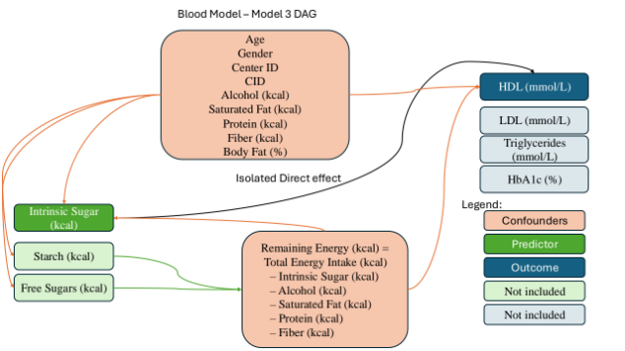
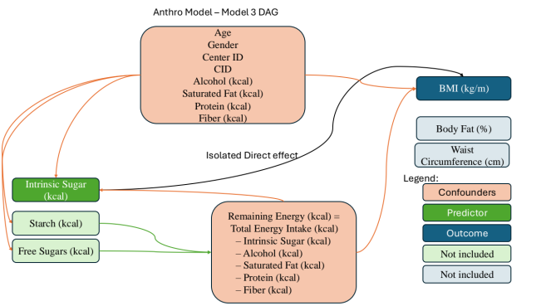
Figure S1 DAGs creation and testing
Figure S1 Directed Acyclic Graphs (DAG) of model 3. Left for anthropometric, right for blood outcomes. Predictors in green on left. Each predictor may be used for each outcome, but remaining energy variable is updated accordingly. Confounders with backdoor paths are in orange. Outcomes in blue on the right. Arrows indicate flow of information, with black arrow indicating the causal impact of predictor on outcome of interest. Light green and blue shaded boxes indicate alternative predictors and outcomes that are not present in model 3.

Bayesian Model Specification for Model 3
The Bayesian model specification for Model 3, detailed below, outlines the statistical framework employed in our analysis. This model specification is provided to ensure transparency and reproducibility of our results. By clearly defining the likelihood, linear predictor, and priors, we offer a comprehensive view of the assumptions and structure underlying our inferential approach. The inclusion of this detailed specification allows other researchers to understand the exact methods used, facilitates replication of the study, and enables critical evaluation of the model's robustness. The normal priors chosen for the coefficients reflect a non-informative stance, assuming no prior knowledge about the direction or magnitude of the effects, which is essential for unbiased parameter estimation. Moreover, the use of standardized variables ensures comparability across different predictors, simplifying the interpretation of the model coefficients. Providing this detailed specification aligns with best practices in Bayesian statistics, promoting rigorous scientific inquiry and enhancing the credibility of our findings.
Let $Y_{i}$ denote the outcome of interest. The model can be specified as follows:

Likelihood
$$Y_{i}\sim Ν(μ_{i},σ)$$
where $μ_{i}$ is the mean and $σ$ is the standard deviation of the normal distribution for the i-th observation.

Linear Predictors
$$μ_{i}= α_{sex\left[s\right]}+ a_{center_id\left[j\right]}+ a_{Participant\left[k\right]}+ β_{predictor}*predictor_{i}+ β_{protein}*protein+ β_{alcohol}*alcohol+ β_{fat}*fat+ + β_{fiber}*fiber+ β_{age}*{age}_{i}+ β_{remaining_energy}*remaining_energy$$
$$a_{Participant\left[k\right]}= μ_{Participant}+ {σ_{Participant}*a_{ra{w_participant[k]}_{}}}_{ }$$
Priors
The priors for the parameters are specified as follows:
$$α_{sex\left[s\right]}∼N\left(0,1\right)$$
$$a_{center_id[j]}​∼N(0,1)$$
$$a_{ra{w_participant[k]}_{ }}​∼N(0,1)$$
$$β_{predictor}∼N\left(0,1\right)$$
$$β_{protein}∼N\left(0,1\right)$$
$$β_{alcohol}∼N\left(0,1\right)$$
$$β_{fat}∼N\left(0,1\right)$$
$$β_{fiber}∼N\left(0,1\right)$$
$$β_{energy}∼N\left(0,1\right)$$
$$μ_{Participant} ∼N\left(0,1\right)$$
$$σ∼Exponential\left(1\right)$$
$$σ_{Participant}∼Exponential\left(1\right)$$

Notation
- $Y_{i}$: Outcome for the i-th observation
- $μ_{i}$​: Mean of the normal distribution for the i-th observation
- $σ$: Standard deviation of the normal distribution (assumed to be constant across observations)
- $μ_{Participant}$​: Mean of the participant-level effect
- $σ_{Participant}$: Standard deviation of the participant effect
- $α_{sex[s]}$: Intercept term for each sex g (male, female)
- $a_{center_id[j]}​$: Intercept term for the j-th center
- $a_{ra{w_participant[k]}_{ }}​$: Intercept term for the k-th participant (random effect)
- $a_{Participant\left[k\right]}​$: Individual deviation of participant k
- $β_{predictor}$: Coefficient for the predictor variable
- $β_{protein}$​: Coefficient for the protein variable
- $β_{alcohol}$: Coefficient for the alcohol variable
- $β_{fat}$: Coefficient for the fat variable
- $β_{fiber}$: Coefficient for the fiber variable
- $β_{age}$: Coefficient for the age variable
- $β_{energy}$​: Coefficient for the energy variable
Since all the predictors and outcomes were standardized, normal priors with a mean of 0 were employed for the intercept (alpha) and the coefficients (beta). The choice of a mean of 0 for these priors reflects the assumption that, in the absence of data, the predictor variables do not have a systematic effect on the outcome.
This model structure incorporates repeated measures through a hierarchical approach, where participant-specific intercepts $a_{Participant\left[k\right]}$​ are treated as random effects and modeled using a non-centered parameterization. $μ_{Participant}$​​ represents the overall mean effect pooled across participants, while $σ_{Participant}$ captures the variability between participants. This pooling of information allows the model to borrow strength across individuals, improving the stability and precision of the estimates. The non-centered parameterization is facilitated by the introduction of the auxiliary variable $a_{ra{w_participant[k]}_{ }}$​, which follows a standard normal distribution. This approach enhances the model's flexibility and computational efficiency, particularly in Bayesian inference, by improving the convergence properties of the sampling algorithm. By including $a_{Participant\left[k\right]}$​ as a random effect, the model effectively controls for clustering within the same participant, accounting for the repeated measurements and individual-level variability. This results in more robust and reliable estimates of the effects of interest.

Table S3 Substitution effects for carbohydrate components and key outcomes

Outcome | Intake decreased | Intake increased | Substitution Effect | Sensitivity analysis excluding 6-month dropouts
Body Fat (%) | Free Sugars (g) | Starch (g) | ↑  (-0.3; 2.5) | ⌀  (-0.6; 2.4)
 | Starch (g) | Fiber (g) | ↓  (-5.5; -2.1) | ↓  (-5.6; -2.0)
 | Intrinsic Sugars (g) | Starch (g) | ↑  (1.4; 4.9) | ↑  (1.5; 5.3)
 | Free Sugars (g) | Fiber (g) | ↓  (-3.4; -1.3) | ↓  (-3.8; -1.5)
 | Free Sugars (g) | Intrinsic Sugars (g) | ↓  (-4.2; -1.0) | ↓  (-4.9; -1.3)
BMI | Free Sugars (g) | Starch (g) | ↑  (0.5; 2.4) | ↑  (0.9; 2.9)
 | Starch (g) | Fiber (g) | ↓  (-3.9; -1.7) | ↓  (-4.9; -2.6)
 | Intrinsic Sugars (g) | Starch (g) | ↑  (1.8; 4.1) | ↑  (2.7; 5.2)
 | Free Sugars (g) | Fiber (g) | ↓  (-1.8; -0.4) | ↓  (-2.2; -0.7)
 | Free Sugars (g) | Intrinsic Sugars (g) | ↓  (-3.0; -0.8) | ↓  (-3.7; -1.5)
Waist Circumference (cm) | Free Sugars (g) | Starch (g) | ⌀  (-1.1; 3.5) | ⌀  (-1.4; 3.1)
 | Starch (g) | Fiber (g) | ↓  (-5.6; -0.4) | ↓  (-6.7; -1.3)
 | Intrinsic Sugars (g) | Starch (g) | ↑  (-0.3; 5.3) | ↑  (0.5; 6.2)
 | Free Sugars (g) | Fiber (g) | ↓  (-3.3; 0.1) | ↓  (-4.7; -1.1)
 | Free Sugars (g) | Intrinsic Sugars (g) | ⌀  (-4.2; 1.0) | ↓  (-5.6; -0.3)
Weight change (kg) | Free Sugars (g) | Starch (g) | ⌀  (-0.5; 1.4) | ↑  (-0.2; 1.9)
 | Starch (g) | Fiber (g) | ⌀  (-1.9; 0.3) | ↓  (-2.5; 0.0)
 | Intrinsic Sugars (g) | Starch (g) | ↑  (-0.2; 2.2) | ⌀  (-0.4; 2.2)
 | Free Sugars (g) | Fiber (g) | ⌀  (-1.0; 0.5) | ⌀  (-1.1; 0.5)
 | Free Sugars (g) | Intrinsic Sugars (g) | ⌀  (-1.8; 0.4) | ⌀  (-1.4; 1.0)
HDL (mmol/L) | Free Sugars (g) | Starch (g) | ⌀  (-0.2; 0.0)
 | Starch (g) | Fiber (g) | ↑  (-0.0; 0.3)
 | Intrinsic Sugars (g) | Starch (g) | ⌀  (-0.2; 0.1)
 | Free Sugars (g) | Fiber (g) | ⌀  (-0.1; 0.1)
 | Free Sugars (g) | Intrinsic Sugars (g) | ⌀  (-0.1; 0.2)
LDL (mmol/L) | Free Sugars (g) | Starch (g) | ⌀  (-0.2; 0.4)
 | Starch (g) | Fiber (g) | ↓  (-0.6; 0.1)
 | Intrinsic Sugars (g) | Starch (g) | ⌀  (-0.1; 0.5)
 | Free Sugars (g) | Fiber (g) | ⌀  (-0.3; 0.1)
 | Free Sugars (g) | Intrinsic Sugars (g) | ⌀  (-0.4; 0.2)
HbA1c (%) | Free Sugars (g) | Starch (g) | ↑  (0.0; 0.2)
 | Starch (g) | Fiber (g) | ⌀  (-0.2; 0.0)
 | Intrinsic Sugars (g) | Starch (g) | ⌀  (-0.0; 0.2)
 | Free Sugars (g) | Fiber (g) | ⌀  (-0.0; 0.1)
 | Free Sugars (g) | Intrinsic Sugars (g) | ⌀  (-0.1; 0.1)
Table S3 summarizes the outcomes of the substitution analyses, illustrating the effects of substituting carbohydrate components on key health outcomes. The outcome measures of body fat percentage, HDL, LDL, HbA1c, BMI, and waist circumference are listed, and the impact of decreasing the intake of one nutrient while increasing the intake of another is shown. For each substitution, the direction and magnitude of the effect is provided, along with 89% credible intervals. The substitution effects are represented by symbols indicating no effect (⌀), an increase (↑), or a decrease (↓). For instance, substituting intrinsic sugars with fiber is associated with an increase in body fat percentage, while replacing free sugars with fiber results in a significant decrease in both body fat percentage and waist circumference. A sensitivity analysis was conducted at 6 months, which excluded dropout participants whose last investigation visit was at 6 months (n = 193 of dropouts for the indices of body fat group).

Analysis of changes in nutrient intake

Table S4 Characterstics of NoHoW (Navigating to a Healthy Weight) study participants at last available CID.
 | Indices of body fat outcome group at CID 4  (up to 18-months follow-up) |  | Cardiometabolic risk outcome group at CID 3  (12-months follow-up)
Characteristic | n | Mean ± SD | n | Mean ± SD
Age (years) | 529 | 49.1 ± 11.6 | 736 | 47.1 ± 11.8
Sex (% male) | 529 | 22.1 | 736 | 24.7
Dietary Factors
Energy (kcal) | 529 | 1617 ± 518 | 736 | 1637 ± 512
Fat (g) | 529 | 63.4 ± 28.8 | 736 | 63.7 ± 29.8
Saturated fat (g) | 529 | 17.4 ± 10.5 | 736 | 17.8 ± 10.7
Protein (g) | 529 | 79.5 ± 28.4 | 736 | 78.6 ± 25.4
Carbohydrate (g) | 529 | 169.8 ± 69.9 | 736 | 175.3 ± 66.2
Fiber (g) | 529 | 7.6 ± 6.1 | 736 | 8.2 ± 6.5
Intrinsic sugars (g) | 529 | 21.5 ± 22.5 | 736 | 23.3 ± 23.8
Free sugars (g) | 529 | 21.8 ± 25.0 | 736 | 23.7 ± 25.4
Starch (g) | 529 | 73.8 ± 53.9 | 736 | 75.9 ± 50.8
Total sugars (g) | 529 | 44.6 ± 39.6 | 736 | 48.5 ± 40.6
Alcohol (g) | 529 | 7.0 ± 13.0 | 736 | 7.4 ± 12.3
Cholesterol (mg) | 529 | 259 ± 175 | 736 | 250 ± 151
Anthropometric Outcomes
BMI (kg/m²) | 529 | 29.7 ± 5.3 | 736 | 29.4 ± 5.1
Body fat (kg) | 529 | 33.0 ± 12.2 | 736 | 32.1 ± 12.1
Body fat (%) | 529 | 38.6 ± 8.6 | 736 | 37.7 ± 8.9
Waist circumference (cm) | 529 | 93.3 ± 13.6 | 736 | 93.1 ± 13.1
Cardiometabolic Outcomes
HbA1c (%) |  |  | 736 | 5.3 ± 0.4
HDL (mmol/L) |  |  | 736 | 1.8 ± 0.4
LDL (mmol/L) |  |  | 736 | 2.7 ± 0.9
Data are baseline means ± standard deviations. BMI: body mass index; HbA1c: glycated hemoglobin A1c; HDL: high-density lipoprotein; LDL: low-density lipoprotein.

We investigated the change in consumption of four key nutrients by calculating the difference between reported intakes at last and first CID per participant. The averages and standard deviations with corresponding distributions are shown in Table S5 and Figure S2.

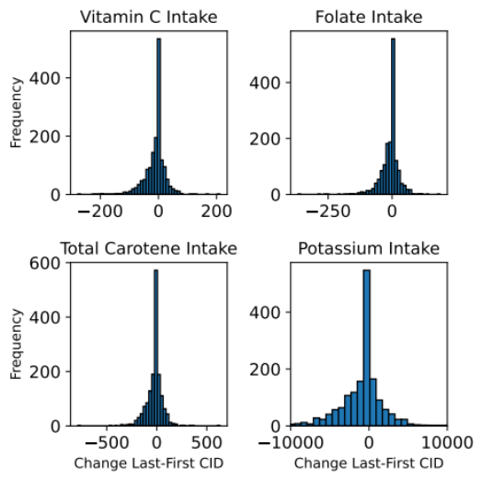
Table S5 and Figure S2

Nutrient | Mean Change | Standard Deviation
Vitamin C Intake | -10.8 | 36.1
Folate Intake | -8.7 | 36.9
Total Carotene Intake | -20.3 | 81.1
Potassium Intake | -892.7 | 2922.2

Table S4 / Figure S2 Summary of Nutrient Change analysis. Mean change is the average change in intake for four nutrients across all Participants, where the first CID average consumption was subtracted from the last CID average consumption. Histograms of distributions are shown in Figure on the right.
Further, we encoded the average consumption per participant for the first and last CID into 58 dimensional vectors with rows Protein (g), Fat (g), Carbohydrate (g), Energy (kJ), Alcohol (g), Fibre (Englyst) (g), Total Sugars (g), Non-Milk Extrinsic Sugars (g), Intrinsic Sugars (g), Other Sugars (g), Saturated Fatty Acids (g), Cholesterol (mg), Fructose (g), Glucose (g), Starch (g), Sucrose (g), Vitamin A (µg), Vitamin D (µg), Vitamin C (mg), Vitamin E (mg), Folate (µg), Sodium (mg), Calcium (mg), Iron (mg), Haem Iron (mg), Non-Haem Iron (mg), Zinc (mg), Selenium (µg), Alpha-Carotene (µg), Beta-Carotene (µg), Total Carotene (µg), Beta-Cryptoxanthin (µg), Biotin (µg), Chloride (mg), Cis-Monounsaturated Fatty Acids (g), Cis n-3 Fatty Acids (g), Cis n-6 Fatty Acids (g), Copper (mg), Iodine (µg), Lactose (g), Magnesium (mg), Maltose (g), Manganese (mg), Niacin (mg), Niacin Equivalents (mg), Nitrogen Conversion Factor, Total Nitrogen (g), Pantothenic Acid (mg), Phosphorus (mg), Potassium (mg), Retinol (µg), Riboflavin (mg), Thiamin (mg), Trans Fatty Acids (g), Tryptophan (60 mg), Vitamin B12 (µg), Vitamin B6 (mg), and Water (g). These vectors were were normalized with respect to average consumption per nutrient and analyzed to quantify the total change, direction of change, correlation of changes within the dietary profile of each participant. Results are shown in Figure S3.

1. Magnitude of Dietary Change (Euclidean Distance):

Each participant’s dietary intake is represented as a 10-dimensional vector at two time points: baseline and follow-up. The difference vector is computed as C = A − B, where A is the vector at baseline and B is the vector at follow-up. The Euclidean distance ∥C∥ is then calculated to quantify the overall magnitude of change in dietary intake. This measure provides insight into the extent of dietary shifts, regardless of the direction of change.

2. Pattern Similarity (Cosine Similarity):

To assess whether participants’ dietary patterns remained consistent or changed significantly, the cosine similarity is calculated as:

Cosine similarity = (A ⋅ B) / (∥A∥ ∥B∥)

This metric reveals whether the relative proportions of different dietary components were maintained or shifted, even if absolute intake levels changed.

Figure S3
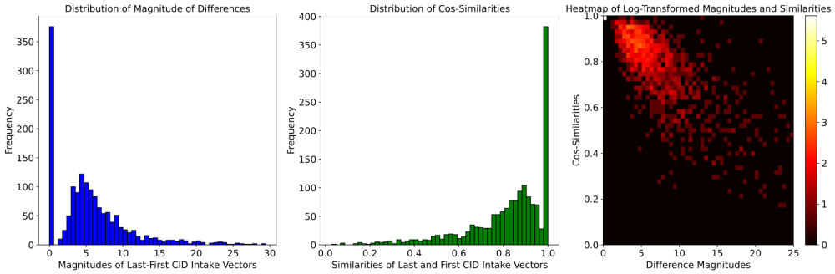

Figure S3 Histograms of distribution of mean normalized changes in magnitudes and similarities between participant consumptions. Left shows distribution of magnitudes of difference vectors, middle distribution of cosine similarity values, and right the log-transformed (to increase contrast of rare events) 2-d heatmap of the combined changes. Values indicate that most participants changed consumption magnitudes by a similar amount, but within different nutrient groups. Overall, this indicates reduced caloric intake but not specific to any nutrient type.

