Supplements

Supplementary Material 1. Measurement of urinary isoflavones and metabolites
Supplementary Material 2. Measurement of the gut microbiota

Supplementary Table 1. Dietary sources of isoflavones among 1,110 participants
Supplementary Table 2. Sex, age, soy isoflavone intakes, and urinary isoflavone levels according to equol production
Supplementary Table 3. Relative abundances of the four bacterial phyla with a mean abundance of >0.2% according to equol production
Supplementary Table 4. Relative abundance of the 34 bacterial genera with a mean relative abundance of >0.2% according to equol production
Supplementary Table 5. Relative abundance of the 71 bacterial species with a mean relative abundance of >0.1% according to equol production
Supplementary Table 6. Spearman’s correlation coefficients between the equol/daidzein ratio and the relative abundances of 71 bacterial species with a mean relative abundance of >0.1%
Supplementary Table 7. Relative abundances of 12 potentially equol-producing species according to equol production in the first urine samples.

Supplementary Figure 1. Flowchart of the study participants
Supplementary Figure 2. Indices of gut microbiota α-diversity according to sex and age group
Supplementary Figure 3. Indices of gut microbiota α-diversity according to tertiles of isoflavone intake
Supplementary Figure 4. Comparison of gut microbiota α-diversity between equol producers (n=53) and non-producers (n=169) in the first collected urine samples by analysis of covariance with adjustment for survey time, sex, and age
Supplementary Figure 5. Comparison of Chao1 between equol producers and non-producers by age group
Supplementary Figure 6. Principal coordinate analysis (PCoA) plots based on UniFrac distances of the gut microbiota for the comparison between equol production (n=53) and non-production (n=169) in the first urines
Supplementary Figure 7. Principal coordinate analysis (PCoA) plots based on UniFrac distances of the gut microbiota for the comparison between equol production and non-production by sex
Supplementary Figure 8. Principal coordinate analysis (PCoA) plots based on UniFrac distances of the gut microbiota for the comparison between equol producers and non-producers by age group
Supplementary Figure 9. Principal coordinate analysis (PCoA) plots based on UniFrac distances of the gut microbiota according to isoflavone intake (n=223)

Supplementary Material 1. Measurement of urinary isoflavones and metabolites

Sample preparation was performed as reported by Fleck et al.,¹⁾ with minor modifications. Samples were incubated for 1 h at 37°C for enzymatic hydrolysis. Sample clean-up was performed using Isolute SLE+ 96-well plates (Biotage, Uppsala, Sweden). The eluent was evaporated for dryness under nitrogen and then reconstituted with 50% methanol (500 μL).
Analyses were performed using the Nexera X2 UHPLC system (Shimadzu, Kyoto, Japan) coupled with a Triple Quad 5500+ mass spectrometer (AB Sciex LLC, Framingham, MA) with an atmospheric pressure chemical ionization (APCI) ion source, negative-ion mode. The APCI source parameters were set as follows: collision-activated dissociation gas (N₂) at 8 psig, curtain gas at 20 psig, ion source gas at 40 psig, heated nebulizer temperature at 400°C, and discharge needle current at −2 μA. The multiple reaction monitoring transitions monitored were as follows: 241→121 for equol, 246→94 for equol-d4, 253→223 for daidzein, 256→137 for daidzein-d6, 269→133 for genistein, and 274→137 for genistein-d4.
For urine analysis, a Sunshell C18 column (2.1 × 100 mm, 2.6 μm; ChromaNik Technologies Inc., Osaka, Japan) was used at 40°C. The injection volume was 1 μL. Mobile phase A consisted of a 0.25-mmol/L ammonium acetate buffer (pH 6)/methanol (6/4, v/v), and mobile phase B was acetonitrile. The flow rate was set to 0.3 mL/min. The gradient was as follows: 20% B for 2 min, from 20% to 45% B in 1.5 min, 45% to 95% B in 0.01 min, 95% B for 4.5 min, from 95% to 20% B in 0.01 min, and then 20% B for 1 min.

1) Fleck SC, Churchwell MI, Doerge DR, Teeguarden JG, et al. Urine and serum biomonitoring of exposure to environmental estrogens II: Soy isoflavones and zearalenone in pregnant women. Food Chem Toxicol. 2016;95:19-27.

Supplementary Material 2. Measurement of the gut microbiota

DNA extraction and 16S amplicon sequencing
Fecal DNA was isolated and purified following a previously described method.²⁾ The DNA was purified with a 20% PEG solution (PEG6000 in 2.5 M NaCl), pelleted by centrifugation, rinsed with 75% ethanol, and dissolved in TE buffer. The 16S ribosomal RNA gene V1-V2 region was amplified by polymerase chain reaction (PCR) using the forward primer (5′-AATGATACGGCGACCACCGAGATCTACAC NNNNNNNNACACTCTTTCCCTACACGACGCTCTTCCGATCTagrgtttgatymtggctcag-3′) containing the flow cell adapter (Illumina Inc., San Diego, CA), a unique 8-bp barcode sequence for each sample (indicated in N), the sequence adapter (Illumina), and 27Fmod (5′-agrgtttgatymtggctcag),²⁾ and the reverse primer (5′-CAAGCAGAAGACGGCATACGAGATNNNNNNNNGTGACTGGAGT TCAGACGTGTG CTCTTCCGATCTtgctgcctcccgtaggagt-3′ ) containing the flow cell adapter, a unique 8-bp barcode sequence for each sample (indicated in N), the sequence adapter, and 338R (5′- tgctgcctcccgtaggagt-3′). PCR was performed in 50 μL of 1× Ex Taq PCR buffer composed of 10 mM Tris–HCl (pH 8.3), 50 mM KCl, and 1.5 mM MgCl2 in the presence of 250 mM dNTP, 1 U Ex Taq polymerase (Takara Bio, Inc.), forward and reverse primers (0.2 mM) and ~20 ng template DNA. Thermal cycling consisted of initial denaturation at 96°C for 2 min, followed by 20 cycles of denaturation at 96°C for 30 s, annealing at 55°C for 45 s and extension at 72°C for 1 min, and final extension at 72°C on a PCR system (Applied Biosystems, Foster City, CA). Negative controls were treated similarly, except that no template DNA was added to the PCR reactions. PCR products of ~370 bp were visualized by electrophoresis on 3% agarose gels, while negative controls failed to produce visible PCR products and were excluded from further analysis. PCR amplicons were purified by AMPure XP magnetic purification beads (Beckman Coulter, Inc., Brea, CA), and quantified using the Quant-iT PicoGreen dsDNA Assay Kit (Life Technologies, Carlsbad, CA). Equal amounts of each PCR amplicon were mixed and sequenced with the MiSeq Platform using MiSeq Reagent Kit v3 (600 cycles; Illumina).

Data analysis
After demultiplexing the 16S sequence reads based on the sample-specific index, the reads lacking both forward and reverse primer sequences were removed using BLAST and Cutadapt version 1.15 followed by trimming off both primer sequences. Data were further denoised by removing reads with average quality values <25. Reads having BLAST match lengths <90% with the representative sequence in the 16S databases were considered as chimeras and removed. Finally, filter-passed reads were used for further analysis.

2) Kim SW, Suda W, Kim S. et al. Robustness of gut microbiota of healthy adults in response to probiotic intervention revealed by high-throughput pyrosequencing. DNA Res. 2013;20:241-253.
Supplementary Table 1. Dietary sources of isoflavones among 1,110 participants
 | percentages
Soybeans | 3.1%
Soybeans, green | 3.9%
Kinako (roasted and ground soybeans) | 0.1%
Tofu | 44.6%
Natto (fermented soybeans) | 14.9%
Soymilk | 4.6%
Soybean sprouts | 4.9%
Miso | 22.2%
Soy sauce | 1.2%
Soy snacks | 0.3%

Supplementary Table 2. Sex, age, soy isoflavone intakes, and urinary isoflavone levels according to equol production
 | The first collected urine samples |  |  |  |  |  |  |  |  |  |  |  |  | The second collected urine samples
 | Equol (+), n=288 |  |  |  |  | Equol (-), n=812 |  |  |  |  |  |  |  | Equol (+), n=217 |  |  |  |  |  |  |  |  |  | Equol (-), n=755
 | n | % | estimated mean | s.e. |  | n | % | estimated mean | s.e. | pª |  |  |  | n |  | % |  | estimated mean |  | s.e. |  |  |  | n |  | % |  | estimated mean |  | s.e. |  | pª
Sex
boy | 140 | 25.2% |  |  |  | 415 | 74.8% |  |  | 0.47 |  |  |  | 111 |  | 22.8% |  |  |  |  |  |  |  | 376 |  | 77.2% |  |  |  |  |  | 0.73
girl | 148 | 27.2% |  |  |  | 397 | 72.8% |  |  |  |  |  |  | 106 |  | 21.9% |  |  |  |  |  |  |  | 379 |  | 78.1%
Age
7-8 years old | 66 | 24.6% |  |  |  | 202 | 75.4% |  |  | 0.74 |  |  |  | 29 |  | 17.6% |  |  |  |  |  |  |  | 136 |  | 82.4% |  |  |  |  |  | 0.27
10-11 years old | 79 | 27.5% |  |  |  | 208 | 72.5% |  |  |  |  |  | 62 |  | 23.2% |  |  |  |  |  |  |  | 205 |  | 76.8%
13-14 years old | 143 | 26.2% |  |  |  | 402 | 73.8% |  |  |  |  |  |  | 126 |  | 23.3% |  |  |  |  |  |  |  | 414 |  | 76.7%
Daily intake
soy (g) |  |  | 86.0 | 2.9 |  |  |  | 85.7 | 1.7 | 0.94 |  |  |  |  |  |  |  | 89.0 |  | 3.4 |  |  |  |  |  |  |  | 84.1 |  | 1.8 |  | 0.20
isoflavone (mg) |  |  | 32.9 | 1.0 |  |  |  | 33.2 | 0.6 | 0.76 |  |  |  |  |  |  |  | 34.0 |  | 1.1 |  |  |  |  |  |  |  | 32.8 |  | 0.6 |  | 0.43
Urinary level
(µg/g creatinine)
daidzein |  |  | 3.7 | 0.3 |  |  |  | 6.1 | 0.2 | <0.001 |  |  |  |  |  |  |  | 7.4 |  | 0.5 |  |  |  |  |  |  |  | 10.6 |  | 0.3 |  | <0.001
genistein |  |  | 2.2 | 0.2 |  |  |  | 3.9 | 0.1 | <0.001 |  |  |  |  |  |  |  | 4.8 |  | 0.4 |  |  |  |  |  |  |  | 7.9 |  | 0.2 |  | <0.001
glycitein |  |  | 0.5 | 0.04 |  |  |  | 0.7 | 0.02 | 0.003 |  |  |  |  |  |  |  | 0.7 |  | 0.06 |  |  |  |  |  |  |  | 0.8 |  | 0.03 |  | 0.25
s.e.: standard error. Soy and isoflavone intakes indicate habitual intake during the past 6 months assessed by the food frequency questionnaire, which are adjusted for total energy by using the residual method proposed by Willett. The first and second urines were collected before and after two days of soymilk supplementation, respectively.
ªp values for the comparison by χ² test (for sex and age) or analysis of covariance with adjustment for survey time, sex, and age (for soy isoflavone intakes and urinary isoflavone levels).

Supplementary Table 3. Relative abundances of the four bacterial phyla with a mean abundance of >0.2% according to equol production
 | The first collected urine samples |  |  |  |  |  |  |  |  | The second collected urine samples
 | Equol (+), n=53 |  |  | Equol (-), n=169 |  |  | pª |  |  | Equol (+), n=28 |  |  | Equol (-), n=105 |  |  | pª
 | mean | s.d. |  | mean | s.d. |  | pª |  |  | mean | s.d. |  | mean | s.d. |  | pª
Firmicutes | 55.44 | 12.61 |  | 54.04 | 13.64 |  | 0.915 |  |  | 57.74 | 12.51 |  | 50.06 | 12.77 |  | 0.023 | *
Bacteroidetes | 32.16 | 15.70 |  | 32.65 | 14.63 |  | 0.960 |  |  | 27.42 | 16.50 |  | 35.07 | 15.18 |  | 0.037 | *
Actinobacteria | 10.63 | 7.51 |  | 11.16 | 9.01 |  | 0.960 |  |  | 12.67 | 8.50 |  | 12.50 | 10.03 |  | 0.540
Proteobacteria | 1.68 | 1.29 |  | 2.01 | 1.57 |  | 0.315 |  |  | 2.04 | 1.60 |  | 2.19 | 1.75 |  | 0.540
s.d.: standard deviation. The first and second urines were collected before and after two days of soymilk supplementation, respectively.
ªRelative abundances were compared between equol producers and non-producers using the Wilcoxon rank sum test with Benjamin-Hochberg adjustment.
*p<0.05, **p<0.01, ***p<0.001.
Orange asterisks indicate a higher abundance of the phylum in equol producers.
Blue asterisks indicate a lower abundance of the phylum in equol producers.

Supplementary Table 4. Relative abundance of the 34 bacterial genera with a mean relative abundance of >0.2% according to equol production
 | The first collected urine samples |  |  |  |  |  |  |  | The second collected urine samples
 | Equol (+), n=53 |  |  | Equol (-), n=169 |  | pª |  |  | Equol (+), n=28 |  |  | Equol (-), n=105 |  | pª
 | mean | s.d. |  | mean | s.d. | pª |  |  | mean | s.d. |  | mean | s.d. | pª
Bacteroides | 22.78 | 13.15 |  | 26.22 | 13.42 | 0.199 |  |  | 18.27 | 11.39 |  | 28.62 | 14.20 | 0.006 | **
Blautia | 11.28 | 4.25 |  | 13.15 | 5.86 | 0.125 |  |  | 11.53 | 4.39 |  | 12.47 | 5.84 | 0.763
Bifidobacterium | 9.18 | 7.34 |  | 10.20 | 8.67 | 0.623 |  |  | 11.04 | 8.35 |  | 11.39 | 9.58 | 0.996
Faecalibacterium | 9.13 | 4.56 |  | 7.85 | 5.54 | 0.125 |  |  | 7.81 | 4.50 |  | 7.16 | 4.98 | 0.578
Fusicatenibacter | 3.52 | 2.56 |  | 4.65 | 4.08 | 0.245 |  |  | 4.13 | 3.84 |  | 4.65 | 4.20 | 0.514
Anaerostipes | 4.37 | 4.11 |  | 4.28 | 3.70 | 0.953 |  |  | 4.01 | 4.42 |  | 3.65 | 3.43 | 0.763
Streptococcus | 2.17 | 3.48 |  | 2.58 | 3.10 | 0.489 |  |  | 3.02 | 4.77 |  | 2.39 | 2.99 | 0.763
Romboutsia | 3.09 | 5.91 |  | 2.20 | 4.85 | 0.125 |  |  | 4.37 | 7.66 |  | 1.66 | 4.11 | 0.024 | *
G_undefined_Lachnospiraceae | 2.53 | 2.98 |  | 2.35 | 3.17 | 0.403 |  |  | 2.59 | 2.65 |  | 1.70 | 2.49 | 0.030 | *
Parabacteroides | 1.94 | 1.48 |  | 2.47 | 2.41 | 0.656 |  |  | 1.54 | 1.24 |  | 2.61 | 2.37 | 0.129
Prevotella | 4.68 | 11.13 |  | 1.12 | 6.36 | 0.064 |  |  | 5.03 | 12.60 |  | 1.26 | 7.38 | 0.005 | **
Anaerobutyricum | 2.21 | 2.10 |  | 1.85 | 1.91 | 0.429 |  |  | 2.85 | 2.16 |  | 1.77 | 2.05 | 0.024 | *
Roseburia | 1.31 | 1.66 |  | 1.17 | 2.03 | 0.149 |  |  | 1.20 | 1.87 |  | 1.00 | 2.11 | 0.385
Intestinibacter | 0.73 | 0.73 |  | 0.98 | 1.14 | 0.613 |  |  | 0.90 | 1.03 |  | 0.88 | 0.97 | 0.808
Faecalicatena | 0.95 | 1.14 |  | 0.86 | 1.28 | 0.144 |  |  | 1.22 | 1.31 |  | 0.91 | 1.34 | 0.130
Robinsoniella | 0.41 | 0.64 |  | 0.99 | 1.35 | 0.011 | * |  | 0.24 | 0.45 |  | 1.00 | 1.33 | 0.016 | *
Collinsella | 1.16 | 1.74 |  | 0.72 | 1.38 | 0.099 |  |  | 1.28 | 1.84 |  | 0.84 | 1.64 | 0.092
Lachnoclostridium | 0.64 | 0.50 |  | 0.84 | 0.64 | 0.113 |  |  | 0.61 | 0.51 |  | 0.88 | 0.68 | 0.076
Alistipes | 1.21 | 1.53 |  | 0.62 | 1.00 | <0.001 | *** |  | 1.29 | 1.59 |  | 0.56 | 0.83 | 0.005 | **
Veillonella | 0.39 | 0.82 |  | 0.85 | 1.26 | 0.008 | ** |  | 0.38 | 0.90 |  | 0.90 | 1.44 | 0.047 | *
Eubacterium | 0.64 | 0.50 |  | 0.60 | 0.70 | 0.190 |  |  | 0.66 | 0.45 |  | 0.53 | 0.71 | 0.034 | *
Parasutterella | 0.39 | 0.55 |  | 0.64 | 0.92 | 0.798 |  |  | 0.54 | 0.67 |  | 0.62 | 0.94 | 0.284
Sutterella | 0.57 | 0.73 |  | 0.52 | 0.84 | 0.429 |  |  | 0.57 | 0.76 |  | 0.55 | 0.84 | 0.763
Drancourtella | 0.47 | 0.77 |  | 0.50 | 0.52 | 0.232 |  |  | 0.34 | 0.89 |  | 0.48 | 0.53 | 0.024 | *
Dorea | 0.62 | 0.60 |  | 0.37 | 0.59 | 0.003 | ** |  | 0.75 | 0.62 |  | 0.44 | 0.65 | 0.010 | *
Ruminococcus | 0.47 | 0.66 |  | 0.38 | 0.88 | 0.004 | ** |  | 0.38 | 0.56 |  | 0.30 | 0.72 | 0.080
Megamonas | 0.60 | 1.71 |  | 0.35 | 2.02 | 0.010 | ** |  | 0.69 | 1.93 |  | 0.46 | 2.44 | 0.204
Clostridium | 0.26 | 0.42 |  | 0.45 | 1.18 | 0.798 |  |  | 0.22 | 0.28 |  | 0.26 | 0.59 | 0.385
Butyricicoccus | 0.41 | 0.33 |  | 0.39 | 0.32 | 0.645 |  |  | 0.41 | 0.39 |  | 0.43 | 0.34 | 0.763
Erysipelatoclostridium | 0.23 | 0.38 |  | 0.45 | 0.54 | <0.001 | *** |  | 0.19 | 0.31 |  | 0.49 | 0.58 | 0.002 | **
Escherichia | 0.25 | 0.63 |  | 0.41 | 1.04 | 0.104 |  |  | 0.40 | 0.95 |  | 0.49 | 1.13 | 0.717
Lachnospira | 0.30 | 0.46 |  | 0.39 | 0.71 | 0.904 |  |  | 0.17 | 0.26 |  | 0.29 | 0.56 | 0.763
Turicibacter | 0.27 | 0.42 |  | 0.33 | 0.77 | 0.645 |  |  | 0.30 | 0.50 |  | 0.30 | 0.67 | 0.763
Dialister | 0.36 | 0.54 |  | 0.20 | 0.35 | 0.356 |  |  | 0.34 | 0.46 |  | 0.20 | 0.33 | 0.554
s.d.: standard deviation. The first and second urines were collected before and after two days of soymilk supplementation, respectively.
ªRelative abundances were compared between equol producers and non-producers using the Wilcoxon rank sum test with Benjamin-Hochberg adjustment.
*p<0.05, **p<0.01, ***p<0.001.
Orange asterisks indicate a higher abundance of the genus in equol producers.
Blue asterisks indicate a lower abundance of the genus in equol producers.

Supplementary Table 5. Relative abundance of the 71 bacterial species with a mean relative abundance of >0.1% according to equol production
 | The first collected urine samples |  |  |  |  |  |  |  | The second collected urine samples
 | Equol (+), n=53 |  |  | Equol (-), n=169 |  | pª |  |  | Equol (+), n=28 |  |  | Equol (-), n=105 |  | pª
 | mean | s.d. |  | mean | s.d. | pª |  |  | mean | s.d. |  | mean | s.d. | pª
Blautia luti | 6.15 | 3.15 |  | 7.37 | 4.50 | 0.194 |  |  | 6.51 | 2.71 |  | 6.76 | 4.45 | 0.955
Bacteroides vulgatus | 4.90 | 6.83 |  | 7.59 | 9.66 | 0.604 |  |  | 4.96 | 5.29 |  | 7.47 | 10.30 | 0.860
Bacteroides dorei | 3.57 | 5.10 |  | 5.56 | 7.71 | 0.717 |  |  | 1.52 | 2.22 |  | 6.31 | 7.80 | 0.090
Bifidobacterium pseudocatenulatum | 3.81 | 4.49 |  | 4.59 | 5.61 | 0.899 |  |  | 3.44 | 5.22 |  | 5.12 | 6.34 | 0.583
Faecalibacterium prausnitzii | 5.05 | 3.25 |  | 3.90 | 3.53 | 0.043 | * |  | 4.29 | 2.73 |  | 3.79 | 3.31 | 0.371
Anaerostipes hadrus | 4.22 | 4.15 |  | 4.09 | 3.80 | 0.899 |  |  | 3.93 | 4.40 |  | 3.44 | 3.52 | 0.655
Bifidobacterium longum | 2.34 | 2.02 |  | 3.31 | 3.34 | 0.286 |  |  | 2.56 | 2.29 |  | 3.81 | 3.63 | 0.319
Fusicatenibacter saccharivorans | 2.34 | 1.75 |  | 3.24 | 3.03 | 0.232 |  |  | 2.69 | 2.21 |  | 3.28 | 3.19 | 0.500
Bacteroides stercoris | 2.05 | 3.93 |  | 2.70 | 4.97 | 0.608 |  |  | 0.97 | 1.70 |  | 3.35 | 5.64 | 0.655
Romboutsia timonensis | 3.07 | 5.89 |  | 2.19 | 4.83 | 0.123 |  |  | 4.36 | 7.63 |  | 1.64 | 4.08 | 0.030 | *
[Eubacterium] rectale | 2.51 | 2.95 |  | 2.33 | 3.14 | 0.377 |  |  | 2.57 | 2.63 |  | 1.68 | 2.45 | 0.034 | *
Bacteroides uniformis | 2.65 | 3.95 |  | 2.14 | 3.11 | 0.391 |  |  | 1.96 | 3.33 |  | 2.37 | 3.33 | 0.992
Bacteroides ovatus | 1.01 | 1.87 |  | 1.88 | 2.67 | 0.198 |  |  | 0.78 | 1.40 |  | 1.77 | 2.30 | 0.151
Prevotella copri | 3.64 | 10.13 |  | 0.89 | 5.46 | 0.232 |  |  | 4.82 | 12.20 |  | 1.06 | 6.38 | 0.018 | *
Bacteroides fragilis | 0.93 | 2.01 |  | 1.74 | 4.18 | 0.033 | * |  | 1.01 | 2.43 |  | 1.77 | 4.56 | 0.034 | *
[Ruminococcus] gnavus | 0.85 | 1.76 |  | 1.68 | 2.20 | 0.002 | ** |  | 0.41 | 0.69 |  | 1.77 | 2.37 | 0.002 | **
Bacteroides coprocola | 1.23 | 3.48 |  | 0.85 | 3.44 | 0.072 |  |  | 0.94 | 2.68 |  | 1.17 | 4.15 | 0.153
Bifidobacterium faecale | 1.28 | 2.42 |  | 0.76 | 2.13 | 0.043 | * |  | 2.30 | 3.03 |  | 0.84 | 2.48 | 0.009 | **
Bifidobacterium adolescentis | 1.20 | 2.59 |  | 0.74 | 2.04 | 0.351 |  |  | 1.89 | 3.32 |  | 0.79 | 2.24 | 0.204
Streptococcus salivarius | 0.85 | 0.90 |  | 0.83 | 1.04 | 0.544 |  |  | 0.78 | 0.71 |  | 0.88 | 1.04 | 0.832
Intestinibacter bartlettii | 0.66 | 0.67 |  | 0.87 | 1.03 | 0.604 |  |  | 0.81 | 0.93 |  | 0.78 | 0.86 | 0.832
Bacteroides plebeius | 1.97 | 4.24 |  | 0.43 | 2.17 | <0.001 | *** |  | 2.42 | 4.88 |  | 0.62 | 2.64 | 0.011 | *
Streptococcus equinus | 0.39 | 1.10 |  | 0.87 | 2.47 | 0.365 |  |  | 0.89 | 2.18 |  | 0.85 | 2.60 | 0.947
[Ruminococcus] torques | 0.80 | 1.60 |  | 0.73 | 1.07 | 0.861 |  |  | 0.87 | 1.74 |  | 0.73 | 1.00 | 0.704
Streptococcus pasteurianus | 0.80 | 3.38 |  | 0.71 | 1.99 | 0.354 |  |  | 1.21 | 4.45 |  | 0.52 | 1.38 | 0.603
Collinsella aerofaciens | 0.98 | 1.40 |  | 0.62 | 1.25 | 0.072 |  |  | 1.11 | 1.56 |  | 0.72 | 1.47 | 0.168
Parabacteroides merdae | 0.69 | 0.76 |  | 0.71 | 1.13 | 0.072 |  |  | 0.64 | 0.65 |  | 0.80 | 1.06 | 0.602
Anaerobutyricum hallii | 0.90 | 1.60 |  | 0.62 | 1.28 | 0.112 |  |  | 1.22 | 1.98 |  | 0.67 | 1.25 | 0.250
Bacteroides xylanisolvens | 0.75 | 1.71 |  | 0.64 | 1.34 | 0.536 |  |  | 0.17 | 0.23 |  | 0.76 | 1.58 | 0.992
Bacteroides thetaiotaomicron | 0.46 | 0.73 |  | 0.72 | 1.35 | 0.536 |  |  | 0.28 | 0.36 |  | 0.68 | 1.02 | 0.139
Roseburia intestinalis | 0.56 | 1.29 |  | 0.60 | 1.33 | 0.455 |  |  | 0.54 | 1.28 |  | 0.48 | 1.36 | 0.643
Parasutterella excrementihominis | 0.34 | 0.50 |  | 0.56 | 0.82 | 0.861 |  |  | 0.51 | 0.63 |  | 0.54 | 0.83 | 0.204
Bacteroides caccae | 0.46 | 0.91 |  | 0.53 | 1.34 | 0.043 | * |  | 0.66 | 1.27 |  | 0.64 | 1.57 | 0.057
Drancourtella massiliensis | 0.46 | 0.76 |  | 0.49 | 0.51 | 0.232 |  |  | 0.34 | 0.89 |  | 0.48 | 0.52 | 0.028 | *
Dorea formicigenerans | 0.62 | 0.59 |  | 0.36 | 0.58 | 0.002 | ** |  | 0.74 | 0.61 |  | 0.44 | 0.64 | 0.018 | *
Megamonas hypermegale | 0.59 | 1.71 |  | 0.34 | 2.02 | 0.033 | * |  | 0.69 | 1.92 |  | 0.46 | 2.44 | 0.219
Escherichia coli | 0.25 | 0.63 |  | 0.41 | 1.04 | 0.084 |  |  | 0.40 | 0.95 |  | 0.49 | 1.13 | 0.655
Veillonella ratti | 0.23 | 0.54 |  | 0.43 | 0.75 | 0.065 |  |  | 0.13 | 0.36 |  | 0.46 | 0.85 | 0.151
Bacteroides massiliensis | 0.46 | 1.14 |  | 0.31 | 1.54 | 0.153 |  |  | 0.39 | 0.84 |  | 0.23 | 1.40 | 0.030 | *
Alistipes putredinis | 0.50 | 0.59 |  | 0.26 | 0.52 | <0.001 | *** |  | 0.50 | 0.61 |  | 0.30 | 0.55 | 0.030 | *
Turicibacter sanguinis | 0.26 | 0.41 |  | 0.33 | 0.77 | 0.608 |  |  | 0.29 | 0.49 |  | 0.30 | 0.67 | 0.795
Clostridium saudiense | 0.16 | 0.29 |  | 0.30 | 0.99 | 0.593 |  |  | 0.14 | 0.20 |  | 0.16 | 0.46 | 0.319
Ruminococcus lactaris | 0.29 | 0.62 |  | 0.24 | 0.63 | 0.048 | * |  | 0.18 | 0.45 |  | 0.19 | 0.54 | 0.318
Bifidobacterium breve | 0.07 | 0.17 |  | 0.29 | 1.02 | 0.164 |  |  | 0.05 | 0.15 |  | 0.39 | 1.20 | 0.111
Roseburia faecis | 0.20 | 0.37 |  | 0.25 | 1.32 | 0.536 |  |  | 0.16 | 0.41 |  | 0.25 | 1.60 | 0.992
[Eubacterium] eligens | 0.20 | 0.28 |  | 0.25 | 0.47 | 0.519 |  |  | 0.20 | 0.24 |  | 0.18 | 0.42 | 0.057
Eubacterium ventriosum | 0.24 | 0.29 |  | 0.23 | 0.40 | 0.048 | * |  | 0.22 | 0.23 |  | 0.22 | 0.42 | 0.034 | *
Bifidobacterium catenulatum | 0.03 | 0.12 |  | 0.28 | 0.94 | 0.536 |  |  | 0.01 | 0.03 |  | 0.23 | 0.71 | 0.643
Erysipelatoclostridium ramosum | 0.10 | 0.15 |  | 0.24 | 0.33 | <0.001 | *** |  | 0.08 | 0.14 |  | 0.27 | 0.33 | 0.002 | **
Dialister invisus | 0.27 | 0.41 |  | 0.19 | 0.34 | 0.646 |  |  | 0.31 | 0.45 |  | 0.18 | 0.32 | 0.434
Parabacteroides distasonis | 0.18 | 0.34 |  | 0.20 | 0.48 | 0.604 |  |  | 0.07 | 0.11 |  | 0.22 | 0.46 | 0.526
Lachnospira pectinoschiza | 0.14 | 0.31 |  | 0.22 | 0.60 | 0.864 |  |  | 0.11 | 0.25 |  | 0.17 | 0.51 | 0.886
Phascolarctobacterium faecium | 0.20 | 0.42 |  | 0.18 | 0.47 | 0.072 |  |  | 0.24 | 0.46 |  | 0.18 | 0.43 | 0.159
Roseburia inulinivorans | 0.22 | 0.52 |  | 0.17 | 0.41 | 0.153 |  |  | 0.12 | 0.20 |  | 0.10 | 0.26 | 0.168
Faecalimonas umbilicata | 0.04 | 0.17 |  | 0.22 | 0.71 | 0.033 | * |  | 0.28 | 1.33 |  | 0.19 | 0.45 | 0.226
Odoribacter splanchnicus | 0.21 | 0.22 |  | 0.16 | 0.30 | 0.011 | * |  | 0.19 | 0.20 |  | 0.15 | 0.32 | 0.030 | *
Bifidobacterium bifidum | 0.24 | 0.63 |  | 0.14 | 0.45 | 0.274 |  |  | 0.42 | 0.89 |  | 0.11 | 0.44 | 0.033 | *
Prevotella stercorea | 0.38 | 2.41 |  | 0.09 | 0.84 | 0.242 |  |  | 0.00 | 0.00 |  | 0.05 | 0.52 | 0.541
Prevotellamassilia timonensis | 0.52 | 2.67 |  | 0.04 | 0.56 | 0.334 |  |  | 0.24 | 1.25 |  | 0.07 | 0.71 | 0.280
Ruminococcus callidus | 0.18 | 0.37 |  | 0.14 | 0.50 | 0.049 | * |  | 0.19 | 0.41 |  | 0.10 | 0.37 | 0.111
[Clostridium] bolteae | 0.05 | 0.08 |  | 0.18 | 0.36 | <0.001 | *** |  | 0.08 | 0.25 |  | 0.20 | 0.42 | 0.002 | **
Veillonella infantium | 0.04 | 0.07 |  | 0.18 | 0.61 | 0.155 |  |  | 0.16 | 0.69 |  | 0.19 | 0.67 | 0.430
[Clostridium] innocuum | 0.10 | 0.26 |  | 0.16 | 0.24 | 0.043 | * |  | 0.08 | 0.15 |  | 0.17 | 0.26 | 0.111
Barnesiella intestinihominis | 0.17 | 0.34 |  | 0.12 | 0.36 | 0.033 | * |  | 0.22 | 0.41 |  | 0.04 | 0.16 | 0.002 | **
Anaerostipes caccae | 0.11 | 0.42 |  | 0.14 | 0.34 | 0.132 |  |  | 0.01 | 0.02 |  | 0.17 | 0.33 | 0.003 | **
Butyricicoccus faecihominis | 0.15 | 0.15 |  | 0.12 | 0.14 | 0.193 |  |  | 0.13 | 0.16 |  | 0.12 | 0.14 | 0.992
Holdemanella biformis | 0.36 | 2.28 |  | 0.03 | 0.35 | 0.132 |  |  | 0.59 | 3.10 |  | 0.08 | 0.56 | 0.450
Bacteroides finegoldii | 0.12 | 0.40 |  | 0.12 | 0.66 | 0.072 |  |  | 0.06 | 0.19 |  | 0.18 | 0.82 | 0.583
Klebsiella pneumoniae | 0.12 | 0.52 |  | 0.11 | 0.65 | 0.755 |  |  | 0.16 | 0.55 |  | 0.16 | 0.80 | 0.701
Bacteroides eggerthii | 0.10 | 0.63 |  | 0.12 | 0.65 | 0.544 |  |  | 0.02 | 0.07 |  | 0.17 | 0.82 | 0.333
Flavonifractor plautii | 0.07 | 0.06 |  | 0.11 | 0.10 | 0.043 | * |  | 0.06 | 0.07 |  | 0.12 | 0.10 | 0.019 | *
s.d.: standard deviation. The first and second urines were collected before and after two days of soymilk supplementation, respectively.
ªRelative abundances were compared between equol producers and non-producers using the Wilcoxon rank sum test with Benjamin-Hochberg adjustment.
*p<0.05, **p<0.01, ***p<0.001.
Orange asterisks indicate a higher abundance of the species in equol producers.
Blue asterisks indicate a lower abundance of the species in equol producers.

Supplementary table 6. Spearman’s correlation coefficients between the equol/daidzein ratio and the relative abundances of 71 bacterial species with a mean relative abundance of >0.1%
 | The first collected urine samples (n=204) |  |  | The second collected urine samples (n=126)
 | Spearman’s ρ | pª |  | Spearman’s ρ | pª
Blautia luti | -0.047 | 0.607 |  | -0.043 | 0.704
Bacteroides vulgatus | -0.049 | 0.607 |  | -0.002 | 0.983
Bacteroides dorei | -0.015 | 0.838 |  | -0.118 | 0.325
Bifidobacterium pseudocatenulatum | -0.017 | 0.838 |  | -0.205 | 0.060
Faecalibacterium prausnitzii | 0.144 | 0.136 |  | 0.047 | 0.704
Anaerostipes hadrus | 0.039 | 0.646 |  | 0.143 | 0.216
Bifidobacterium longum | -0.104 | 0.311 |  | -0.205 | 0.060
Fusicatenibacter saccharivorans | -0.049 | 0.607 |  | -0.080 | 0.488
Bacteroides stercoris | -0.027 | 0.758 |  | -0.101 | 0.384
Romboutsia timonensis | 0.104 | 0.311 |  | 0.218 | 0.050 | *
[Eubacterium] rectale | 0.114 | 0.264 |  | 0.349 | 0.001 | ***
Bacteroides uniformis | 0.074 | 0.431 |  | 0.020 | 0.888
Bacteroides ovatus | -0.085 | 0.395 |  | -0.078 | 0.497
Prevotella copri | 0.078 | 0.414 |  | 0.189 | 0.086
Bacteroides fragilis | -0.166 | 0.074 |  | -0.206 | 0.060
[Ruminococcus] gnavus | -0.226 | 0.012 | * | -0.400 | 0.000 | ***
Bacteroides coprocola | 0.059 | 0.545 |  | 0.194 | 0.079
Bifidobacterium faecale | 0.134 | 0.161 |  | 0.230 | 0.049 | *
Bifidobacterium adolescentis | 0.069 | 0.462 |  | 0.085 | 0.477
Streptococcus salivarius | 0.078 | 0.414 |  | 0.002 | 0.983
Intestinibacter bartlettii | -0.044 | 0.621 |  | 0.056 | 0.660
Bacteroides plebeius | 0.172 | 0.065 |  | 0.237 | 0.045 | *
Streptococcus equinus | -0.101 | 0.318 |  | -0.049 | 0.704
[Ruminococcus] torques | 0.078 | 0.414 |  | 0.154 | 0.171
Streptococcus pasteurianus | -0.175 | 0.065 |  | -0.013 | 0.924
Collinsella aerofaciens | 0.100 | 0.318 |  | 0.130 | 0.267
Parabacteroides merdae | 0.139 | 0.149 |  | 0.064 | 0.600
Anaerobutyricum hallii | 0.121 | 0.223 |  | 0.349 | 0.001 | ***
Bacteroides xylanisolvens | 0.077 | 0.414 |  | -0.114 | 0.341
Bacteroides thetaiotaomicron | -0.048 | 0.607 |  | -0.110 | 0.359
Roseburia intestinalis | 0.096 | 0.318 |  | 0.099 | 0.389
Parasutterella excrementihominis | -0.016 | 0.838 |  | -0.021 | 0.888
Bacteroides caccae | 0.201 | 0.032 | * | 0.176 | 0.105
Drancourtella massiliensis | -0.108 | 0.308 |  | -0.177 | 0.105
Dorea formicigenerans | 0.242 | 0.009 | ** | 0.324 | 0.002 | **
Megamonas hypermegale | 0.157 | 0.092 |  | 0.237 | 0.045 | *
Escherichia coli | -0.098 | 0.318 |  | -0.142 | 0.217
Veillonella ratti | -0.099 | 0.318 |  | -0.101 | 0.384
Bacteroides massiliensis | 0.105 | 0.311 |  | 0.124 | 0.293
Alistipes putredinis | 0.352 | 0.000 | *** | 0.223 | 0.050 | *
Turicibacter sanguinis | 0.006 | 0.934 |  | -0.082 | 0.488
Clostridium saudiense | 0.041 | 0.630 |  | 0.213 | 0.056
Ruminococcus lactaris | 0.156 | 0.092 |  | 0.172 | 0.112
Bifidobacterium breve | -0.163 | 0.077 |  | -0.232 | 0.049 | *
Roseburia faecis | 0.080 | 0.414 |  | 0.011 | 0.928
[Eubacterium] eligens | 0.041 | 0.630 |  | 0.208 | 0.060
Eubacterium ventriosum | 0.230 | 0.012 | * | 0.361 | 0.001 | ***
Bifidobacterium catenulatum | -0.077 | 0.414 |  | -0.101 | 0.384
Erysipelatoclostridium ramosum | -0.268 | 0.002 | ** | -0.307 | 0.004 | **
Dialister invisus | 0.051 | 0.607 |  | 0.087 | 0.470
Parabacteroides distasonis | -0.023 | 0.793 |  | -0.110 | 0.359
Lachnospira pectinoschiza | 0.031 | 0.719 |  | 0.084 | 0.477
Phascolarctobacterium faecium | 0.139 | 0.149 |  | 0.102 | 0.384
Roseburia inulinivorans | 0.125 | 0.205 |  | 0.221 | 0.050 | *
Faecalimonas umbilicata | -0.184 | 0.059 |  | -0.182 | 0.102
Odoribacter splanchnicus | 0.203 | 0.031 | * | 0.224 | 0.050 | *
Bifidobacterium bifidum | 0.068 | 0.462 |  | 0.219 | 0.050 | *
Prevotella stercorea | 0.069 | 0.462 |  | 0.043 | 0.704
Prevotellamassilia timonensis | 0.054 | 0.586 |  | -0.015 | 0.916
Ruminococcus callidus | 0.174 | 0.065 |  | 0.177 | 0.105
[Clostridium] bolteae | -0.310 | 0.000 | *** | -0.384 | 0.000 | ***
Veillonella infantium | -0.046 | 0.607 |  | -0.181 | 0.102
[Clostridium] innocuum | -0.229 | 0.012 | * | -0.228 | 0.049 | *
Barnesiella intestinihominis | 0.168 | 0.072 |  | 0.244 | 0.045 | *
Anaerostipes caccae | -0.178 | 0.065 |  | -0.377 | 0.000 | ***
Butyricicoccus faecihominis | 0.136 | 0.154 |  | -0.047 | 0.704
Holdemanella biformis | 0.058 | 0.550 |  | 0.055 | 0.660
Bacteroides finegoldii | 0.093 | 0.330 |  | 0.203 | 0.062
Klebsiella pneumoniae | 0.094 | 0.330 |  | -0.133 | 0.255
Bacteroides eggerthii | 0.097 | 0.318 |  | 0.045 | 0.704
Flavonifractor plautii | -0.173 | 0.065 |  | -0.238 | 0.045 | *
The first and second urines were collected before and after two days of soymilk supplementation, respectively.
ªBenjamin-Hochberg adjusted p values. *p<0.05, **p<0.01, ***p<0.001.
Orange asterisks indicate a positive association between the relative abundances of species and the equol/daidzein ratio.
Blue asterisks indicate an inverse association between the relative abundances of species and the equol/daidzein ratio.

Supplementary Table 7. Relative abundances of 12 potentially equol-producing species according to equol production in the first urine samples.
 | Detection rate (%) | Equol (+), n=53 |  |  | Equol (-), n=169
Species | Detection rate (%) | mean | s.d. |  | mean | s.d. |  | pª
Bifidobacterium longum | 97.3% | 2.337 | 2.019 |  | 3.314 | 3.341 |  | 0.173
Bacteroides ovatus | 77.6% | 1.008 | 1.869 |  | 1.877 | 2.672 |  | 0.103
Bifidobacterium breve | 52.9% | 0.065 | 0.169 |  | 0.290 | 1.020 |  | 0.078
Lacticaseibacillus paracasei | 19.7% | 0.066 | 0.186 |  | 0.067 | 0.284 |  | 0.449
Limosilactobacillus mucosae | 4.0% | 0.031 | 0.142 |  | 0.032 | 0.286 |  | 0.141
Asaccharobacter celatus | 26.0% | 0.049 | 0.065 |  | 0.003 | 0.012 |  | <0.001
Latilactobacillus sakei | 1.4% | 0.000 | 0.000 |  | 0.012 | 0.160 |  | 0.333
Slackia isoflavoniconvertens | 2.2% | 0.009 | 0.044 |  | 0.001 | 0.010 |  | 0.003
Streptococcus intermedius | 16.6% | 0.002 | 0.005 |  | 0.002 | 0.005 |  | 0.503
Finegoldia magna | 8.1% | 0.000 | 0.002 |  | 0.002 | 0.012 |  | 0.176
Lactococcus garvieae | 1.4% | 0.000 | 0.001 |  | 0.002 | 0.025 |  | 0.709
Proteus mirabilis | 2.2% | 0.000 | 0.001 |  | 0.001 | 0.005 |  | 0.834
s.d.: standard deviation. Equol production was determined in urine collected before soymilk supplementation.
ªRelative abundances were compared between equol producers and non-producers using the Wilcoxon rank sum test.

Supplementary Figure 1. Flowchart of the study participants

A public elementary and a junior high school students in Gifu, Japan, 2013-2016 (n=1563)
7–8 years (the 2nd grade) 10–11 years (the 5th grade) 13–14 years (the 8th grade)
(n=427) (n=477) (n=659)

Participants (n=1332, 85,2%)
7–8 years 10–11 years 13–14 years
Total n= 377 (88.3%) n=402 (84.3%) n=553 (83.9%)
2013 n=104 n=108 n=146
2014 n=97 n=105 n=145
2015 n=90 n=92 n=133
2016 n=86 n=97 n=129

The 2nd and 5th grade students in the 2013 survey (n=212)
FFQ was unmeasured (n=4)
Urines were uncollected (n=6)

Excluded

Participants included in the analysis (n=1110)
7–8 years (n=268) 10–11 years (n=292) 13–14 years (n=550)

Urine collected before and after soymilk supplementation
1106 and 972 samples at the first (before) and second (after) collection
→ 6 samples unable to determine equol production
1100 and 972 samples at the first and second collection with determination of equol production

→ For analysis on isoflavone exposure and equol production

Feces collected in 2016 (n=231)
→ (Excluded) Those who took antibiotics within 3 days before collection (n=8)
223 feces
222 with equol production in the first urine samples
133 with equol production in the second urine samples

→ For analysis on gut microbiome and equol production

Supplementary Figure 2. Indices of gut microbiota α-diversity according to sex and age group
S2-a. Observed OTU number S2-d. Observed OTU number

300
250
200
150
100

300
250
200
150
100

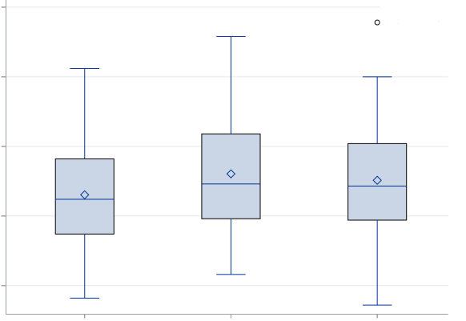
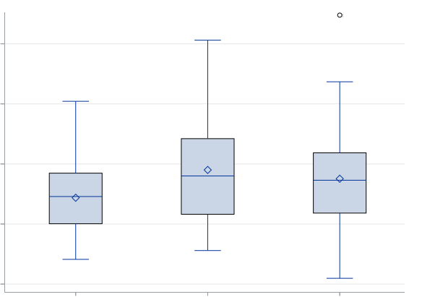
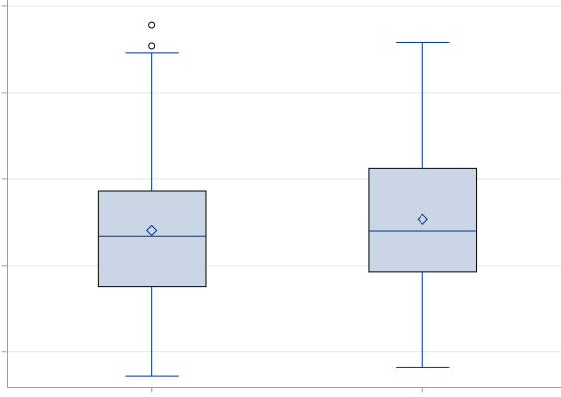
p=0.078
p=0.26
500
400
300
200
100

7-8 y. 10-11 y. 13-14 y.
male female

S2-b. Chao1 S2-e. Chao1
1-d. Chao1
1-d. Chao1
1-d. Chao1
1-d. Chao1
1-d. Chao1
1-d. Chao1

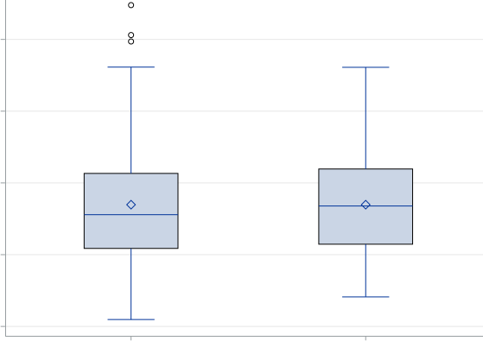
p=0.001
p=1.00
500
400
300
200
100

7-8 y. 10-11 y. 13-14 y.
male female

S2-c. Shannon S2-f. Shannon

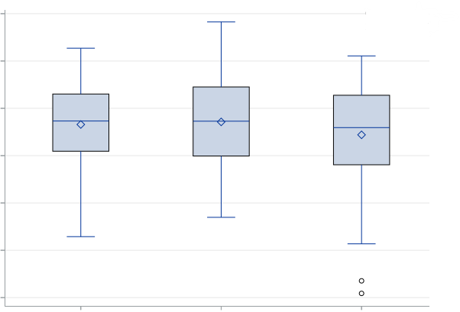
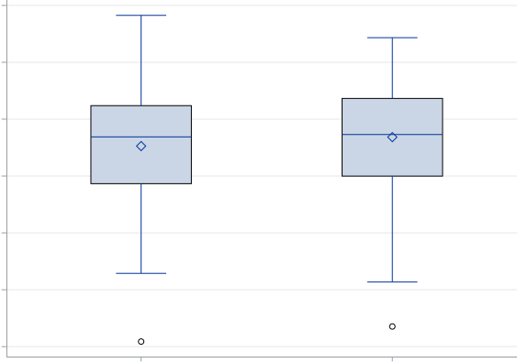
p=0.21
p=0.23
6.0
5.5
5.0
4.5
4.0
3.5
3.0
6.0
5.5
5.0
4.5
4.0
3.5
3.0

7-8 y. 10-11 y. 13-14 y.
male female

S2-a, S2-b, S2-c. Comparison of gut microbiome α-diversity between male (n=107) and female (n=116); S2-d, S2-e, S2-f. Comparison of gut microbiome α-diversity between 7-8 years old (n=76), 10-11 years old (n=77), and 13-14 years old (n=70).
P values for the comparison were assessed using t-test (for sex) or analysis of variance (for age group).

Supplementary Figure 3. Indices of gut microbiota α-diversity according to tertiles of isoflavone intake
S3-a. Observed OTU number
300
250
200
150
100

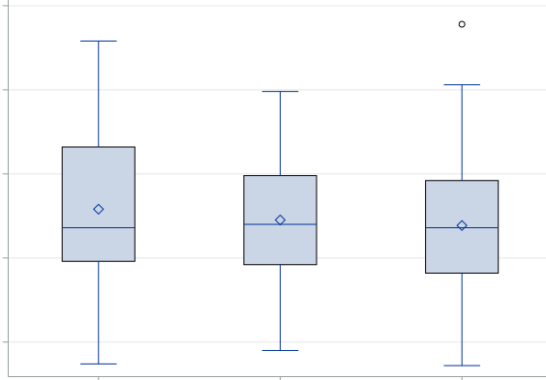
p=0.46

Low middle high

S3-b. Chao1
1-d. Chao1
1-d. Chao1
1-d. Chao1
1-d. Chao1
1-d. Chao1
1-d. Chao1

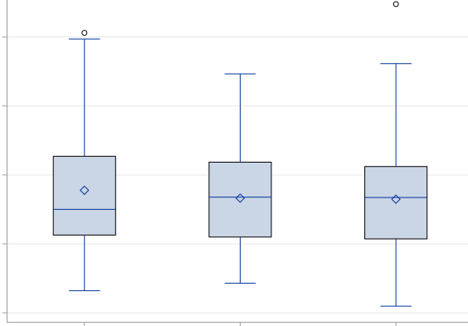
p=0.84
500
400
300
200
100

Low middle high

S3-c. Shannon

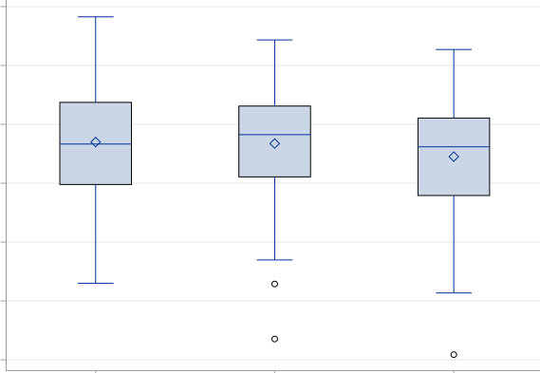
p=0.18
6.0
5.5
5.0
4.5
4.0
3.5
3.0

Low middle high

S3-a, S3-b, S3-c. Comparison of gut microbiome α-diversity between those with isoflavone intake of low (<26 mg/d), middle (26-34 mg/d), and high (>34 mg/d).
Isoflavone intake was adjusted for total energy by using the residual method proposed by Willett.
P values for the comparison between tertiles of isoflavone intake were assessed by analysis of covariance with adjustment for survey time, sex, and age.

Supplementary Figure 4. Comparison of gut microbiota α-diversity between equol producers (n=53) and non-producers (n=169) in the first collected urine samples by analysis of covariance with adjustment for survey time, sex, and age
S4-a. Observed OTU number

300
250
200
150
100

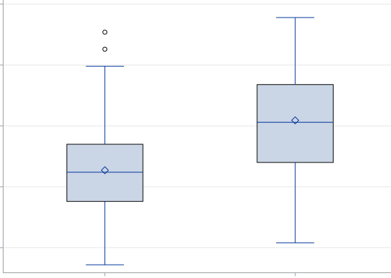
p<0.001

Equol(-) Equol(+)

S4-b. Chao1
1-d. Chao1
1-d. Chao1
1-d. Chao1
1-d. Chao1
1-d. Chao1
1-d. Chao1

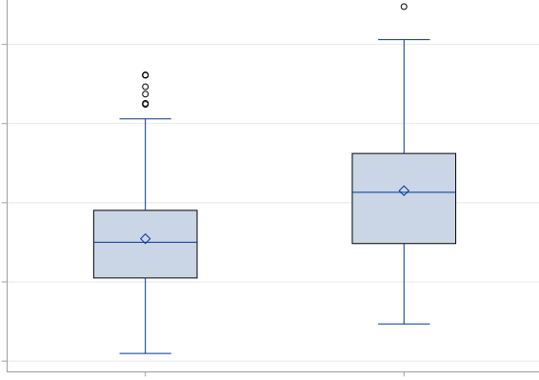
p<0.001
500
400
300
200
100

Equol(-) Equol(+)

S4-c. Shannon

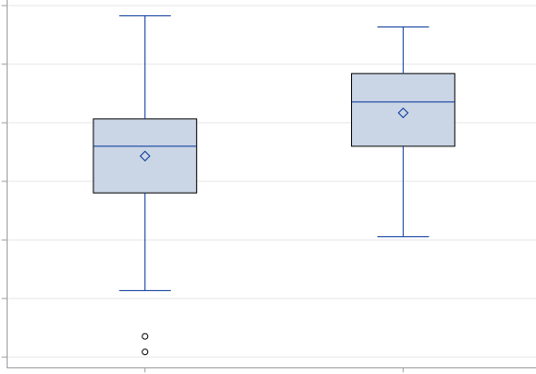
p <0.001
6.0
5.5
5.0
4.5
4.0
3.5
3.0

Equol(-) Equol(+)

Equol production was determined in urine collected before soymilk supplementation.

Supplementary Figure 5. Comparison of Chao1 between equol producers and non-producers by age group
400
300
200
S5-a. 7-8 years old

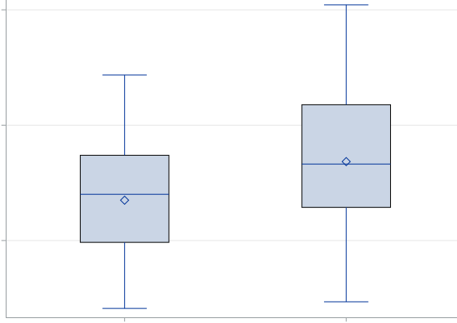
p=0.041

Equol(-) Equol(+)

S5-b. 10-11 years old S5-d. 10-11 years old
1-d. Chao1
1-d. Chao1
1-d. Chao1
1-d. Chao1
1-d. Chao1
1-d. Chao1

500
400
300
200
500
400
300
200
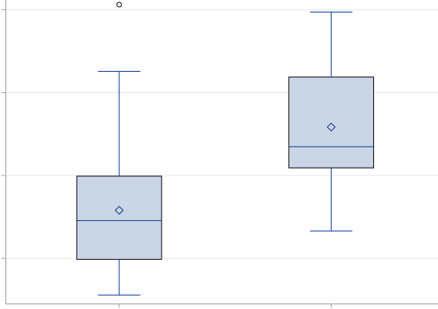
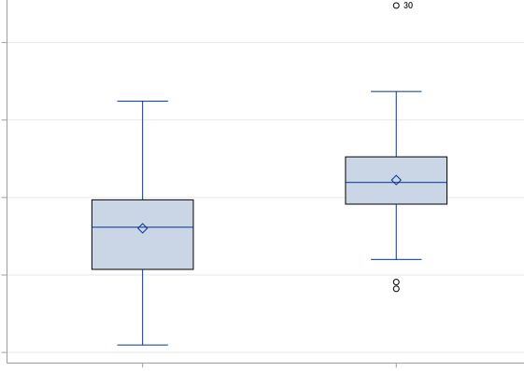
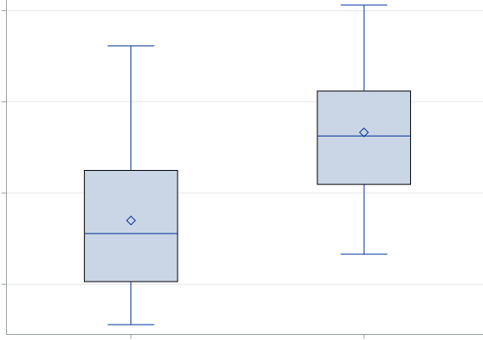
p<0.001
p<0.001
500
400
300
200
100

Equol(-) Equol(+)
Equol(-) Equol(+)

S5-c. 13-14 years old S5-e. 13-14 years old
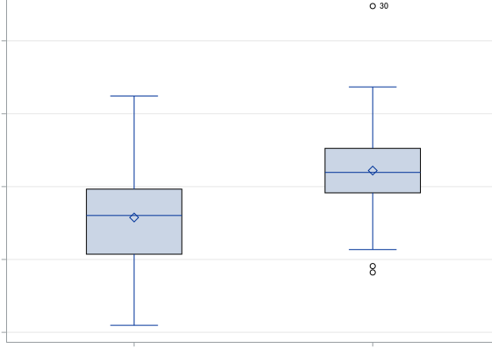
p=0.002
p=0.003
500
400
300
200
100

Equol(-) Equol(+)
Equol(-) Equol(+)

S5-a, S5-b, S5-c. Chao1 of equol producers and non-producers in the first urines among 7-8, 10-11, and 13-14 years old; S5-d, S5-e. Chao1 of equol producers and non-producers in the second urines among 10-11 and 13-14 years old.
The first and second urines were collected before and after two days of soymilk supplementation, respectively. P values for the comparison between equol producer and non-producer were assessed by analysis of covariance after adjustments for survey time, sex, and age.

Supplementary Figure 6. Principal coordinate analysis (PCoA) plots based on UniFrac distances of the gut microbiota for the comparison between equol production (n=53) and non-production (n=169) in the first urines

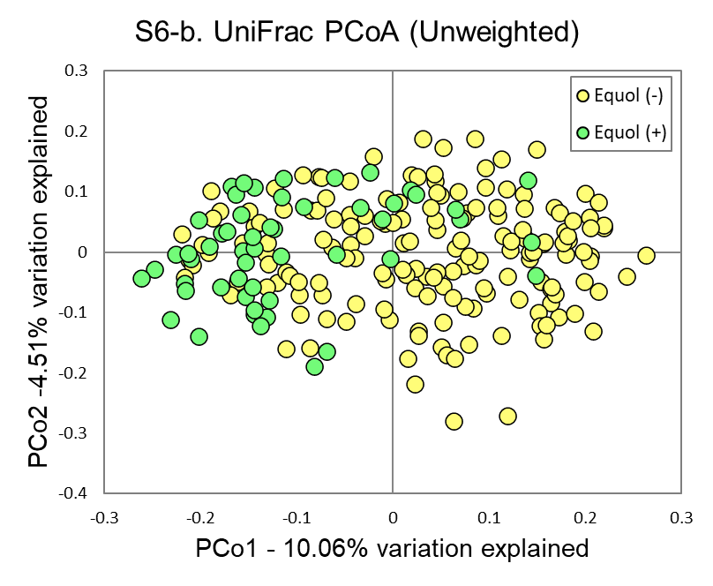
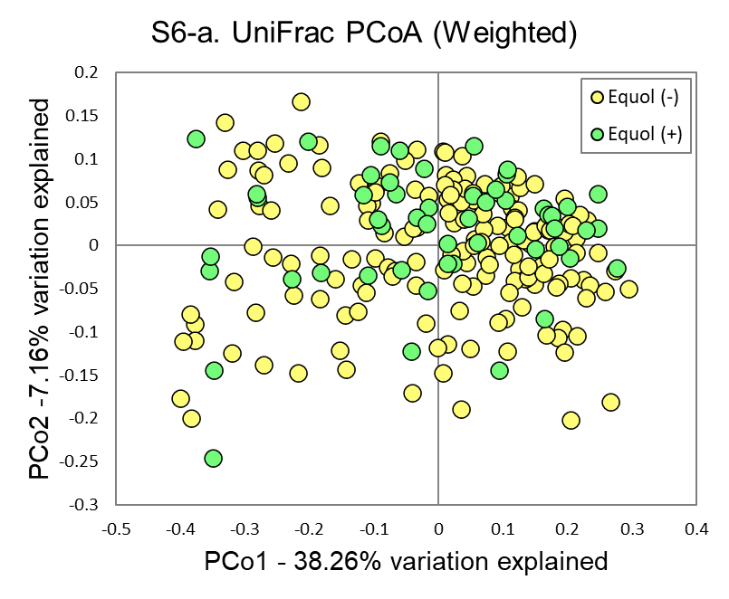

R²: 0.0276, p<0.001 by PERMANOVA
R²: 0.0124, p=0.021 by PERMANOVA

Equol production was determined in urine collected before soymilk supplementation.

Supplementary Figure 7. Principal coordinate analysis (PCoA) plots based on UniFrac distances of the gut microbiota for the comparison between equol production and non-production by sex

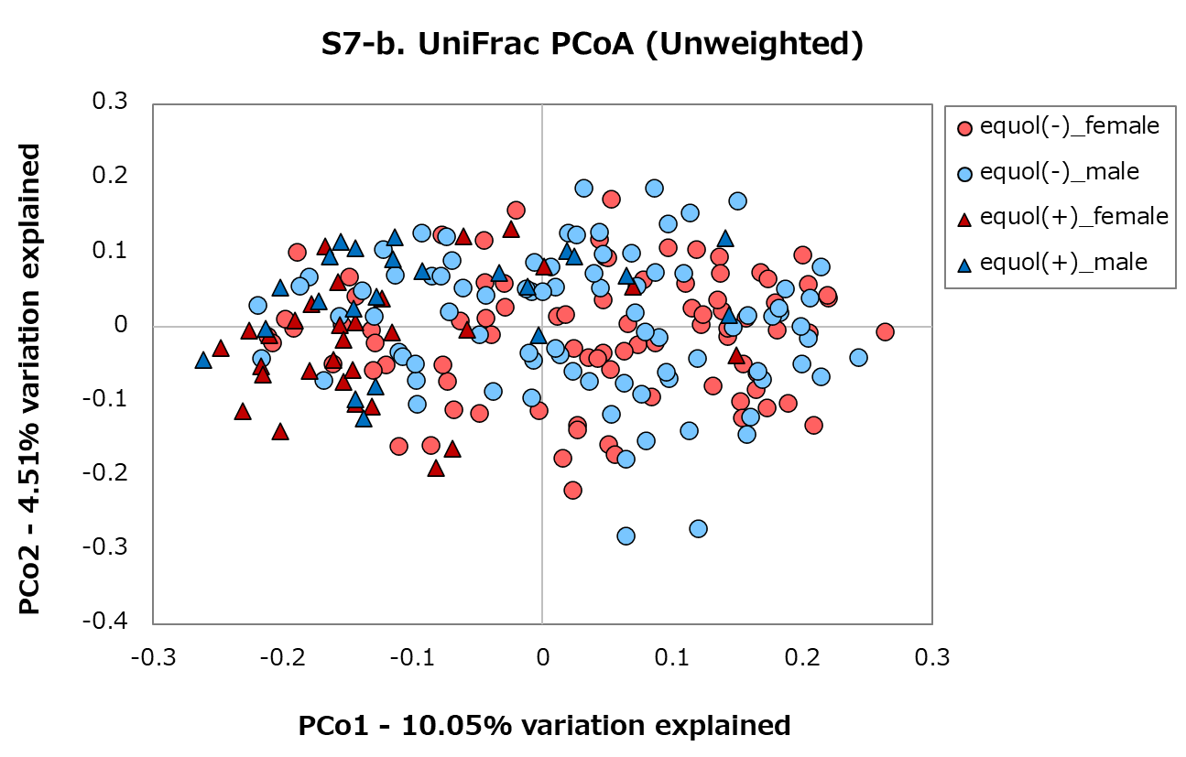
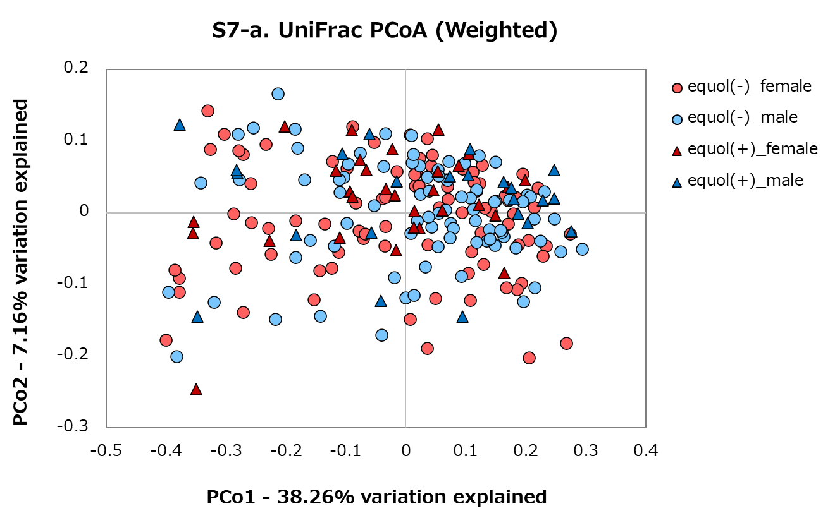

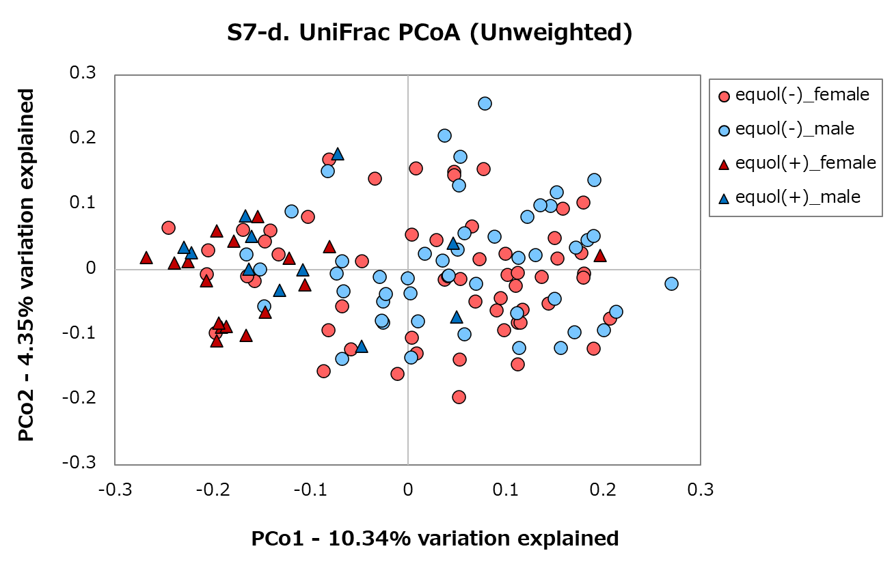
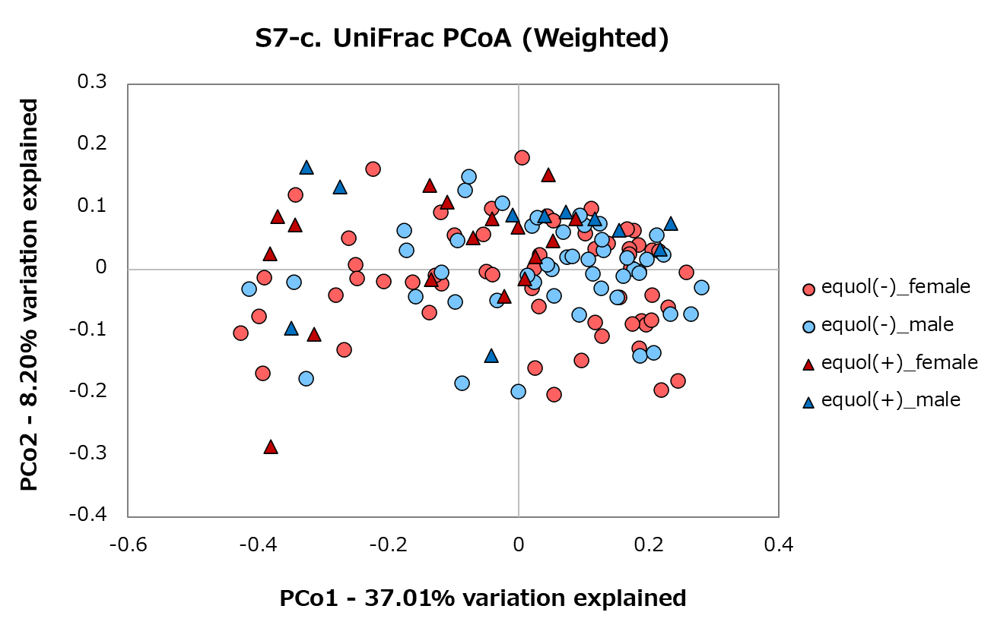

Permanova results of β-diversity according to equol production status by sex
 |  | Weighted UniFrac |  |  | Unweighted UniFrac
Equol, (+) vs. (-) | n | R² | p |  | R² | p
the first urines (S7-a, S7-b)
male | 23 vs. 84 | 0.015 | 0.147 |  | 0.023 | <0.001
female | 30 vs. 85 | 0.018 | 0.073 |  | 0.040 | <0.001
the second urines (S7-c, S7-d)
male | 11 vs. 48 | 0.043 | 0.032 |  | 0.037 | <0.001
female | 17 vs. 57 | 0.049 | 0.006 |  | 0.047 | <0.001

S7-a, S7-b. Equol production (+) vs. (-) in the first urines; S7-c, S7-d. Equol production (+) vs. (-) in the second urines.
The first and second urines were collected before and after two days of soymilk supplementation, respectively.

Supplementary Figure 8. Principal coordinate analysis (PCoA) plots based on UniFrac distances of the gut microbiota for the comparison between equol producers and non-producers by age group
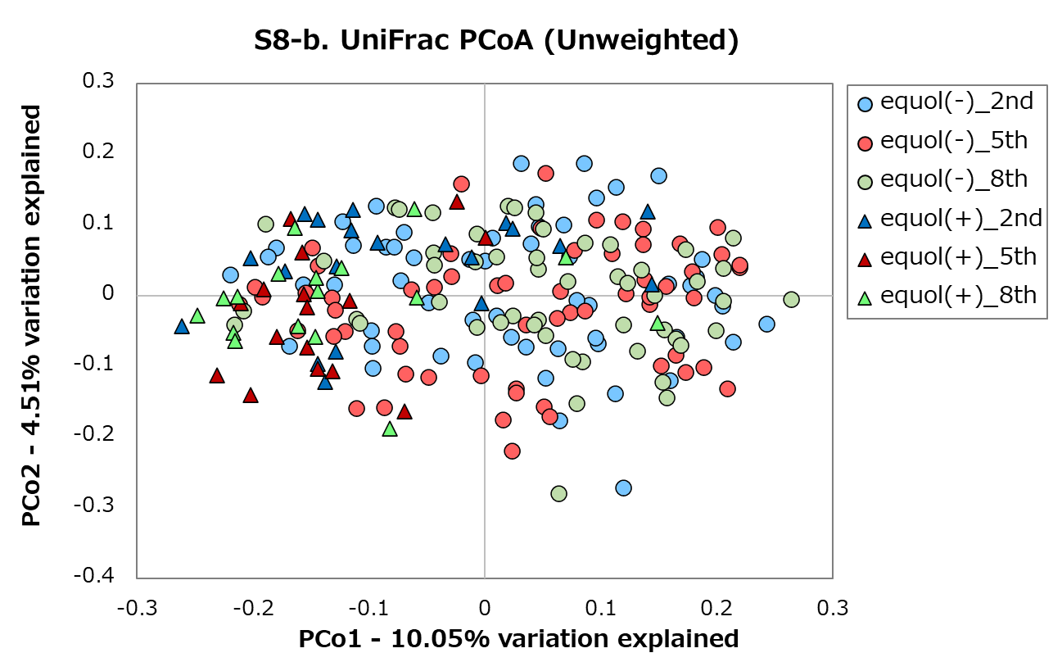
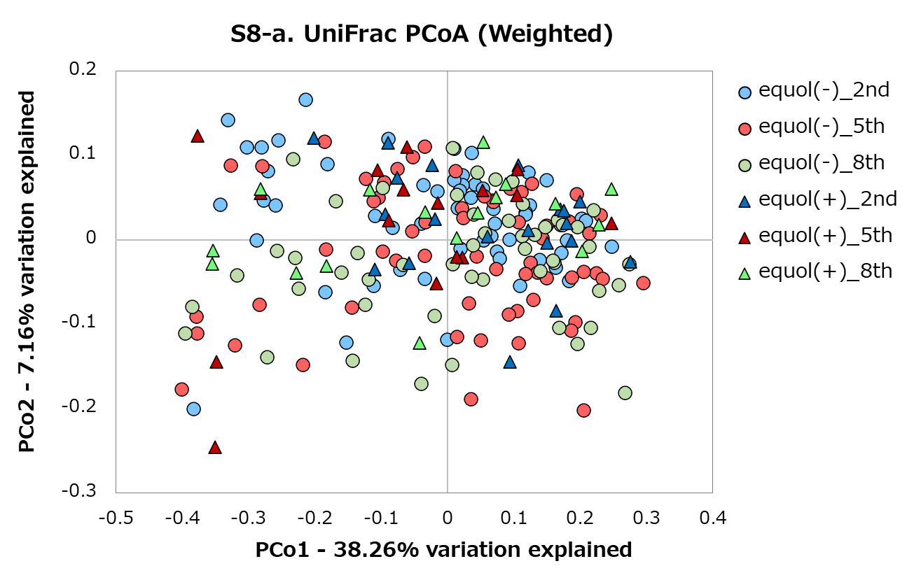

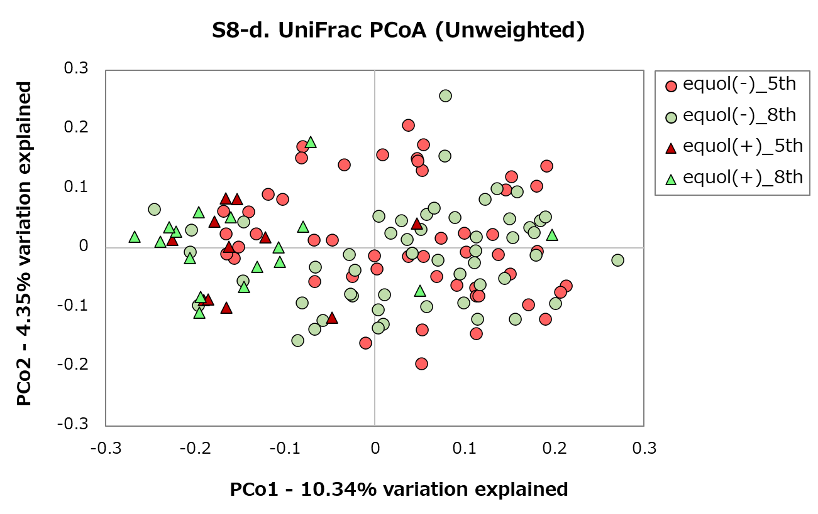
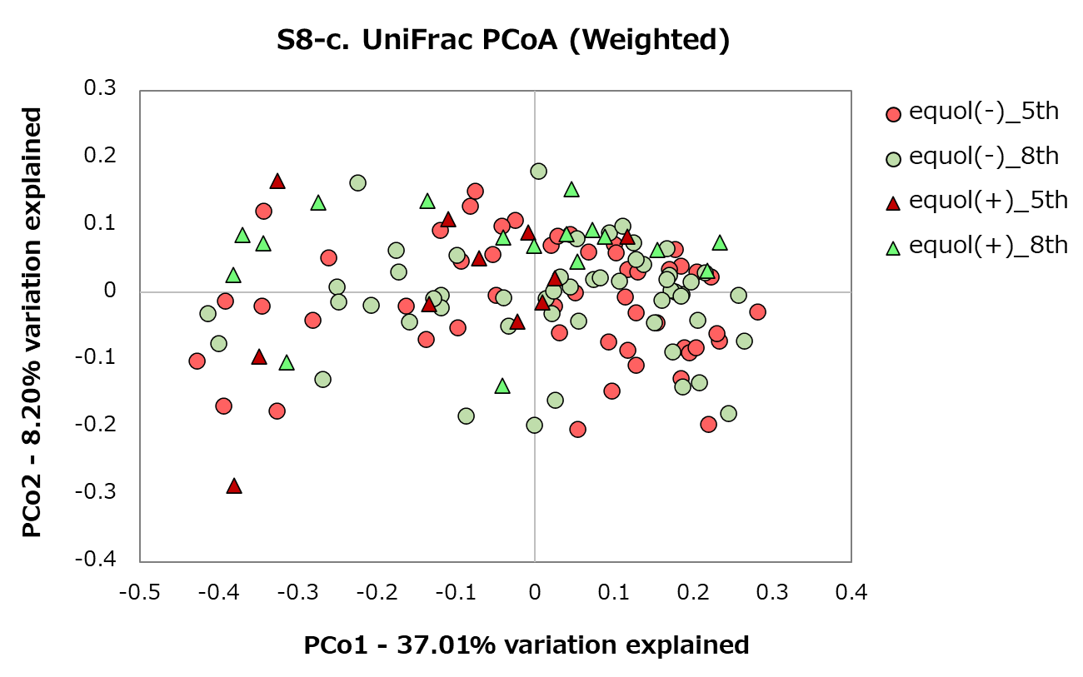

e se
Permanova results of β-diversity according to equol production status by age group
 |  | Weighted UniFrac |  |  | Unweighted UniFrac
Equol, (+) vs. (-) | n | R² | p |  | R² | p
the first urines (S8-a, S8-b)
7-8 years (2nd) | 20 vs. 56 | 0.036 | 0.030 |  | 0.027 | <0.001
10-11 years (5th) | 16 vs. 61 | 0.037 | 0.026 |  | 0.040 | <0.001
13-14 years (8th) | 17 vs. 52 | 0.029 | 0.085 |  | 0.047 | <0.001
the second urines (S8-c, s S8-d)
10-11 years (5th) | 11 vs. 52 | 0.046 | 0.024 |  | 0.040 | <0.001
13-14 years (8th) | 17 vs. 53 | 0.043 | 0.015 |  | 0.047 | <0.001

S8-a, S8-b. Equol production (+) vs. (-) in the first urines; S8-c, S8-d. Equol production (+) vs. (-) in the second urines.
The first and second urines were collected before and after two days of soymilk supplementation, respectively.

Supplementary Figure 9. Principal coordinate analysis (PCoA) plots based on UniFrac distances of the gut microbiota according to isoflavone intake (n=223)
S9-a. UniFrac PCoA (Weighted) S9-b. UniFrac PCoA (Unweighted)

R²: 0.006, p=0.055 by PERMANOVA
R²: 0.003, p=0.67 by PERMANOVA

S9-a, S9-b. Principal coordinate analysis (PCoA) plots based on UniFrac distances of the gut microbiomes with isoflavone intake.
Isoflavone intake was adjusted for total energy by using the residual method proposed by Willett.

