Supplementary Material
Journal: European Journal of Nutrition
Title: The potential of Nutri-Score to discriminate foods according to environmental impact
Authors: Elly Steenbergenª, Reina E Vellingaª, Joline WJ Beulens^{bc}, Elisabeth HM Temme^{ad}
ªNational Institute for Public Health and the Environment, Bilthoven, The Netherlands
^{b}Department of Epidemiology & Data Science, Amsterdam UMC, location Vrije Universiteit, Amsterdam, The Netherlands
^{c}Amsterdam Public Health research institute, Amsterdam, The Netherlands
^{d}Wageningen University & Research, Division of Human Nutrition and Health, Wageningen, The Netherlands

Corresponding author: Elly Steenbergen, elly.steenbergen@rivm.nl

Contents:
Supplementary Table S1 Food groups and their assumed fruits, vegetables and legumes content (%) used for the calculations of Nutri-Score
Supplementary Table S2 Distribution of final score of Nutri-Score of foods by food group
Supplementary Table S3 Distribution of Nutri-Score classifications (A-E, %) of foods by food group
Supplementary Table S4 Distribution of environmental impact indicators (greenhouse gas emission and blue water consumption) per kg of food by category of Nutri-Score algorithm
Supplementary Table S5 Distribution of blue water consumption (m³) per kg of food by food group, in boxplot
Supplementary Table S6 Spearman’s correlation between final score of Nutri-Score and greenhouse gas emission (kg CO₂ equivalents) and blue water consumption (m³)
Supplementary Table S7 Median (P50) greenhouse gas emission (kg CO₂ equivalents) and blue water consumption (m³) per kg of foods within Nutri-Score classifications by food group
Supplementary Figure S1 Distribution of greenhouse gas emissions (kg CO₂ equivalents) per kg of food by category of Nutri-Score, in boxplot
Supplementary Figure S2 Distribution of blue water consumption (m³) per kg of food by category of Nutri-Score, in boxplot
Supplementary Figure S3 Distribution of greenhouse gas emissions (kg CO₂ equivalents) per kg of food by food group, in boxplot
Supplementary Figure S4 Distribution of blue water consumption (m³) per kg of food by food group, in boxplot
Table S1 Food groups and their assumed fruits, vegetables and legumes content (%) used for the calculations of Nutri-Score
Food group | N | Fruits, vegetables and legumes content (%)* | Exceptions within food group
Vegetables | 177 | >80
Legumes | 24 | >80
Fruits | 95 | >80
Bread | 111 | ≤40
Cereals and cereal products | 84 | ≤40
Potatoes and tubers | 28 | ≤40
Nuts and seeds | 33 | ≤40
Milk and milk products | 113 | ≤40 | Dairy based added fats (e.g. cream) are calculated according to algorithm for added fats, nuts and seeds. Dairy based beverages are calculated according to algorithm for beverages. Dairy based solid foods are calculated according to algorithm for general foods.
Meat and dairy substitutes | 43 | >40 | Dairy substitutes of beverages (e.g. soy drinks) are calculated according to algorithm for beverages. Dairy substitutes of added fats (e.g. plant based cream) are calculated according to algorithm for added fats, nuts and seeds. Meat and dairy substitutes of solid foods are calculated according to algorithm for general foods.
Fish | 75 | ≤40
Cheese | 65 | ≤40
Cold meat cuts | 55 | ≤40 | Point allocation for protein differed for red meat.
Meat and poultry | 115 | ≤40 | Point allocation for protein differed for red meat.
Soups | 25 | ≤40
Sugar, sweets and sweet sauces | 115 | ≤40
Savoury sauces | 69 | ≤40
Pastry and biscuits | 147 | ≤40
Savoury snacks | 50 | ≤40
Savoury bread spreads | 21 | ≤40 | Spreads based on nuts and seeds (e.g. peanut butter) are calculated according to algorithm for added fats, nuts and seeds
Fats and oils | 59 | ≤40 | Fats and oils based on fruits, vegetables and legumes (e.g. olive oil) contain >80% fruits, vegetables and legumes.
Non-alcoholic beverages | 107 | ≤40 | Mineral waters always receive Nutri-Score classification A. Beverages which included the terms ‘light’, ‘zero’, ‘sweeteners’ or ‘sugar free’ were considered to contain non-nutritive sweeteners. 100% fruit juices contain >80% fruit, vegetables and legumes content.
*assumptions based on expert judgement
Table S2 Distribution of final score of Nutri-Score of foods by food group
 | Final score of Nutri-Score
Food group | N | Mean | P5 | P25 | P50 | P75 | P95
Vegetables | 177 | -4 | -8 | -5 | -5 | -4 | 0
Legumes | 24 | -10 | -12 | -12 | -11 | -9 | -5
Fruits | 95 | 0 | -5 | -3 | -2 | 0 | 10
Bread | 111 | 6 | -2 | 0 | 3 | 13 | 21
Cereals and cereal products | 84 | 5 | -6 | -1 | 3 | 11 | 18
Potatoes and tubers | 28 | 2 | 0 | 1 | 2 | 4 | 5
Nuts and seeds | 33 | 0 | -10 | -6 | -2 | 6 | 16
Milk and milk products | 113 | 7 | -1 | 2 | 5 | 12 | 19
Meat and dairy substitutes | 43 | 5 | -4 | -1 | 2 | 11 | 19
Fish | 75 | 3 | -6 | -5 | -1 | 11 | 24
Cheese | 65 | 15 | 7 | 13 | 15 | 17 | 20
Cold meat cuts | 55 | 20 | 12 | 16 | 20 | 23 | 31
Meat and poultry | 115 | 5 | -5 | -1 | 2 | 11 | 23
Soups | 25 | 3 | 1 | 2 | 3 | 4 | 5
Sugar, sweets and sweet sauces | 115 | 22 | 6 | 18 | 20 | 28 | 32
Savoury sauces | 69 | 13 | 1 | 8 | 13 | 18 | 23
Pastry and biscuits | 147 | 20 | 8 | 15 | 21 | 26 | 29
Savoury snacks | 50 | 16 | 3 | 11 | 17 | 21 | 24
Savoury bread spreads | 21 | 10 | 2 | 8 | 11 | 14 | 17
Fats and oils | 59 | 9 | 1 | 4 | 7 | 16 | 24
Non-alcoholic beverages | 107 | 8 | 0 | 4 | 7 | 12 | 20

Table S3 Distribution of Nutri-Score classifications (A-E, %) of foods by food group
 |  | Nutri-Score classification (%)
Food group | N | A | B | C | D | E
Vegetables | 177 | 95 | 2 | 0 | 2 | 1
Legumes | 24 | 100 | 0 | 0 | 0 | 0
Fruits | 95 | 76 | 4 | 16 | 4 | 0
Bread | 111 | 37 | 8 | 23 | 23 | 9
Cereals and cereal products | 84 | 36 | 13 | 19 | 29 | 4
Potatoes and tubers | 28 | 14 | 54 | 32 | 0 | 0
Nuts and seeds | 33 | 36 | 24 | 30 | 6 | 3
Milk and milk products | 113 | 12 | 19 | 35 | 19 | 16
Meat and dairy substitutes | 43 | 19 | 33 | 21 | 21 | 7
Fish | 75 | 59 | 11 | 4 | 17 | 9
Cheese | 65 | 0 | 0 | 11 | 74 | 15
Cold meat cuts | 55 | 0 | 0 | 0 | 35 | 65
Meat and poultry | 115 | 37 | 16 | 23 | 17 | 9
Soups | 25 | 0 | 32 | 68 | 0 | 0
Sugar, sweets and sweet sauces | 115 | 0 | 3 | 5 | 18 | 74
Savoury sauces | 69 | 4 | 1 | 28 | 48 | 19
Pastry and biscuits | 147 | 0 | 0 | 8 | 32 | 60
Savoury snacks | 50 | 2 | 2 | 14 | 42 | 40
Savoury bread spreads | 21 | 5 | 14 | 19 | 57 | 5
Fats and oils | 59 | 0 | 8 | 63 | 15 | 14
Non-alcoholic beverages | 107 | 2 | 15 | 30 | 14 | 39

Table S4 Distribution of environmental impact indicators (greenhouse gas emission and blue water consumption) per kg of food by category of Nutri-Score algorithm
 | Greenhouse gas emissions (kg CO₂ equivalents) |  |  |  |  |  |  | Blue water consumption (m³)
Category of algorithm | N | Mean | P5 | P25 | P50 | P75 | P95 | Mean | P5 | P25 | P50 | P75 | P95
General foods | 1341 | 5.15 | 0.72 | 1.40 | 2.51 | 6.06 | 15.4 | 0.11 | 0.01 | 0.02 | 0.05 | 0.11 | 0.36
Added fats, nuts and seeds | 118 | 4.81 | 1.54 | 2.52 | 4.46 | 5.01 | 12.2 | 0.63 | 0.02 | 0.05 | 0.10 | 0.17 | 4.09
Beverages | 152 | 1.81 | 0.32 | 0.62 | 0.93 | 2.19 | 3.61 | 0.07 | 0.01 | 0.01 | 0.02 | 0.09 | 0.33

Table S5 Spearman’s correlation between algorithm component points and greenhouse gas emission (kg CO₂ equivalents) and blue water consumption (m³)
Food group | Algorithm component |  |  | GHGe | BWC
General foods | Energy component |  | r_{s} | 0.22 | -0.03
 |  |  | p | 0.000 | 0.347
 | Sugar component |  | r_{s} | -0.23 | -0.05
 |  |  | p | 0.000 | 0.044
 | SFA component |  | r_{s} | 0.52 | 0.13
 |  |  | p | 0.000 | 0.000
 | Salt component |  | r_{s} | 0.33 | 0.06
 |  |  | p | 0.000 | 0.031
 | Fiber component |  | r_{s} | -0.22 | -0.08
 |  |  | p | 0.000 | 0.006
 | Protein component |  | r_{s} | 0.43 | 0.03
 |  |  | p | 0.000 | 0.204
Added fats, nuts and seeds | Energy component |  | r_{s} | 0.58 | -0.04
 |  |  | p | 0.000 | 0.635
 | Sugar component |  | r_{s} | -0.08 | 0.10
 |  |  | p | 0.398 | 0.287
 | SFA component |  | r_{s} | 0.00 | 0.07
 |  |  | p | 0.998 | 0.000
 | Salt component |  | r_{s} | 0.07 | 0.03
 |  |  | p | 0.431 | 0.780
 | Fiber component |  | r_{s} | -0.06 | 0.70
 |  |  | p | 0.530 | 0.000
 | Protein component |  | r_{s} | -0.20 | 0.51
 |  |  | p | 0.028 | 0.000
Beverages | Energy component |  | r_{s} | 0.54 | 0.27
 |  |  | p | 0.000 | 0.001
 | Sugar component |  | r_{s} | 0.34 | 0.34
 |  |  | p | 0.000 | 0.000
 | SFA component |  | r_{s} | 0.34 | 0.02
 |  |  | p | 0.000 | 0.854
 | Salt component |  | r_{s} | 0.40 | 0.31
 |  |  | p | 0.000 | 0.000
 | Fiber component |  | r_{s} | 0.21 | 0.14
 |  |  | p | 0.081 | 0.000
 | Protein component |  | r_{s} | 0.58 | -0.09
 |  |  | p | 0.000 | 0.204
GHGe: greenhouse gas emission (kg CO₂ equivalents), BWC: blue water consumption (m³), r_{s}: Spearman’s correlation coefficient, p: p-value
Table S6 Spearman’s correlation between final score of Nutri-Score and greenhouse gas emission (kg CO₂ equivalents) and blue water consumption (m³)
Food group | N |  | GHGe | BWC
Vegetables | 177 | r_{s} | 0.14 | 0.18
 |  | p | 0.056 | 0.014
Legumes | 24 | r_{s} | -0.26 | 0.44
 |  | p | 0.228 | 0.030
Fruits | 95 | r_{s} | 0.20 | 0.17
 |  | p | 0.054 | 0.093
Bread | 111 | r_{s} | 0.60 | 0.53
 |  | p | 0.000 | 0.000
Cereals and cereal products | 84 | r_{s} | 0.46 | 0.39
 |  | p | 0.000 | 0.000
Potatoes and tubers | 28 | r_{s} | 0.36 | 0.39
 |  | p | 0.058 | 0.038
Nuts and seeds | 33 | r_{s} | 0.57 | -0.15
 |  | p | 0.001 | 0.391
Milk and milk products | 113 | r_{s} | 0.35 | 0.40
 |  | p | 0.000 | 0.000
Meat and dairy substitutes | 43 | r_{s} | 0.05 | 0.15
 |  | p | 0.744 | 0.333
Fish | 75 | r_{s} | -0.48 | -0.44
 |  | p | 0.000 | 0.000
Cheese | 65 | r_{s} | 0.13 | 0.28
 |  | p | 0.291 | 0.025
Cold meat cuts | 55 | r_{s} | 0.14 | 0.09
 |  | p | 0.300 | 0.498
Meat and poultry | 115 | r_{s} | 0.01 | -0.26
 |  | p | 0.914 | 0.005
Soups | 25 | r_{s} | -0.63 | -0.65
 |  | p | 0.001 | 0.000
Sugar, sweets and sweet sauces | 115 | r_{s} | 0.58 | 0.32
 |  | p | 0.000 | 0.000
Savoury sauces | 69 | r_{s} | 0.52 | 0.53
 |  | p | 0.000 | 0.000
Pastry and biscuits | 147 | r_{s} | 0.51 | -0.01
 |  | p | 0.000 | 0.923
Savoury snacks | 50 | r_{s} | 0.19 | -0.18
 |  | p | 0.197 | 0.213
Savoury bread spreads | 21 | r_{s} | -0.12 | -0.41
 |  | p | 0.619 | 0.063
Fats and oils | 59 | r_{s} | 0.38 | -0.14
 |  | p | 0.003 | 0.282
Non-alcoholic beverages | 107 | r_{s} | 0.19 | 0.06
 |  | p | 0.051 | 0.548
GHGe: greenhouse gas emission (kg CO₂ equivalents), BWC: blue water consumption (m³), r_{s}: Spearman’s correlation coefficient, p: p-value
Table S7 Median (P50) greenhouse gas emission (kg CO₂ equivalents) and blue water consumption (m³) per kg of foods within Nutri-Score classifications by food group
 | Median greenhouse gas emission (kg CO₂ equivalents) within Nutri-Score classifications |  |  |  |  |  |  |  |  |  | Median blue water consumption (m³) within Nutri-Score classifications
 | A |  | B |  | C |  | D |  | E |  | A |  | B |  | C |  | D |  | E
Food group | N | P50 | N | P50 | N | P50 | N | P50 | N | P50 | N | P50 | N | P50 | N | P50 | N | P50 | N | P50
Vegetables | 169 | 1.56 | 4 | 1.62 | . | . | 3 | 2.34 | 1 | 6.63 | 169 | 0.05 | 4 | 0.06 | . | . | 3 | 0.11 | 1 | 0.43
Legumes | 24 | 1.93 | . | . | . | . | . | . | . | . | 24 | 0.07 | . | . | . | . | . | . | . | .
Fruits | 72 | 1.13 | 4 | 1.32 | 15 | 2.44 | 4 | 3.54 | . | . | 72 | 0.20 | 4 | 0.37 | 15 | 0.70 | 4 | 0.60 | . | .
Bread | 41 | 1.19 | 9 | 1.19 | 25 | 1.23 | 26 | 1.77 | 10 | 2.42 | 41 | 0.02 | 9 | 0.02 | 25 | 0.02 | 26 | 0.06 | 10 | 0.04
Cereals and cereal
products | 30 | 1.05 | 11 | 1.63 | 16 | 1.55 | 24 | 1.71 | 3 | 2.42 | 30 | 0.02 | 11 | 0.03 | 16 | 0.02 | 24 | 0.06 | 3 | 0.04
Potatoes and tubers | 4 | 1.01 | 15 | 1.09 | 9 | 6.15 | . | . | . | . | 4 | 0.01 | 15 | 0.01 | 9 | 0.09 | . | . | . | .
Nuts and seeds | 12 | 3.60 | 8 | 4.06 | 10 | 4.33 | 2 | 5.73 | 1 | 4.91 | 12 | 0.86 | 8 | 3.31 | 10 | 1.90 | 2 | 0.11 | 1 | 0.07
Milk and milk products | 13 | 2.30 | 22 | 2.03 | 39 | 2.19 | 21 | 2.41 | 18 | 2.47 | 13 | 0.02 | 22 | 0.02 | 39 | 0.02 | 21 | 0.02 | 18 | 0.02
Meat and dairy substitutes | 8 | 4.39 | 14 | 0.76 | 9 | 2.95 | 9 | 3.77 | 3 | 2.92 | 8 | 0.07 | 14 | 0.01 | 9 | 0.04 | 9 | 0.04 | 3 | 0.06
Fish | 44 | 7.26 | 8 | 6.75 | 3 | 6.95 | 13 | 2.81 | 7 | 2.81 | 44 | 0.04 | 8 | 0.04 | 3 | 0.04 | 13 | 0.02 | 7 | 0.02
Cheese | . | . | . | . | 7 | 8.80 | 48 | 10.72 | 10 | 9.90 | . | . | . | . | 7 | 0.07 | 48 | 0.09 | 10 | 0.10
Cold meat cuts | . | . | . | . | . | . | 19 | 10.82 | 36 | 11.98 | . | . | . | . | . | . | 19 | 0.10 | 36 | 0.11
Meat and poultry | 42 | 12.42 | 18 | 30.28 | 26 | 25.20 | 19 | 15.68 | 10 | 9.76 | 42 | 0.15 | 18 | 0.24 | 26 | 0.20 | 19 | 0.17 | 10 | 0.10
Soups | . | . | 8 | 2.82 | 17 | 0.71 | . | . | . | . | . | . | 8 | 0.05 | 17 | 0.03 | . | . | . | .
Sugar, sweets and
sweet sauces | . | . | 3 | 1.13 | 6 | 1.10 | 21 | 1.47 | 85 | 2.70 | . | . | 3 | 0.01 | 6 | 0.03 | 21 | 0.06 | 85 | 0.03
Savoury sauces | 3 | 0.43 | 1 | 2.05 | 19 | 1.72 | 33 | 2.92 | 13 | 4.33 | 3 | 0.01 | 1 | 0.02 | 19 | 0.04 | 33 | 0.04 | 13 | 0.07
Pastry and biscuits | . | . | . | . | 12 | 2.29 | 47 | 2.72 | 88 | 3.86 | . | . | . | . | 12 | 0.06 | 47 | 0.04 | 88 | 0.06
Savoury snacks | 1 | 0.95 | 1 | 1.07 | 7 | 3.47 | 21 | 4.83 | 20 | 4.83 | 1 | 0.09 | 1 | 0.01 | 7 | 0.05 | 21 | 0.08 | 20 | 0.06

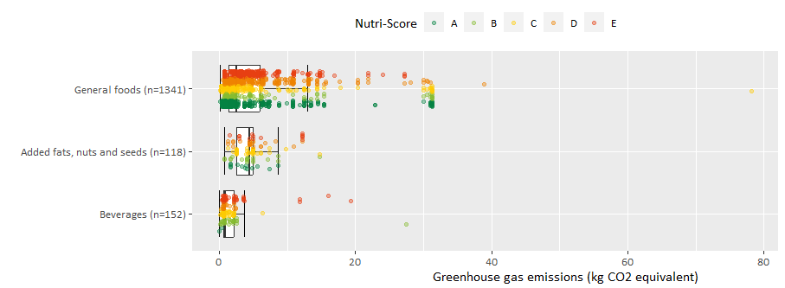
Fig. S1 Distribution of greenhouse gas emissions (kg CO₂ equivalents) per kg of food by category of Nutri-Score, in boxplot. Dots reflect individual observations according to the colours of Nutri-Score classifications A-E. The white box represents the interquartile range, the black vertical line in the box represents the median of the data, the whiskers of the box present the minimum and maximum values of the data, excluding the outliers. The specific outlier within general foods for greenhouse gas emissions is dried goji berries
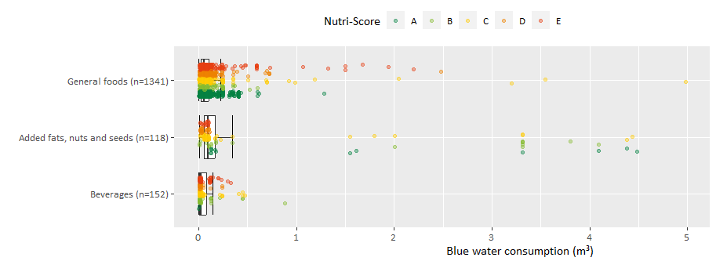Fig. S2 Distribution of blue water consumption (m³) per kg of food by category of Nutri-Score, in boxplot. Dots reflect individual observations according to the colours of Nutri-Score classifications A-E. The white box represents the interquartile range, the black vertical line in the box represents the median of the data, the whiskers of the box present the minimum and maximum values of the data, excluding the outliers
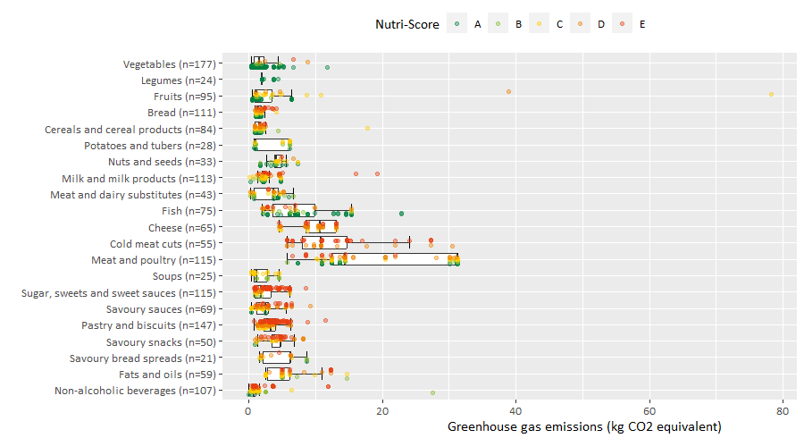
Fig. S3 Distribution of greenhouse gas emissions (kg CO₂ equivalents) per kg of food by food group, in boxplot. Dots reflect individual observations according to the colours of Nutri-Score classifications A-E. The white box represents the interquartile range, the black vertical line in the box represents the median of the data, the whiskers of the box present the minimum and maximum values of the data, excluding the outliers. The specific outlier within general foods for greenhouse gas emissions is dried goji berries
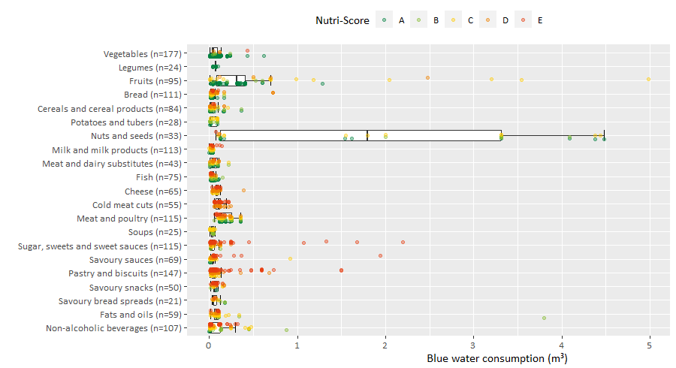
Fig. S4 Distribution of blue water consumption (m³) per kg of food by food group, in boxplot. Dots reflect individual observations according to the colours of Nutri-Score classifications A-E. The white box represents the interquartile range, the black vertical line in the box represents the median of the data, the whiskers of the box present the minimum and maximum values of the data, excluding the outliers

